Kun Zhao

Github username: kunkunbu

**Task 1:**

Result 1: top 20 most frequent words

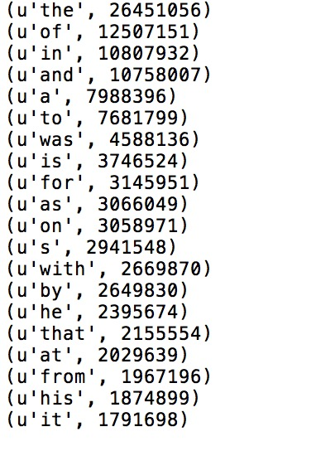

Result 2: last 20 words in your 20k feature vector

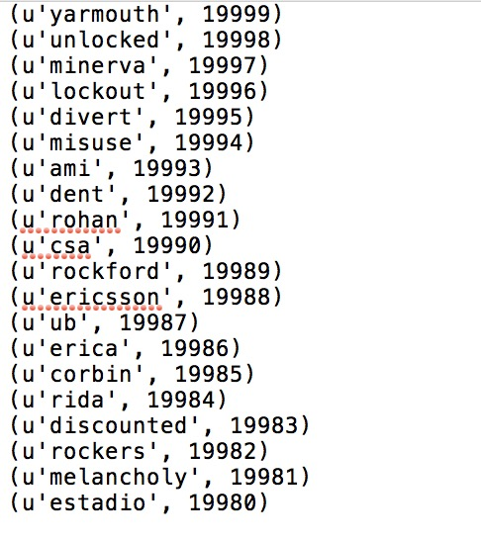

Spark history:

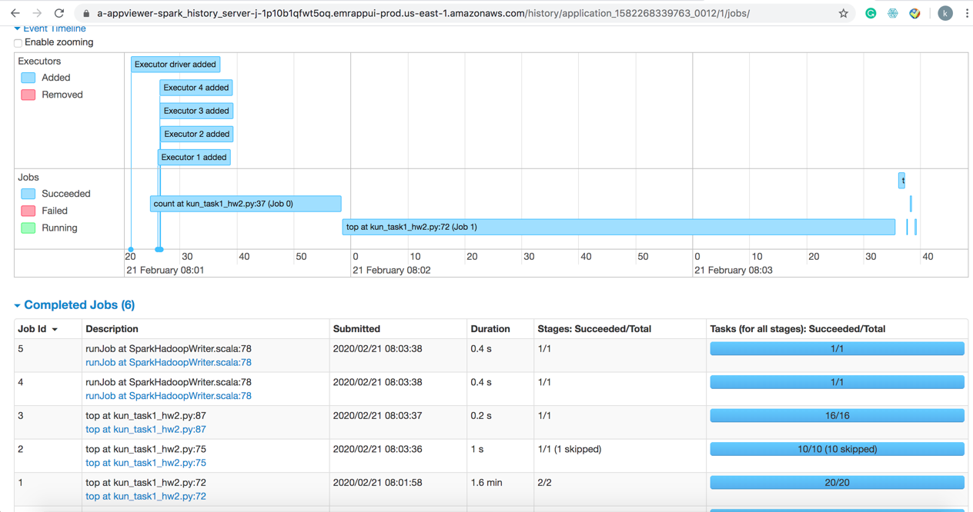

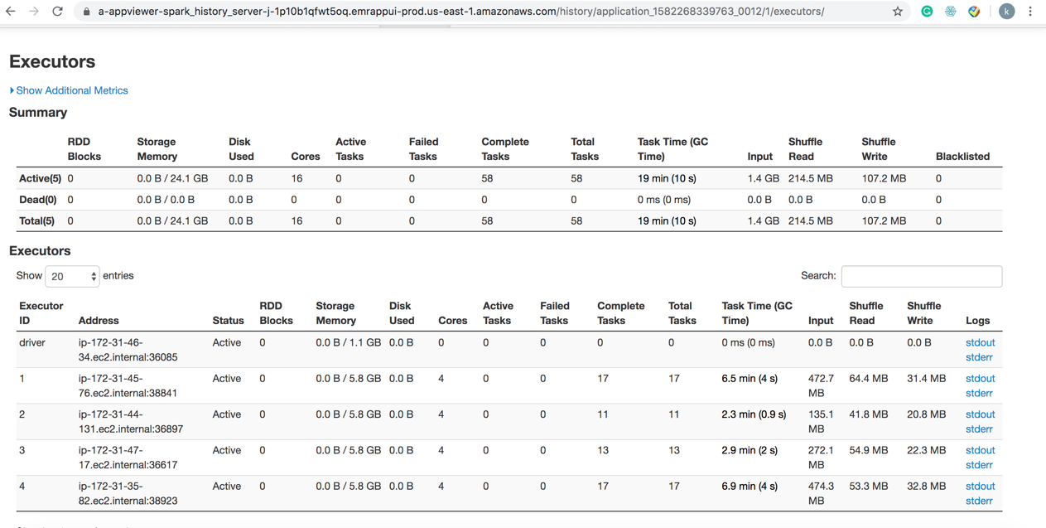

**Task 2:**

Result 1: allDocsAsNumpyArrays.take(3)

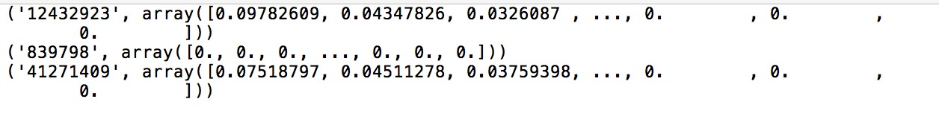

Result 2: allDocsAsNumpyArraysTFidf.take(2)

Spark history:

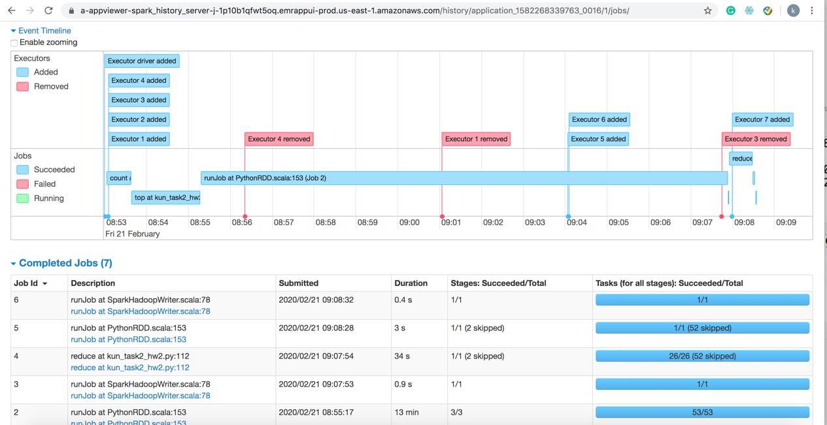

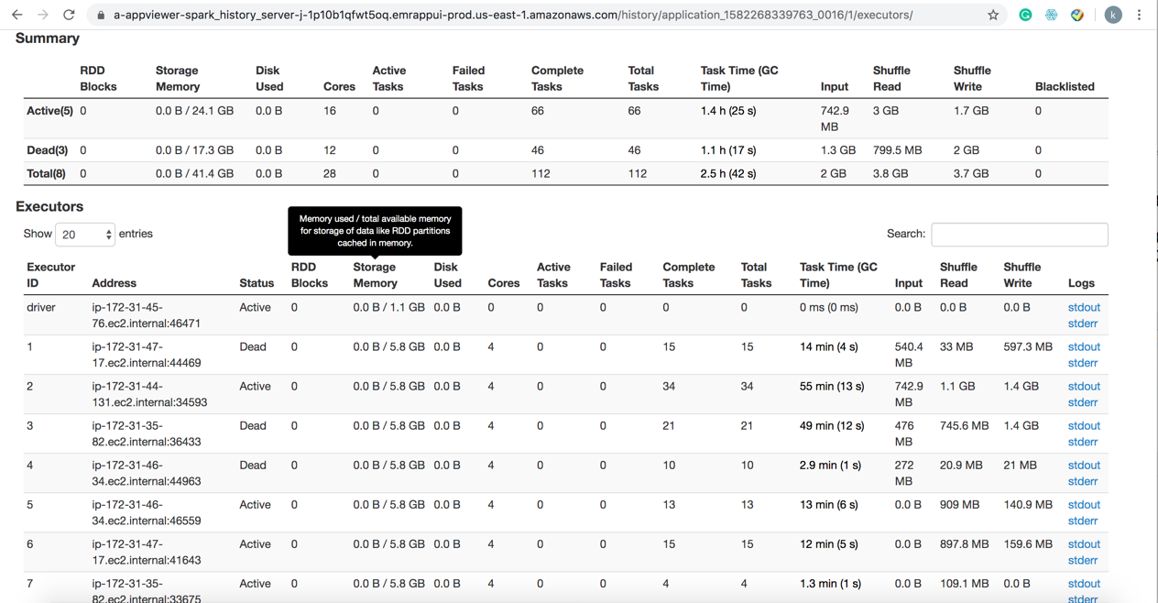

**Task 3:**

**Results:**

1.getPrediction('Sport Basketball Volleyball Soccer', 10)

2. getPrediction('What is the capital city of Australia?', 10)

3. getPrediction('How many goals Vancouver score last year?', 10)

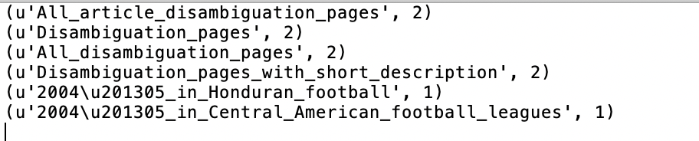

**Spark history:**

**Task 4: using dataframe to predict category:**

**Small dataset Results:**

1.getPrediction('Sport Basketball Volleyball Soccer', 10)

2. getPrediction('What is the capital city of Australia?', 10)

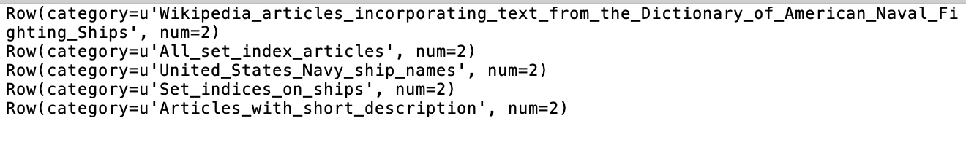

3. getPrediction('How many goals Vancouver score last year?', 10)

Spark history:

**Large data set:**

I met memory error when I run the code. I have tried a lot of methods like reduce(), toPandas(). However, I can’t figure this problem now. I will continue doing this!!

Error reason:

