**FileService REST-API Documentation**

To get a list of all uploaded files, I decided to create a database for the File service server with a single table called “file_uploads”.

The structure of the database is located in /documentation/database. It is a MySQL database, Kindly import to restore the database. Or you can create a database with name “exb_fileservice” once the file server service is running, it will create the table itself.

The application.properties files contains the database credentials and some other properties used for the File server service and it is located

\task\spring-fileservice-demo-project\server\src\main\resources

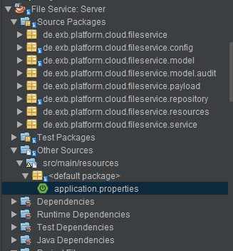

To accomplish the task, some additional dependencies were added to the pom.xml which are

* mysql-connector-java: For MySQL database connection
* spring-boot-devtools: For Automatic reload
* springfox-swagger2: For API documentation
* springfox-swagger-ui: For API documentation
* org.projectlombok: For generating getter and setter

The Swagger UI can be accessed at <http://127.0.0.1:8080/swagger-ui.html>

The FileServiceController contains the basic CRUD functionalities.

To avoid new file with the same name as existing file in the storage to overwrite existing file, a batch number which is unique is appended to new files uploaded.

**Testing**

The test package contains the test class for the FileServiceController. It test the CRUD endpoints.

JUnit and MockMVC for the testing also a dummy aSessionId was also used.

**Client Implementation Documentation**

The FileClient consumed the REST API exposed by the File Service in the FileClient interface.

**Authentication and Authorization**

To secure the File Service service Json Web Token can be used. The client or other services accessing the File Server service will have to provide a username and password. The File Server service will authenticate the credentials and send an access token to the client and the client will have to include the access token generated for every call to the File server service.

The access token will have and expire time and after the expired time, the token will be invalid.