<R.G.E Meet-Ups!>

# User Manual

Version 0.0

12/09/2019

Table of Contents

1. Introduction 1

2. Navigating the site 2

2.1 Registration 2

2.2 Sign in 2

2.6 Viewing ‘Meet-Ups!” on User Profile 2

2.4 Deleting ‘Meet-Ups!” 2

2.5 Create a new ‘Meet-Ups!” 2

2.6 View & RSVP ‘Meet-Up’ 2

2.7 View All Users 2

Appendix A: Sign Up Page 3

Appendix B: Log In Page 4

Appendix C: savedConnections Page 5

Appendix D: Deleting ‘Meet-Ups!” 6

Appendix E: Create a new ‘Meet-Ups!” 7

Appendix F: View & RSVP 8

Appendix G: View All Users 9

## Introduction

The intended user of the web application for ‘***R.G.E Meet-Ups!***’ is a male or female university student. As a user of the site, you will have the opportunity to use the platform to create “Meet-ups”, that might be of interest to other registered members of the application. The intended purpose of the platform is to promote networking and collaboration amongst local and international students.

## Navigating the site

### 

**Registration:** To properly utilize the site, the user will need to create a user account by filling out the form on the ‘Sign Up’ page. Refer to ***Appendix A***

**Sign in:** Once registered, users need to log in into the application using their email and chosen password via the ‘Log In’ page. Refer to ***Appendix B***

**Viewing ‘Meet-Ups!” on User Profile:** Users will need to be able to view the available Meet-Ups on their profile, as soon as they log in. Refer to ***Appendix C***

**Deleting ‘Meet-Ups!”:** Users will able to delete Meet-Ups! from their profile. Refer to ***Appendix D***

**Create a new ‘Meet-Ups!”:** Users will able to create Meet-Ups! from the ‘Create a Meet-Up’ page. Refer to ***Appendix E***

**View & RSVP ‘Meet-Up’**: Users will able to view and RSVP (*Yes, No, or Maybe*) a Meet-Ups. Refer to ***Appendix F***

**View All Users**: Users will able to view all registered users, as well as being able to *View, Update and Delete* the user’s information from their profile. Refer to ***Appendix G***

Appendix A: Sign Up page

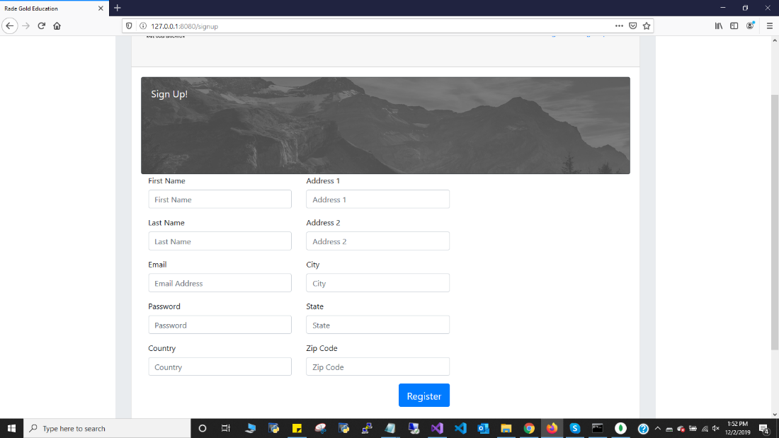

Appendix B: Log In Page

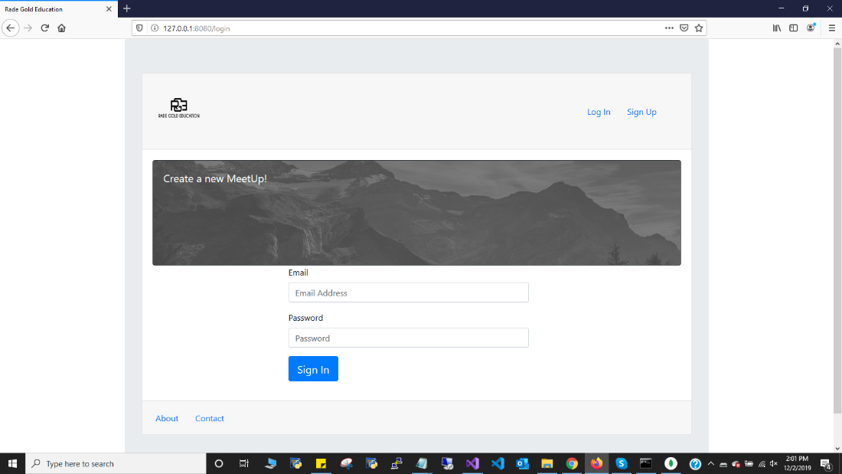

Appendix C: savedConnections Page

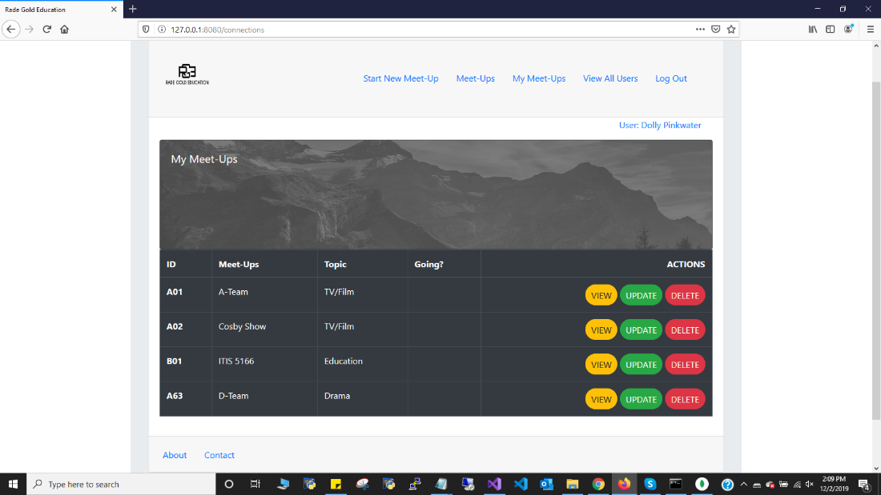

Appendix D: Deleting Meet-Ups!

Notice the address in the address bar suggests a Meet-Up! with the id ‘D99’ was deleted.

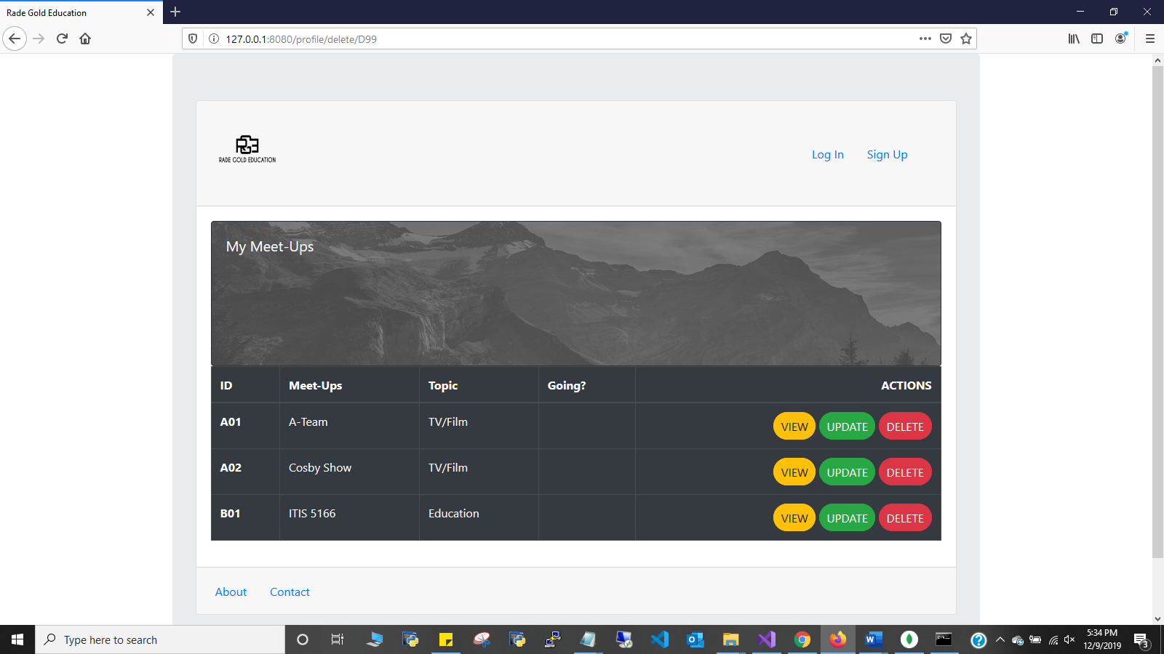

Appendix E: Create Meet-Up!

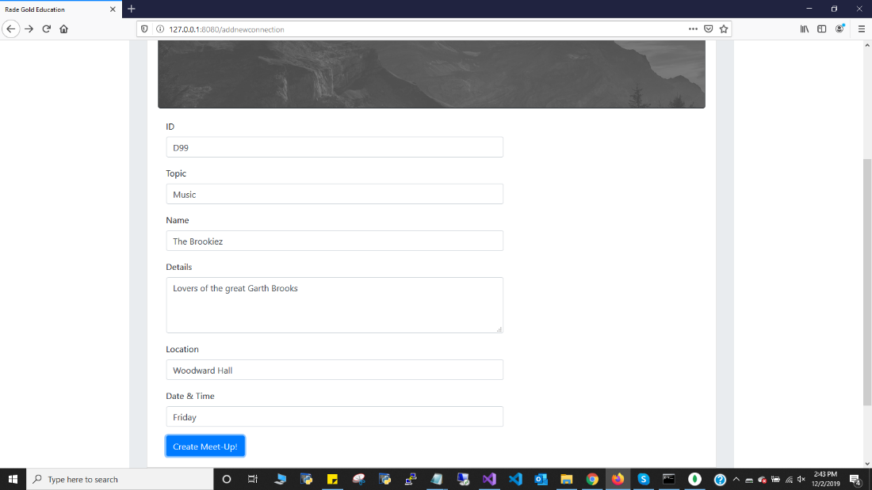

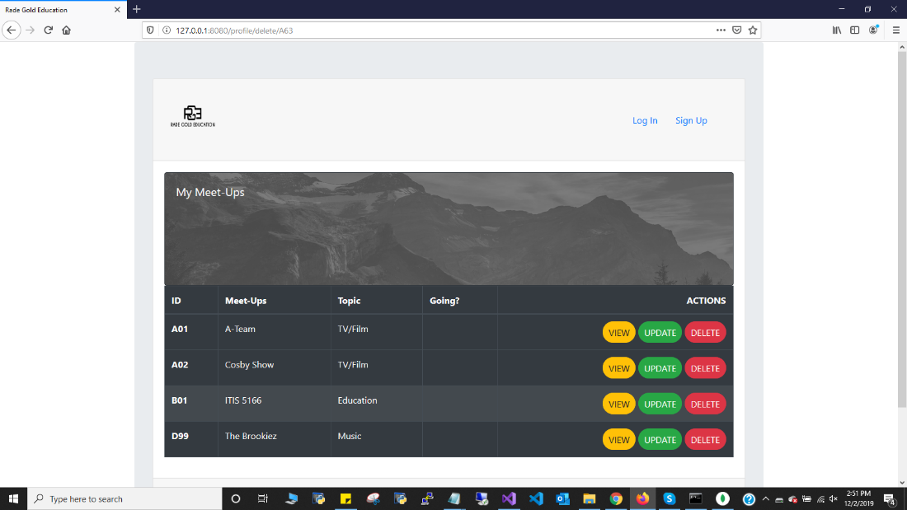

Appendix F: View & RSVP

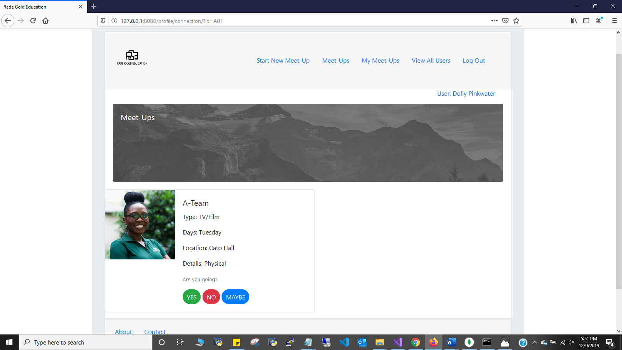

Appendix G: View All Users

