CROSS-COUNTRY SATELLITE-BASED ALLOCATION OF SUBNATIONAL ELECTRICITY CONSUMPTION: A FIVE-COUNTRY CALIBRATION STUDY

ABSTRACT
Subnational electricity consumption data is essential for infrastructure planning and investment targeting but is systematically unavailable in the countries where electricity deficits are most severe. This paper presents a method for allocating a known national consumption total across a country's regions using two globally available inputs: population and VIIRS nighttime light radiance. The model is a log-linear robust regression trained on four countries with verified subnational consumption data (United States, France, United Kingdom, Italy), spanning a 2.75× range in per-capita consumption, and validated independently on Turkey, a fifth country held out entirely from model development.
The model predicts regional consumption shares with minimum R² of 0.885 across all holdout countries, outperforming population-proportional allocation in three of five cases. Of 26 candidate specifications tested (incorporating settlement-masked VIIRS, urban classification, built-up surface area, lit area fraction, and climate degree-days), only raw VIIRS radiance sum consistently improved on population alone under cross-country holdout. Features widely reported as effective in the within-country nighttime-lights literature did not survive the harder test of cross-country transfer, a validation standard the majority of comparable studies have not applied.
The choice between the satellite-augmented model and population alone does not resolve to a single recommendation: share R², the metric aligned with the allocation task, favours the satellite model; MAPE, which weights small regions equally, favours population. No reliable pre-screening rule was identified to predict which model a given unseen country would favour. The paper reports both models, their relative strengths across metrics and countries, and the conditions under which each is preferable.

1.0 Introduction
Electricity infrastructure is financed geographically. A plant serves a grid zone; a distribution network covers a franchise area. Yet the data required to target these investments (how consumption is distributed across a country's subnational units) is absent precisely where investment is most needed.
The mismatch is large. Private investment in electricity infrastructure across low- and middle-income countries reached $86 billion in 2023 (World Bank, 2024), while 730 million people remained without electricity access in 2024, 80% of them in sub-Saharan Africa (IEA, 2025). Nigeria, the Democratic Republic of Congo, and Ethiopia alone account for roughly a third of the global deficit (World Bank, 2024). None publishes a reliable subnational consumption breakdown.
This is not incidental. Subnational data in well-supplied economies is a byproduct of metering and billing infrastructure - every metered customer is a data point. In electricity-constrained economies, metering is partial and self-generation, often exceeding formal grid capacity several times over, goes unrecorded (Oseni, 2017; Energy for Growth Hub, 2023). The same resource constraints that produce the electricity deficit also produce the data gap; waiting for it to close means waiting for the deficit to resolve first.
This paper presents a method for closing that gap using data already available globally at consistent resolution: satellite-derived population, VIIRS nighttime light radiance, and climate reanalysis data. Given a national consumption figure from any source, the method allocates it across a country's states, provinces, or regions. It does not estimate national consumption (a separate problem) but answers what planners and investors need once that figure exists: where, specifically, is it concentrated?
The model is a log-linear robust regression trained on four countries with verified subnational data, the United States, France, the United Kingdom, and Italy, spanning a 2.75× range in per-capita consumption (EIA, 2020; RTE, 2020; DESNZ, 2020; Terna, 2020), and validated on Turkey, held out entirely from training (TUIK, 2020). A further stress test on verified US state data evaluates robustness to industrial gas flaring, a confound relevant to resource-extraction economies.
Two findings follow. The model predicts each unit's share of national consumption with a minimum R² of 0.885 across all holdout countries and mean absolute share error below one percentage point, consistently outperforming population-proportional allocation. Second, most satellite features common in the nighttime-lights literature do not improve on population alone once tested cross-country rather than within one country - the validation standard used by most comparable work, including the majority of 226 studies reviewed by Bhattarai et al. (2023).

2.0 Literature Review
Two bodies of work bear on this paper: research using nighttime satellite imagery to estimate electricity consumption, and research on allocating a known consumption total across subnational geography. Both are relevant; neither, on its own, established what this paper needed to know before building the model, and the gap in each motivates a specific design choice made here.
Nighttime lights as a consumption proxy
The relationship between VIIRS-observed nighttime radiance and electricity consumption has been studied extensively. A systematic review of 226 such studies found that raw, uncorrected radiance predicts consumption weakly; one representative study reported R² of 0.18, rising to 0.896 after image correction and noise reduction (Bhattarai et al., 2023). Gas flares, fires, and other transient high-temperature sources are the primary contaminant requiring removal before radiance functions as a consumption signal (Bhattarai et al., 2023), consistent with VIIRS sensor documentation showing the instrument records phenomena unrelated to electric lighting, including aurora, wildfires, and persistent gas flares retained even in noise-filtered composites (Elvidge et al., 2017).
Later work improves on raw radiance by combining it with other covariates. Wang et al. (2021) combined nighttime imagery with land-use classification and landscape metrics across Chinese prefecture-level cities, achieving adjusted R² of 0.92 using multi-scale geographically weighted regression. Li and Wang (2025) combined VIIRS composites with LandScan and GHSL population data across multiple sub-Saharan African countries, reporting average R² of 0.88 for the NTL-consumption relationship. Chen et al. (2025) incorporated a temperature–radiance interaction term for monthly prediction in China's Yangtze River Delta, reducing mean absolute relative error to 7.96% in training and 10.38% out of sample. The pattern across all three is consistent: radiance combined with population, land cover, or climate data outperforms radiance alone, the same combination this paper's own model selection independently converged on.
A related dataset, High Resolution Electricity Access (HREA), approaches the same underlying signal differently. Rather than using radiance magnitude, it estimates the statistical likelihood that a settlement is electrified by comparing its brightness against matched uninhabited areas across repeated observations (Min et al., 2024). HREA is validated against household survey data across the developing world and estimates that at least 1.18 billion people show no statistical evidence of electricity use from space (Min et al., 2024). Its coverage sits in the low-electrification settings this paper's calibration countries do not reach, a complementary signal addressed in the methodology section.
The allocation problem
A smaller literature addresses this paper's specific question: given a known total, how should it be distributed spatially? This is typically framed as spatialization of a national or regional energy balance. Within-country applications report strong performance: Wang et al. (2021) achieved adjusted R² of 0.92 at the prefecture level in China; Wang, Wu, and Niu (2025) produced a spatialised Chinese electricity consumption dataset for 2012–2023 with average R² of 0.94 using NPP-VIIRS data and a power function model; Lu et al. (2024) demonstrated pixel-level allocation using high-resolution Luojia 1-01 nighttime imagery combined with urban functional zoning. These results establish that satellite-based spatial allocation works well within a single country.
Each of these studies, however, fits its model using data from the same country it evaluates. A model that allocates Chinese consumption accurately using Chinese training data establishes nothing about its accuracy in a country that supplied none of the training data. For a method meant to serve countries that cannot generate their own subnational training data, that is precisely the property that needs testing, and it is precisely what the existing literature has not tested.
Cross-country consumption benchmarking
A separate strand of work addresses national consumption levels rather than spatial allocation. Moss and Portelance regressed per-capita electricity consumption against per-capita gross national income across roughly 136 countries (R² of 0.84), using each country's distance from that fitted line as an indicator of unmet demand. Nigeria emerged as the most underpowered country in the sample, consuming approximately 79% less than its income level would predict (Moss and Portelance, 2024). This independently corroborates the severity of the data gap motivating this paper's method.

Positioning
This paper draws on both literatures and extends each in the same direction. From the nighttime-lights literature, it takes the established finding that radiance alone is incomplete and selects among covariate combinations using cross-country holdout performance rather than in-sample fit. From the spatialization literature, it takes the framing of allocating a known total across subnational units and evaluates under the harder standard of a country contributing no data to model training, a test none of the reviewed studies applies.
One comparison is worth drawing, with a caveat on what it does and does not establish. Li and Wang (2025), training and testing within sub-Saharan Africa, report R² of 0.88 for the correlation between nighttime radiance and consumption levels. This paper's model, trained on zero sub-Saharan African data and validated on a structurally different holdout country, achieves minimum share R² of 0.885, though the two figures measure different quantities (level correlation versus share prediction) under different validation regimes, and the comparison is indicative rather than direct. What it does indicate is that cross-country share prediction, without access to any target-region training data, can reach accuracy comparable to in-region level estimation, a property the existing literature has not tested for.

3.0 Data
Electricity consumption at the subnational level was collected for five countries: the United States, France, the United Kingdom, Italy, and Turkey. The first four serve as the model's training set; Turkey, held out entirely from model fitting, serves as the sole independent validation country. Satellite-derived features (population, nighttime light radiance, and climate) were extracted for all five countries through Google Earth Engine (Gorelick et al., 2017), using the same processing pipeline and parameter settings throughout, to ensure consistency across countries. Administrative boundary files define the spatial units over which both consumption and satellite features are aggregated. This section describes each data source, the processing applied, and the specific decisions that shaped the final dataset.

3.1 Consumption data
Subnational electricity consumption data was sourced from each country's national statistics agency or transmission system operator, covering multiple years where available. All figures are denominated in GWh.
The United States data comprises retail electricity sales by state (50 states plus the District of Columbia) for 2014–2025, obtained from the Energy Information Administration's Open Data API (EIA, 2020). France data comprises regional gross consumption for 13 metropolitan administrative regions, monthly from 2014–2026, obtained from RTE's éCO2mix regional data portal (RTE, 2020). The United Kingdom data comprises metered consumption estimates for 9 English regions, annually from 2005–2024, published by the Department for Energy Security and Net Zero (DESNZ, 2020). Italy data comprises end-user consumption by sector aggregated to 20 administrative regions, obtained from Terna's Download Centre for 2019, 2022, and 2024 (Terna, 2020). Turkey data comprises total electricity consumption by sector for 81 provinces, for 2019 and 2022, obtained from the Turkish Statistical Institute's central dissemination system (TUIK, 2020). The primary analysis uses 2019 data for all countries; the rationale for this selection and the role of remaining years are discussed in Section 3.5.
One measurement inconsistency required correction. The US, UK, and Italian figures represent metered or retail consumption, excluding distribution losses. France's RTE data reports gross regional consumption inclusive of distribution losses, which inflates French regional values by approximately 5–8% relative to the other countries. A uniform 7% reduction was applied to all French regional values to normalise them to a metered basis, consistent with Eurostat's reported French distribution loss factor for 2019. After correction, French per-capita consumption is 6,818 kWh, consistent with the range implied by the other countries' data and France's known national statistics.
The five countries span a 3.7× range in national per-capita electricity consumption, from 3,080 kWh (Turkey) to 11,342 kWh (United States), and collectively provide 174 subnational units for model training and validation.

3.2 Satellite-derived features
Three satellite-derived variables enter the final model: nighttime light radiance, population, and climate. All were extracted via Google Earth Engine (GEE), using server-side zonal statistics over administrative boundary polygons, avoiding the need to download raw raster files.
Nighttime light radiance was extracted from the NOAA VIIRS Day/Night Band Annual Composite V2.1 (NOAA EOG, 2020), using the average band, which represents mean annual radiance in nW/cm²/sr at approximately 460m resolution. For each subnational unit, total radiance was summed across all pixels within the boundary at 500m processing scale. The V2.1 product applies monthly median-based outlier removal to filter fires and other transient sources, though persistent gas flares are retained in the composite (Elvidge et al., 2017). The implications of this for resource-extraction regions are examined in Section 5 (Results) through a dedicated stress test.
Population was extracted from the JRC Global Human Settlement Layer population grid (GHS-POP R2023A), epoch 2020, at native 100m resolution (Schiavina et al., 2023). Pixels with negative values (NoData encoding) were masked before summing. A single population year (2020) was used for all countries; the rationale is discussed in Section 3.5.
Climate was derived from ERA5-Land monthly aggregated reanalysis (Muñoz Sabater et al., 2021), using the 2m air temperature band at approximately 9km resolution. Monthly mean temperature was extracted for each subnational unit for all 12 months of 2019, then converted to heating degree-days (HDD) and cooling degree-days (CDD) using a base temperature of 18°C: HDD = Σ max(0, 18 − T_month) × days_in_month; CDD = Σ max(0, T_month − 18) × days_in_month. These were summed to produce total degree-days (total_dd = HDD + CDD), a single measure of annual climate stress on electricity demand from both heating and cooling.
Several additional satellite features were extracted using the same pipeline (including settlement-masked VIIRS radiance, GHSL built-up surface area, GHSL settlement classification (GHS-SMOD), ESA WorldCover land use fractions, and lit area fraction) and tested during model selection. Their extraction and the reasons they were not retained in the final specification are discussed in Section 4 (Methodology).

3.3 Administrative Boundaries
Boundary shapefiles define the spatial units over which both consumption data and satellite features are aggregated. Each country's boundaries were sourced from the relevant national mapping or statistical agency, with one exception.
United States state boundaries were obtained from the Census Bureau's TIGER/Line 2025 release (US Census Bureau, 2025), in NAD83 (EPSG:4269). French regional boundaries (post-2016 reform, 13 metropolitan regions) were obtained from data.gouv.fr, in WGS84 (EPSG:4326). United Kingdom regional boundaries (9 English regions, December 2025 edition) were obtained from the ONS Open Geography Portal, in British National Grid (EPSG:27700). Italian regional boundaries (20 regions, January 2026 edition) were obtained from Istat, in UTM zone 32N (EPSG:32632). All non-WGS84 shapefiles were reprojected to EPSG:4326 before use. Turkey's provincial boundaries (81 provinces) were sourced from the GADM database version 4.1 (GADM, 2022), the only country for which an official national source was not used. GADM was selected for convenience and consistency with its wide use in cross-country geospatial research.
US territories (FIPS codes 60, 66, 69, 72, 78) and French overseas territories (codes 01–04, 06) were excluded to match the spatial coverage of the corresponding consumption data. All geometries were simplified to 0.01-degree tolerance to remain within GEE's 10MB upload payload limit, with negligible impact on zonal statistics at the state/region aggregation level.

3.4 Data Processing Decisions
Several decisions made during dataset construction affect how the results should be interpreted.
Year selection. The primary analysis uses 2019 for all consumption and satellite data. This is the last full pre-COVID calendar year; 2020 consumption patterns in multiple countries were distorted by lockdown-related demand reductions, making cross-country comparison unreliable as a basis for calibration. Additionally, 2019 aligns most naturally with the satellite inputs: the VIIRS V2.1 annual composite covers 2019 directly, and the GHSL population and built-up products use a 2020 epoch, the nearest available. An early exploratory analysis confirmed that the cross-sectional consumption pattern is temporally stable across all available years, with inter-year rank correlations exceeding r = 0.99 for every country. This means the choice of any single recent year has negligible effect on the relative shares the model is designed to predict. The remaining years (2014–2025 for the US, 2005–2024 for the UK, and so on) are available for robustness checks but were not used in the main analysis.
Single population epoch. Population features use the 2020 GHSL epoch for all countries regardless of consumption year. In developed countries with low population growth and stable internal migration patterns, subnational population distributions shift slowly enough that a one-year offset between the population layer (2020) and the consumption year (2019) introduces negligible error at the state/region level. This assumption would require re-examination for countries with rapid internal migration or displacement.
Settlement mask fallback. During model development, satellite features were also extracted within GHSL-defined settlement pixels only (built-up surface > 0), to isolate nightlight radiance attributable to human settlements from radiance produced by gas flares, oil infrastructure, or other non-settlement sources. In eight Turkish provinces, GHSL detected zero built-up pixels. The cause was not absent settlements but GHSL's built-up detection threshold, which, trained primarily on European urban morphology, missed small, dispersed rural towns. For these provinces, raw (unmasked) VIIRS values were substituted. This fallback is noted here because it affects any future application of settlement-masked features to countries with sparse or non-European settlement patterns, including Nigeria. The settlement-masked features were ultimately not retained in the final model specification (see Section 4), but the fallback issue is relevant to the broader methodological discussion.
Log transformation. All continuous features and the consumption target are log-transformed before model fitting. The key variables (population, VIIRS radiance sum, and consumption) are severely right-skewed: US state consumption ranges from 5,400 GWh (Vermont) to 429,000 GWh (Texas), an 80× span. In raw units, regression minimises absolute errors in GWh, which concentrates model attention on the largest regions and effectively ignores small ones. Log transformation converts this to minimising proportional errors, treating a 20% miss on Vermont as equally important as a 20% miss on Texas. The bivariate correlation between VIIRS radiance and consumption rises from r = 0.33 in raw units to r = 0.80 in log-log space, confirming that the underlying relationship is multiplicative (power-law), not additive (linear).
)

Descriptive Statistics
Table 1 summarises the final dataset. All values correspond to the 2019 analysis year, after the France correction described in Section 3.1.
Table 1 Summary of the calibration and validation dataset
 | United States | France | United Kingdom | Italy | Turkey
Role | Training | Training | Training | Training | Validation
Regions | 51 | 13 | 9 | 20 | 81
Per-Capita (kWh) | 11,342 | 6,818 | 4,126 | 5,012 | 3,080
Source | EIA | RTE | DESNZ | Terna | TUIK
Consumption Definition | Retail Sales | Gross (Corrected -7%) | Metered | End User by Sector | Total by Sector

The dataset spans a 3.7× range in per-capita consumption across countries and substantially wider variation within countries. US state-level per-capita ranges from approximately 6,200 kWh (California) to 28,200 kWh (Louisiana), while Turkey's provincial range runs from approximately 870 kWh (Hakkari) to 6,800 kWh (Kocaeli). This within-country variation is what the model is designed to capture: the factors that cause one region to consume a larger or smaller share of the national total than its population alone would suggest.
Turkey's role as validation rather than training was determined empirically during model development, not assumed in advance. Early iterations included Turkey in the training set, but its inclusion degraded model performance on other holdout countries, an effect traced to data quality issues in two satellite-derived features (GHSL settlement classification and settlement-masked VIIRS) that interacted poorly with Turkey's more dispersed rural settlement patterns. Excluding Turkey from training and retaining it as a pure out-of-sample test improved performance on the remaining training countries without sacrificing Turkey's own holdout accuracy. The details of this decision are developed in Section 4.

4.0 Methodology

4.1 Model Specification
The final model predicts log-transformed total electricity consumption as a linear function of three log-transformed inputs:
$$logC_{i}= β_{0}+ β_{1}logP_{i}+ β_{2}logV_{i} + ε_{i}$$ | 1.1
where $C_{i}$ is electricity consumption in GWh for region i, $P_{i}$ is total population, and $V_{i}$ is total VIIRS nighttime radiance sum (raw, unmasked). All variables are in their extensive (summed) rather than intensive (per-capita or per-area) forms.
Each term captures a distinct driver of regional consumption. Population is the dominant determinant of how much electricity a region consumes in absolute terms: larger regions consume more, approximately proportionally. VIIRS radiance sum adds information beyond population alone: two regions of equal population can differ in brightness because one has more commercial activity, more public lighting, or more industrial infrastructure visible from space.
The log-log specification means the coefficients are elasticities: β₁ ≈ 1 implies that a 1% increase in population corresponds to approximately a 1% increase in consumption, holding radiance constant. This functional form was not assumed. It was selected because the bivariate correlation between VIIRS radiance and consumption rises from r = 0.33 in raw units to r = 0.80 in log space (Section 3.4), confirming that the underlying relationships are multiplicative.
Two features of the specification require explicit justification: the use of raw (unmasked) VIIRS radiance rather than settlement-masked VIIRS, and the absence of climate variables despite their known relationship to electricity demand. Both were tested extensively during model selection; the specific holdout results that determined these choices are detailed in Section 4.5.

4.2 Estimation
The model is estimated using Huber robust regression (Huber, 1964) rather than ordinary least squares (OLS). The two methods differ in how they treat observations that deviate substantially from the fitted relationship.
OLS minimises the sum of squared residuals, which gives disproportionate influence to extreme values. In a cross-country dataset where a single outlier (a sparsely populated region with anomalously high industrial or extractive-sector radiance) can shift the fitted coefficients for all 93 training observations. This sensitivity is a practical problem rather than a theoretical concern. Huber regression addresses it by applying a squared loss to residuals below a threshold and a linear loss to residuals above it, effectively down-weighting observations that lie far from the bulk of the data without excluding them entirely.
The threshold parameter (epsilon) controls where the transition from squared to linear loss occurs. A value of 1.35, used throughout this study, is the standard default: it provides 95% asymptotic efficiency relative to OLS when errors are normally distributed, while substantially reducing the influence of heavy-tailed outliers (Huber, 1964). This value was not tuned; the same epsilon was applied to every model variant tested during selection, ensuring that performance differences between specifications reflect feature choice rather than regularisation differences.
The choice of Huber over OLS was validated empirically rather than assumed. In early model iterations, switching from OLS to Huber consistently improved holdout share R² by 3–8 percentage points across specifications, with the largest gains on holdout countries containing regions with high extractive-sector radiance. Alternative robust estimators (Theil-Sen) and regularised approaches (Ridge regression) were also tested; neither consistently outperformed Huber, and Ridge specifically failed to resolve the outlier-leverage problem because the issue was influential observations, not multicollinearity.

4.3 Validation design
The model is validated at two levels, each testing a different property.
Leave-One-Country-Out (LOCO) cross-validation operates within the four training countries: US, France, UK, and Italy. In each fold, one country is excluded from training and the model is fitted on the remaining three, then used to predict the excluded country's regional consumption shares. This cycles through all four countries, producing four sets of holdout predictions. LOCO tests whether the satellite-consumption relationship learned from three countries generalises to a fourth country whose data played no role in fitting, a harder test than the within-country train/test splits used by most comparable studies, but still within the pool of countries that collectively inform the model's development (feature selection, transformation choices, and regression method were all evaluated with LOCO results in view).
Independent holdout validation uses Turkey, which was excluded not only from each individual fold but from the entire model development process. Turkey's data did not inform feature selection, did not contribute to any LOCO fold used to compare candidate specifications, and was not used to diagnose or fix any data quality issue in the training set. When the final model predicts Turkey's 81 provincial shares, it is encountering a country it has genuinely never seen, the closest available analogue to applying the model to a new country in practice. Turkey's per-capita consumption (3,080 kWh) also sits below every training country, providing a partial test of whether the model extrapolates downward in consumption level, not just across geography.
The distinction matters for interpreting the results. LOCO performance reflects how well the model transfers across countries of the type it was designed around, wealthy, well-metered, high-electrification economies. Turkey's holdout performance reflects something closer to the actual use case: prediction in a country the model knows nothing about, at a lower consumption level than anything in training.

4.4 Share Prediction
The model's raw output is log-consumption, which exponentiates to a predicted GWh value for each region. These absolute values are not the model's intended deliverable. Cross-country testing established early in model development that absolute consumption predictions do not transfer reliably across countries at different development levels, the model trained on European and US data systematically under-predicted Turkish consumption in GWh terms, because the relationship between satellite features and absolute consumption is mediated by country-level factors (income, energy prices, industrial structure, appliance ownership) that the model has no access to and that vary sharply across countries.
What does transfer is each region's predicted share of the national total. To convert model output to shares, the predicted GWh for each region within a country is divided by the sum of all predicted GWh values in that country:
$$s_{i}= \frac{e^{y_{i}}}{\sum_{j}{e^{y_{j}}}}$$ | 1.2
where $y_{i}$ is the model's log-consumption prediction for region i and the sum runs over all regions in the same country. This normalisation cancels whatever country-level scaling factor the model gets wrong. If the model systematically over-predicts every Turkish province by 3×, that factor appears in both numerator and denominator and drops out, the shares remain correct as long as the model captures the relative pattern across regions, regardless of whether it captures the absolute level.
This reflects a structural property of the problem. The national-level factors that determine how much electricity a country consumes per capita (income, tariffs, efficiency standards) are approximately constant across a country's own regions. What varies within a country, and what the satellite features capture, is population concentration, settlement density, and climate, which determine how the national total is distributed geographically. Share prediction isolates this within-country variation and discards the between-country variation that the model cannot and does not attempt to capture.

The practical implication is that the model requires an externally supplied national total to produce GWh estimates for any individual region. It provides the percentages; the user supplies the denominator. This is a deliberate design choice, The alternative, predicting absolute consumption directly, was tested and failed under cross-country validation for exactly the reasons described above.

Model Selection
The final specification (population and raw VIIRS sum) emerged from systematic testing of 26 candidate model variants, evaluated by share R² under LOCO cross-validation across all five countries. The selection criterion was the minimum holdout R² across countries (not the mean), on the basis that a model which fails catastrophically on even one holdout country cannot be trusted on an unseen country where failure would be undetectable. A full account of all variants tested, including per-country holdout results, is available in the project repository; this section summarises the principal alternatives explored and the specific evidence that eliminated each.
Per-capita formulation. The earliest model variants predicted consumption per capita from intensive (per-unit-area or per-person) satellite features, then multiplied by population to recover total consumption. This approach was motivated by the intuition that separating "how much each person consumes" from "how many people there are" would improve cross-country transfer, since per-capita consumption should be more comparable across countries than raw totals. It failed on two holdout countries. In the United Kingdom, per-capita consumption is nearly uniform across regions (standard deviation of 85 kWh across 9 English regions, against a mean of 4,126 kWh), the model introduced artificial variation by predicting that London's higher density should produce different per-capita consumption than the South West, when in fact the shares are almost perfectly proportional to population. The per-capita formulation scored share R² of −0.007 on the UK holdout, worse than random. In the United States, per-capita variation is real but driven by industrial structure (petrochemicals in Texas, manufacturing in the Midwest) rather than by anything satellites observe, producing systematic over-prediction of large, service-economy states like California (+7.3 percentage points) and under-prediction of industrial states. Switching to a direct total-consumption formulation with population as an explicit feature resolved both failures.
Settlement-masked VIIRS. VIIRS radiance was also extracted within GHSL-defined built-up pixels only, excluding non-settlement areas where radiance may originate from gas flares, oil infrastructure, or highway lighting. This treatment was developed specifically to address an early finding that Alaska's raw VIIRS signal was dominated by oil-field lighting rather than population-driven consumption. Settlement masking reduced this confound in the US (settled VIIRS captured only 33% of raw total radiance), but it degraded cross-country holdout performance overall: raw VIIRS achieved minimum holdout share R² of 0.885, while settlement-masked VIIRS achieved 0.678 on the same test. The degradation was traced to two sources. First, GHSL's built-up detection threshold, calibrated on European urban morphology, missed sparse rural settlements, eight Turkish provinces returned zero settled VIIRS pixels despite having real populations and real VIIRS signal, requiring a fallback to raw values. Second, settlement masking concentrated the signal in dense urban cores, amplifying the influence of urban-rural brightness contrasts that do not correspond proportionally to consumption differences. Raw VIIRS, despite retaining some non-settlement radiance, produced more stable cross-country share predictions.
GHSL settlement classification (GHS-SMOD). The percentage of each region classified as urban centre or dense urban cluster by the GHSL Settlement Model was tested as an urbanisation proxy. It improved within-training-set results in early iterations but introduced noise when Turkey was added to the evaluation: 47 of 81 Turkish provinces were classified as having zero urban area, an artefact of the same GHSL detection-threshold issue affecting the settlement mask. Models including SMOD performed worse than the same specification without it on minimum holdout R², and it was dropped.
Built-up surface features. GHSL built-up surface, both as a total (built_sum) and as a mean intensity (built_mean), was tested as an alternative or supplement to VIIRS. Built_sum is highly correlated with both population (r = 0.85) and VIIRS sum (r = 0.81). Including it alongside population produced unstable coefficients: in one specification, population's coefficient turned negative (−0.19), an economically meaningless result attributable to multicollinearity. Built_mean, as an intensity feature, avoided this but performed worse than raw VIIRS on cross-country holdout, minimum share R² of 0.601 versus 0.885 for the raw VIIRS specification.
Lit area fraction. The proportion of a region's area with detectable nightlight (radiance > 0.5 nW/cm²/sr) was tested as a measure of electrification extent. It performed well in direct proportional allocation (no regression) within some countries but degraded regression-based LOCO performance when added to the population-plus-VIIRS specification, reducing minimum holdout share R² from 0.885 to 0.813. The feature added explanatory power for some countries (UK, Turkey) while hurting others (US), a pattern consistent with it capturing a country-specific property (what fraction of land area is inhabited) rather than a universally transferable consumption signal.
Climate (degree-days). Heating and cooling degree-days, derived from ERA5 monthly temperature data (Section 3.2), were tested both as a combined total (HDD + CDD) and as separate terms. Climate has a well-established physical relationship to electricity demand, hotter regions need cooling; colder regions need heating, and adding total degree-days to the population-only baseline did improve some individual holdouts. However, when added to the population-plus-raw-VIIRS specification, climate reduced minimum holdout share R² from 0.885 to 0.866. The loss was concentrated in the US holdout (0.885 to 0.866) and Italy (0.903 to 0.869), while France was unchanged and Turkey improved marginally (+0.005). The pattern suggests that for share allocation purposes, VIIRS radiance already captures much of the climate signal, brighter regions tend to be those with higher climate-driven demand, and adding an explicit climate term introduces redundancy that degrades worst-case performance. Climate was not retained in the final specification.
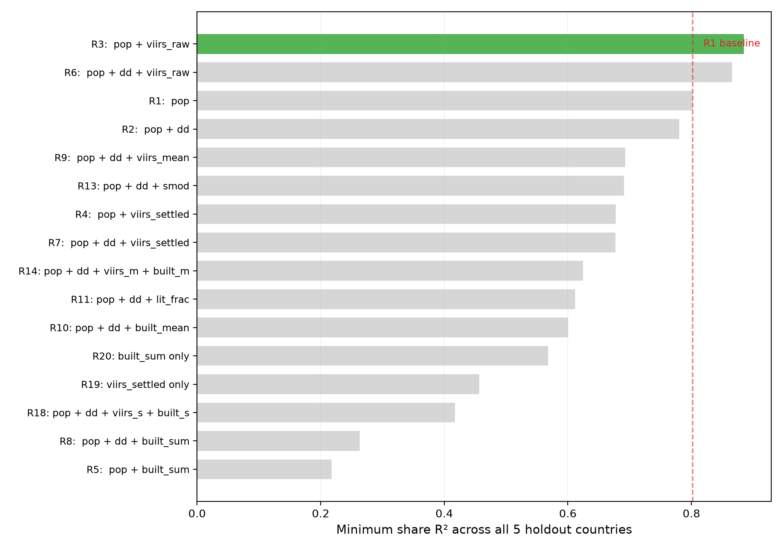
Figure 1 Feature Selection Summary - MIN $R^{2}$ for Each Tested Variant, Sorted by Performance

Flare stress test
The model uses raw, unmasked VIIRS radiance, which retains signal from gas flares and other combustion sources unrelated to electricity consumption. This is a known property of the VIIRS annual composite (Elvidge et al., 2017; Bhattarai et al., 2023), and it raises a specific concern for any intended application to resource-extraction economies, most directly, Nigeria's Niger Delta, one of the most intense gas-flaring zones globally.
To test whether this confound distorts the model's share predictions in practice, a dedicated stress test was conducted using the one calibration country with both verified ground-truth consumption data and significant gas-flaring activity: the United States. The model was trained on France, UK, and Italy only (excluding the US entirely), then used to predict consumption shares for all 51 US states. Predicted shares were compared against actual shares, with specific attention to five states with the highest gas-flaring volumes, Texas, North Dakota, Oklahoma, New Mexico, and Louisiana, and five states of comparable population but minimal flaring, California, New York, Florida, Illinois, and Ohio.
The test examines a precise question: does the model systematically over-allocate consumption to flare-heavy states? If raw VIIRS radiance from flares inflates a region's predicted share relative to its actual consumption, this would appear as a consistent positive share error for flare-heavy states, without a corresponding error for non-flaring states of similar size. If the model handles the confound adequately, either because population dominates the prediction, or because flare radiance is small relative to settlement radiance at the state aggregation level, flare-heavy and non-flaring states should show comparable error distributions.
The results of this test are reported in Section 5.

Results

5.1 LOCO cross-validation
Table 2 reports share prediction performance for each training country held out in turn, with the model trained on the remaining three. The population-proportional baseline, each region's share set equal to its share of national population, is included as a reference, since any model that fails to outperform this baseline is adding noise rather than signal.
Table 2 Loco share $R^{2}$ by holdout country
Holdout | Model (pop + VIIRS) | Population Only | Difference
United States | +0.885 | +0.802 | +0.083
France | +0.942 | +0.865 | +0.077
United Kingdom | +0.924 | +0.989 | -0.065
Italy | +0.903 | +0.849 | +0.054
The model outperforms population-proportional allocation on three of four training holdouts. The margins are substantial: +0.083 for the US, +0.077 for France, +0.054 for Italy. These are countries where regional consumption patterns diverge meaningfully from population proportionality, industrial concentration in the US Midwest and Gulf states, regional economic specialisation in France, and the north-south structural divide in Italy all create consumption shares that population alone cannot predict.
The exception is the United Kingdom, where population alone achieves share R² of +0.989 and the full model scores +0.924. Per-capita electricity consumption is nearly uniform across the nine English regions (standard deviation of 85 kWh against a mean of 4,126 kWh), so shares are almost perfectly proportional to population. Adding VIIRS introduces small deviations from that proportionality that, for the UK specifically, reduce accuracy. The model correctly predicts the UK's consumption pattern but cannot improve on an already near-perfect baseline.
No training holdout falls below share R² of +0.885.

5.2 Independent Validation (Turkey)
Turkey was held out from the entire model development process, not rotated through LOCO folds, not used to compare candidate specifications, not used to diagnose data issues. The final model, trained on all four calibration countries (93 regions), was applied to Turkey's 81 provinces to predict consumption shares. Table 3 reports the result alongside the same population-proportional baseline.
Table 3 Independent Validation - Turkey
 | Model (pop + VIIRS) | Population Only | Difference
Share $R^{2}$ | +0.887 | +0.894 | -0.007
Spearman $ρ$ | +0.838 | +0.856 | -0.018
The model predicts Turkish provincial shares with R² of +0.887, accounting for nearly 89% of the variance in how consumption is distributed across 81 provinces, in a country it has never seen, using only population and nighttime radiance as inputs.
The satellite features do not improve on population alone for Turkey. The population-proportional baseline achieves +0.894, effectively identical. This parallels the UK finding in Section 5.1: Turkey's provincial consumption shares are close to proportional to population, leaving limited residual variation for VIIRS to explain.
For the intended application, the relevant finding is not whether the model beats population on every individual country, it is whether the model is at least as reliable as the simplest baseline everywhere, while being substantially more accurate where consumption patterns deviate from population proportionality. On this criterion, the model delivers: it matches the population baseline on Turkey and the UK (where the baseline is already strong) while outperforming it by 5–8 percentage points on the US, France, and Italy (where the baseline is weaker). A practitioner applying this model to an unseen country does not know in advance which regime that country falls into, the model provides a hedge that performs well in both.
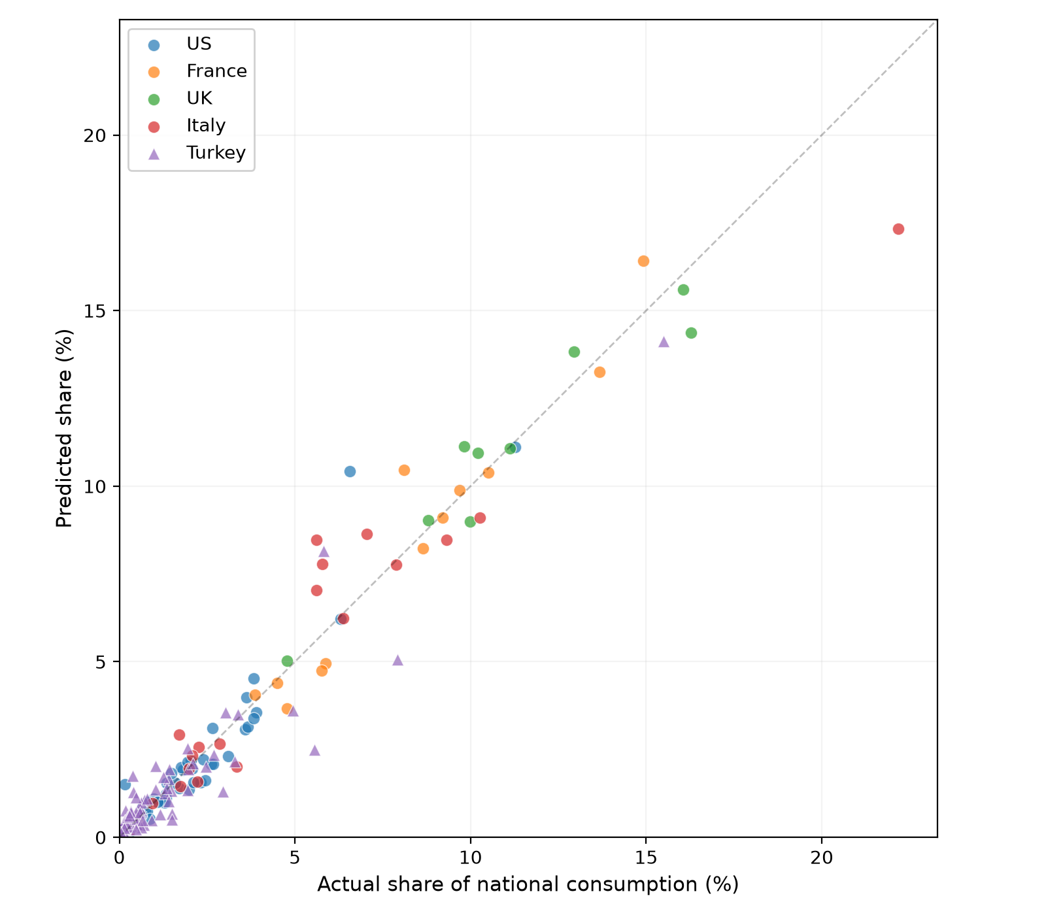
Figure 2 Predicted vs Actual Shares, All 5 Countries

5.3 Comparing R1 and R3 across all five holdout countries
Table 4 consolidates the results of Sections 5.1 and 5.2, comparing the two-feature model (R3: population + VIIRS) against population-proportional allocation (R1) across all five holdout countries, the four LOCO folds and the independent Turkey validation together.
Table 4 R3 vs R1 across all holdout countries
Country | R1 (Population) | R3 (population + VIIRS) | Difference (R3 - R1)
United States | +0.802 | +0.885 | +0.083
France | +0.865 | +0.942 | +0.077
Italy | +0.849 | +0.903 | +0.054
United Kingdom | +0.989 | +0.924 | -0.065
Turkey | +0.894 | +0.887 | -0.007
MEAN | +0.880 | +0.908 | +0.028
MIN | +0.802 | +0.885 | +0.083
MIN $ρ$ | +0.856 | +0.838 | -0.018
Table 4b MAPE and MdAPE on shares - R3 vs R1
Country | MAPE (%) |  | MdAPE (%)
Country | R1 | R3 | R1 | R3
United States | 26.3 | 34.8 | 21.3 | 14.8
France | 9.0 | 10.0 | 9.6 | 5.1
Italy | 23.5 | 20.5 | 17.7 | 15.2
United Kingdom | 1.6 | 6.7 | 1.9 | 6.8
Turkey | 62.3 | 71.0 | 34.0 | 41.5
MEAN | 24.6 | 28.6
Table 5 reports mean and median absolute percentage error (MAPE and MdAPE) on predicted shares for the same five holdout countries.
R3 outperforms R1 on share R² in three of five countries, the US (+0.083), France (+0.077), and Italy (+0.054). It underperforms narrowly in Turkey (−0.007, effectively tied) and more substantially in the UK (−0.065), where population alone already achieves near-ceiling accuracy (0.989). Where R3 wins, the margins are larger than where it loses. On minimum R² across all holdouts, the worst observed outcome, R3 leads by 8.3 percentage points (0.885 vs 0.802).
R3 also produces lower MdAPE in three of five countries, including reducing it by roughly a third for the US (14.8% vs 21.3%) and nearly halving it for France (5.1% vs 9.6%). On MAPE, R1 leads (mean 24.6% vs 28.6%). The reversal reflects a structural property of the metric: MAPE weights every region equally regardless of size, and small regions, where even modest absolute misallocation produces large percentage errors, dominate the average. Regions in the smallest tercile by share show mean absolute percentage error of 98.4%, compared to 16.8% for the largest tercile. The comparable literature reports MAPE because those studies predict absolute consumption levels per region independently (Wang et al., 2021; Chen et al., 2025). This paper's task is structurally different, allocating a fixed total across regions that sum to 100%, making share R² the appropriate primary criterion, since errors on larger regions carry larger absolute GWh consequences. MAPE is reported for comparability with prior work.
Three candidate pre-tests were examined to determine, without consumption data, whether a new country would fall into the regime where R3 helps or where R1 suffices: the coefficient of variation, max/min ratio, and Gini coefficient of VIIRS-per-capita. None reliably separated the two regimes, France and the UK, which most need separating, were nearly indistinguishable on all three measures. With five countries in the sample, identifying a screening rule is left as an open question.
R3 is recommended as the default specification: it outperforms R1 more often, by larger margins when it wins than when it loses, and its worst-case outcome (0.885) exceeds R1's worst case (0.802) by a margin large enough to justify incorporating satellite data into the allocation pipeline.

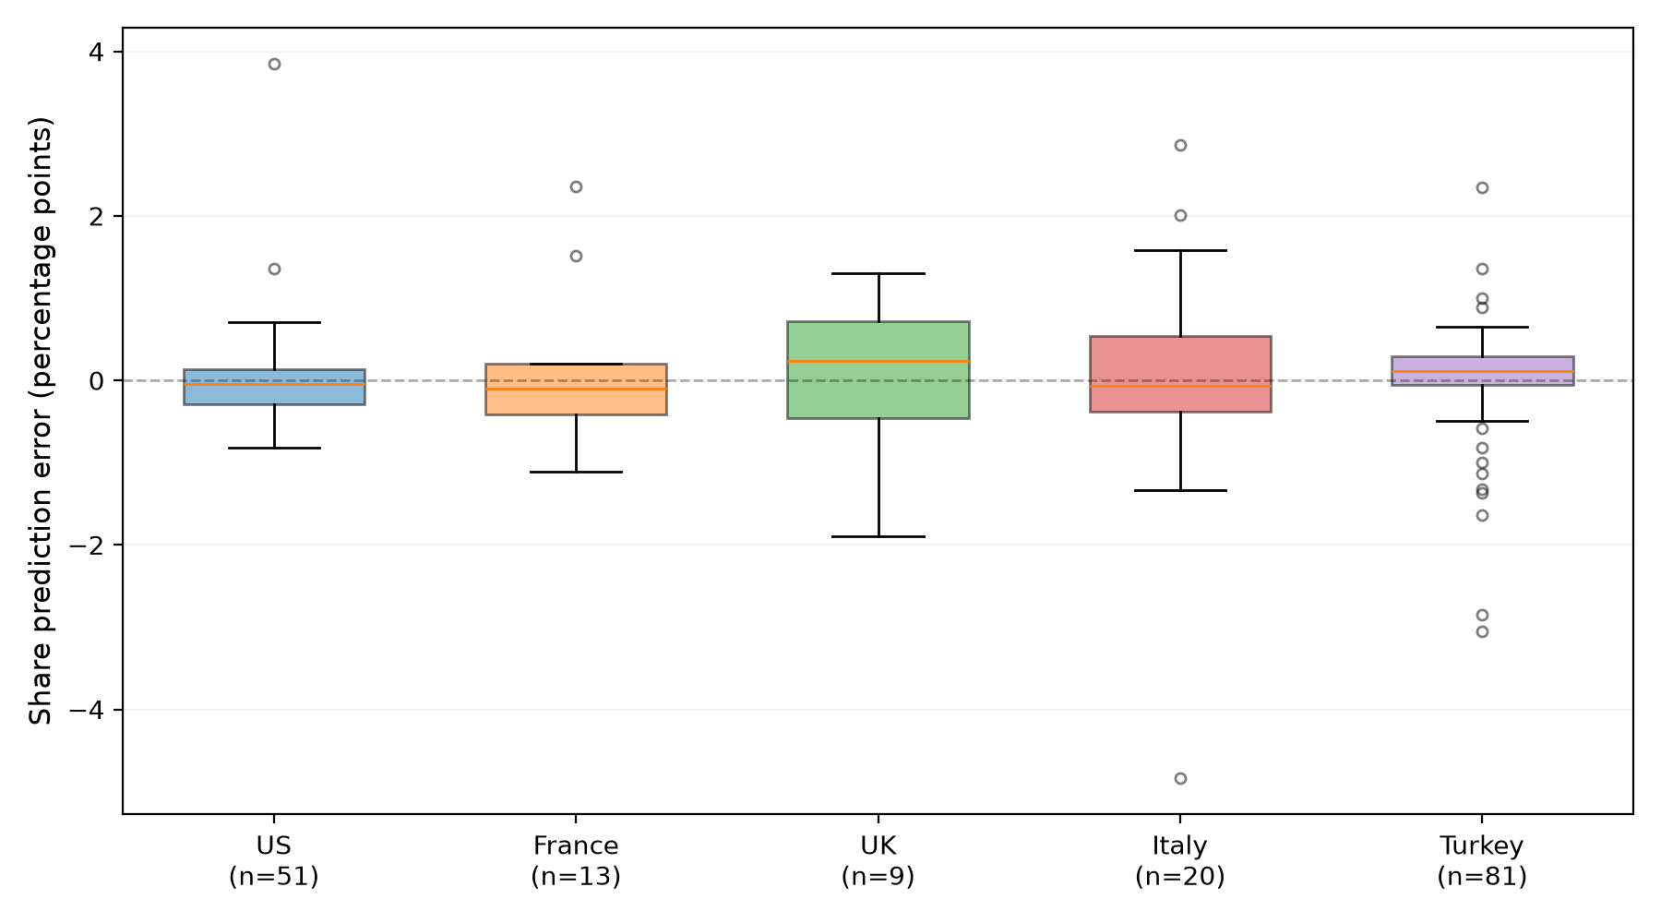
Figure 3 Share Error Distribution by Country

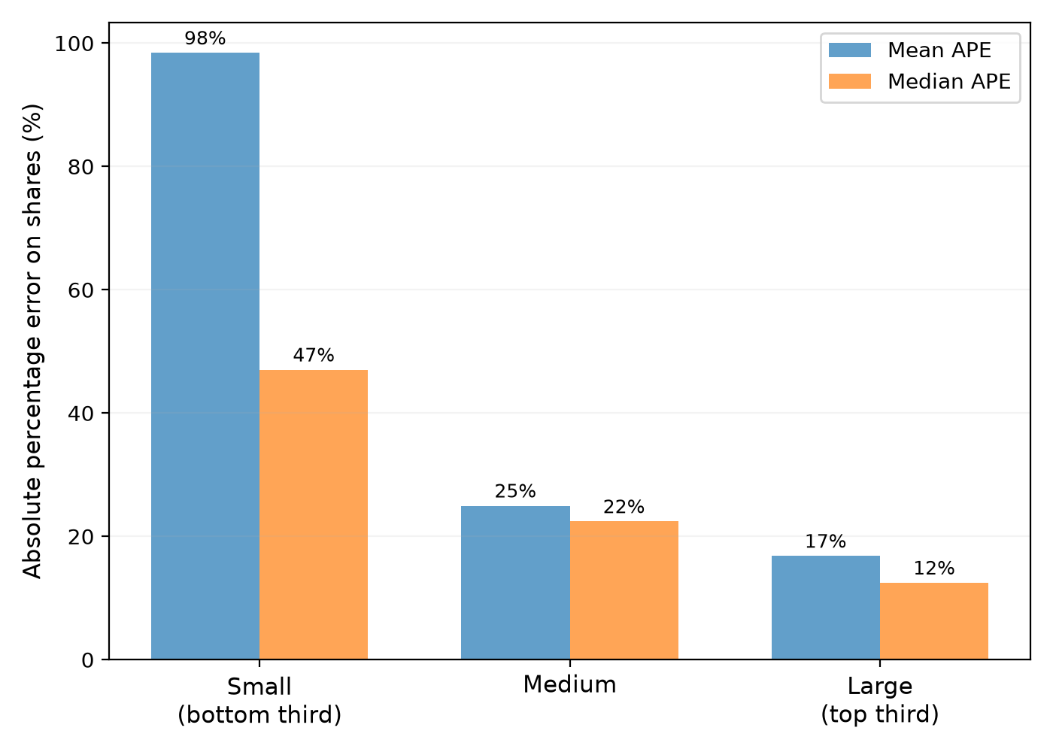
Figure 4 MAPE by region-size tercile

5.4 Flare stress test
The model uses raw, unmasked VIIRS radiance, which retains signal from gas flares. Section 4.5 reported that several alternative VIIRS treatments, developed specifically to address this and related confounds, were tested and rejected on cross-country share prediction grounds. Before concluding that raw VIIRS is an acceptable choice for an application involving significant gas flaring (Nigeria's Niger Delta), each treatment was additionally tested against verified ground truth on the one calibration country with substantial flaring: the United States. The model (trained on France, UK, and Italy, excluding the US) was used to predict all 51 US states' shares, with five known flare-heavy states (Texas, North Dakota, Oklahoma, New Mexico, Louisiana) and five population-comparable, low-flare states (California, New York, Florida, Illinois, Ohio) examined specifically.

Table 5 Flare stress test - MAE by VIIRS treatment for flare-heavy vs comparison states
Treatment | Flare-state MAE | Comparison-state MAE | Overall US MAE
Raw VIIRS + population (R3) | 0.47pp | 1.27pp | 0.44pp
Settlement-masked VIIRS | 0.90pp | 1.50pp | 0.47pp
Settlement-masked VIIRS (mean) | 1.22pp | 1.55pp | 0.54pp
Population only (R1) | 1.02pp | 1.59pp | 0.50pp
Raw VIIRS, capped at p95 | 1.28pp | 1.04pp | 0.48pp
Built-up area (no VIIRS) | 0.94pp | 1.06pp | 0.48pp
Raw VIIRS (R3) has the lowest error on flare-heavy states of any treatment tested, including treatments specifically designed to suppress flare contamination. Texas, the largest single source of US flaring, is under-predicted by 0.63 percentage points under R3, the opposite of the over-allocation a flare confound would produce. Every alternative treatment performs worse on flare states than raw VIIRS does, which is consistent with the broader pattern established in Section 4.5: modifications intended to fix a specific, plausible-sounding problem with raw VIIRS (settlement masking for flares and empty-land brightness, capping for extreme outliers, built-up substitution to avoid VIIRS altogether) did not deliver the improvement they were designed for, here or in the cross-country share prediction results.
R1 (population only) also performs reasonably on this test (flare-state MAE 1.02pp), or comparably to several of the modified VIIRS treatments, a result consistent with the finding in Section 5.3 that R1 remains a credible model in its own right, not merely a fallback when R3 is unavailable.
On comparison states (large-population, low-flare states tested alongside) R3's MAE (1.27pp) sits in the middle of the six treatments: better than settlement-masked (1.50pp), settlement-masked mean (1.55pp), and population only (1.59pp), but behind capped VIIRS (1.04pp) and built-up substitution (1.06pp). R3's flare-state advantage does not come at a substantial comparison-state cost, it is clearly better than the corrective VIIRS treatments and population alone on non-flare states, and only slightly behind the two treatments purpose-built to suppress outliers. No single treatment dominates on both flare and non-flare states simultaneously, but R3 comes closest to balanced performance across both groups.
This result does not guarantee the same balance holds in Nigeria's Niger Delta, where flaring intensity relative to population may differ structurally from the US pattern. It establishes that raw VIIRS's flare exposure is not, on the one testable ground-truth case available, a fatal or even a leading weakness relative to the alternatives, including the alternatives purpose-built to avoid it.

5.5 Model Coefficients
The final specification (R3), fitted on all four training countries (93 regions: US, France, UK, Italy), produces the following coefficients:
Table 6 Final model coefficients
Term | Coefficient | Interpretation
Log(population) | 0.531 | A 1% increase in population is associated with a 0.53% increase in consumption, holding VIIRS constant
Log(VIIRS sum) | 0.598 | A 1% increase in VIIRS radiance is associated with a 0.60% increase in consumption, holding population constant
Intercept | -4.489 | -
Both coefficients are positive, as expected, and of comparable magnitude, population and VIIRS radiance contribute roughly equally to the fitted relationship, with VIIRS carrying marginally more weight (0.598 vs 0.531). Neither coefficient approaches the elasticity of 1.0 that would indicate the model degenerates into a single-variable relationship; both terms are doing substantive work; This is consistent with the cross-country holdout results in Section 5.3, where dropping either variable (population-only in R1, or a VIIRS-only variant tested during model selection) measurably reduced performance in at least some countries.
For comparison, the population-only model (R1), fitted on the same 93 regions, produces a single coefficient of 1.065 on log(population), close to the theoretical value of 1.0 implied by pure proportionality, and consistent with R1 functioning as a near-direct population-share allocator.
These coefficients are specific to the training data and are not re-estimated per application; the same fitted model is applied to any new country, consistent with the design goal of a method usable without target-country consumption data.

6.0 Discussion

6.1 What the results establish
The cross-country holdout tests in Section 5 produced three sets of findings.
On model performance:
- R3 (population + VIIRS) achieves higher share R² than R1 (population alone) in three of five countries, with a worst-case share R² of 0.885 versus 0.802, an 8.3 percentage point improvement on the floor
- R1 achieves higher share R² in two countries (UK: 0.989 vs 0.924; Turkey: 0.894 vs 0.887), both cases where consumption is already near-proportional to population
- R1 produces marginally better rank correlation in the worst case (MINρ = 0.856 vs 0.838), meaning population alone orders regions from largest to smallest consumer slightly more reliably
- On MAPE, R1 leads (24.6% vs 28.6%), driven by small-region error inflation; on MdAPE, R3 leads in three of five countries, indicating better typical-region accuracy
- Neither model dominates the other on all metrics simultaneously
On feature selection:
- Of 26 variants tested under cross-country holdout, only raw VIIRS sum improved on population alone consistently enough to justify inclusion
- Settlement-masked VIIRS, GHSL-SMOD classification, built-up surface area, lit area fraction, and climate degree-days all failed to improve worst-case cross-country performance, despite strong within-country results reported for similar features in prior work
- Raw VIIRS outperformed all modified VIIRS treatments on the US flare stress test, including treatments specifically designed to suppress flare contamination

On transferability:
- Share prediction transfers across countries at different development levels where absolute level prediction does not, Turkey's absolute-level predictions produced negative R², but its share predictions achieved R² of 0.887
- No reliable pre-test was found to predict in advance whether a given country would favour R3 or R1; three candidate screening rules (CV, max/min ratio, Gini of VIIRS-per-capita) failed to separate the two regimes
- The partial correlation between VIIRS and consumption, after controlling for population, does explain the pattern across the five test countries (r = 0.926), but computing it requires consumption data, making it a retrospective diagnostic rather than a usable pre-screening tool

6.2 Why most satellite features failed to transfer
Of 26 model variants tested, only one satellite input, raw VIIRS radiance sum, consistently improved on population alone under cross-country holdout. Every other satellite feature tested either failed to improve on population or actively degraded performance. This is a substantially higher failure rate than the within-country literature reviewed in Section 2 would suggest, where combinations of NTL with land use, population, or climate covariates routinely report strong performance (Wang et al., 2021; Li and Wang, 2025).
The explanation is not that these features are poorly constructed. It is that within-country validation and cross-country validation test different properties, and a feature can satisfy the first without satisfying the second.
GHS-SMOD urban classification captures real structure within a single country, which regions are urban centres, which are rural periphery. But its detection thresholds, calibrated primarily on European and North American urban morphology, classified 47 of 81 Turkish provinces as having zero urban area, not a reflection of reality but of a training bias in the underlying dataset. Within Turkey, this is a fixable data quality problem. Across countries, it becomes a systematic inconsistency: the same feature carries different meaning in Turkey than in France, and a model trained to exploit its relationship with consumption in one country will misapply it in another.
Settlement-masked VIIRS illustrates the same dynamic from a different angle. It was developed to solve a demonstrated problem, raw VIIRS in the US includes non-settlement radiance from oil infrastructure, most visibly in Alaska. Masking to settlement pixels removed that confound within the US, but evaluated cross-country, the same operation also excluded real Turkish settlements that GHSL fails to detect. A correction tuned to one country's failure mode introduced a new failure mode in another, producing a net loss on cross-country performance (MIN share R² dropping from 0.885 to 0.678).
Climate followed a subtler version of the same pattern. Degree-days have an unambiguous physical relationship to electricity demand, yet adding them to population and VIIRS reduced worst-case performance (MIN from 0.885 to 0.866). The most plausible explanation is redundancy: VIIRS radiance already correlates with climate-driven demand, brighter regions tend to be more developed and more climate-conditioned, so the explicit climate term added collinear noise rather than independent signal.
Italy illustrates a distinct class of feature failure: measurement contamination. Italian municipalities spend approximately €28.7 per capita on public lighting, nearly six times Germany's €5.8 (Nonsprecare, 2023; Quantumesco, 2023). This makes Italian settlements appear disproportionately bright relative to their electricity consumption, since VIIRS measures photons emitted, not electricity consumed, and Italy converts more electricity into visible outdoor light per unit of consumption than other countries in the training set. This does not invalidate VIIRS as an input, Italy's share R² under R3 is 0.903, the third-highest holdout result, but it establishes that the VIIRS-consumption relationship is not uniform across countries even when both variables are measured correctly. Any satellite feature that inherits this measurement channel (settlement-masked VIIRS, lit area fraction) inherits the inconsistency.
The common thread is that cross-country transferability must be tested directly; it cannot be inferred from within-country performance. This is the gap identified in Section 2, and the result, that most features tested do not survive the harder standard, is itself among this paper's more transferable findings, independent of which specific model is recommended.

6.3 The choice between R1 and R3 remains context-dependent
The comparison in Section 5.3 does not resolve to a single dominant model. R3 achieves higher share R² and lower MdAPE in three of five countries and a higher worst-case R² overall; R1 achieves higher share R² in two countries, lower MAPE overall, and marginally higher rank correlation. Each model is preferable on some combination of country and metric, and no observable feature of the input data was found to predict which combination will hold for a country not already in the sample.

This is a property of the underlying relationship, not an artefact of model specification. Section 6.2 traced the mechanism: VIIRS carries information beyond population only where regional brightness, independent of population size, corresponds to real variation in consumption, industrial concentration, commercial density, or other electricity-intensive activity not proportional to population. Where a country's regions consume electricity in near-proportion to their population (UK, and to a lesser extent Turkey), that additional information is largely absent, and incorporating VIIRS yields no improvement. Where it is present (US, France, Italy), the improvement is substantial. Whether a given country falls into one regime or the other is, on present evidence, not determinable from the inputs available before consumption data exists.

6.4 The choice between R1 and R3 remains context-dependent
The systematic review by Bhattarai et al. (2023) catalogues 226 studies using nighttime lights to estimate electricity consumption. The overwhelming majority validate within one country, fitting and testing on data from the same national context. This paper's contribution is not a better model than those studies produce, several report higher accuracy on their own terms, but an answer to a question they do not ask: which of their findings transfer to a country that supplied none of the training data?
The answer, from five countries tested, is: less than expected. Features and processing steps that appear to improve estimation within a single country, settlement masking, urban classification, climate adjustment, land-use integration, did not survive cross-country holdout validation in this study. The one satellite input that did survive, raw VIIRS radiance sum, is also the simplest and least processed. This does not mean the within-country literature is wrong; those results are valid for the task they address. It means that cross-country transferability is a distinct property that requires its own validation, and that strong within-country performance is not evidence of it.
The spatialization literature, allocating a known national total across subnational units, is the closest methodological match to this paper's task. Wang, Wu, and Niu (2025) and Lu et al. (2024) report strong results within China; Li and Wang (2025) report R² of 0.88 across sub-Saharan African countries. Each trains and evaluates on data from the same region it serves. This paper applies a stricter test: training on four countries (none in Africa) and validating on a fifth (Turkey) withheld entirely from model development. The resulting share R² of 0.887 on Turkey is comparable to the within-region figures those studies report, though the two numbers measure different quantities under different validation regimes (share prediction versus level correlation), so the comparison is indicative rather than direct. What it does indicate is that cross-country share prediction, without target-region training data, can reach a level of accuracy that is at least in the range of what purpose-built, within-region models achieve.
The cross-country consumption benchmarking literature (Moss and Portelance, 2024) addresses a different question, national-level demand estimation rather than subnational allocation, but shares a structural concern. Their income-consumption regression (R² = 0.84 across 136 countries) relies on GDP, which in supply-constrained economies is itself depressed by the electricity shortage being measured. This paper's inputs (population, VIIRS radiance) do not have that endogeneity, population does not decline because the grid is inadequate, and VIIRS measures light actually emitted regardless of whether it comes from grid or generator power. This distinction does not make the present method superior for national-level estimation (it is not designed for that task), but it does mean the subnational allocation it produces is not contaminated by the circular dependency that affects GDP-anchored approaches.
What this paper does not establish is whether its findings hold beyond the five countries tested. The training set spans a 3.7× range in per-capita consumption and includes meaningfully different economic structures, climates, and settlement patterns, but all five countries have near-universal electrification and functioning utility billing systems. Whether the satellite-consumption relationships documented here, and particularly the finding that raw VIIRS outperforms processed alternatives, extend to countries with partial electrification, high self-generation, or fundamentally different settlement morphology is an open question that this study's design cannot answer. The HREA dataset (Min et al., 2024), validated specifically in low-electrification settings but not available for this paper's calibration countries, represents one potential path toward testing that extension.

7.0 Limitations
The most consequential limitation is sample size at the country level. The model is trained on four countries and validated independently on one. While the 174 individual regions provide adequate statistical power for fitting a two-variable regression, the number of countries, five, is too small to support strong claims about generalisability. Every cross-country finding in this paper, including the feature-selection results in Section 4.5, the R1-versus-R3 comparison in Section 5.3, and the failed pre-test search, rests on five observations at the country level. A feature that fails on five countries might succeed on fifteen; a model that wins in three of five might win in three of fifteen. The results are consistent with the interpretations offered, but five countries cannot establish them with the confidence a larger sample would provide.
All five countries have near-universal electrification, functioning utility billing systems, and electricity markets where supply meets demand. The countries where this method is most needed, those without subnational consumption data, are, almost by definition, countries where these conditions do not hold. Nigeria's electrification rate is approximately 57%, with substantial regional variation; metering covers a fraction of connections; self-generation may equal or exceed grid supply. Whether the relationship between satellite features and consumption shares, estimated on well-supplied economies, transfers to a supply-constrained economy with fundamentally different electricity infrastructure is the central uncertainty in applying this work, and it is not resolved by the Turkey holdout, which, at 3,080 kWh per capita and near-full electrification, is structurally closer to the training countries than to Nigeria.
Section 5.3 established that the choice between R3 and R1 varies by country, and that no observable feature of the input data predicts which model will perform better in advance. This means a practitioner applying the model to an unseen country cannot determine, from the information available, whether adding VIIRS to population will improve or slightly degrade the allocation. R3 is the statistically better default across the five countries tested, but the basis for that recommendation, it wins more often and by larger margins, is itself a statement about five countries, not a general law.
The model's accuracy is substantially lower for small regions than for large ones. Regions in the smallest tercile by consumption share show mean absolute percentage error of 98.4%, compared to 16.8% for the largest tercile (Section 5.3). This is partly a mathematical property of percentage error applied to near-zero denominators, but it has real consequences: for a country like Nigeria, where many states account for less than 2% of national consumption individually, the per-state estimate carries wide relative uncertainty even when the overall allocation pattern is accurate. Share R², the primary metric used throughout this paper, is less sensitive to this because it is variance-weighted, but a decision-maker relying on a specific small state's predicted share should treat it with considerably less confidence than the headline R² figures suggest.
VIIRS measures photons emitted, not electricity consumed. The relationship between the two depends on how much of a country's electricity use produces visible outdoor light, a quantity that varies across countries and is not directly observable. Italy's public lighting expenditure, at approximately €28.7 per capita, is nearly six times Germany's (Section 6.2), making Italian settlements appear disproportionately bright relative to their consumption. The model accommodates this well enough within the training set (Italy holdout R² = 0.903), but the same class of inconsistency could appear in different and unpredictable ways in countries outside the training set. The flare stress test (Section 5.4) addressed one specific instance of non-consumption brightness and found it manageable on US data; other instances, advertising lighting, security lighting, religious or cultural lighting practices that vary by country, were not tested and cannot be tested without consumption data from the affected countries.
The GHSL datasets underpinning several tested features (settlement-masked VIIRS, built-up surface area, GHS-SMOD classification) use detection algorithms calibrated primarily on European and North American built environments. Section 4.5 documented that 47 of 81 Turkish provinces were classified as having zero urban area under GHS-SMOD, and eight provinces returned zero built-up pixels, both artefacts of detection thresholds, not real absences of urbanisation. These failures contributed directly to the rejection of settlement-masked VIIRS and SMOD from the final specification. For countries with even less dense or less formalised settlement patterns than Turkey, which includes most of sub-Saharan Africa, the same detection limitations would be expected to affect any feature derived from GHSL, including features not tested here. The raw VIIRS input retained in R3 does not depend on GHSL and is not subject to this limitation.
In countries with significant self-generation, diesel and petrol generators operating outside the formal grid, VIIRS captures the combined light output of grid and generator electricity. The model cannot distinguish between the two sources. For calibration countries where self-generation is negligible, this is immaterial. For a country like Nigeria, where generator capacity may be several times grid capacity (World Bank, 2023; Energy for Growth Hub, 2023), the model's predicted shares would reflect the spatial distribution of all electricity consumption from all sources, not grid delivery specifically. Whether this is an advantage (capturing total demand including self-service) or a confound (conflating two distinct supply channels) depends on what the national total being allocated represents, grid-only delivery or total consumption from all sources, and should be interpreted accordingly.
The UK holdout comprises nine English regions, the smallest subnational division in the dataset. At this sample size, a single region's misallocation can shift share R² substantially. The UK's strong R1 performance (0.989) and weaker R3 performance (0.924) may reflect genuine structural properties of UK consumption, or may be partly an artefact of low N amplifying small deviations. The finding that population alone is near-optimal for the UK should be treated with less confidence than the equivalent finding for the US (51 states) or Turkey (81 provinces).
The analysis uses a single year (2019) for all consumption and satellite data. Cross-year rank correlations exceed r = 0.99 for all countries in the dataset (Section 3.4), confirming that the spatial consumption pattern is stable in mature, slowly-changing electricity systems. This stability should not be assumed for countries undergoing rapid grid expansion, new electrification programmes, or large-scale migration, conditions that characterise several of the countries where this method would be most useful. A model calibrated on 2019 relationships may not reflect a target country's 2025 spatial consumption pattern if that pattern is evolving quickly.

8.0 Conclusion
This paper addressed a specific problem: how to allocate a national electricity consumption total across subnational regions in countries where no published regional breakdown exists, using globally available satellite-derived inputs. A log-linear model combining population and raw VIIRS nighttime radiance, estimated via robust regression on four countries and validated independently on a fifth, predicts regional consumption shares with minimum R² of 0.885 across all holdout countries and outperforms population-proportional allocation in three of five cases tested.

The testing process produced findings that extend beyond the recommended model. Of 26 candidate specifications incorporating features widely used in the nighttime-lights-to-consumption literature, settlement-masked VIIRS, urban classification, built-up surface area, lit area fraction, climate degree-days, none consistently improved on population alone under cross-country holdout, despite strong within-country performance reported for similar features in prior work. The distinction between within-country validation (the prevailing standard in the field, applied in the majority of 226 studies reviewed) and cross-country validation (applied here) is not a difference of rigour but of what is being tested: a feature can capture real, useful structure within one country without that structure being defined consistently enough across countries to transfer. This finding is independent of the specific model recommended and applies to any satellite-based consumption estimation method intended for use outside its training geography.

The comparison between the satellite-augmented model (R3) and population alone (R1) did not resolve to a single dominant specification. R3 wins on share R² in three of five countries and raises the worst-case floor by 8.3 percentage points; R1 wins on MAPE and produces marginally better regional rankings. The two metrics reflect structurally different evaluation criteria, share R² weights by contribution to total variance (appropriate for allocating a fixed sum), MAPE weights every region equally regardless of size (appropriate for independent level prediction), and the choice between models depends in part on which criterion better fits the intended use. No reliable pre-test was found, from the inputs available before consumption data exists, to predict which model a given country would favour. The partial correlation between VIIRS and consumption, controlling for population, explains the pattern across the five test countries nearly perfectly (r = 0.926) but requires consumption data to compute, leaving the pre-test question unresolved for genuinely new applications.

Applying this method to the countries that need it most, those with partial electrification, high self-generation, and no subnational consumption data, requires two things the model itself does not provide. The first is a credible national demand figure to allocate. The model produces percentages, not absolute quantities; without a reliable national total, the shares have no denominator. For countries where reported national consumption reflects supply constraints rather than actual demand, producing that figure is a separate research problem, one that methods such as disequilibrium demand estimation, generator-expenditure-based revealed preference, or cross-country income-consumption benchmarking are designed to address, each with their own data requirements and limitations. The second is confidence that the satellite-consumption relationships estimated on well-supplied, near-universally electrified economies transfer to a structurally different context. The Turkey holdout provides partial evidence, the model performs well on a country outside the training set with lower per-capita consumption, but Turkey's electricity system is fundamentally closer to the training countries than to the intended application countries. Validating the method on a country with genuinely low electrification, significant self-generation, and partial metering, using either the HREA dataset as an independent cross-check or retrospective comparison against any partial ground truth that becomes available, remains the most important next step before the allocations this model produces should be treated as actionable for infrastructure investment or policy decisions.

REFERENCES
Bhattarai, N., Pollard, J.A., Lobell, D.B., Fishman, R., Lieberman, B., Aiken, E. and Burke, M. (2023) 'Remote sensing of night-time lights and electricity consumption: a systematic literature review and meta-analysis', Geography Compass, 17(2), e12684.
Chen, S., Yan, D., Li, C., Chen, J., Yan, J. and Zhang, Z. (2025) 'Monthly urban electricity power consumption prediction using nighttime light remote sensing: a case study of the Yangtze River Delta urban agglomeration', Remote Sensing, 17(14), 2478.
Elvidge, C.D., Baugh, K., Zhizhin, M., Hsu, F.C. and Ghosh, T. (2017) 'VIIRS night-time lights', International Journal of Remote Sensing, 38(21), pp. 5860–5879.
Energy for Growth Hub (2023) How big is Nigeria's power demand? Available at: https://energyforgrowth.org (Accessed: September 2026).
Huber, P.J. (1964) 'Robust estimation of a location parameter', Annals of Mathematical Statistics, 35(1), pp. 73–101.
Li, S. and Wang, X. (2025) 'Evaluating electricity accessibility and consumption patterns in Africa using VIIRS nighttime imagery', Remote Sensing Applications: Society and Environment, 39, 101684.
Lu, S., Xiao, Y., Lu, Y. and Lin, J. (2024) 'Spatialization of electricity consumption by combining high-resolution nighttime light remote sensing and urban functional zoning information', Geo-spatial Information Science, 28(2), pp. 527–540.
Min, B., O'Keeffe, Z., Haim, D. and Zhang, F. (2024) 'Lost in the dark: a survey of energy poverty from space', Joule, 8(6), pp. 1728–1746.
Moss, T. and Portelance, G. (2024) The biggest satisfier: how electricity explains the wealth of nations and why so many remain poor. Center for Global Development.
Muñoz Sabater, J., Dutra, E., Agustí-Panareda, A., Albergel, C., Arduini, G., Balsamo, G., Boussetta, S., Choulga, M., Harrigan, S., Hersbach, H., Martens, B., Miralles, D.G., Piles, M., Rodríguez-Fernández, N.J., Zsoter, E., Buontempo, C. and Thépaut, J.-N. (2021) 'ERA5-Land: a state-of-the-art global reanalysis dataset for land applications', Earth System Science Data, 13(9), pp. 4349–4383.
Oseni, M.O. (2017) 'Self-generation and households' willingness to pay for reliable electricity service in Nigeria', The Energy Journal, 38(4), pp. 165–194.
Schiavina, M., Freire, S., Carioli, A. and MacManus, K. (2023) GHS-POP R2023A - GHS population grid multitemporal (1975-2030). European Commission, Joint Research Centre (JRC). Available at: https://ghsl.jrc.ec.europa.eu/ghs_pop2023.php (Accessed: September 2026).
Wang, J. and Lu, J. (2021) 'Modeling the electricity consumption by combining land use types and landscape patterns with nighttime light imagery', Energy, 234, 121305.
Wang, Y., Wu, M. and Niu, Z. (2025) 'Spatialisation of electricity consumption in China based on nighttime light remote sensing from 2012 to 2023', Sensors, 25(7), 1963.
World Bank (2024) Private participation in infrastructure (PPI) annual report 2023. Washington, DC: World Bank Group.

