FPT UNIVERSITY
COURSE: IOT102 — INTERNET OF THINGS

FINAL PROJECT REPORT

SMART WAREHOUSE IoT MANAGEMENT SYSTEM
ESP32-S3-N16R8 + Spring Boot + PostgreSQL

Platform: ESP32-S3-N16R8 + Spring Boot + PostgreSQL

Student: ..............................
Student ID:
Nguyễn Minh Hiếu – DE200322
Nguyễn Minh Huy – DE190806
Nguyễn Minh Trung – DE190522
Chu Cao Huy – DE190541
TABLE OF CONTENTS

Chapter 1. INTRODUCTION
1.1 Problem Statement
1.2 Project Objectives
1.3 Project Scope
Chapter 2. THEORETICAL BACKGROUND
2.1 Overview of IoT
2.2 ESP32-S3 Microcontroller
2.3 MediaPipe — Hand Gesture Recognition
2.4 Spring Boot & REST API
2.5 PostgreSQL
Chapter 3. SYSTEM ANALYSIS AND DESIGN
3.1 Requirements Analysis
3.2 Use Case Diagram
3.3 System Architecture
3.4 Hardware Design
3.5 Database Design
3.6 API Design
3.7 User Interface Design
Chapter 4. IMPLEMENTATION
4.1 ESP32-S3 Firmware
4.2 Spring Boot Backend
4.3 Web Dashboard Frontend
4.4 System Integration
Chapter 5. RESULTS AND EVALUATION
5.1 Achieved Results
5.2 Strengths and Limitations
Chapter 6. CONCLUSION AND FUTURE WORK
6.1 Conclusion
6.2 Future Work
CHAPTER 1: INTRODUCTION
1.1 Problem Statement
In the context of Industry 4.0, applying Internet of Things (IoT) technology to warehouse management has become an inevitable trend. Traditional warehouse management using paper records and Excel spreadsheets suffers from many limitations: manual data entry errors, lack of real-time updates, difficulty controlling large-scale warehouses, and inability to monitor remotely.
In many small and medium-sized enterprises, warehouse staff must manually record each stock-in/stock-out transaction, leading to data discrepancies, time-consuming inventory checks, and delayed detection of out-of-stock or overstock situations. This directly impacts operational efficiency and business costs.
To address these challenges, the "Smart Warehouse IoT Management System" project was developed to provide an automated stock-in/stock-out solution using camera-based QR code recognition and hand gesture detection, enabling fast, accurate, and contactless operations.
1.2 Project Objectives
The project sets the following specific objectives:
• Build an automated stock-in/stock-out system by scanning product QR codes through the ESP32-S3 camera
• Recognize hand gestures (Thumbs Up/Down) to switch between STOCK-IN/STOCK-OUT modes using MediaPipe AI
• Design an energy-saving Deep Sleep mechanism with PIR motion sensor wake-up
• Develop a Backend REST API (Spring Boot) and Database (PostgreSQL) for data storage and management
• Build a real-time Web Dashboard with modern Glassmorphism interface design
• Implement a 5-layer duplicate QR scan prevention system ensuring data accuracy
1.3 Project Scope
Implementation scope:
• The system operates on a local area network (LAN), not deployed on the public Internet
• Uses 1 ESP32-S3 connected to 1 camera, suitable for small to medium-scale warehouses
• Web interface on browser, compatible with Chrome/Edge
• Not included: user authentication, data encryption (HTTPS), mobile application

CHAPTER 2: THEORETICAL BACKGROUND
2.1 Overview of IoT (Internet of Things)
The Internet of Things (IoT) refers to a network of physical devices embedded with sensors, software, and connectivity technologies that enable them to collect and exchange data over the Internet or local networks. In warehouse management, IoT provides:
• Real-time warehouse status monitoring
• Automated stock-in/stock-out processes through sensors and cameras
• Energy savings through Deep Sleep mechanisms
• Visual feedback via LCD, LED, and Buzzer
2.2 ESP32-S3 Microcontroller
The ESP32-S3 is a next-generation microcontroller from Espressif Systems, designed for AIoT (AI + IoT) applications. The N16R8 variant used in this project features:
• CPU: Xtensa® dual-core 32-bit LX7, up to 240 MHz clock speed
• Flash: 16 MB Quad SPI — sufficient for complex firmware storage
• PSRAM: 8 MB Octal SPI — required for camera frame buffers
• Built-in WiFi 802.11 b/g/n — direct connectivity without external modules
• RTC GPIO support — maintains I/O pin functionality during Deep Sleep
• 8-bit parallel camera interface — direct connection to OV3660
The dual-core architecture enables simultaneous camera streaming (Core 0) and main control logic (Core 1) without mutual blocking.
2.3 MediaPipe — Hand Gesture Recognition
Google MediaPipe is an open-source AI framework providing image and video processing solutions that run directly on devices. In this project, MediaPipe Tasks Vision is used for hand gesture recognition:
• Model: gesture_recognizer.task (float16, ~5MB)
• Runs inference on browser GPU through WebGL/WebAssembly
• Supports: Thumbs Up, Thumbs Down, Open Palm, Closed Fist, Victory, Pointing Up
• Project usage: Thumbs Up (👍) = STOCK-IN, Thumbs Down (👎) = STOCK-OUT
MediaPipe processes entirely on the client side (browser), eliminating the need to send images to the server, ensuring low latency and data privacy.
2.4 Spring Boot & REST API
Spring Boot is a Java framework that enables rapid web application development with minimal configuration. The project uses Spring Boot 3.2 with:
• Spring Data JPA: ORM that automatically maps Java Entities to PostgreSQL tables
• Hibernate 6.x: JPA implementation that auto-creates/updates database schema
• REST Controller: Provides API endpoints for frontend HTTP calls
• @Transactional: Ensures atomicity for stock-in/stock-out operations
2.5 PostgreSQL
PostgreSQL is an open-source relational database management system, highly regarded for stability and SQL compliance. Features used in this project:
• CHECK constraint: Ensures quantity >= 0 at the database level
• UUID: Uses gen_random_uuid() for transaction_logs primary keys
• TIMESTAMP: Tracks record creation and update times
• Indexes: Optimizes queries with 3 indexes on the transaction_logs table

CHAPTER 3: SYSTEM ANALYSIS AND DESIGN
3.1 Requirements Analysis
3.1.1 Functional Requirements
# | Requirement | Description
1 | QR Code Scanning | ESP32 camera streams images, browser decodes QR using jsQR
2 | Stock-In | Increase product quantity when scanning QR in STOCK-IN mode
3 | Stock-Out | Decrease product quantity when scanning QR in STOCK-OUT mode
4 | Gesture Mode Switch | Recognize Thumbs Up/Down via MediaPipe AI
5 | Manual Mode Switch | STOCK-IN/STOCK-OUT buttons on the Web interface
6 | Real-time Dashboard | Display inventory, transaction history, 7-day charts
7 | Energy Saving | Deep Sleep when idle, PIR motion wake-up
8 | LCD Display | Status, countdown, current mode on LCD screen
9 | Duplicate Prevention | 5-layer protection (4 frontend + 1 backend idempotency)

3.1.2 Non-Functional Requirements
# | Requirement | Description
1 | Response Time | QR scan and inventory update < 1 second
2 | Energy Efficiency | Deep Sleep consumes only ~10µA (vs. ~200mA when active)
3 | Reliability | Idempotency ensures no data corruption despite network retries
4 | Camera FPS | 30 FPS MJPEG stream, smooth for QR scanning and gesture detection
5 | User Interface | Glassmorphism design, dark mode, responsive layout
3.2 Use Case Diagram
The Use Case diagram illustrates the actors and main functionalities of the system:
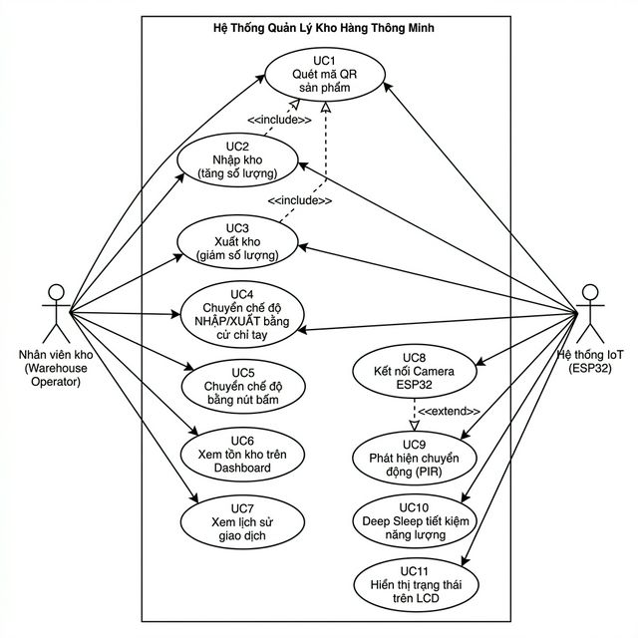
Figure 3.1: Use Case Diagram — Smart Warehouse Management System
3.3 System Architecture
The system follows a 4-layer architecture: IoT Hardware (ESP32-S3), Web Browser (client-side AI processing), Backend REST API (Spring Boot), and Database (PostgreSQL).
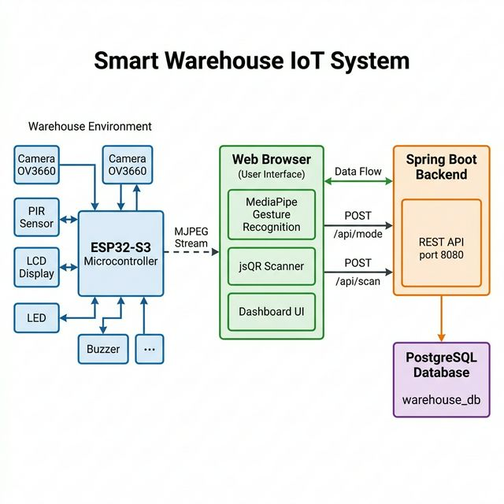
Figure 3.2: Overall System Architecture — Smart Warehouse IoT
Main data flow:
• ESP32 streams MJPEG camera → Web Browser displays
• Browser recognizes hand gestures (👍 STOCK-IN / 👎 STOCK-OUT) → POST /api/mode
• Browser scans QR from stream → POST /api/scan (with scanEventId UUID)
• Spring Boot Backend processes stock-in/stock-out logic → updates PostgreSQL
• Dashboard auto-refreshes data every 3 seconds
3.4 Hardware Design
3.4.1 Component List
# | Component | Model | Qty | Purpose
1 | Microcontroller | ESP32-S3-N16R8 | 1 | Main processor, dual-core, WiFi, 8MB PSRAM
2 | Camera | OV3660 (3MP) | 1 | MJPEG stream for QR scan + Gesture recognition
3 | LCD Display | 1602A I2C (PCF8574) | 1 | Countdown, mode, status display
4 | PIR Sensor | HC-SR501 | 1 | Motion detection, Deep Sleep wake-up
5 | Buzzer | 5V Active | 1 | Audio feedback for success/error
6 | Transistor | 2N2222 NPN | 1 | Drive 5V Buzzer from 3.3V GPIO
7 | Green LED | 3mm | 1 | Blink warning when countdown < 10s
8 | Resistors | 220Ω, 1kΩ | Multiple | LED current limiting, transistor base control

3.4.2 Hardware Wiring Diagram
Detailed wiring diagram of all components connected to the ESP32-S3-N16R8:
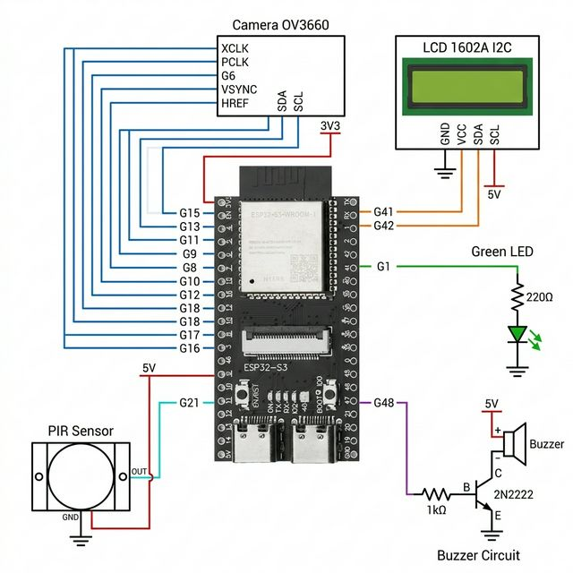

Figure 3.3: Hardware Wiring Diagram
3.4.3 ESP32-S3 Pin Mapping
Component | ESP32 Pin | Function
Camera XCLK | GPIO 15 | Master clock 20MHz
Camera PCLK | GPIO 13 | Pixel clock
Camera VSYNC | GPIO 6 | Vertical sync
Camera HREF | GPIO 7 | Horizontal reference
Camera D0-D7 | GPIO 11,9,8,10,12,18,17,16 | 8-bit parallel data bus
Camera SIOD/SIOC | GPIO 4, 5 | I2C Camera bus (SCCB protocol)
LCD SDA | GPIO 41 | I2C Data — dedicated LCD bus
LCD SCL | GPIO 42 | I2C Clock — dedicated LCD bus
PIR OUT | GPIO 21 | RTC GPIO — Deep Sleep wake-up (ext0)
Buzzer (Base) | GPIO 48 | Via 2N2222 transistor + 1kΩ resistor
Green LED | GPIO 1 | Via 220Ω current-limiting resistor
3.5 Database Design
The database consists of 2 main tables: inventory (stock levels) and transaction_logs (transaction history). The tables have no Foreign Key relationship — allowing FAILED logs to be recorded even when a QR code does not exist in the inventory.
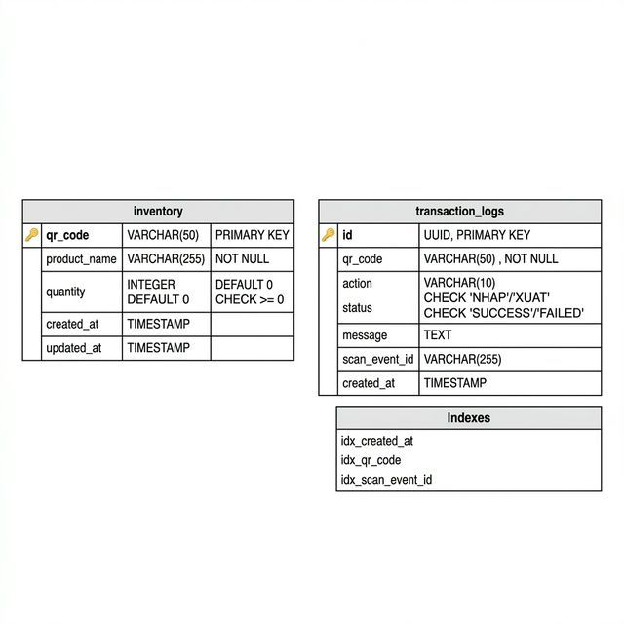
Figure 3.4: ER Diagram — warehouse_db Database
3.6 API Design
Endpoint | Method | Description
/api/mode | GET | Get current mode (STOCK-IN/STOCK-OUT/IDLE)
/api/mode | POST | Set new mode
/api/scan | POST | Process QR scan (with idempotency key)
/api/inventory | GET | List all inventory (sorted by updated_at)
/api/logs | GET | 50 most recent transactions
/api/camera/stream | GET | Proxy MJPEG stream from ESP32 (CORS bypass)
/api/health | GET | Server health check
3.7 User Interface Design
The web interface follows a Glassmorphism design — frosted glass effect with dark mode background. Main pages:
• Dashboard: 4 stat cards + 7-day transaction chart (Chart.js)
• Inventory: Stock table + inline QR codes + PNG download button
• History: Detailed transaction table with new row highlighting
• Camera: Live stream + scan status + mode badge + STOCK-IN/OUT buttons
• Settings: Camera IP, API URL, refresh interval, connection test

CHAPTER 4: IMPLEMENTATION
4.1 ESP32-S3 Firmware
The firmware is written using the Arduino Framework with built-in FreeRTOS on ESP32-S3. It follows a modular architecture with separate header files:
File | Function
smart_warehouse.ino | Main file — State machine, setup(), loop()
config.h | WiFi credentials, GPIO pins, timeouts, debug flags
camera_module.h | OV3660 initialization, JPEG/VGA/PSRAM configuration
display_module.h | LCD I2C — status display with anti-flicker mechanism
feedback_module.h | LED blinking, Buzzer beep patterns
sensor_module.h | PIR digital read, Deep Sleep ext0 wake-up
stream_module.h | MJPEG HTTP server, FreeRTOS task on Core 0
wifi_module.h | WiFi connection with 15s timeout

4.1.1 Dual-Core Architecture
The ESP32-S3 dual-core enables true hardware parallelism (not time-sharing):
• Core 0: Camera streaming task — MJPEG server port 81, continuously serving Web clients at ~30 FPS
• Core 1: Main loop — PIR polling, LCD updates, LED control, Serial commands, API server port 82
4.1.2 Deep Sleep Mechanism
Deep Sleep reduces power consumption from ~200mA (Active) to ~10µA, a reduction of approximately 20,000 times:
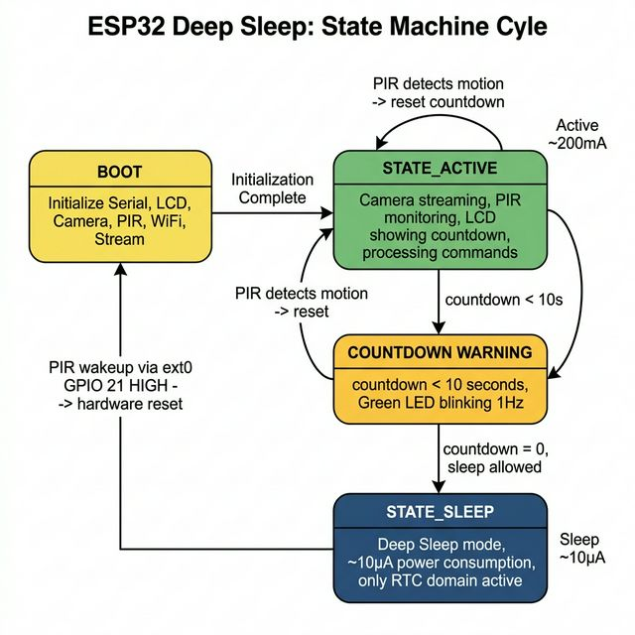
Figure 4.1: Deep Sleep State Machine — ESP32-S3
PIR warm-up guard: After Cold Boot, the firmware prevents Sleep for the first 30 seconds to allow the PIR sensor to stabilize. When waking from Deep Sleep, the PIR is already warmed up, requiring no delay.
4.2 Spring Boot Backend
The backend follows a 3-layer architecture: Controller → Service → Repository, adhering to the Single Responsibility principle.
Layer | Class | Responsibility
Controller | WarehouseController | Receive HTTP requests, validate input, return responses
Service | WarehouseService | Business logic, mode state, idempotency check
Repository | InventoryRepository | Query/update inventory table (JPA)
Repository | TransactionLogRepository | Write transaction logs (JPA)
Entity | Inventory, TransactionLog | JPA entities mapped to database tables
DTO | ScanRequest, ScanResponse | Data Transfer Objects for API communication

Idempotency Feature: Each scan request includes a scanEventId (UUID). The backend checks transaction_logs — if the ID already exists, it returns the cached result without modifying the quantity. The entire processScan() logic runs within @Transactional, ensuring atomicity.
4.3 Web Dashboard Frontend
The frontend uses pure Vanilla HTML/CSS/JavaScript (no framework), combined with CDN libraries:
Library | Version | Purpose
MediaPipe Tasks Vision | 0.10.3 | AI hand gesture recognition (WebAssembly + GPU)
jsQR | — | QR code decoding from canvas pixels
Chart.js | 4.x | 7-day transaction activity charts
QRCode.js | — | Inline QR code generation in inventory table
Google Fonts (Inter) | — | Modern typography

4.3.1 QR Scanning Pipeline
The QR scanning process passes through 5 duplicate prevention layers, ensuring each scan is processed exactly once:

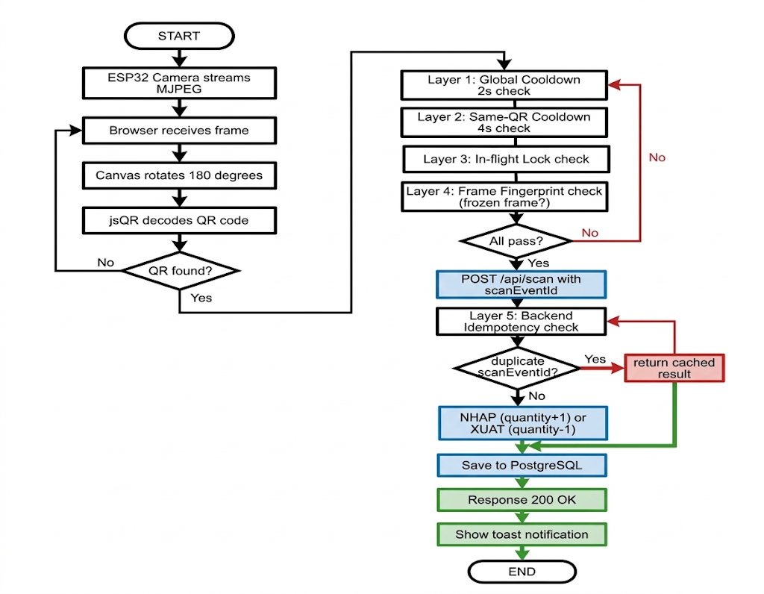
Figure 4.2: QR Scan Flowchart — 5-Layer Duplicate Prevention
Layer | Location | Mechanism | Problem Solved
1 | Frontend | Global cooldown 2s | Burst scanning in rapid succession
2 | Frontend | Same-QR cooldown 4s | Camera held on QR → repeated scans
3 | Frontend | In-flight lock | Slow network → duplicate requests
4 | Frontend | Frame fingerprint | Stream lag → frozen frame detection
5 | Backend | scanEventId idempotency | Network retry → duplicate mutations
4.3.2 Gesture Recognition Pipeline
MediaPipe AI recognizes hand gestures with a Temporal Consensus mechanism — requiring 4 consecutive frames with the same gesture before switching modes, virtually eliminating false positives:
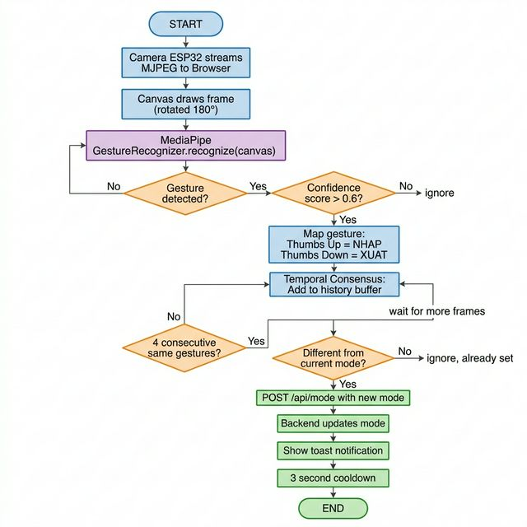
Figure 4.3: Gesture Recognition Flowchart — Temporal Consensus
4.4 System Integration
Steps to integrate and run the complete system:
• Step 1: Initialize database — run init.sql on PostgreSQL (port 5432)
• Step 2: Start Backend — mvn spring-boot:run (port 8080)
• Step 3: Upload firmware to ESP32-S3 via Arduino IDE
• Step 4: Open browser → http://localhost:8080 → Settings → Enter camera IP → Connect
• Step 5: Show 👍 (STOCK-IN) or 👎 (STOCK-OUT) → Present QR code to camera → System processes automatically

CHAPTER 5: RESULTS AND EVALUATION
5.1 Achieved Results
After development and testing, the system achieved the following results:
# | Feature | Result | Notes
1 | QR Code Scanning | ✓ Stable operation | Recognition in < 0.5s
2 | Stock-In/Stock-Out | ✓ 100% accuracy | 5-layer duplicate prevention works correctly
3 | Gesture Recognition | ✓ Works well | Temporal Consensus eliminates false positives
4 | Deep Sleep | ✓ 99.995% energy saving | ~200mA → ~10µA, PIR wake-up < 1s
5 | Web Dashboard | ✓ Real-time updates | Auto-refresh 3s, Glassmorphism UI
6 | Camera Stream | ✓ 30 FPS | MJPEG, dual-core prevents lag
7 | LCD + LED + Buzzer | ✓ Good feedback | Countdown, warnings, audio alerts
8 | Idempotency | ✓ No duplicates | scanEventId UUID protects database integrity
5.2 Strengths and Limitations
5.2.1 Strengths
• High automation: Simply show a gesture and present QR — no manual data entry required
• Excellent energy savings: Deep Sleep reduces consumption by 20,000x compared to Active mode
• Robust duplicate prevention: 5-layer protection from frontend to backend ensures data integrity
• Client-side AI: MediaPipe runs on browser GPU, consuming no server resources
• Dual-core architecture: Camera stream and main logic run in parallel without blocking
• Modern interface: Glassmorphism dark theme, responsive design, intuitive UX
• Modular firmware: Separated into header modules for easy maintenance and extension

5.2.2 Limitations
• No authentication: Anyone on the LAN can access the API
• No encryption (HTTP): Data transmitted in plaintext, unsuitable for sensitive environments
• Mode stored in RAM: Backend restart resets mode to IDLE
• Single instance: Does not support multiple backend instances
• LAN dependency: System does not function when WiFi is unavailable
• Inverted OV3660 camera: Requires 180° rotation on frontend (slight browser CPU overhead)

CHAPTER 6: CONCLUSION AND FUTURE WORK
6.1 Conclusion
The "Smart Warehouse IoT Management System" project successfully achieved all initially defined objectives. The system integrates the ESP32-S3 microcontroller with the OV3660 camera, PIR sensor, LCD display, and feedback devices (LED, Buzzer) to create a comprehensive automated warehouse management solution.
A key highlight of the project is the combination of IoT hardware with artificial intelligence (MediaPipe) running directly in the web browser, enabling contactless hand gesture recognition. The 5-layer QR scan duplicate prevention mechanism ensures the highest level of data integrity. The Deep Sleep mode enables the device to consume extremely low power when not in use.
The Spring Boot backend with PostgreSQL provides a solid foundation for data storage and querying. The Web Dashboard with modern Glassmorphism design delivers an intuitive and professional user experience.
6.2 Future Work
The system can be extended in the following directions:
• Integrate user authentication (JWT/OAuth2) and HTTPS encryption
• Develop a Mobile App (React Native/Flutter) for mobile warehouse management
• Deploy to Cloud (AWS/GCP/Azure) for remote access
• Integrate RFID readers alongside QR codes for faster scanning
• Apply AI product recognition using Computer Vision
• Support multiple ESP32 devices for large warehouse systems with multiple zones
• Add notification features (Email/SMS/Push) when stock is running low
• Build automatic reporting system (PDF export, Excel export)
• Integrate with enterprise ERP/WMS systems

REFERENCES

[1] Espressif Systems, "ESP32-S3 Series Datasheet", Version 1.4, 2024. https://www.espressif.com/en/products/socs/esp32-s3
[2] Espressif Systems, "ESP-IDF Programming Guide — Deep Sleep", 2024. https://docs.espressif.com/projects/esp-idf/en/stable/esp32s3/api-reference/system/sleep_modes.html
[3] Google, "MediaPipe Tasks Vision — Gesture Recognition", 2024. https://ai.google.dev/edge/mediapipe/solutions/vision/gesture_recognizer
[4] Spring, "Spring Boot Reference Documentation", Version 3.2, 2024. https://docs.spring.io/spring-boot/docs/current/reference/htmlsingle/
[5] PostgreSQL Global Development Group, "PostgreSQL 16 Documentation", 2024. https://www.postgresql.org/docs/16/
[6] OmniVision Technologies, "OV3660 3MP Product Brief", 2020. https://www.ovt.com/sensor/ov3660
[7] Pivotal, "Spring Data JPA Reference Documentation", 2024. https://docs.spring.io/spring-data/jpa/docs/current/reference/html/
[8] cozmo, "jsQR — A pure JavaScript QR code reading library", GitHub. https://github.com/cozmo/jsQR
[9] Chart.js Contributors, "Chart.js Documentation", Version 4.x, 2024. https://www.chartjs.org/docs/latest/
[10] Arduino, "Arduino-ESP32 Documentation", 2024. https://docs.espressif.com/projects/arduino-esp32/en/latest/

APPENDICES
A. Project Directory Structure
D:\Semester_4\IOT102\Project\
• hardware/esp32-firmware/src/smart_warehouse/ — ESP32 Firmware
◦ smart_warehouse.ino — Main file
◦ config.h, camera_module.h, display_module.h — Modules
◦ feedback_module.h, sensor_module.h, stream_module.h, wifi_module.h
• software/backend/warehouse-api/ — Spring Boot Backend
◦ src/main/java/com/warehouse/ — Controller, Service, Repository, Entity, DTO
◦ pom.xml — Maven dependencies
• software/frontend/ — Web Dashboard
◦ index.html, css/style.css, js/app.js
• software/database/init.sql — PostgreSQL schema + sample data
B. LCD Display States
State | Line 1 | Line 2
Boot | Smart Warehouse | Khoi dong...
WiFi Connecting | Ket noi WiFi... | [SSID]
WiFi Connected | WiFi OK! | [IP Address]
PIR Warm-up | DANG ON DINH... | Vui long cho PIR
Awaiting Mode | Cho lenh NH/XU | Sleep: XXs
STOCK-IN Mode | >> NHAP << | Sleep: XXs
STOCK-OUT Mode | >> XUAT << | Sleep: XXs
Sleep Warning | (Unchanged) | Sap ngu: Xs
Going to Sleep | DI NGU... | Bye bye!
Waking Up | THUC DAY! | PIR phat hien
C. Buzzer Sound Patterns
Pattern | Duration | Trigger
beepShort() | 120ms | Mode set via Serial command
beepSuccess() | 350ms | QR scan successful
beepError() | 3×(70ms ON + 70ms OFF) | QR scan failed or out of stock

