Kunal Mukherjee

CS 475

12/2/17

Mr. Randall

**ICMP Lab**

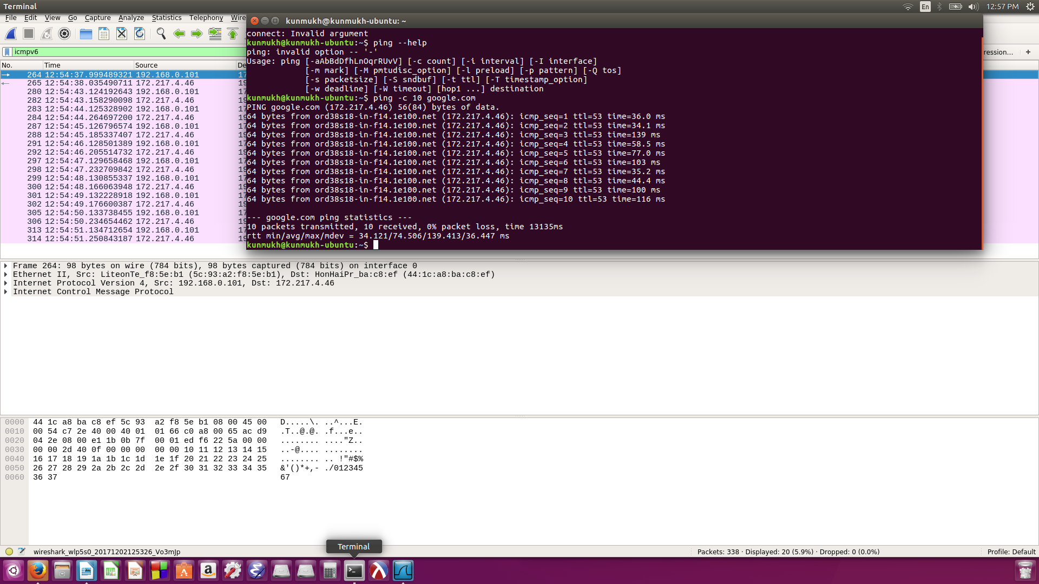

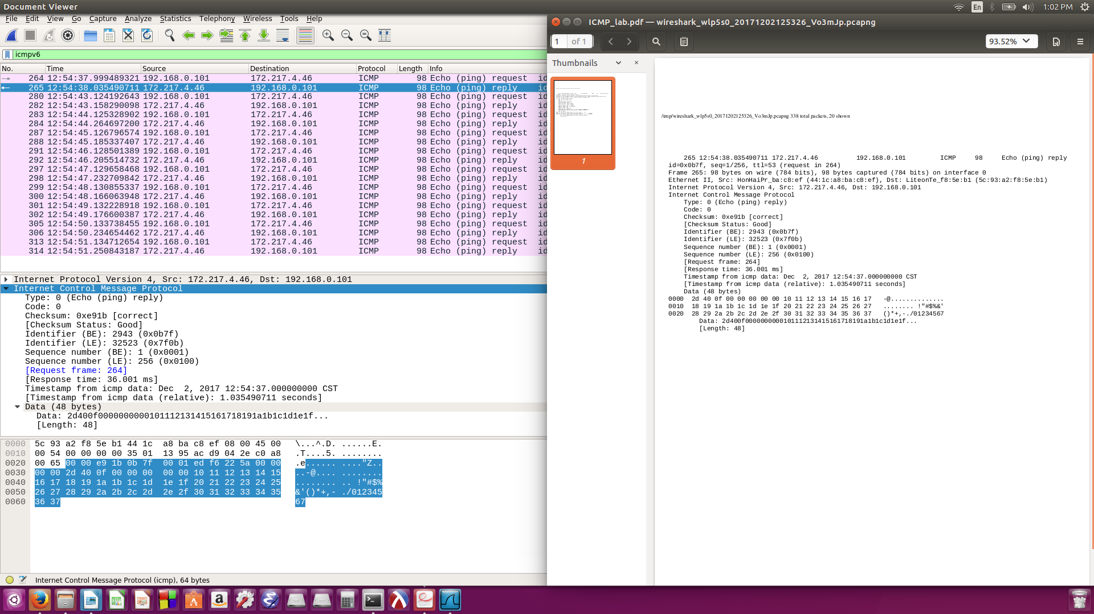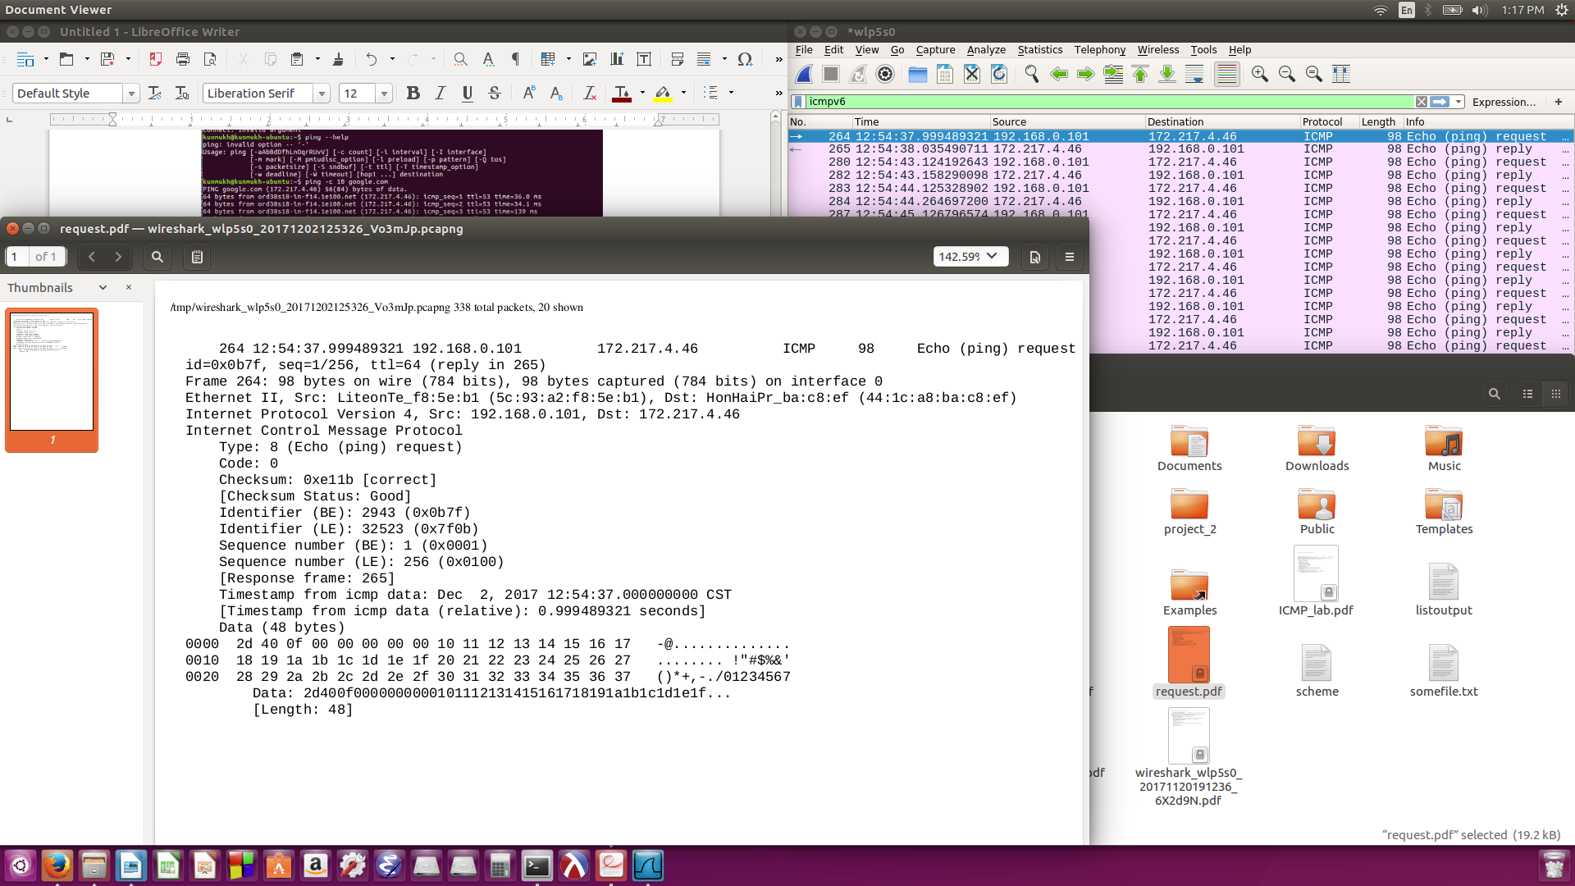

1> The IP of my Host is – 192.168.0.101

The IP of my destination host – 172.217.4.46

2> The ICMP was made to communicate network layer information between hosts and routers. It uses “Type” and “Code” combination to identify the specific message being received. The network software itself interprets all ICMP messages, so no port number is needed to direct the ICMP message to an application layer protocol.

3> ICMP type- 8

ICMP code – 0

The ICMP packet has checksum, identifier, sequence number, and data fields.

Checksum, Sequence Number and Identifier field 2 bytes each.

4> ICMP type- 0

ICMP code – 0

The ICMP packet has checksum, identifier, sequence number, and data fields.

Checksum, Sequence Number and Identifier field 2 bytes each.

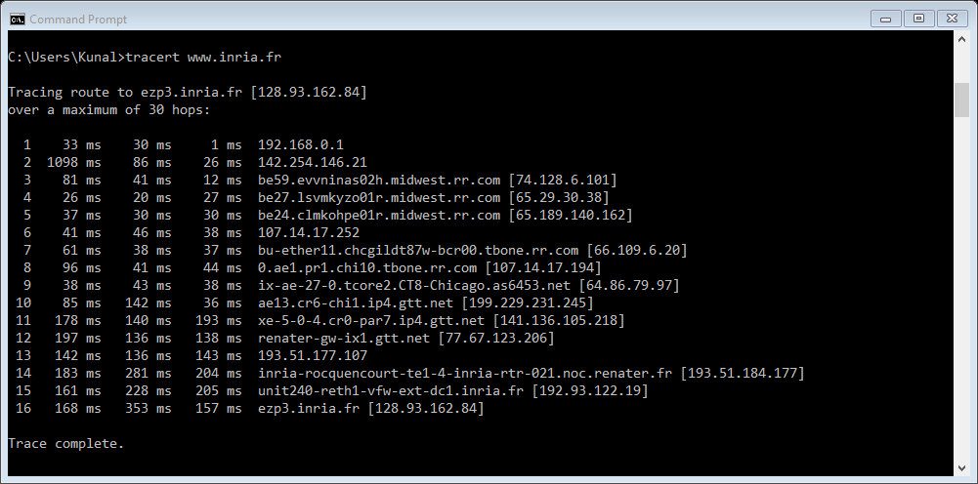

5> The IP address of my host is 192.168.0.101.

The IP of my target destination IP is 128.93.162.84

6> if ICMP sent UDP packets instead. The IP Protocol number should be 0x11.

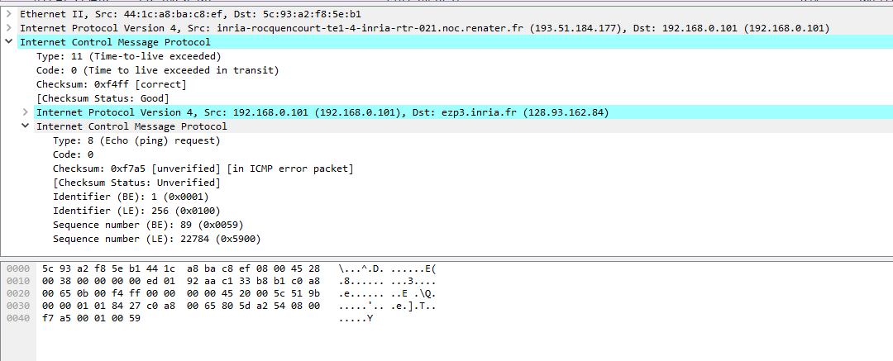

7> The echo packet has the same field as the ping query packets.

8> ICMP error packet is not the same as the query packet. It contains IP header and the first 8 bytes of the ICMP packet sent originally, that helps identify the error.

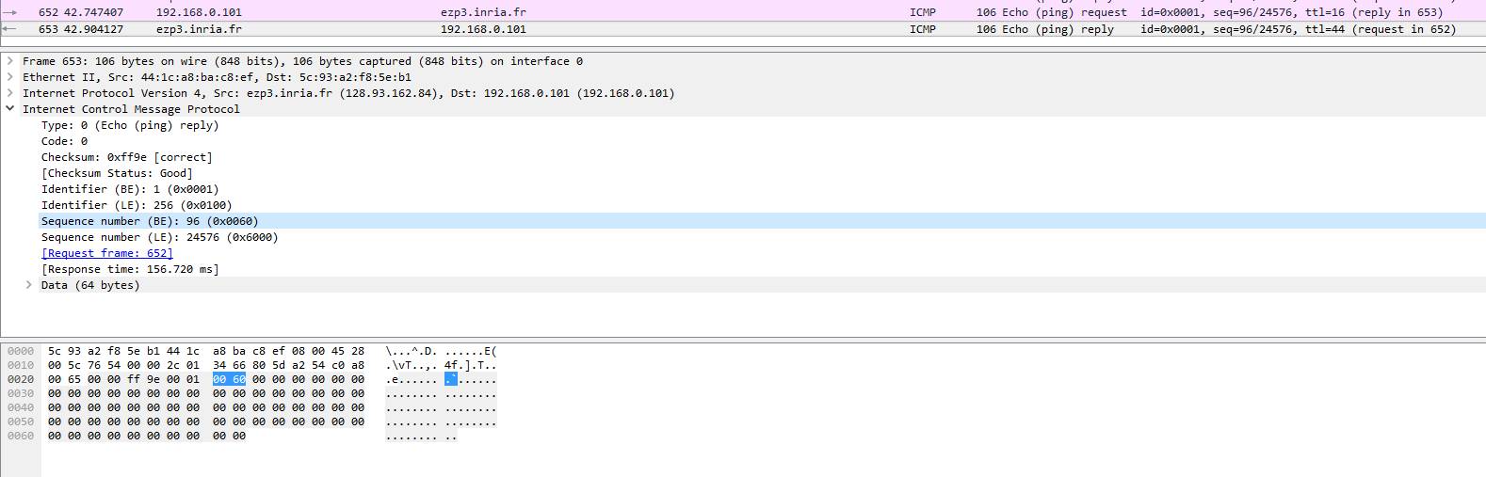9> The last three are of the type 0, rather than 11. The possible result is that the datagram messages made it to the destination port before the TTL expired.

10> Yes, the link between 10 and 11 has a significantly longer delay as it has to go from Chicago to Renater, France. It connects the Midwest to the Chicago. I figure4, the link is from New York to Pastourelle, France.