Kunal Mukherjee

ee 354

Project 1: hour-glass simulation EE 354 10/19/2018

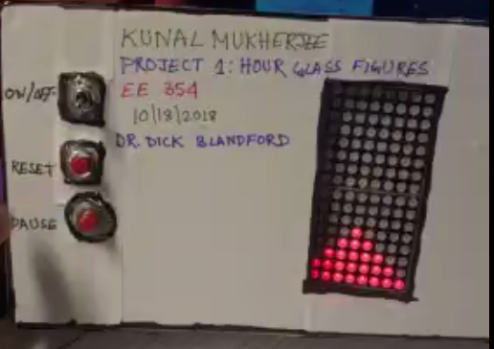

Contents

Novel Feature 2

Working Feature 2

Safety, reliability, economic, manufacturability and environmental factors 2

Hardware Documentation 3

Software Documentation 3

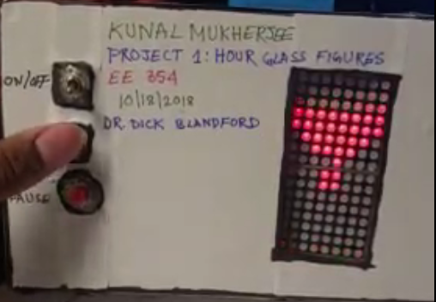

# Novel Feature

My hourglass has three novel features:

1. The hour glass does not let the sand fall until the tilt of the box is more that 45°. This is a feature that can be seen in normal hour glass also, that if you don’t tilt the glass more than till a limit the sands would move but not fall. I tried to emulate that effect. This happens on both axes.
2. The hour glass has a pause button, that if you press that button will be paused at that instant and you can move the hour glass whichever way you want, when you resume it the sands will flow according to gravity.
3. The hourglass works continuously, that you can keep rotating the hourglass and the sands will flow, without the need for resetting.

# Working Feature

The physical sheet has been provided. The following features shown working:

1. Does not rattle when shaken
2. Project uses AT89C51CC03
3. Batteries can be changed without disassembly
4. The project is fully self-contained (uses batteries)
5. There are an on/off and reset switch
6. Software has a mix of C and assembly code
7. Successfully does hour glass simulation
8. Successfully works when rotated

# Safety, reliability, economic, manufacturability and environmental factors

**Safety:**

The box is made with plastic and every wire ending is insulated with hot glue. The lid is water proof and is also, made with plastic. So, there is no conduction of current possible from the box.

**Reliability:**

The hour glass, only function, the sands flow, if it is above a particular tilt. You can rely on the hourglass to get see the direction of gravity as well as the orientation of the box, that is the sand is flowing then the box is at a tile more than 45° from the x-axis.

**Economic:**

The entire board has constructed cost is less than $100.So, it is extremely cheap to manufacture the hour glass, if the user has access to the hardware and software documentation.

**Manufacturability:**

The entire software, hardware documentation as well as the source code is provided. With this project documentation guide, anyone with basic engineering knowledge can recreate my hour glass.

**Environmental:**

Rechargeable 9V battery can be used for this project, so it saved the environment as we are reusing battery. The project does not emit any harmful gas or chemical substance.

# Hardware Documentation

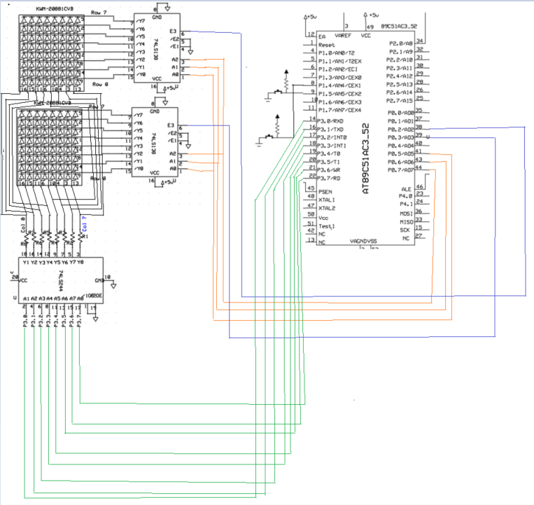

All resistors are 1 kΩ.

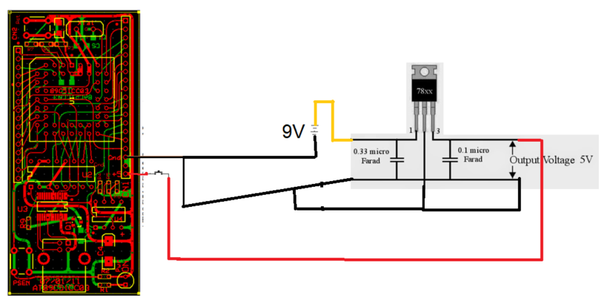

# Software Documentation

