

RC, RL, and RLC Filter design

Kunal Mukherjee



March 2, 2019

University of evansville

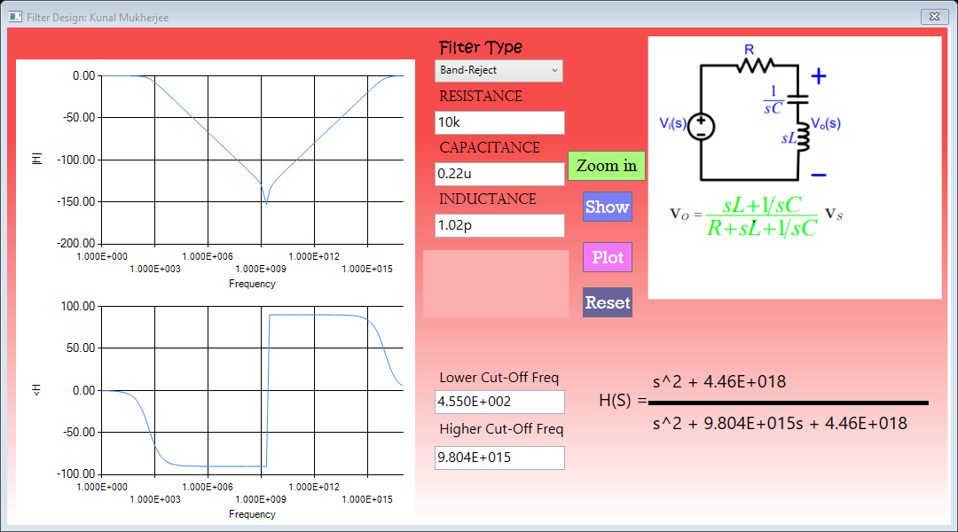

Contents

Problem Design 2

Design 2

Theoretical Results 4

Simulation Results 4

Experimental Design 5

Measure Results 5

Conclusion 5

Code 6

# Problem Design

The problem we are trying to solve is how to accurately guess the frequency response from R, L or C value. Therefore, building a simulator to emulate different filter types is the best choice of action. In engineering sometimes, it is necessary to check a pre-built circuit’s frequency response as well as to know what value of resistors, capacitors and inductors to use to build the filter. Therefore, I decided to design C# WPF application that shows the user the Bode magnitude plot and Bode phase plot, if the user enters the filter type then, R, L or C value, or center/cut-off frequency and any one of R, L or C value. The application also shows the transfer function and a sample circuit diagram.

# Design

There were two major design hurdles. The first design hurdle was to get all the transfer functions for RC low/high pass, RL low/high pass, RLC bandpass or RLC band stop filters. The second hurdle was to find the appropriate frequency increment value, so that all the necessary information of the bode plot is preserved but does not need a huge dataset.

The transfer function was calculated using the following equations:

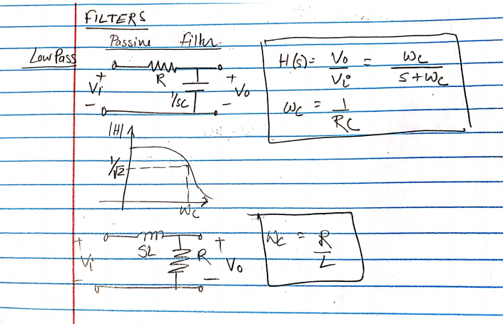

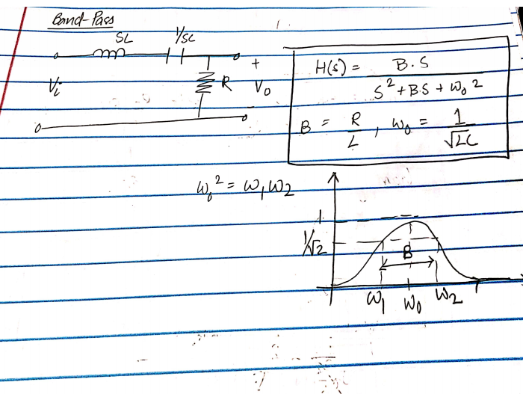

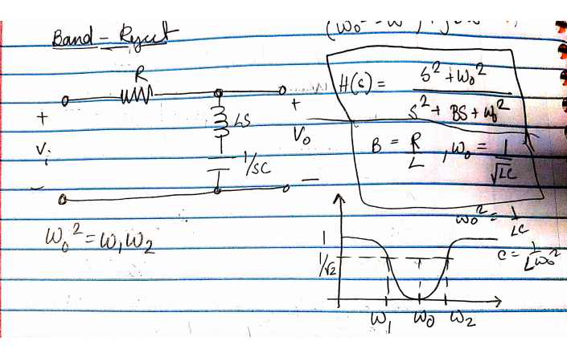

The second design issue was solved by using a multiplicative increment. For example, let say, we want to graph for a frequency of 10-1000 Hz, I will use the following frequency values e.g. 1,2,3...10,20,30…100,200,300…1000. In that way, we don’t need all the points in between 10-20, as the log scale of the frequency axis will not care, and this increment captures all the necessary information to plot the frequency response.

As extra feature, I have added, that you can put u-micro, p-pico, n-nano, f-femto, m-mili, k or K-kilo and M-mega along with numbers for R, L and C values. I have also added a zoom feature that will zoom in the center or the cut-off frequency depending on the filter type.

# Theoretical Results

The project should be working as per the following specifications mentioned above as the calculated transfer function matches with the transfer function in the book.

# Simulation Results

I used OKAWA Electric Design simulator software to test my design. The simulation result matched with the application results. The following illustration is showing the band pass filter for 1k, 0.1u C and 0.1u for I, from OKAWA electric and my application.

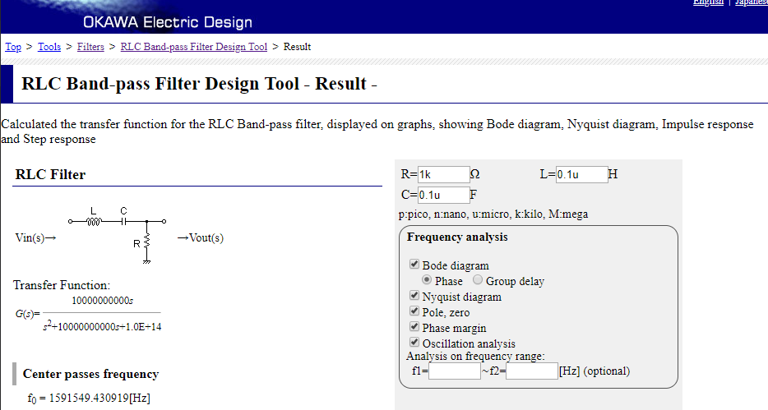

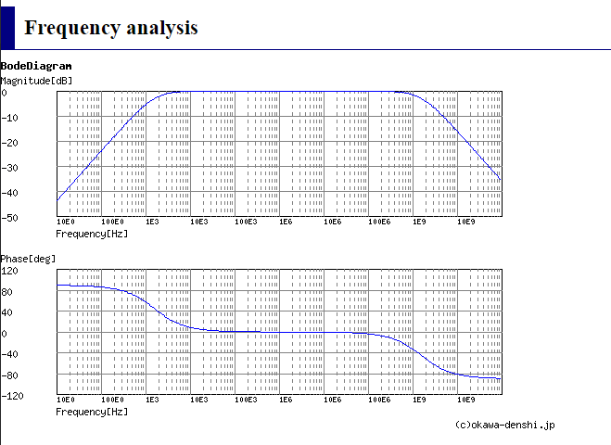

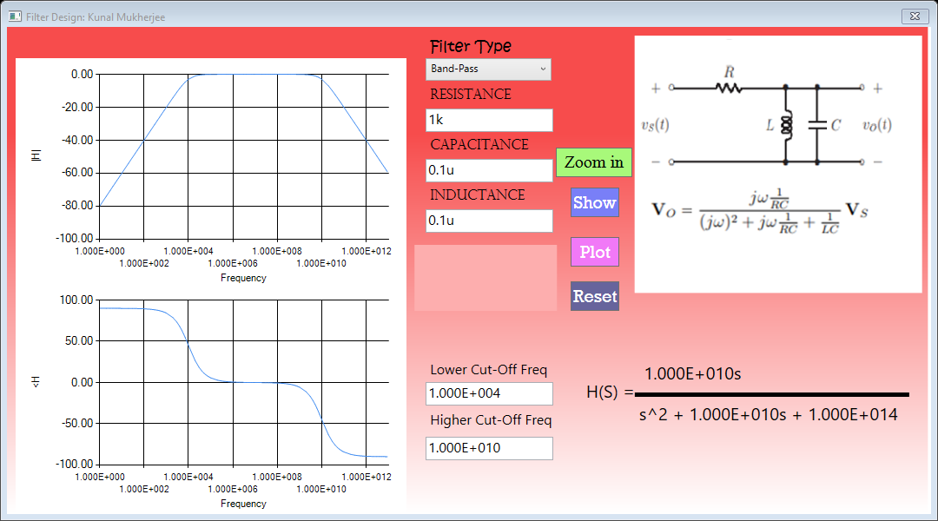

# Experimental Design

The project did not need much experimentation, except for finding how much of a frequency range to show the relative trend of the graph.

# Measure Results

The project did not need much measurement, but I checked all my simulation results e.g. frequency response, cut-off/center frequency and transfer function with OKAWA electric’s simulation.

# Conclusion

The project met the specifications of WPF C# application that shows the user the Bode magnitude plot and Bode phase plot, when the user enters the filter type then, R, L or C value, or center/cut-off frequency and any one of R, L or C value. The project also shows the sample circuit as well as the transfer function.

# Code