Kunal Mukherjee

Km411@evansville.edu

Kunal Mukherjee  
EE 356  
Project 4  
10/14/2019

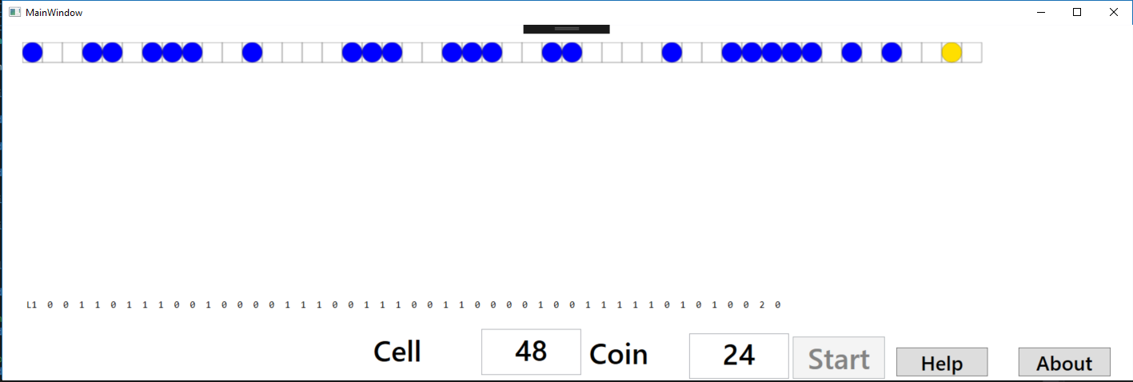My program is a simulation of a children game called Gold button. You make a move in my game by left clicking on the start spot and right clicking on the end spot. The coin moves by animation and the winner is displayed by animation. You can additionally, select the number of cells and coin. The gold coin will always be in the last 25% of the cells and messages are shown when a player changes or an illegal move happen. The extra feature is the help, about and continually reset the program after one-person wins. The Help gives the user the game rules and the about gives information about the programmer. Classes were used to construct the program, the cells were a class and the coins were a class, so that it was easy to see if a cell was the last cell and attach color to a coin. Using class made the architecture of the game very simple and easy to construct.

