Kunal Mukherjee

uNIVERSITY OF EVANSVILLE

pROJECT 3 (UTPIDPWMOC)

# STATEMENT OF THE PROJECT

The project is supposed to give the students expertise with PID controller, serial communication, USART, and LCD display. A PID controller is “Proportional Integral Derivative” controller. A PID controller gives an output depending on the error of the system as well as certain parameter such as predicting what error is going to come. For example, if the error is more than the output signal will be large and vice-versa. The LCD display used USART serial communication to communicate with the nucleo board.

This project first asks the user to map the position of the pivot arm somehow, here we use a potentiometer to measure the angle or the position of the drone motor. Then, the project uses a PWM signal to control the DC drone motor to increase or decrease thrust. The ultimate objective of the project is that the drone is supposed to hover at a target angle. The “error” in the angle, will be utilized by the PID controller to change the PWM signal, so that the drone can hover over the desired angle.

# POSSIBLE UTILITY OF THE PROJECT

The physical project maybe of just practice utility, but the PID algorithm used can be readily used for other project requiring a PID. While doing this project I had to use my knowledge of ADC, PWM and PID controllers. So, I had practice. After this project, I think I should have made a drone as my senior project.

# IDENTIFICATION OF SPECIFICATION

Design specification are as follows:

* Create a basic PID controller with externally adjustable coefficient
* Method for externally triggering a capture of the target position
* Demonstrate it can control a physical system like the 1-D helicopter
* Target position can be set in software
* Some method of display for the PID coefficients

# IDENTIFICATION OF DESIGN ISSUES AND SOLUTION

The first design issue that was presented on how to use a 3.3V PWM signal from the nucleo board to control a DC drone motor. The DC motor needs at least 10 V and current up to 1 A. Therefore, to solve this issue, I used a H-bridge to drive the motor. H-bride increased the response time of the motor but, it does not affect the system drastically.

The second design issue was how to display coefficient. I used a 16x2 LCD display and used USART to communicate with it. The USART takes a noticeable amount of time, so I update the display only if the values change.

The third design issue of how to quantify position of the drone arm, but it was already solved by the professor as the arm was attached to a potentiometer. The voltage of the potentiometer gave a quantification of the location or the angle at which the arm should over.

The PID controller give an output value that corresponds to an ADC value. The fourth design issue was how to use that output value and convert it to a PWM signal that will change the speed of the propeller. It was solved by using clever mathematical tools. First, finding the percentage of the ADC value compared the max range of ADC value (212 = 4095), then multiplying by the max time width of the PWM signal. For example, PWM = (Output / 4096) * MAX_ARR_PWM Then, the output PWM signal will be of the same percentage of the max time period of the PWM, as the output ADC is of the max ADC value.

The final design issue was how to find the correct constant values. Dr. Mitchell suggested that to first turn all the constants to 0, except for the proportionality constant. Increase the proportionality constant slowly until, I get a sinusoidal motion on the drone. Once, I get the motion, then increasing the derivate constant, so that the arm comes to the position without overshoot or undershooting. That was the proper way to get the constant values.

# SCHEMATIC OF COMPONENTS EXTERNAL TO THE STM32F446 BOARD

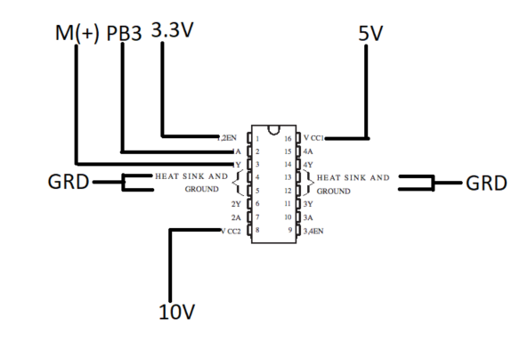

H-bridge Connection

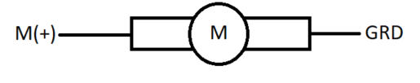

Motor Connection

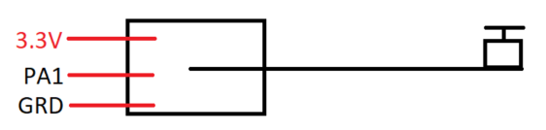

Potentiometer Connection

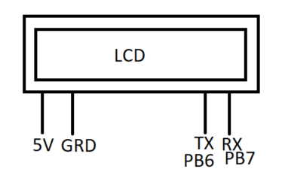

LCD Connection

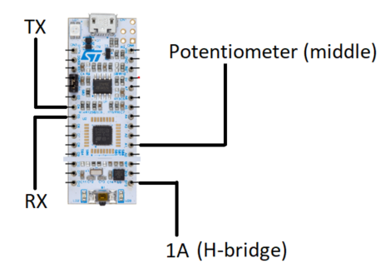

Nucleo Board Connection

# INFORMATIONAL RESOURCES USED

* Youtube board showing PID tuning

https://www.youtube.com/watch?v=0t3JL_zGEYY