NIP Project — Submission Template
Pega Platform project · This document is your complete submission
Read this before you start:
1. Fill in Section 1 completely. The Pega application name must follow the format NIP-[Project]-[YourName].
2. Create a new Operator in Pega with your full name and log in as that operator before taking any screenshot.
3. When you create your test case, enter YOUR FULL NAME in the Issue Description (Vehicle) or Movie Name (Movie) field.
4. Complete only the section for your chosen project. Delete the other project section.
5. Paste one screenshot per user story (10 total). Follow the screenshot rules in your selected project section.
6. Answer every question in Sections 3 and 4 in your own words.
7. Save the file using this format: ProjectName_FirstName_LastName.docx. Use VehicleService or MovieTicket as the ProjectName. Examples: VehicleService_Ravi_Kumar.docx or MovieTicket_Ravi_Kumar.docx.

Section 1 — Your Details
Full Name | kunnal yadav
Email ID (registered on NIP) | Kunnalyadav@9gmail.com
Phone Number | 7017957083
College Name | ITM Dehradun
Course (e.g. IT, CS) | b.com
State | utttrakhand
Project Chosen (Vehicle Service OR Movie Ticket Booking) | Movie ticket booking
Pega Application Name (e.g. NIP-VehicleService-YourName) | Media s Entertainment Kunnal_Yadav
Case Type Name (exact) | TICKET BOOKING
Pega Instance URL | https://5eqwj5la.pegaacademy.net/prweb/app/media-s-entertainment/
Operator Name (created in Pega with your full name) | kunnalyadav@MSE

Section 2A — Vehicle Service Management Application
Complete this section only if you selected this project. Delete the other project section before submitting.

Screenshot rules — IMPORTANT before you start:
1. Name your Pega application as: NIP-VehicleService-YourName OR NIP-MovieTicket-YourName
2. Create a new Operator in Pega with your full name (Security → Operators) and log in as that operator.
3. When you create your test case, enter YOUR FULL NAME in the Issue Description (Vehicle) or Movie Name (Movie) field.
4. The logged-in operator name must be visible in every screenshot wherever the Pega interface displays it.
5. The student's full name must be visible in all running-case screenshots.
6. Configuration screenshots must clearly show the relevant application or rule name.
Screenshots that do not show these will not be accepted.

US-001 — Submit Vehicle Service Request
What is expected:
Case created, customer submits Vehicle ID, Vehicle Model, Issue Description. Validation applied.
Screenshot — paste your screenshot below this line:
[ Paste screenshot here - follow the screenshot rules above ]

What I built for this (1–2 lines in your own words):

US-002 — Perform Vehicle Inspection
What is expected:
Inspection stage with Service Advisor step. Inspection Notes and Condition Rating captured.
Screenshot — paste your screenshot below this line:
[ Paste screenshot here - follow the screenshot rules above ]

What I built for this (1–2 lines in your own words):
.

US-003 — Generate Service Estimate
What is expected:
Labor Cost and Parts Cost captured. Total Cost calculated automatically by declare expression.
Screenshot — paste your screenshot below this line:
[ Paste screenshot here - follow the screenshot rules above ]

What I built for this (1–2 lines in your own words):

US-004 — Approve Service Estimate
What is expected:
Approval stage assigned to Customer. Approval Status captured. Flow branches on approve/reject.
Screenshot — paste your screenshot below this line:
[ Paste screenshot here - follow the screenshot rules above ]

What I built for this (1–2 lines in your own words):

US-005 — Maintain Vehicle Data
What is expected:
Reusable Vehicle data object created with Vehicle ID, Model, Type — linked to case.
Screenshot — paste your screenshot below this line:
[ Paste screenshot here - follow the screenshot rules above ]

What I built for this (1–2 lines in your own words):

US-006 — Review Service Estimate
What is expected:
Approval screen shows Labor Cost, Parts Cost and Total Cost clearly to the Customer persona.
Screenshot — paste your screenshot below this line:
[ Paste screenshot here - follow the screenshot rules above ]

What I built for this (1–2 lines in your own words):

US-007 — Auto Assign Technician
What is expected:
Service Execution stage with routing to HeavyVehicleQueue or LightVehicleQueue. Assigned Technician and Service Status properties maintained.
Screenshot — paste your screenshot below this line:
[ Paste screenshot here - follow the screenshot rules above ]

What I built for this (1–2 lines in your own words):

US-008 — Notify Service Completion
What is expected:
Correspondence rule created and triggered on case resolution. Email includes case and vehicle details.
Screenshot — paste your screenshot below this line:
[ Paste screenshot here - follow the screenshot rules above ]

What I built for this (1–2 lines in your own words):

US-009 — Define Service SLA
What is expected:
SLA configured on the case type. Goal: 2 days. Deadline: 3 days. Priority increases on breach.
Screenshot — paste your screenshot below this line:
[ Paste screenshot here - follow the screenshot rules above ]

What I built for this (1–2 lines in your own words):

US-010 — Route by Vehicle Type
What is expected:
Routing rule or Decision Table routes to HeavyVehicleQueue or LightVehicleQueue based on Vehicle Type property.
Screenshot — paste your screenshot below this line:
[ Paste screenshot here - follow the screenshot rules above ]

What I built for this (1–2 lines in your own words):

Section 2B — Movie Ticket Booking Management Application
Complete this section only if you selected this project. Delete the other project section before submitting.

Screenshot rules — IMPORTANT before you start:
1. Name your Pega application as: NIP-VehicleService-YourName OR NIP-MovieTicket-YourName
2. Create a new Operator in Pega with your full name (Security → Operators) and log in as that operator.
3. When you create your test case, enter YOUR FULL NAME in the Issue Description (Vehicle) or Movie Name (Movie) field.
4. The logged-in operator name must be visible in every screenshot wherever the Pega interface displays it.
5. The student's full name must be visible in all running-case screenshots.
6. Configuration screenshots must clearly show the relevant application or rule name.
Screenshots that do not show these will not be accepted.

US-001 — Submit Movie Ticket Request
What is expected:
Case created, customer submits Movie Name, Show Date, Show Time, Number of Tickets. Validation applied.
Screenshot — paste your screenshot below this line:
[ Paste screenshot here - follow the screenshot rules above ]

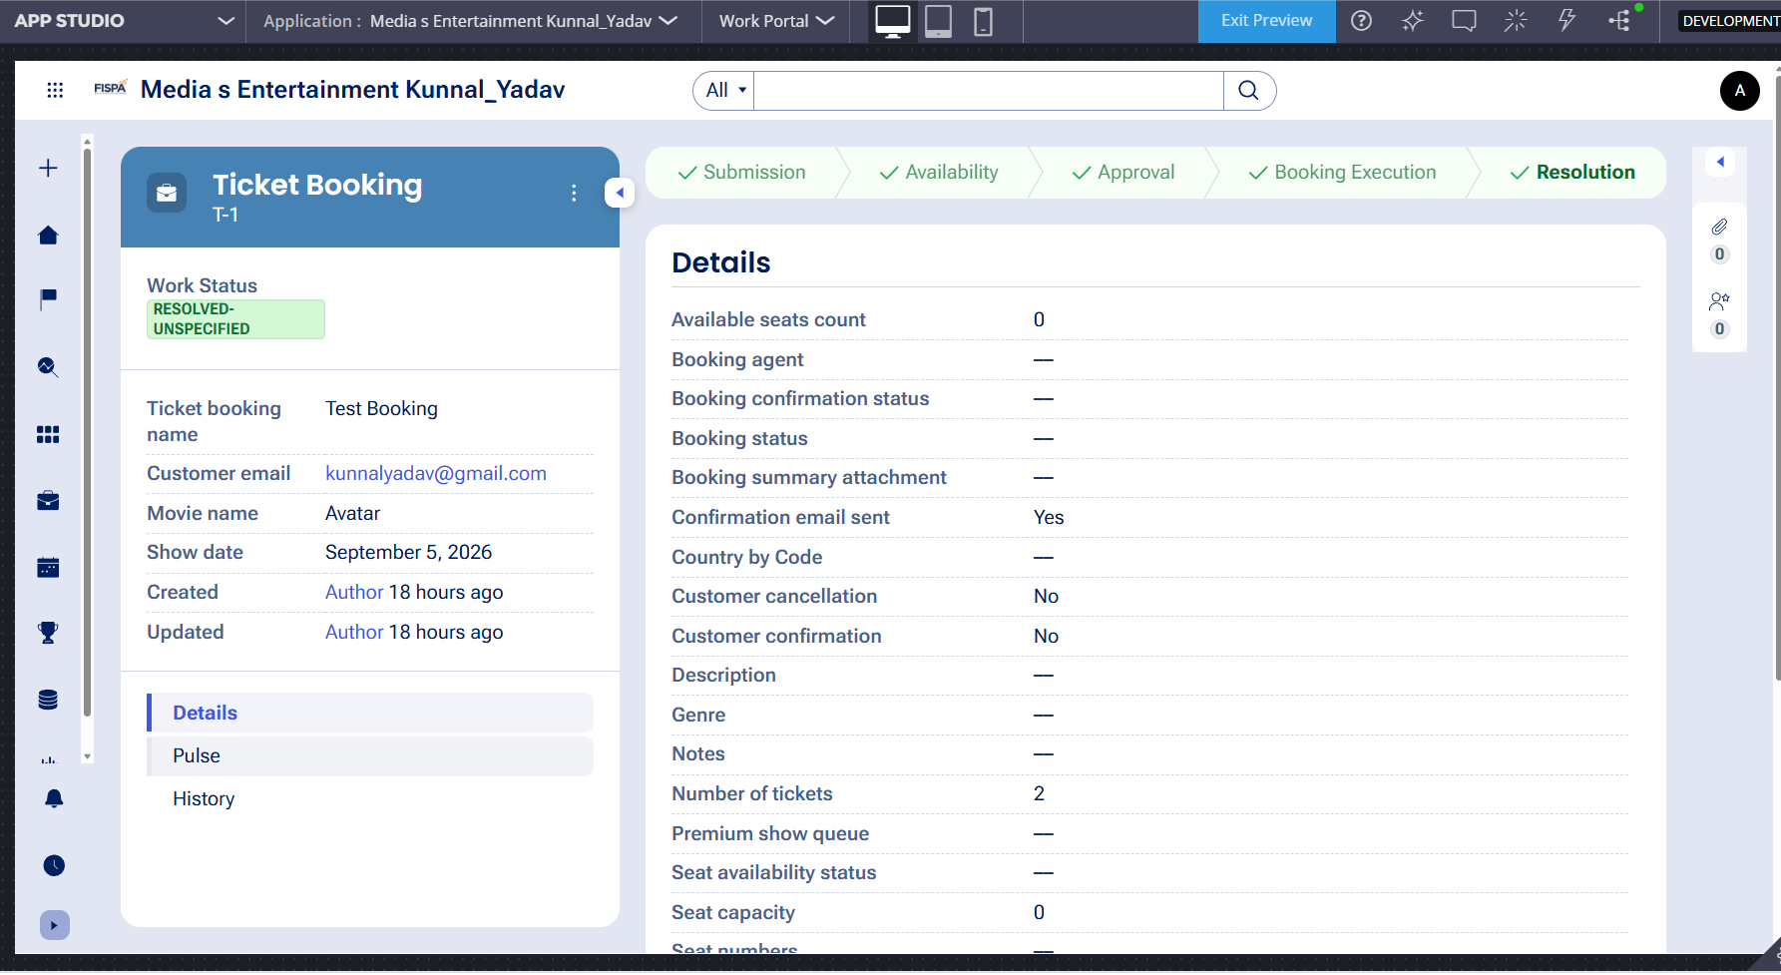

What I built for this (1–2 lines in your own words):
Created a ticket booking form to collect movie name, show date, show time, number of tickets, and customer details with input validation

US-002 — Check Show Availability
What is expected:
Availability stage. Seat Availability Status and Available Seats Count captured. Booking proceeds only if available.
Screenshot — paste your screenshot below this line:
[ Paste screenshot here - follow the screenshot rules above ]
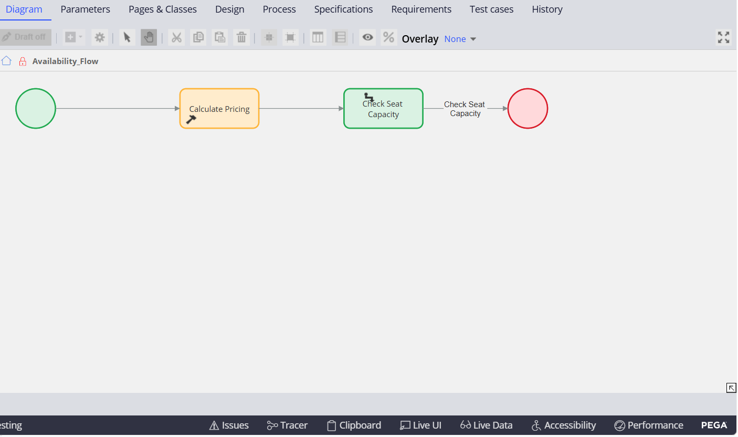

What I built for this (1–2 lines in your own words):
Added a seat availability check using Available Seats Count and Seat Availability Status before proceeding with the booking.

US-003 — Calculate Booking Cost
What is expected:
Total Cost calculated automatically from Ticket Price and Number of Tickets using a business rule.
Screenshot — paste your screenshot below this line:
[ Paste screenshot here - follow the screenshot rules above ]

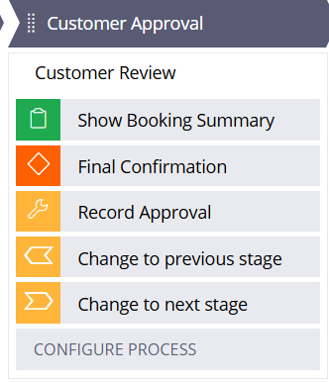

What I built for this (1–2 lines in your own words):
Configured automatic booking cost calculation using ticket price and the number of tickets.

US-004 — Confirm Booking Request
What is expected:
Approval stage assigned to Customer. Booking Status captured. Flow branches on confirm/cancel.
Screenshot — paste your screenshot below this line:
[ Paste screenshot here - follow the screenshot rules above ]
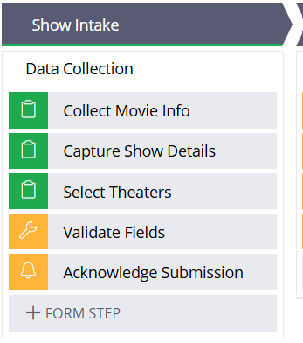

What I built for this (1–2 lines in your own words):
Created a customer approval flow with a booking summary and Confirm or Cancel options.

US-005 — Maintain Movie and Show Data
What is expected:
Reusable Movie and Show data objects created with Movie Name, Genre, Show Date, Show Time, Seat Capacity — linked to case.
Screenshot — paste your screenshot below this line:
[ Paste screenshot here - follow the screenshot rules above ]
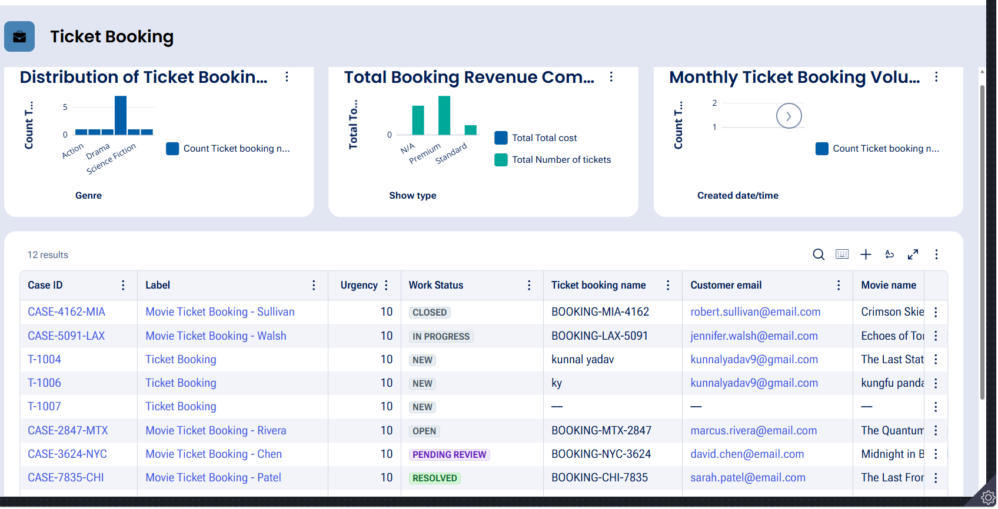

What I built for this (1–2 lines in your own words):
Created a Show Intake flow to collect and maintain movie information, show details, theater selection, and seat capacity.

US-006 — Review Booking Details
What is expected:
Confirmation screen shows Movie Name, Show Timing, Number of Tickets and Total Cost clearly.
Screenshot — paste your screenshot below this line:
[ Paste screenshot here - follow the screenshot rules above ]
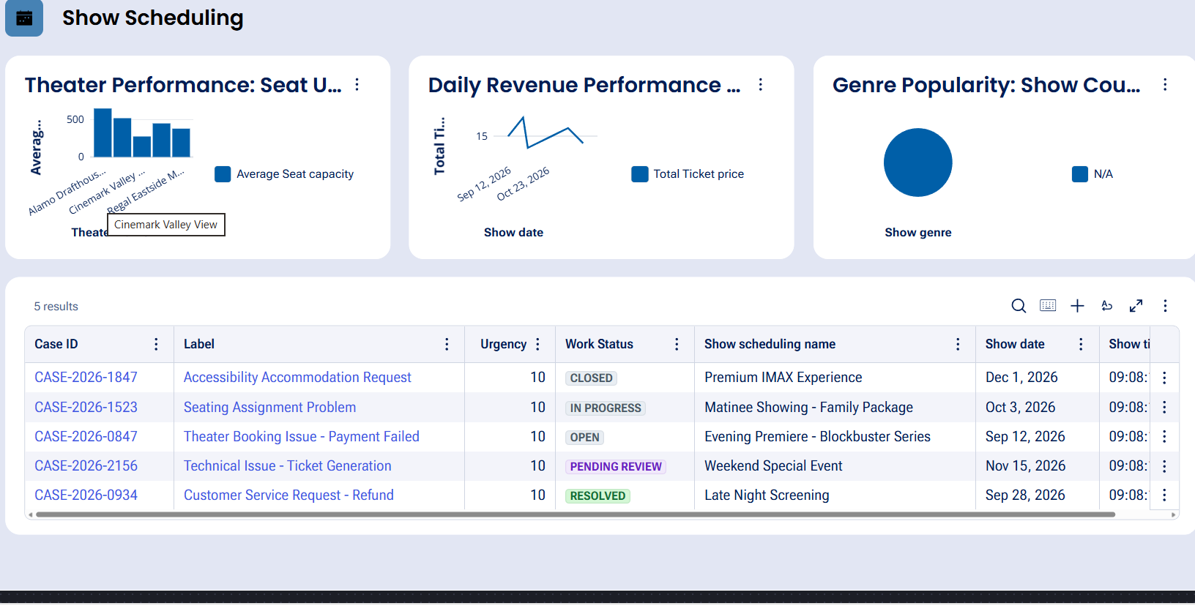

What I built for this (1–2 lines in your own words):
Added a booking summary step so customers can review movie, show timing, ticket quantity, and total cost before confirmation

US-007 — Process Ticket Booking
What is expected:
Booking Execution stage. Seat Numbers, Ticket ID and Booking Confirmation Status maintained.
Screenshot — paste your screenshot below this line:
[ Paste screenshot here - follow the screenshot rules above ]
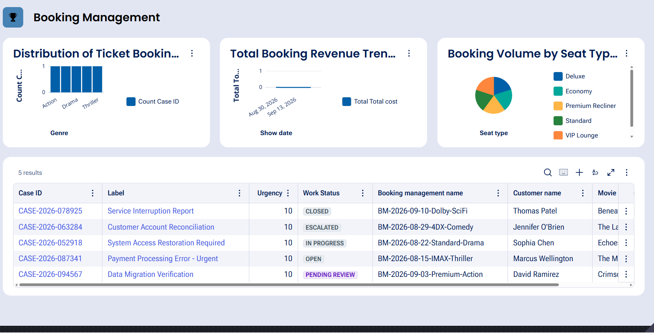

What I built for this (1–2 lines in your own words):
Configured the booking execution flow to evaluate show type, assign seats, generate a Ticket ID, and update booking status.

US-008 — Notify Booking Confirmation
What is expected:
Correspondence rule triggered on case resolution. Email includes movie, show, seat and cost details.
Screenshot — paste your screenshot below this line:
[ Paste screenshot here - follow the screenshot rules above ]
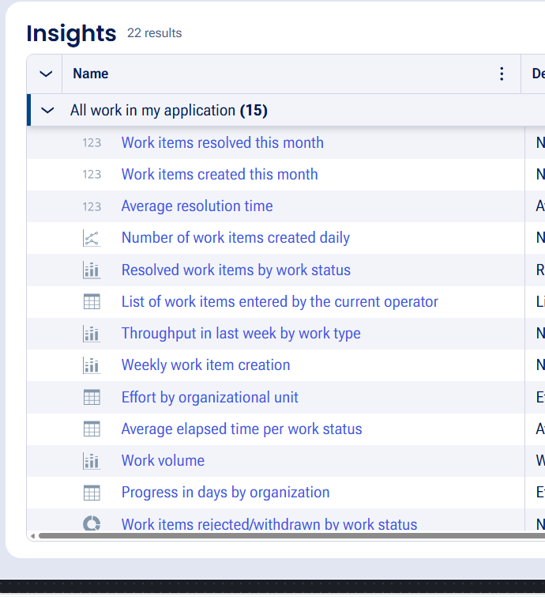

What I built for this (1–2 lines in your own words):
Configured the Resolution stage to send a booking confirmation email after the booking process is completed.

US-009 — Define Booking SLA
What is expected:
SLA configured on the case type. Goal: 1 day. Deadline: 2 days. Priority increases on breach.
Screenshot — paste your screenshot below this line:
[ Paste screenshot here - follow the screenshot rules above ]
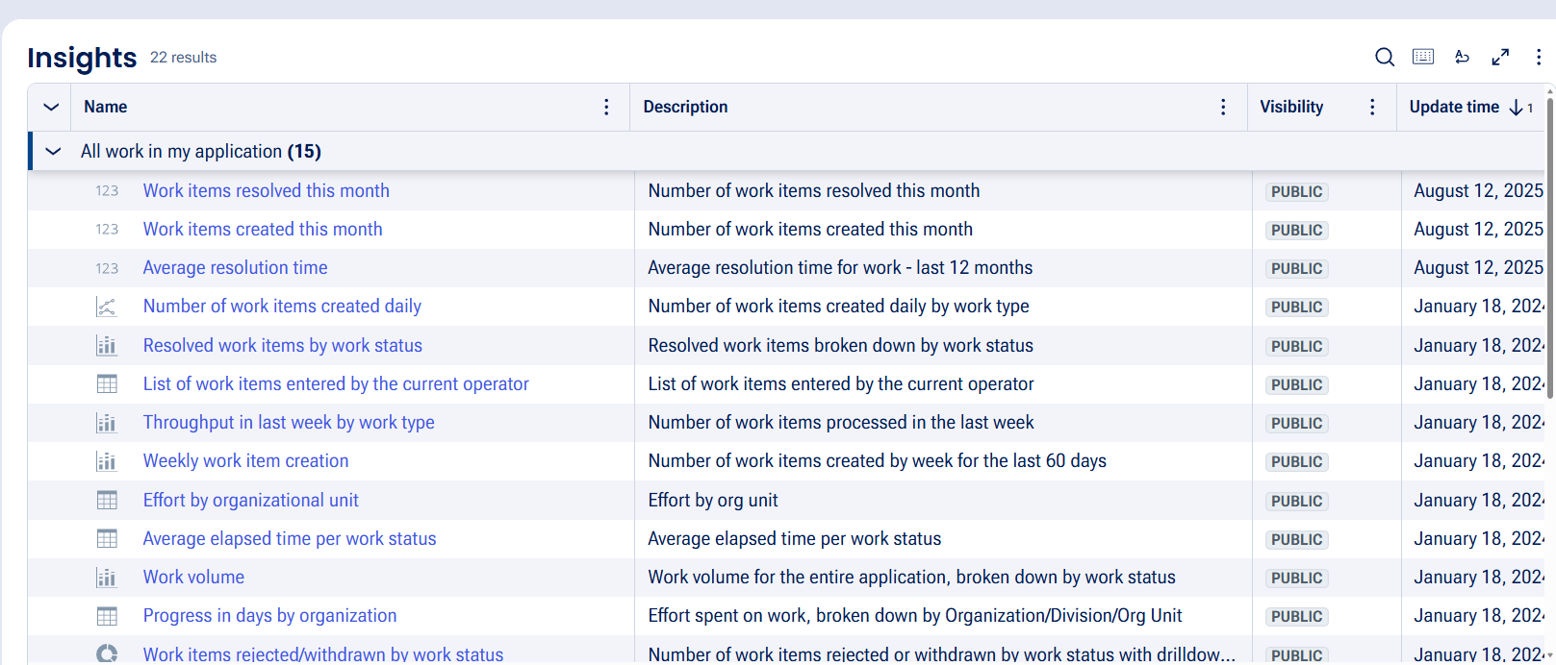

What I built for this (1–2 lines in your own words):
Configured a booking SLA with a 1-day goal and 2-day deadline to track timely completion of requests.

US-010 — Route by Show Type
What is expected:
Routing rule or Decision Table routes to PremiumShowQueue or StandardShowQueue based on Show Type property.
Screenshot — paste your screenshot below this line:
[ Paste screenshot here - follow the screenshot rules above ]
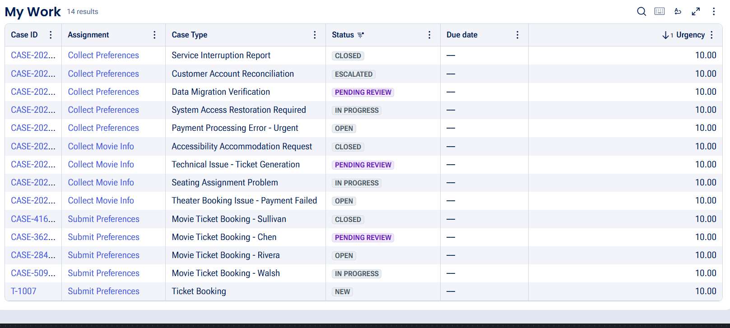

What I built for this (1–2 lines in your own words):
Configured show-type based routing so Premium and Standard bookings can be assigned to their respective queues.

Section 3 — About Your Application
These answers are checked against your screenshots. Write exactly what is in your application.

Q1. List your stages in the order they appear in your case lifecycle.
Stage names in order, separated by commas.
Booking Intake, Availability Check, Customer Approval, Booking Execution, Resolution

Q2. Name the data object(s) you created and the properties inside them.
Data object name and its properties.
Movie/Show data — Movie Name, Genre, Show Date, Show Time, Seat Capacity. Ticket Booking data — Customer Email, Number of Tickets, Ticket Booking Name, Ticket Price, Total Cost, Seat Numbers, Ticket ID, Booking Status.

Q3. What is the exact name and type of the rule you used to calculate Total Cost?
Provide:
• Rule Name
• Rule Type
• Properties used in the calculation
• Formula used
CalculateTotalCost — Declare Expression. Properties used: Ticket Price, Number of Tickets, Total Cost. Formula: Total Cost = Ticket Price × Number of Tickets.

Section 4 — Your Understanding
Short, honest and specific answers score well.

Q4. What did Blueprint generate for you, and what did you add or change yourself afterwards?
Be specific about what was already there and what you built or modified on top.
Blueprint generated the basic movie ticket booking case flow, stages, and initial steps. I configured the booking forms, availability checking, approval, booking execution, ticket details, confirmation, SLA, and routing based on the requirements.

Q5. Was there anything Blueprint created that you had to correct or configure further? Describe one example.
A real example from your own work.
Yes. Some generated workflow steps were not fully configured for execution. I reviewed the stages and configured the required steps, fields, actions, and routing so the booking flow matched the user stories.

Q6. Explain your case flow from creation to resolution, in order.
What happens first, who does what, when the case closes.
The customer submits movie and show preferences in Booking Intake. Availability is checked and pricing is calculated, then the booking summary is presented for customer approval. After confirmation, seats are assigned, a Ticket ID and booking status are updated, and the confirmation is sent before the case is resolved

Q7. Pick two design choices you made in your application and explain why you made them.
For each design choice, provide:
• What you implemented
• Why you chose that approach
• What benefit it provides to the application
- I separated availability checking from customer approval so the customer only confirms a booking after availability and pricing are reviewed. This makes the process easier to follow.
- I separated booking execution from approval so seat assignment and Ticket ID generation happen only after confirmation. This prevents premature ticket processing.

Q8. What was the hardest part, and how exactly did you fix it?
Specific and honest. A real challenge scores much better than a generic answer.
The hardest part was getting the generated workflow steps to execute correctly. I reviewed the lifecycle and step configuration, corrected the workflow configuration, and used the available Pega screens to verify the booking stages and actions.

Q9. If the approval step was only needed when Total Cost is above a certain amount, what would you change in your application?
Explain what you would change and where. You do not need to build this.
I would add a condition to the approval step based on Total Cost. If Total Cost is above the specified amount, the case would go to Customer Approval; otherwise, it would continue directly to Booking Execution

Q10. List three exact rule names from your application that you personally created or modified.
Include the rule name and rule type for each one (for example: CalculateTotalCost - Declare Expression).
CalculateTotalCost – Declare Expression
ValidateBookingInputs – Validate Rule
AssignBookingSeats – Decision Table

Q11. List all personas used in your application.
List the persona names exactly as they appear in your application.
Customer, Booking Agent, Theater Manager, Pricing Analyst, System Administrator, Support Specialist, Application Control Agent

Q12. List all work queues used in your application and explain when each one is used.
For each work queue, provide its exact name and the condition or type of work routed to it.
BookingQueue – handles movie ticket booking requests and customer bookings.
PricingQueue – handles pricing-related review and ticket cost calculations.
SupportQueue – handles booking issues, corrections, cancellations, and customer support.

Before You Submit — Check These
Read through once before uploading.
1. Section 1 filled in. Application named as NIP-[Project]-[YourName]. Names match the actual application.
2. New Operator created in Pega with my full name. I logged in as that operator for all screenshots.
3. Only my chosen project section remains — the other project section is deleted.
4. All 10 user story screenshots are pasted and follow the operator, running-case, application, and rule-name evidence requirements.
5. Every question in Sections 3 and 4, including Q10, Q11, and Q12, is answered in my own words.
6. This file is named using the required format: ProjectName_FirstName_LastName.docx (for example, VehicleService_Ravi_Kumar.docx or MovieTicket_Ravi_Kumar.docx) and uploaded as required.

