**A Project Report**

*on*

**Lane Detection Using Image Processing**

*carried out as part of the* ***Minor Project IT3270*** *Submitted*

by

**Hrituparna Pathak**

**219302419**

*in partial fulfilment for the award of the degree* *of*

**Bachelor of Technology**

in

**Information Technology**

Under the Guidance of

**Guide Name**



**School of Information, Security and Data Science**

**Department of Information Technology**

**MANIPAL UNIVERSITY JAIPUR**

**RAJASTHAN, INDIA**

**May 2024**

**CERTIFICATE**

Date: 15th May 2024

This is to certify that the minor project titled Lane Detection Using Image Processing is a record of the bonafide work done by **Hrituparna Pathak** (219302419) submitted in partial fulfilment of the requirements for the award of the Degree of Bachelor of Technology in Information Technologyof Manipal University Jaipur, during the academic year 2023-24.

**Dr. Pratistha Mathur**

*Professor*

*Project Guide, Department of Information Technology*

*Manipal University Jaipur*

**Dr. Pankaj Vyas**

*HoD, Department of Information Technology*

*Manipal University Jaipur*

**ABSTRACT**

Many technical improvements have recently been made in the field of road safety, as accidents have been increasing at an alarming rate, and one of the major causes of such accidents is a driver's lack of attention. To lower the incidence of accidents and keep safe, technological breakthroughs should be made. One method is to use Lane Detection Systems, which function by recognizing lane borders on the road and alerting the driver if he switches to an incorrect lane marking.

A lane detection system is an important part of many technologically advanced transportation systems. Although it is a difficult goal to fulfil because to the varying road conditions that a person encounters, particularly while driving at night or in daytime. A camera positioned on the front of the car catches the view of the road and detects lane boundaries. The method utilized in this research divides the video image into a series of sub-images and generates image-features for each of them, which are then used to recognize the lanes on the road. Several methods for detecting lane markings on the road have been presented.

**LIST OF FIGURES**

|  |  |  |
| --- | --- | --- |
| **Figure No** | **Figure Title** | **Page No** |
|  |  |  |
| 1 | Flowchart | 4 |
| 2 | HSL Converted Image | 7 |
| 3 | Canny Edge Detection | 8 |
| 4 | Region Of Interest | 8 |
| 5 | Hough Transformation and Line Detection | 9 |
| 6 | Output Image | 10 |

1. **Introduction**
   * 1. Introduction

Automobiles have become one of the transportation tools for people to travel due to the rapid development of society. There are an increasing number of vehicles of various types on the narrow road. Lane detection is a prominent topic in the field of machine learning and computer vision and it has been utilized in intelligent vehicle systems. It is an emerging field and finds its applications in the commercial world. The lane detection system comes from the lane markers in an intricate environment and is used to approximate the vehicle’s position and trajectory relative to the lane reliably. At the same time, lane detection plays a substantial part in the lane departure warning system. The task of lane detection is mainly split into two parts: edge detection and line detection. Line detection is equally important as edge detection in the process of lane detection.

With the drastic increase of urban traffic, safety of traffics has become more mandatory. Breaking the lane causes about more than 30% of accidents on highways, and these are due to inattention or fatigued driver. Thus, a system that provides an alert message to drivers if any danger having great potential to save lives. Advanced driver assistance systems are technologies that are designed to aid drivers while driving a car (ADAS). Many systems such as adaptive cruise control, collision avoidance system, night vision, blind spot detection and traffic sign detection are a part of ADAS . Lane departure system is also a part of this category. The system’s goal is to identify the lane marks and notify the driver if the vehicle tends to leave or change the lane. Lane detection is the process to detect lane markers on road and then present these locations to an advanced system. In intelligent transportation systems , intelligent vehicles cooperate with smart infrastructure to achieve a safer environment and better traffic conditions. The applications of a lane detecting system could be as simple as pointing out lane locations to the driver on an external display, to more complex tasks such as predicting a lane change in the instant future to avoid collisions with other vehicles. Other interfaces included that can detect lanes are cameras, laser range images, LIDAR and GPS devices.

* + 1. **Problem Statement**

Traffic safety is becoming increasingly crucial as urban traffic grows. People exiting lanes without respecting the laws cause the majority of accidents on the avenues. The majority of these are the outcome of the driver's interrupted and sluggish behavior. Lane discipline is essential for both drivers and pedestrians on the road. Computer vision is a form of technology that enables automobiles to comprehend their environment. It's an artificial intelligence branch that helps software to understand picture and video input. The system's goal is to find the lane markings. Its goal is to provide a safer environment and better traffic conditions. The functionality of the proposed system can range from displaying road line positions to the bot on any outside display to more advanced applications like recognizing lane switching in the near future to reduce concussions caused on roadways.

* + 1. **Objectives**

In lane recognition and departure warning systems, accurate detection of lane roads is crucial. When a vehicle breaches a lane boundary, vehicles equipped with the predicting lane borders system direct the vehicles to avoid crashes and issue an alarm. These intelligent systems always provide safe travel, but it is not always necessary that lane boundaries are clearly visible, as poor road conditions, insufficient quantity of paint used for marking the lane boundaries, and other factors can make it difficult for the system to detect the lanes accurately. Other factors can include environmental effects such as shadows cast by objects such as trees or other automobiles, or street lights, day and night time conditions, or fog caused by invariant lightening conditions. These factors cause problem to distinguish a road lane in the backdrop of a captured image for a person.

In order to address the issues raised above as a result of lane boundary adjustments. The algorithm used in this work aims to recognize lane markings on the road by feeding the system a video of the road as an input using computer vision technology, with the primary goal of lowering the number of accidents. Accidents caused by irresponsible driving on the roads can be avoided with the installation of a system in automobiles and taxis. It will ensure the safety of the children on school buses. Furthermore, the driver's performance may be tracked, and Road Transportation Offices can use the system to monitor and report driver irresponsibility and lack of attention on the roadways.

* + 1. **Scope of Project**

This project will include the development and implementation of algorithms for accurately detecting lane markers under various driving conditions. Key areas of focus will be image preprocessing techniques such as noise reduction and image enhancement to improve input quality, and edge detection methods like the Canny edge detector to identify lane boundaries. The project will employ the Hough Transform for line detection and polynomial fitting for curved lanes. The scope will also extend to advanced methods, potentially incorporating machine learning and deep learning models to enhance detection robustness and adaptability across diverse environments.

* 1. **Background Detail** 
     1. Conceptual Overview / Literature Review

The Canny Edge Detection: The Canny filter is a multi-stage edge detector. It uses a filter based on the derivative of a Gaussian in order to compute the intensity of the gradients. The Gaussian reduces the effect of noise present in the image. Then, potential edges are thinned down to 1-pixel curves by removing non-maximum pixels of the gradient magnitude. Finally, edge pixels are kept or removed using hysteresis thresholding on the gradient magnitude.

The Canny has three adjustable parameters: the width of the Gaussian (the noisier the image, the greater the width), and the low and high threshold for the hysteresis thresholding.

Gaussian Blur: A grayscale image's pixels are each defined by a single number that indicates the pixel's brightness. The common solution for smoothing an image is to change the value of a pixel with the average value of the pixel intensities around it. A kernel will average out the pixels in order to reduce noise.

Edge Detection: An edge is a region in a picture where the intensity/color between neighboring pixels in the image changes dramatically. A steep change is a significant gradient, while a shallow change is the opposite. In this sense, an image may be thought of as a matrix with rows and columns of intensities. This means that a picture can also be represented in 2D coordinate space, with the x axis traversing the width (columns) and the y axis traversing the image height (rows). The Canny function measures the change in brightness between neighboring pixels by performing a derivative on the x and y axes. In other words, we're calculating the gradient (or brightness change) in all directions. It then traces the strongest gradients with a series of white pixels.

Hough Transform: Hough Transform is a computer vision technique to detect shapes like lines and circles in an image. It converts these shapes into mathematical representations in a parameter space, making it easier to identify them even if they’re broken or obscured. This method is valuable for image analysis, pattern recognition, and object detection.

* 1. **System Design & Methodology**
     1. System Architecture

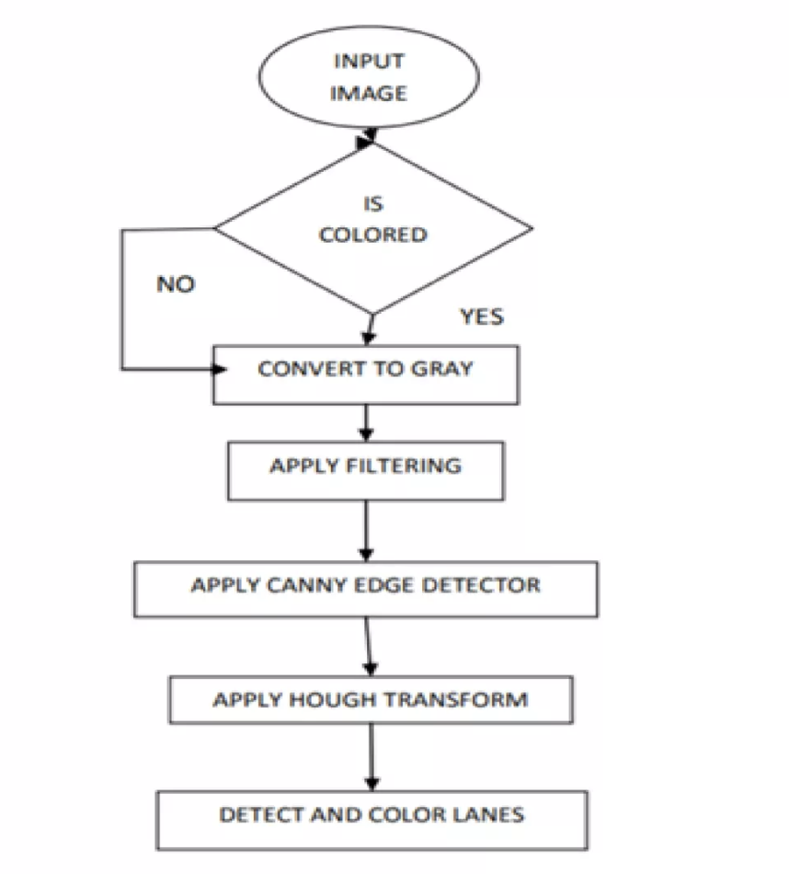

Figure 1 – Flowchart

* + 1. Development Environment

Hardware:

* Camera: A high-resolution camera mounted on the vehicle to capture real-time video frames of the road.
* Storage: Adequate storage capacity to save captured frames and processing results.

Software:

* Operating System: An operating system that supports the required development tools and libraries.
* Programming Language: Python is commonly used for its extensive libraries and ease of use in image processing tasks.
* Image Processing Libraries: OpenCV, NumPy, for implementing image processing algorithms.

Development Environment:

* Integrated Development Environment (IDE): An IDE like PyCharm, Visual Studio Code, or Jupyter Notebooks for writing and testing code.
* Datasets: Pre-collected datasets for training and testing the lane detection model. Common datasets include TuSimple, CULane, or self-collected datasets.

Additional Tools:

* Annotation Tools: Tools for annotating lane markings in the training dataset.
* Visualization Tools: Tools to visualize the results of lane detection, such as Matplotlib or custom dashboards.

3.3. Methodology

* + - Convert original image to grayscale.
    - Darkened the grayscale image (this helps in reducing contrast from discolored regions of road)
    - Convert original image to HLS color space.
    - To make yellow mask, isolate yellow from HLS. (For yellow lane markings)
    - Isolate white from HLS to get white mask. (For white lane markings)
    - Bitwise OR yellow and white masks to get common mask.
    - Bitwise AND mask with darkened image.
    - Apply slight Gaussian Blur.
    - Apply canny Edge Detector (adjust the thresholds trial and error) to get edges.
    - Define Region of Interest. This helps in weeding out unwanted edges detected by canny edge detector.
    - Retrieve Hough lines.
    - Consolidate and extrapolate the Hough lines and draw them on original image.

* 1. **Implementation and Result**

4.1. Implementation Detail

Color Selection:

To acquire the mask between the threshold and hold value, we utilize OpenCV's inRange function. We can determine the threshold range after some trial and error.

For yellow mask:

* + - Hue value was used between 10 and 40.
    - We use higher saturation value (100–255) to avoid yellow from hills.

For white mask:

* We use higher lightness value (200–255) for white mask.

We bit-wise OR both masks to get combined mask.

Convert original image to HLS color space:

The original image is RGB, but we should also look at other color spaces such as HSV and HLS. If we look at them side by side, it's easy to see that in the HLS color space, we can get better color contrast from the streets. This may help in better color selection and in turn lane detection.

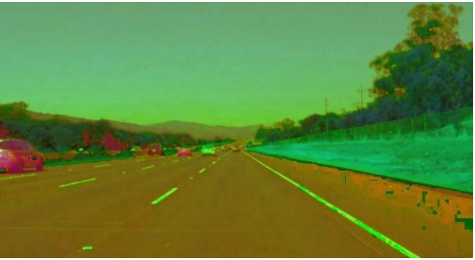

Figure 2- HSL Converted Image

Canny Edge Detection:

Now we apply Canny Edge Detection. The algorithm Canny Edge Detection recognizes edges based on gradient change. Even though picture smoothing with default kernel size 5 is the first stage of Canny Edge detection, we still use explicit Gaussian blur in the prior phase. The other steps in Canny Edge detection include:

* Finding Intensity Gradient of the Image
* Non-maximum Suppression
* Hysteresis Thresholding

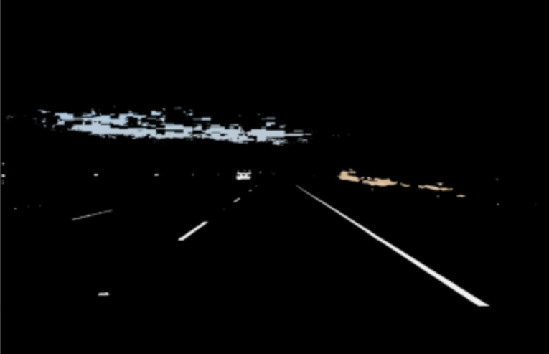

Figure 3 – Canny Edge Detection

Select Region of Interest:

Many non-lane edges are detected even after applying canny edge detection. Regions of interest are polygons that define the regions in the image that the edges are interested in. Note that the image's co-ordinate origin is in the top-left corner, with rows increasing top-down and columns increasing left-right. The assumption is that the camera will remain in the same position and that the lanes will be flat, allowing us to "guess" the region of interest.

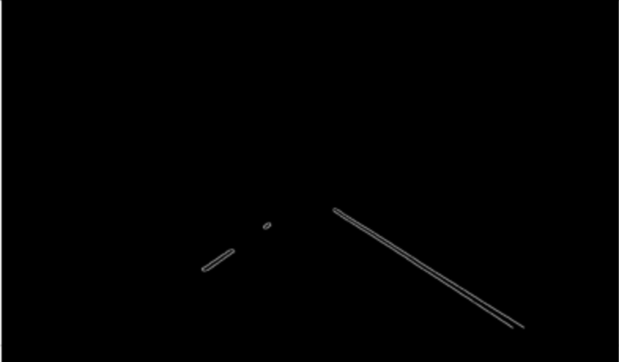

Figure 4 – Selecting Region Of Interest.

Hough Transformation Line Detection:

The Hough transform is a technique for finding a line by identifying every point on the line. This is done by representing the line as a point. Points are also represented as lines / signs (depending on the Cartesian / polar system). If multiple lines sinewaves pass through a point, we can conclude that these points are on the same line.

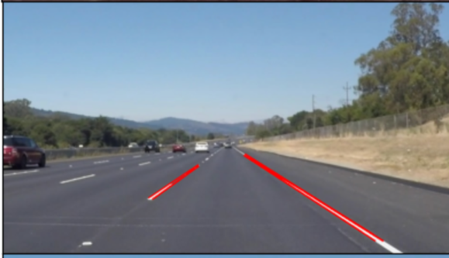

Figure 5 - Hough Transformation and Line Detection

4.3 Results and Discussion

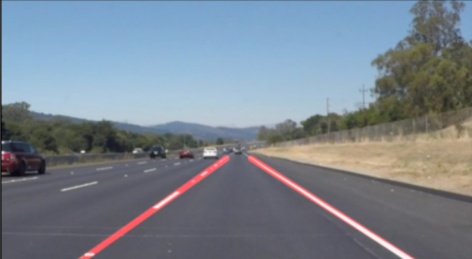

Figure 6 – Result Output

Here, Figure 6 shows the output as a lane detected image on our test images.

Applications:

It can be used for lane detection in a driverless car that isn’t fully automated so that it can assist the driver.

Advantages:

* + - It assists vehicular drivers as well as autonomous cars to drive safely.
    - This does not involve complex and advanced machine learning, deep learning, or neural networks. Rather, relies on easy-to-understand and simple image processing and computer vision techniques.
    - It has minimal cost of development as it uses open-source technologies such as Python, Jupyter and OpenCV.

Disadvantages:

* + - Uniformity of the markings present on the lanes is an important factor to minimize confusion and uncertainty. Our model needs lanes where there are uniform and visible markings.
    - The methods that have been developed so far work efficiently and give good results in cases where noise is not present in the image. But the problem arises when lot of noise is in the road images, as it does not give efficient results.
  1. **Conclusion and Future Plan**

Lane recognition technology plays an important role in intelligent transportation systems. In this paper, we considered how to detect lanes. Most of them resulted in inaccurate results. Therefore, further improvements can be done to enhance the results. Soon, one can modify the existing Hough Transformation so that it can measure both the curved and straight roads. Various steps should be taken to improve the results in different environmental conditions like sunny day, foggy day, rainy day etc. The proposed system and system implementation give the detailed implementation which will result in high accuracy while tackling the limitations of the other systems discussed in the literature survey. The lane detection shall have proved to be an efficient technique to prevent accidents using Intelligent Transportation Systems. Our algorithm will increase the detection accuracy of the system. From the results of the experiment, our method gets lane change and warning goals. It is expected that the proposed algorithm shall detect more than 98% details in the image with good condition, and over 96% details in less-than-ideal weather conditions. A database can be used to store the record of already visited potholes, blockages on the road which may have been visited in the past while passing through the same route. And aim to reduce the number of accidents caused on the roads and also to improve the seriousness of such accidents.

**References**

1. Jianfeng Zhao, Bodong Liang, and Qiuxia Chen, "The key technology toward the self-driving car.", International Journal of Intelligent Unmanned Systems, Vol. 6, No. 1 (2018).
2. Mohamed Aly, “Real Time Detection of Lane Markers in Urban Streets.”, IEEE Intelligent Vehicles Symposium, Eindhoven University of Technology, Eindhoven, The Netherlands (2008).
3. https://docs.opencv.org/4.x/
4. Hongwei Guo, “A Simple Algorithm for fitting a gaussian Function,” IEEE Signal Processing Magazine, September 2011.
5. Y. Wang, E. K. Teoha, and D. Shen., “Lane detection and tracking using B-Snake.”, Image and Vision Computing 22, pp: 269-28 (2004).
6. https://www.cse.unr.edu/~bebis/CS791E/Notes/AreaP rocess.pdf
7. Raman Shukla et al., “Lane Detection System in Python using OpenCV,” IJIRT, Volume 8 Issue 1, June 2021.
8. F. Mariut, C. Fosalau and D. Petrisor, “Lane Mark Detection Using Hough Transform.", IEEE International Conference and Exposition on Electrical and Power Engineering, pp. 871 – 875 (2012).
9. K. Ghazali, R. Xiao, and J. Ma, “Road Lane Detection Using H-Maxima and Improved Hough Transform.”, Fourth International Conference on Computational Intelligence, Modelling and Simulation, pp. 2166-8531 (2012).