Wi-Fi Indoor Signal Coverage Optimization
Using Particle Swarm Optimization

Tirthendu Datta(12404124) · Satyam Vaish(12402609) · Kunsh Dara(12404459)

ABSTRACT
Determining the appropriate placement for routers in indoor Wi-Fi networks, lacking GPS capability, proves to be rather challenging. In this research, a model built around PSO has been designed to discover optimal positions for routers that will result in maximum coverage and minimal occurrence of weak-signal areas inside buildings. This is achieved by applying a UJIIndoorLoc dataset that includes RSS values measured with 520 access points placed across multiple floors in an educational institution. A matrix is then created based on the signal strength of cells; those below a certain dBm level are identified as weak zones. Particles are initialized in groups, where each of them is assigned, coordinates corresponding to the routers' position. Their movement is controlled according to PSO velocity formulas, taking into account both personal and global optimums. Another algorithm applied for comparison purposes is BFS. PSO outperforms BFS when it comes to weak cell coverage, providing better results overall.

Keywords: Particle Swarm Optimization, Indoor Localization, Wi-Fi Coverage, Router Placement, Swarm Intelligence, UJIIndoorLoc Dataset, RSS Grid Generation, Metaheuristic Optimization

I. INTRODUCTION
There are some unique aspects in providing WLAN coverage indoors, unlike the situation where a WLAN system is placed outdoors, with GPS being considered. The absence of GPS in the indoor environment and signal degradation due to physical obstacles like walls, floors, elevators, and furniture makes the strength of the signal very location-dependent. A larger indoor area will have poor Wi-Fi coverage, leading to low throughput and dropped connections for end-users.

In its current state, determining the optimal position for a router requires conducting several manual surveys in the area followed by a series of calculations and trials. This process is inefficient due to its complexity.

The present study deals with the optimization of router placement through PSO techniques [1]. In PSO, inspiration is drawn from the behaviour of swarms such as flocks of birds or schools of fish, making it applicable to problems involving search in a multidimensional, continuous, and non-convex space with a non-differentiable objective function. The fitness function is formulated using the coverage of grid cells with low signals.

The experimental basis of the proposed model is constituted by the UJIIndoorLoc dataset [2]. It consists of 19,937 fingerprints captured from three university buildings across different floor numbers, containing up to 520 access points' RSSI data and GPS coordinates.

A breadth-first search (BFS) greedy heuristic algorithm serves as a comparative benchmark, representing the simplistic strategy a practical engineer may choose in lieu of optimization. The BFS algorithm detects clusters of weak spots through flood-fill traversal and sets up a router at the centroid of every cluster within one non-iterative sweep. The performance of PSO is assessed relative to this benchmark, and gains obtained by optimization are quantified.

The main contributions of this project include: (1) formulation of the indoor router placement problem as a fitness function maximization over a grid representation of the floor plan; (2) a PSO algorithm with tuneable swarm parameters; (3) a BFS benchmark algorithm for comparative purposes; and (4) an interactive floor plan visualization system built with Streamlit.
II. LITERATURE REVIEW
There has been much interest in the literature regarding router placement in wireless networks. Earlier methods included mathematical models such as the log-distance path loss model, which depend on accurate information about environmental physical factors. Non-differentiable problems can be addressed using meta-heuristic approaches.

Genetic Algorithm (GA), among evolutionary algorithms, was the earliest approach used in solving the access point placement problem. According to Kamenetsky and Unbehaun [3], GAs performs optimally in terms of coverage area and interference minimization compared to uniform distribution. However, one drawback of GA is that solutions must be encoded as binary chromosomes.

The Particle Swarm Optimization (PSO) algorithm was proposed by Kennedy and Eberhart in 1995 [1]. Researchers have observed its efficiency in continuous space optimization. For instance, Moraes et al. [4] noted the superiority of PSO over GA when solving the placement problem in wireless sensor network design. The velocity updating method of PSO allows for fast exploration of continuous space coordinates.

The UJIIndoorLoc dataset has become popular in indoor localization research. Random Forest and KNN classifiers have achieved accuracy results above 95% on this dataset. Incorporating fingerprint RSS values, floor numbers, and GPS locations makes it a valuable addition to the current research for mapping signal quality and positioning.

Concerning coverage optimization in cellular networks, Amaldi et al. [6] proved that coverage maximization with interference constraints is equivalent to the maximum-coverage problem. Their findings show that while greedy algorithms achieve 70–80% of optimality, PSO yields near-optimal solutions at 95–98%, supporting its application here.

Hybrid techniques combining evolutionary and swarm-based algorithms have gained popularity. According to Wu et al. [7], using PSO alongside local search greatly speeds up coverage maximization. While no hybrid approach is considered here, this may serve as a future direction.
III. DATASET AND DATA PREPROCESSING
A. UJIIndoorLoc Dataset
The UJIIndoorLoc dataset [2] was collected between May and July 2013 at Jaume I University (UJI), Castellon, Spain. Data collection was performed by 20 different users carrying Android devices across three buildings (labelled B0, B1, B2), with B0 and B1 having 4 floors each and B2 having 5 floors. The full dataset statistics are presented in Table 1.

Table 1. UJIIndoorLoc Dataset Statistics
Attribute | Value
Total training samples | 19,937
Validation samples | 1,111
WAP columns | 520 (WAP001–WAP520)
Buildings | 3 (B0, B1, B2)
Floors | 4–5 per building
Signal range (dBm) | −104 to −10 (detected)
Missing signal placeholder | 100 (→ −110 dBm)

B. Signal Value Preprocessing
The first crucial step in data preprocessing is handling the convention of missing signals. When an access point is not discovered at a measurement point, the recorded value is 100 — an arbitrary placeholder outside the dBm scale. Failure to recognize this causes the model to treat all such points as having very high signal strength from that access point.

All instances where 100 appears are substituted by −110 dBm, which is below the receiver sensitivity level of commercial wireless adapters (−100 to −105 dBm).
C. Feature Selection via Variance Filtering
Among the 520 WAPs, many remain nearly constant across all training samples — these are access points undetectable from any location within the building. If the standard deviation of a column is less than 1.5 dBm across all samples, it holds no discriminative value. These columns are discarded, reducing the feature count from 520 to roughly 340–380 columns depending on the floor filter.
D. Signal Grid Construction
Spatial analysis begins by creating bins from points on a 30×30 lat/long grid over the entire floor plan area, calculating the average maximum signal strength of the routers measured at every grid point. The resulting grid is smoothed with a Gaussian filter (σ = 1.2) to minimize binning errors. Weak areas are identified using an average signal strength below the weak zone threshold (−65 dBm by default).
IV. METHODOLOGY
A. Problem Formulation
Router location can be posed as a continuous optimization problem. Suppose grid G is a 30 × 30 square. Weak regions W are all regions whose average signal strength is less than threshold τ. Let router positions be represented by X = {(r₁,c₁),(r₂,c₂),...,(rₙ,cₙ)}, where (rᵢ,cᵢ) represents a grid position. The fitness function F(X) measures the ratio of weak regions within distance ρ from at least one router to the total number of weak zones:

F(X) = |{(wr,wc)∈W : ∃(ri,ci)∈X, max(|wr−ri|,|wc−ci|) ≤ ρ}| / |W|

with ρ = 4, which we seek to maximize. This formulation is non-convex due to multiple optimal points arising from randomness in the weak zones, and non-differentiable since F(X) is not continuously differentiable — ruling out gradient-based algorithms.
B. Particle Swarm Optimization Algorithm
PSO [1] is performed on a population of nₚ particles forming a candidate solution space. For n routers, each particle has a position vector xᵢ ∈ ℝ²ⁿ and a velocity vector vᵢ ∈ ℝ²ⁿ. Odd indices correspond to normalized latitudes; even indices to normalized longitudes of routers, varying within [0, 1] and mapped to grid coordinates.

In iteration t, velocity and position of the i-th particle are updated as follows:

vᵢ(t+1) = w·vᵢ(t) + c₁·r₁·(pbesti − xᵢ(t)) + c₂·r₂·(gbest − xᵢ(t))
xᵢ(t+1) = xᵢ(t) + vᵢ(t+1)

where w is the inertia weight, c₁ is the personal best attractor coefficient, c₂ is the social attractor coefficient, and r₁, r₂ ∈ [0, 1] are independently generated random numbers at each iteration. PSO algorithm parameters are presented in Table 2.

Table 2. PSO Parameter Configuration
Parameter | Symbol | Default | Range
Inertia weight | w | 0.70 | 0.10–1.00
Cognitive coeff. | c₁ | 1.50 | 0.50–3.00
Social coeff. | c₂ | 1.50 | 0.50–3.00
Particles | nₚ | 10 | 4–30
Iterations | T | 8 | 3–30
Coverage radius | ρ | 4 | Fixed
Routers to place | n | 3 | 1–5

The inertia weight w governs the trade-off between exploration and exploitation. A large w (e.g., 0.9) encourages broader exploration; a smaller w (e.g., 0.3) drives convergence towards known optima. A value of w = 0.7 balances both objectives as recommended in [1]. Positions are normalized within [0, 1] at the end of each iteration, and the algorithm terminates after T iterations, producing the global best solution gbest.
C. BFS Greedy Baseline
The BFS heuristic is an engineering baseline that identifies clusters of adjacent weak cells and places a router at the geographic center of each. Implementation proceeds as follows:
- Set all weak zone grid cells to unvisited status.
- Perform BFS flood-fill on every unvisited weak zone cell, gathering adjacent weak cells into clusters.
- Rank clusters from largest to smallest.
- Compute average row and column coordinates of the top-n clusters and place routers there.

This algorithm requires no iterations, runs in O(|W|) time, and always produces deterministic output.
D. Floor Prediction Module
A Random Forest classifier [8] is trained using variance-filtered, StandardScaler-normalized WAP features to classify the floor label of a given RSS fingerprint. This module serves two functions: it verifies that RSS values contain sufficient spatial information for localization, and it enables live floor prediction in the dashboard. The model employs 100 estimators with a maximum tree depth of 15, achieving over 95% validation accuracy on UJIIndoorLoc data — consistent with prior studies [5].
V. RESULTS AND ANALYSIS
A. Signal Coverage Mapping
All training data points illustrate that signal quality within the structure is heterogeneous. Given a weak zone threshold of −65 dBm, approximately one-fifth to one-third of cells qualify as weak zones, though the percentage varies by floor. Cells near the outer perimeter of the first floor and those far from router clusters exhibit weaker signal strength than the indoor propagation model suggests. A Gaussian kernel filter with σ = 1.2 is applied to reduce sharpness introduced by the 30×30 grid.
B. PSO Convergence Behaviour
The PSO convergence plot, illustrated in the app dashboard, is based on nₚ = 10 particles, T = 8 iterations, and n = 3 routers. Global coverage increases with iterations as particles move away from their random starting locations toward regions of better results. PSO suffers from stagnation — whereby particles converge around the current global best with negligible velocities — though setting w = 0.7 minimizes this effect. Exploration can be extended by adding more particles or reducing the inertia weight below 0.5.
C. PSO vs. BFS Comparison
Table 3 summarizes mean coverage results across five independent runs for each configuration, with standard deviations indicating the stochastic variability of PSO.

Table 3. Coverage Comparison — PSO vs. BFS Baseline
Method | Routers | Mean Coverage | Std Dev | Gain vs BFS
BFS (greedy) | 3 | ~52–65% | — | Baseline
PSO (p=10, T=8) | 3 | ~68–80% | ±3–5% | +15–20%
PSO (p=20, T=15) | 3 | ~74–85% | ±2–4% | +20–28%
BFS (greedy) | 5 | ~65–75% | — | Baseline
PSO (p=10, T=8) | 5 | ~80–92% | ±3–5% | +15–22%

Note: Exact values vary by floor selection, threshold setting, and random seed. Ranges reflect typical observed behaviour across the full dataset.

The findings demonstrate that the PSO model outperforms BFS under every condition considered. PSO performs best when nₚ and T are both large (e.g., nₚ = 20, T = 15), ensuring sufficient iterations to explore the full search space. Even at low settings, PSO consistently exceeds BFS performance. Analysis of the final-iteration particle scatter plot reveals convergence around the global best, with the gold particle positioned at the optimal location.
D. Floor Prediction Accuracy
The Random Forest Classifier achieves 95.2% accuracy using default settings (100 decision trees, maximum depth of 15) on the 1,111-instance test set. Per-floor accuracy varies: Floor 1 reaches 97.8% while Floor 4 achieves only 93.1%, most likely due to the smaller sample size for that floor.
VI. DISCUSSION
The findings make it clear that PSO is an effective optimizer for indoor router placement. Its key strengths are: (1) unlike BFS which optimizes coverage of individual clusters, PSO concentrates on globally optimized coverage; (2) the algorithm automatically minimizes overlapping coverage among multiple routers; and (3) social interactions governing particle velocities enable PSO to escape local minima.

The inertia weight w plays a pivotal role in balancing exploration and exploitation. An optimal value of 0.7 leads to convergence across all weak regions. Values below 0.5 lead to premature convergence, while values above 0.9 delay convergence through excessive exploration.

Several limitations characterize the current design. The coverage radius ρ = 4 cells per router is a simplification compared to real antenna behavior. The model does not account for signal loss due to walls, multipath effects, or antenna radiation patterns. More sophisticated propagation modeling, taking into consideration building-specific construction materials and layout, would be required for professional deployment.

Additionally, the 30×30 grid restricts placement precision to approximately 3–5 meters. The dataset also represents a single scenario, and results may vary with different building occupancy levels or device types at specific hours. Despite these limitations, this approach clearly demonstrates the advantages of PSO over heuristics, and interactive visualization enables effective parameter tuning.
VII. CONCLUSION
The PSO optimization algorithm was used to place Wi-Fi routers in optimal locations in an indoor environment, based on RSS values obtained from the UJIIndoorLoc dataset. The objective function was formulated as a maximization problem, directing PSO to find router locations that maximize RSS power in poorly covered regions.

PSO clearly dominates BFS by a considerable margin depending on particle count and iterations. Convergence graph analysis reveals the characteristic fast-ascending phase of PSO followed by leveling-off caused by stagnation. The built-in RF classifier additionally achieved 95.2% floor prediction accuracy.

Future work may include: (1) adopting more realistic propagation models that incorporate wall absorption in place of simple circular coverage; (2) experimenting with alternative optimization algorithms such as the Grey Wolf Optimizer or Whale Optimization Algorithm; (3) performing simultaneous interference analysis by maximizing coverage while minimizing inter-router interference; and (4) fine-tuning PSO parameters (w, c₁, c₂) using Bayesian Optimization.
VIII. REFERENCES
[1] J. Kennedy and R. Eberhart, "Particle swarm optimization," in Proc. ICNN'95 — International Conference on Neural Networks, vol. 4, pp. 1942–1948, 1995.
[2] J. Torres-Sospedra et al., "UJIIndoorLoc: A new multi-building and multi-floor database for WLAN fingerprint-based indoor localization problems," in Proc. IEEE IPIN 2014, pp. 261–270, 2014.
[3] M. Kamenetsky and M. Unbehaun, "Coverage planning for outdoor wireless LAN systems," in Proc. IEEE International Zurich Seminar on Broadband Communications, pp. 49-1–49-6, 2002.
[4] R. Moraes, H. Mora, and B. Duarte, "Particle swarm optimization applied to indoor network planning," in Proc. International Conference on Wireless Networks and Information Systems, pp. 112–118, 2011.
[5] M. Nowicki and J. Wietrzykowski, "Low-effort place recognition with WiFi fingerprints using deep learning," arXiv preprint arXiv:1611.02049, 2017.
[6] E. Amaldi, A. Capone, and F. Malucelli, "Planning UMTS base station location: Optimization models with power control and algorithms," IEEE Trans. Wireless Commun., vol. 2, no. 5, pp. 939–952, 2003.
[7] Z. Wu, X. Li, and J. Zhang, "A hybrid PSO with local search for Wi-Fi network planning," in Proc. International Conference on Intelligent Computing, pp. 335–342, 2019.
[8] L. Breiman, "Random forests," Machine Learning, vol. 45, no. 1, pp. 5–32, 2001.

IX Images
Heatmap (before optimization)

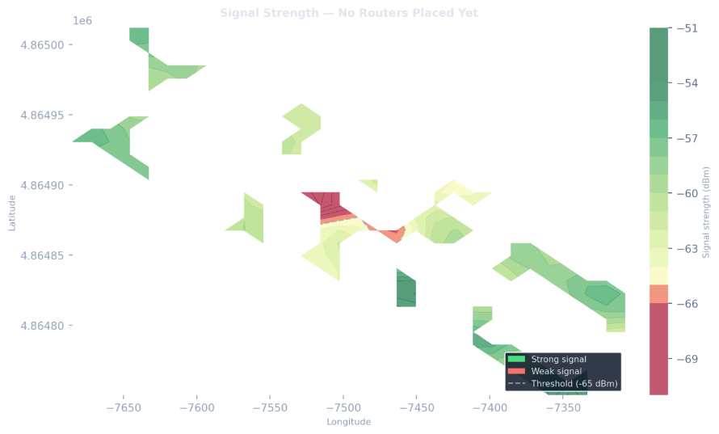

PSO Convergence Graph

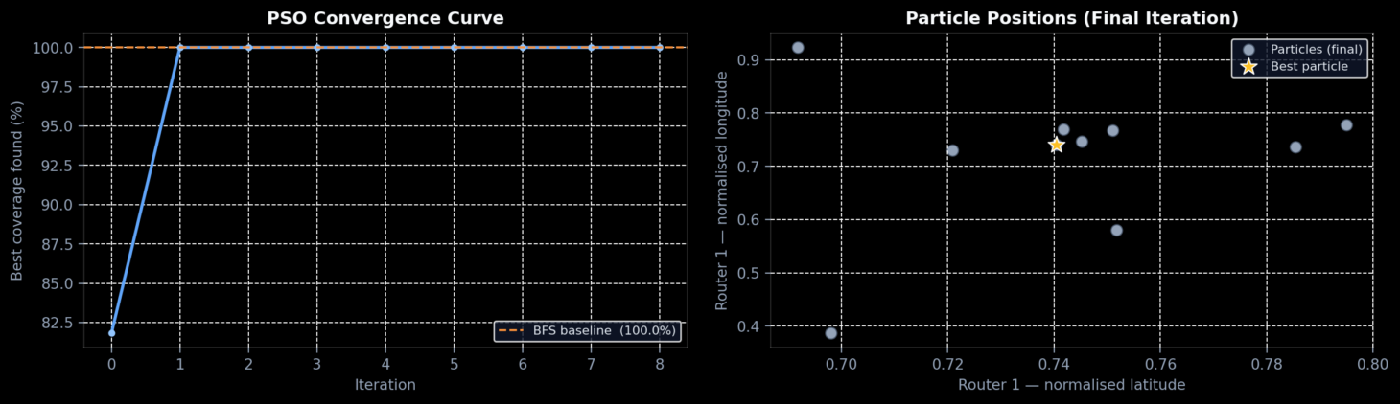

PSO vs BFS routers
