IBM SkillsBuild Cyber Security 2026
Conducted by BharatCares
PROJECT REPORT
Automated Web Scanner
Auditing Websites for Secure Headers and CORS Flaws using Python
Submitted by: Kuntal Mondal
Project No.: 2
Date: October 2026

1. Abstract
Web applications rely on HTTP response headers and Cross-Origin Resource Sharing (CORS) policies to protect users from attacks such as cross-site scripting, clickjacking, protocol downgrade and cross-origin data theft. Misconfiguration of these controls is among the most common and easily preventable weaknesses, and falls under the OWASP category of Security Misconfiguration. This project presents an Automated Web Scanner written in Python that passively audits a website for missing or weak security headers, information leakage, insecure cookie flags and CORS misconfigurations. Each finding is rated by severity, explained, accompanied by a recommended fix, and combined into a 0–100 score with an A–F grade. The tool was validated against a deliberately vulnerable local server (score 0, grade F) and a hardened local server (score 100, grade A), and exports results as JSON, CSV and HTML reports.

2. Introduction
Modern browsers provide many built-in defences, but they only activate when the server tells them to through response headers. A site that omits a Content-Security-Policy gives attackers a wider window for script injection; a site without X-Frame-Options can be framed by a hostile page; and a CORS policy that trusts every origin can allow a malicious website to read a logged-in user's private data. Manually checking each of these controls across many sites is slow and error-prone, so automation is valuable for developers, security teams and auditors.

2.1 Problem Statement
Organisations frequently deploy web applications without verifying that security headers and CORS policies are correctly configured. There is a need for a lightweight, repeatable tool that can detect these issues quickly, explain their impact and suggest remediation.

2.2 Objectives
- Automatically fetch a target URL and inspect its HTTP response headers.
- Verify the presence and quality of eight recommended security headers.
- Detect technology and version leakage and weak cookie attributes.
- Test CORS behaviour using crafted Origin headers and a preflight request.
- Calculate a risk score and grade, and generate shareable reports.
- Provide a safe, offline test lab so the tool can be demonstrated ethically.

3. Technologies and Tools
Tool / Library | Purpose
Python 3 | Core programming language
requests | Sending HTTP GET / OPTIONS requests and reading headers
pandas | Tabular summaries of findings and CSV export
matplotlib | Score visualisation chart
http.server | Built-in local vulnerable and hardened test servers
Jupyter Notebook | Interactive development and submission format

4. Background

4.1 Security Headers
Header | Severity | Protection provided
Strict-Transport-Security | High | Forces HTTPS and prevents SSL-stripping attacks
Content-Security-Policy | High | Restricts content sources; main defence against XSS
X-Frame-Options | Medium | Prevents clickjacking via hostile iframes
X-Content-Type-Options | Medium | Stops MIME-type sniffing
Referrer-Policy | Low | Limits URL information leaked to other sites
Permissions-Policy | Low | Restricts camera, microphone, geolocation, etc.
Cross-Origin-Opener-Policy | Low | Isolates browsing context from other windows
Cross-Origin-Resource-Policy | Low | Prevents other origins from loading resources

4.2 Cross-Origin Resource Sharing (CORS)
The browser's Same-Origin Policy stops a page from reading responses from a different origin. CORS relaxes this rule when the server returns headers such as Access-Control-Allow-Origin (ACAO) and Access-Control-Allow-Credentials (ACAC). Dangerous misconfigurations include reflecting any Origin value, trusting the 'null' origin, using a wildcard together with credentials, and validating origins with weak string matching (for example, accepting any origin that ends with the target's domain name). When such a server also allows credentials, a malicious website can make authenticated requests on behalf of a visitor and read the response.

5. System Design and Methodology

5.1 Workflow
- Step 1 – Fetch: Normalise the URL and send a GET request with a descriptive User-Agent.
- Step 2 – Header audit: Validate each security header (presence and quality), detect leakage, and parse Set-Cookie attributes.
- Step 3 – CORS audit: Send requests with three crafted Origin values (arbitrary, null, suffix-trust bypass) and one OPTIONS preflight, then analyse ACAO, ACAC, Vary and Allow-Methods.
- Step 4 – Scoring: Apply severity penalties to produce the score and grade.
- Step 5 – Reporting: Display tables and a chart, and export JSON, CSV and HTML reports.

5.2 Scoring Model
The score starts at 100 and a penalty is subtracted for every failed check: High = 15, Medium = 8, Low = 3. The final score is limited to a minimum of 0. Grades are assigned as A (90 and above), B (75–89), C (60–74), D (40–59) and F (below 40).

5.3 Safety Design
- Only read-only GET and OPTIONS requests are sent; there is no exploitation, fuzzing or brute-forcing.
- A configurable delay (0.3 s) and timeout (8 s) keep traffic polite.
- The demonstration uses local servers started inside the notebook, so no third-party site is scanned.
- The notebook carries a clear warning to test only authorised systems.

6. Implementation
The code is organised into small, testable functions inside the Jupyter Notebook:
Function | Description
HEADER_RULES | Dictionary of eight header rules, each with severity, explanation, fix and a validator function
audit_headers() | Checks header presence/quality, HTTPS usage and information-leakage headers
audit_cookies() | Parses Set-Cookie and flags missing Secure, HttpOnly and SameSite attributes
audit_cors() | Runs origin-reflection, null-origin and suffix-bypass tests plus preflight analysis
scan_site() | Orchestrates all audits and computes score and grade
start_server() | Launches the vulnerable and hardened demo servers on free local ports
to_html() | Builds the human-readable HTML report

Header validators go beyond presence checks. For example, HSTS is marked weak if max-age is below 180 days, and a Content-Security-Policy is marked weak if it allows 'unsafe-inline', 'unsafe-eval' or wildcard sources. HSTS is skipped for plain-HTTP localhost responses because it only applies to HTTPS.

7. Testing and Results

7.1 Test Environment
Two local servers were used. The vulnerable server omits all security headers, reveals 'Apache/2.4.49' and 'PHP/7.4.3', sets a session cookie without protective flags, reflects any Origin with Allow-Credentials set to true, and answers preflight requests permissively. The hardened server sets all eight security headers, uses a fully protected cookie and returns no CORS headers to untrusted origins.

7.2 Summary of Results
Target | Score | Grade | High | Medium | Low
Vulnerable demo server | 0 | F | 4 | 4 | 9
Hardened demo server | 100 | A | 0 | 0 | 0

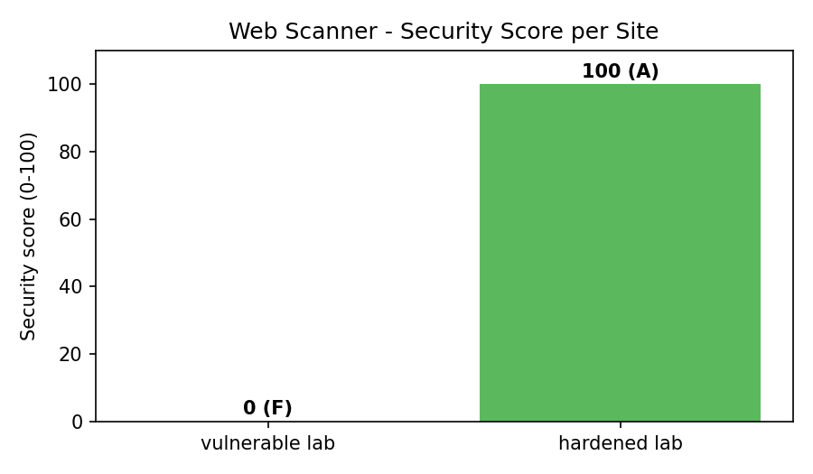
Figure 1: Security score per scanned site

7.3 Findings on the Vulnerable Server
Category | Finding | Severity | Explanation
Header | Content-Security-Policy missing | High | No defence against script injection
Header | X-Frame-Options / X-Content-Type-Options missing | Medium | Clickjacking and MIME-sniffing exposure
Header | Referrer-Policy, Permissions-Policy, COOP, CORP missing | Low | Reduced browser-level isolation and privacy
Leakage | Server: Apache/2.4.49, X-Powered-By: PHP/7.4.3 | Low | Version disclosure helps attackers pick exploits
Cookie | sessionid missing HttpOnly and SameSite | Medium | Cookie readable by scripts; weaker CSRF protection
CORS | Arbitrary origin reflected with credentials | High | Any website could read authenticated responses
CORS | null origin trusted with credentials | High | Exploitable from sandboxed iframes / local files
CORS | Suffix-trust bypass accepted | High | Weak origin validation (attacker-controlled sub-domain)
CORS | Vary: Origin missing | Low | Cache poisoning risk
CORS | Preflight allows PUT/DELETE for untrusted origin | Medium | Dangerous methods exposed cross-origin

7.4 Findings on the Hardened Server
All eight header checks passed, the cookie carried the Secure, HttpOnly and SameSite attributes, no CORS headers were returned for any untrusted origin and the preflight request granted no access. The server scored 100 (grade A) with zero failed checks, confirming that the scanner does not produce false positives on a correct configuration.

8. Recommendations for Remediation
- Send HSTS with a max-age of at least one year and includeSubDomains.
- Deploy a strict Content-Security-Policy without 'unsafe-inline' or wildcard sources.
- Add X-Frame-Options (or frame-ancestors), X-Content-Type-Options: nosniff and a restrictive Referrer-Policy.
- Validate the Origin header against an explicit allow-list; never reflect it blindly and never trust 'null'.
- Never combine Access-Control-Allow-Origin: * with credentials; add Vary: Origin when the value is dynamic.
- Set Secure, HttpOnly and SameSite on all session cookies and hide version banners.

9. Limitations
- Only the single URL supplied is analysed; the scanner does not crawl the whole site.
- Different pages or API endpoints may return different headers.
- Findings indicate misconfiguration, not proven exploitability.
- External websites sit behind CDNs/WAFs that may alter responses for automated clients.

10. Future Enhancements
- Bulk scanning from a file of URLs with parallel requests.
- TLS certificate and protocol-version checks.
- Integration into a CI/CD pipeline as an automated security gate.
- Historical comparison of scans and trend dashboards.
- Additional checks for cookies prefixes (__Host-), CSP report-only mode and subresource integrity.

11. Ethical Considerations
Security testing must be performed only with authorisation. The scanner is passive and rate-limited, but scanning third-party systems without permission may violate laws or terms of service. For this reason, the project was demonstrated entirely on local servers created for the purpose.

12. Conclusion
The Automated Web Scanner meets its objectives: it fetches a site, audits security headers, leakage, cookies and CORS behaviour, explains each issue, and summarises overall posture as a score and grade. Testing on controlled servers showed clear separation between an insecure configuration (0/F) and a hardened one (100/A). The project demonstrates how simple automation can help developers and security teams find and fix common misconfigurations early, strengthening web application security.

13. References
- OWASP Foundation – OWASP Secure Headers Project (owasp.org/www-project-secure-headers).
- OWASP – Top 10: A05 Security Misconfiguration (owasp.org/Top10).
- MDN Web Docs – Cross-Origin Resource Sharing (CORS) (developer.mozilla.org).
- MDN Web Docs – HTTP Security headers and Content-Security-Policy.
- PortSwigger Web Security Academy – CORS (portswigger.net/web-security/cors).
- Python Requests documentation (requests.readthedocs.io).
- IBM SkillsBuild – Cyber Security course material.

