AI Mini Project - Technical Report
Generated on 2026-04-09

1. Project Overview
AI Mini Project is an interactive web application for visualizing algorithmic problem-solving. It includes a Sudoku solver and a Maze solver with multiple search strategies and animated playback.

2. Objectives
- Provide a clear visual understanding of algorithm behavior.
- Allow users to compare solver strategies for pathfinding and puzzle solving.
- Keep the architecture lightweight and easy to deploy.

3. Simplified System Architecture
The architecture is intentionally simple: a React frontend runs in the browser, while a Python FastAPI server serves static frontend files and a health endpoint.
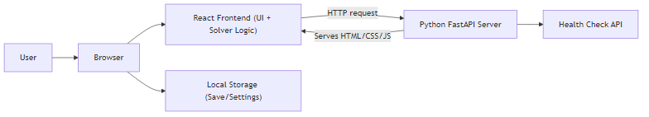
Figure 1: Simplified system architecture

4. Core Features
- Sudoku solver with hints, scoring, and difficulty presets.
- Maze solver with BFS, DFS, A*, Dijkstra, Greedy, and Q-learning modes.
- Animation controls: run, play/pause, rewind, and fast-forward.
- Weighted maze mode to demonstrate cost-aware search behavior.

5. Experimental Results (Bar Graphs)
The following charts summarize representative performance and behavior trends for poster/report usage.
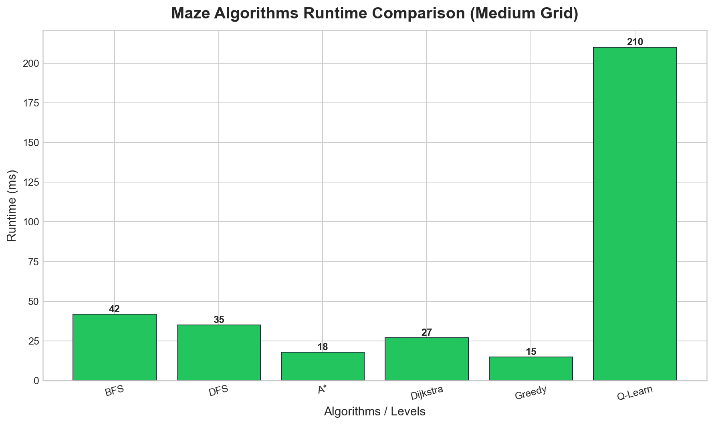
Figure 2: Maze algorithm runtime comparison
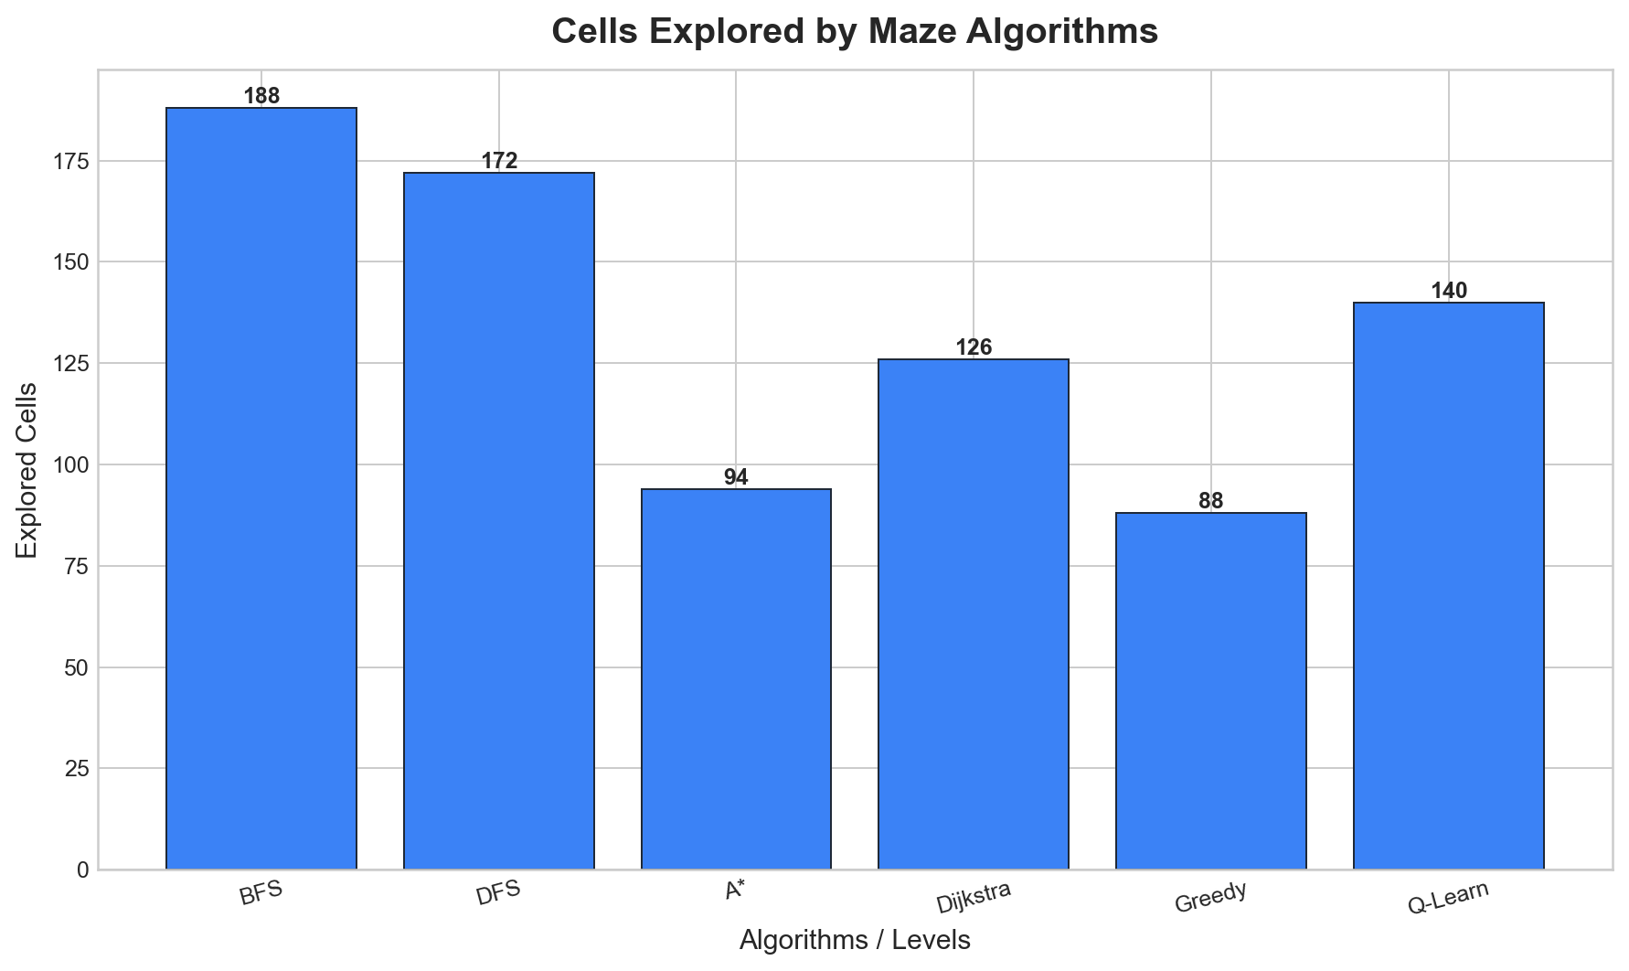
Figure 3: Cells explored by maze algorithms
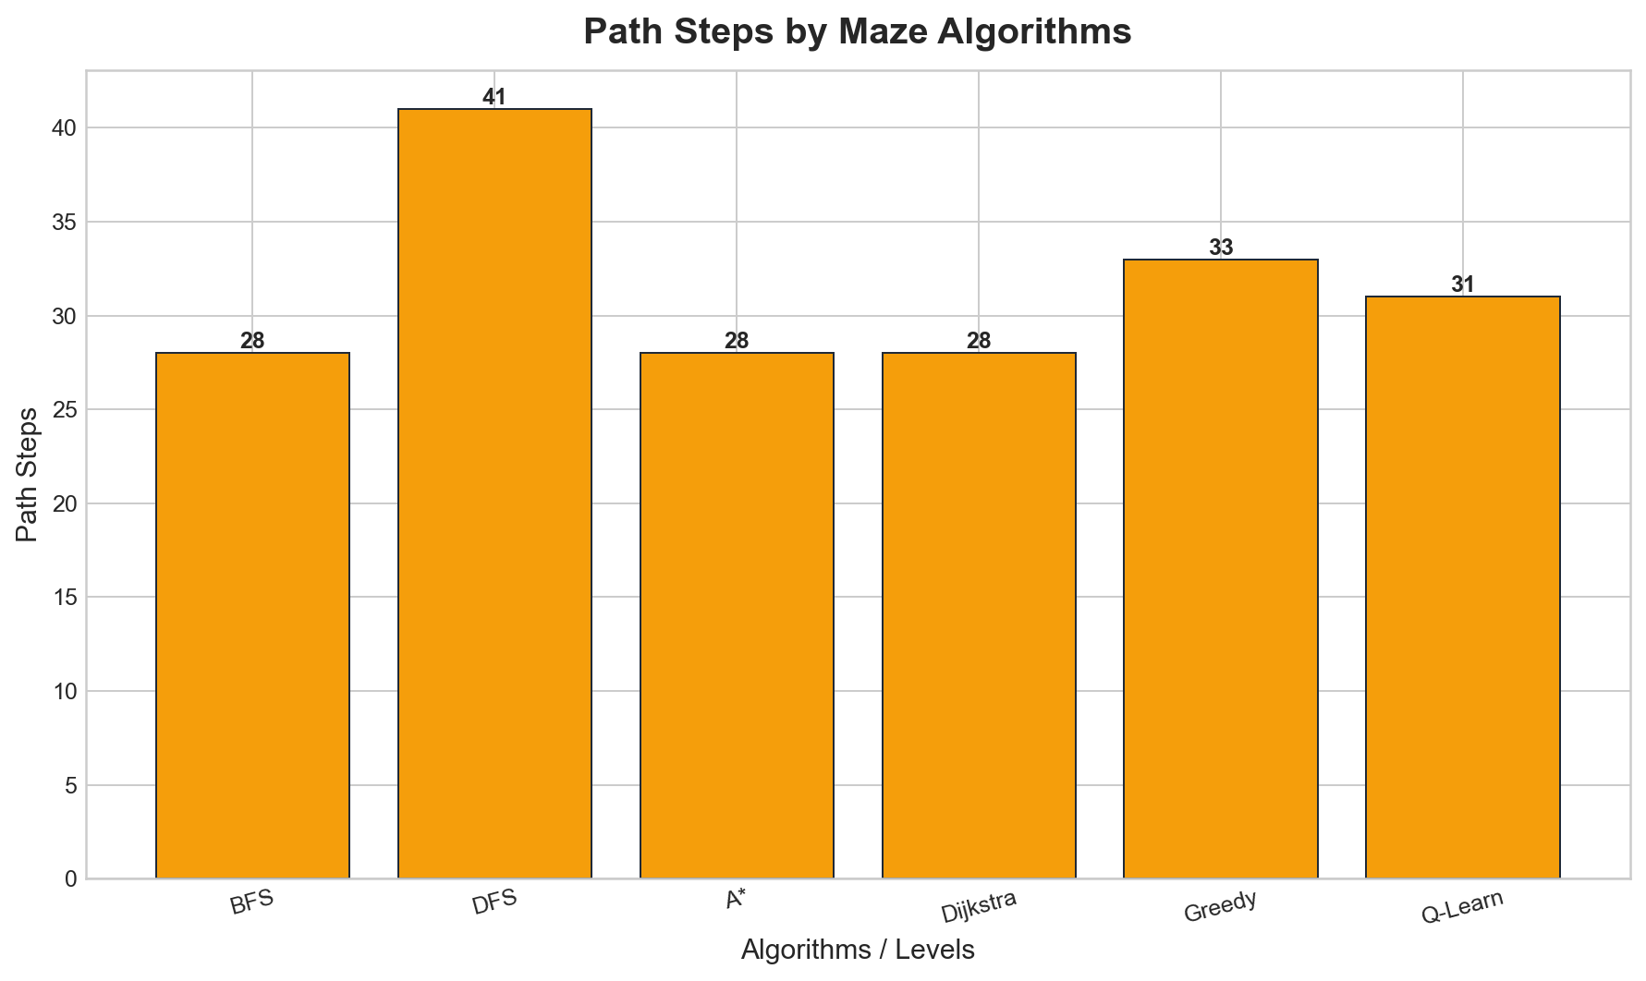
Figure 4: Path steps by maze algorithms
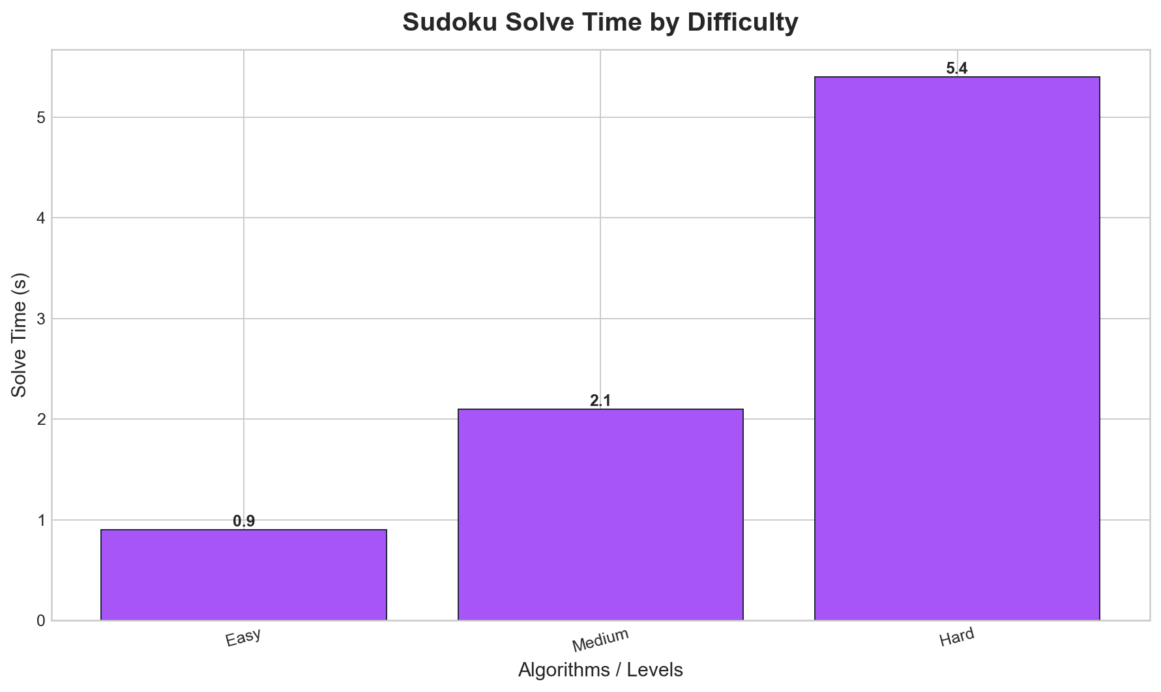
Figure 5: Sudoku solve time by difficulty

6. Conclusion
The project demonstrates how algorithm education can be made interactive and practical using a browser-first architecture. The system remains easy to maintain while still supporting rich visual analytics.

7. Future Scope
- User accounts and global leaderboard.
- Additional maze generation strategies and benchmark automation.
- Mobile-first UX optimization and expanded educational walkthroughs.

