AI Mini Project - Technical Report
Generated on 2026-04-09

1. Project Overview
AI Mini Project is an interactive web application for visualizing algorithmic problem-solving. It includes a Sudoku solver and a Maze solver with multiple search strategies and animated playback.

2. Objectives
- Provide a clear visual understanding of algorithm behavior.
- Allow users to compare solver strategies for pathfinding and puzzle solving.
- Keep the architecture lightweight and easy to deploy.

3. Simplified System Architecture
The architecture is intentionally simple: a React frontend runs in the browser, while a Python FastAPI server serves static frontend files and a health endpoint.
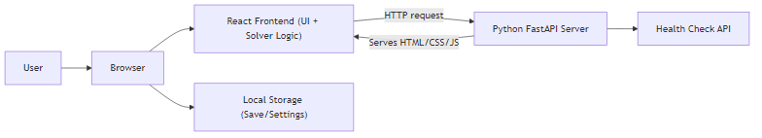
Figure 1: Simplified system architecture

4. Core Features
- Sudoku solver with hints, scoring, and difficulty presets.
- Maze solver with BFS, DFS, A*, Dijkstra, Greedy, and Q-learning modes.
- Animation controls: run, play/pause, rewind, and fast-forward.
- Weighted maze mode to demonstrate cost-aware search behavior.

5. Experimental Results (Bar Graphs)
The following charts summarize representative performance and behavior trends for poster/report usage.
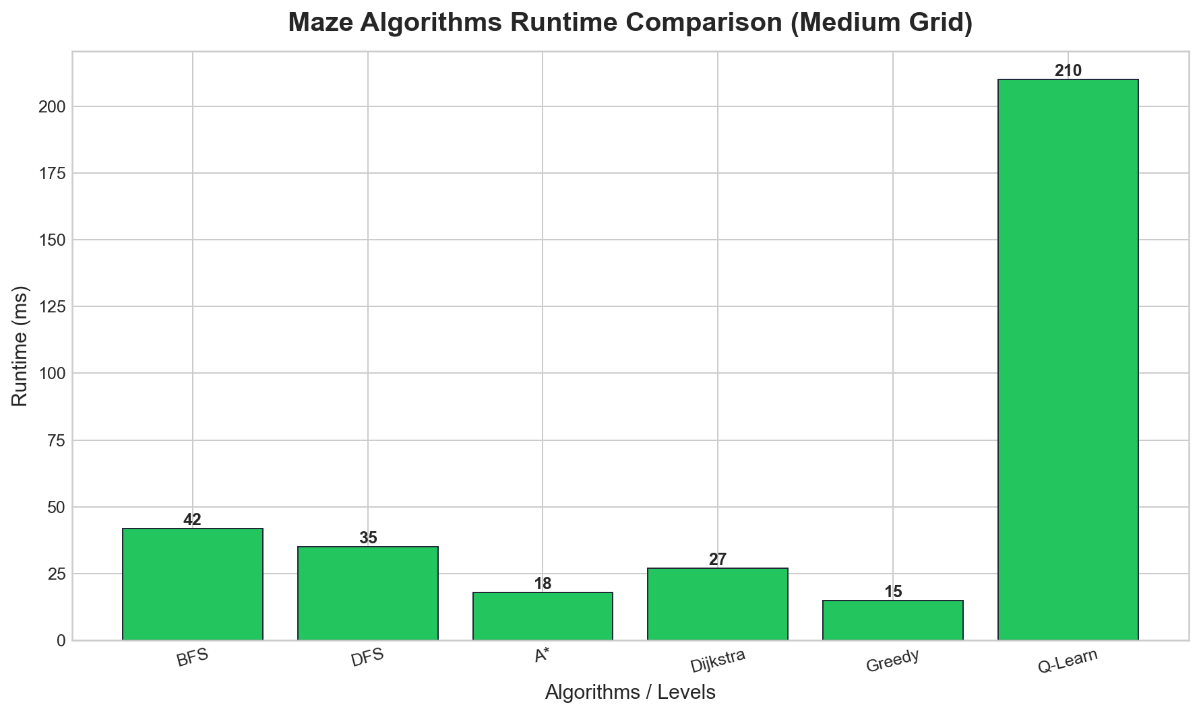
Figure 2: Maze algorithm runtime comparison
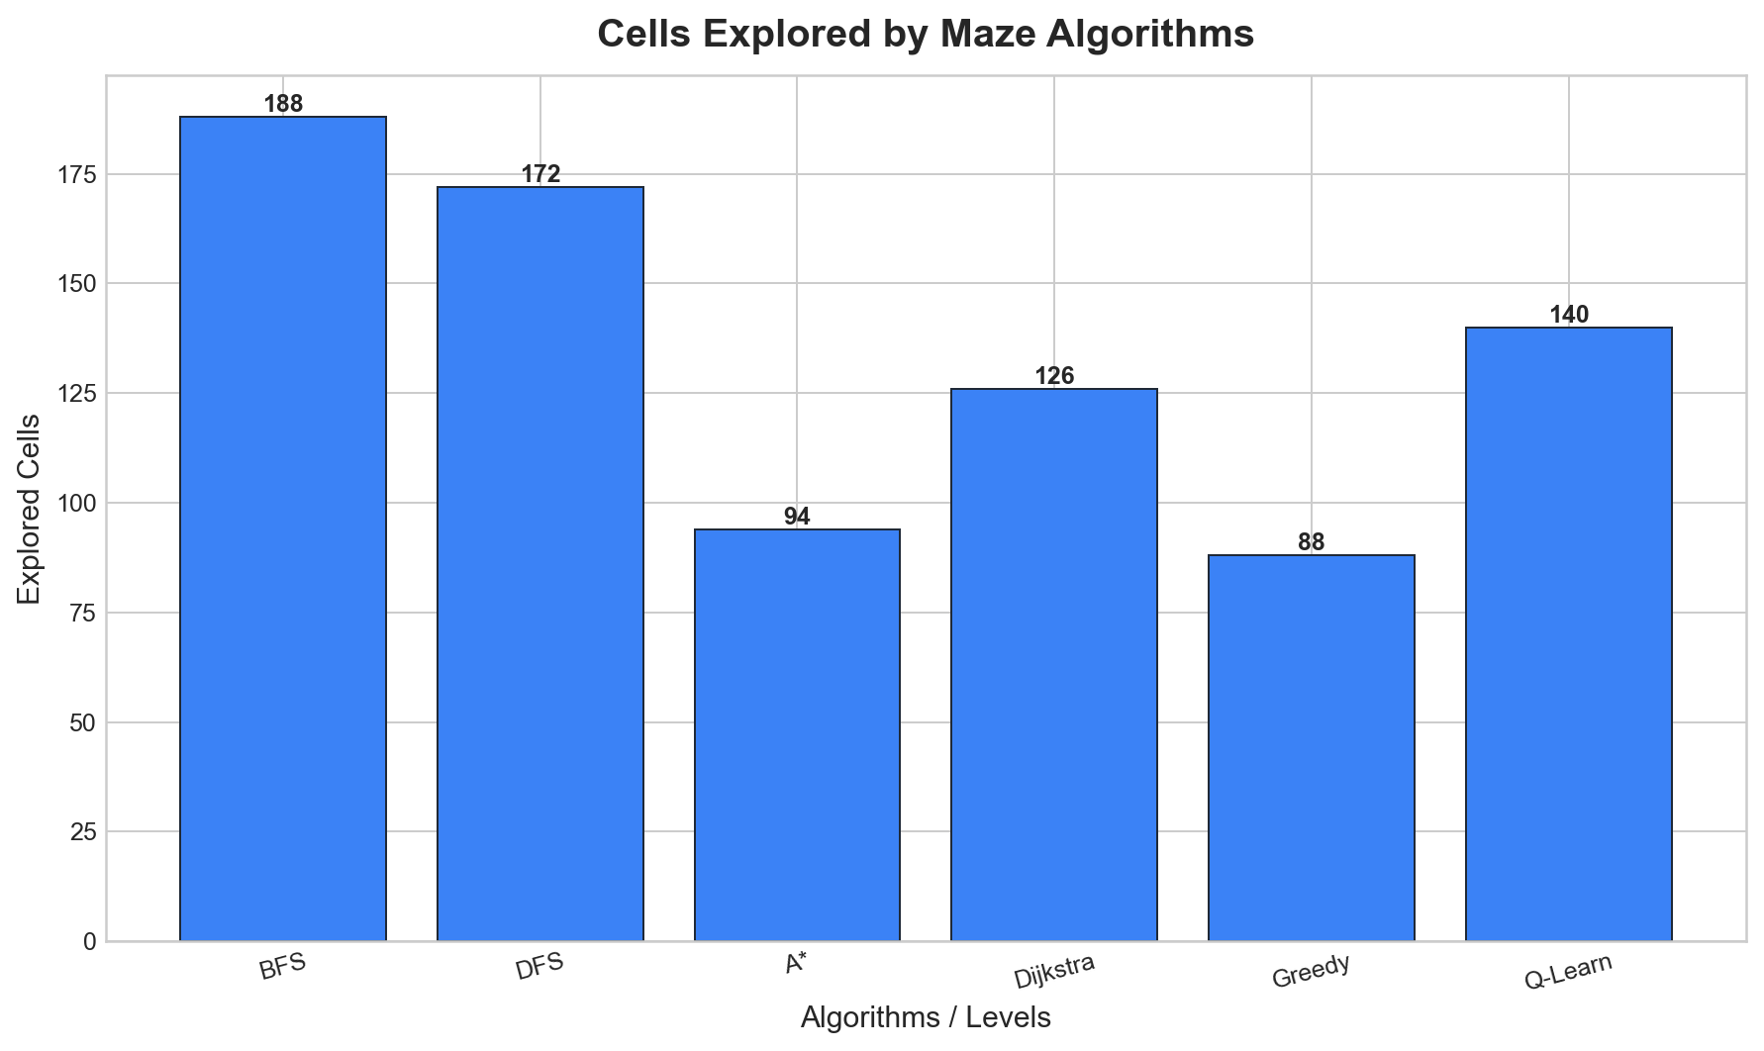
Figure 3: Cells explored by maze algorithms
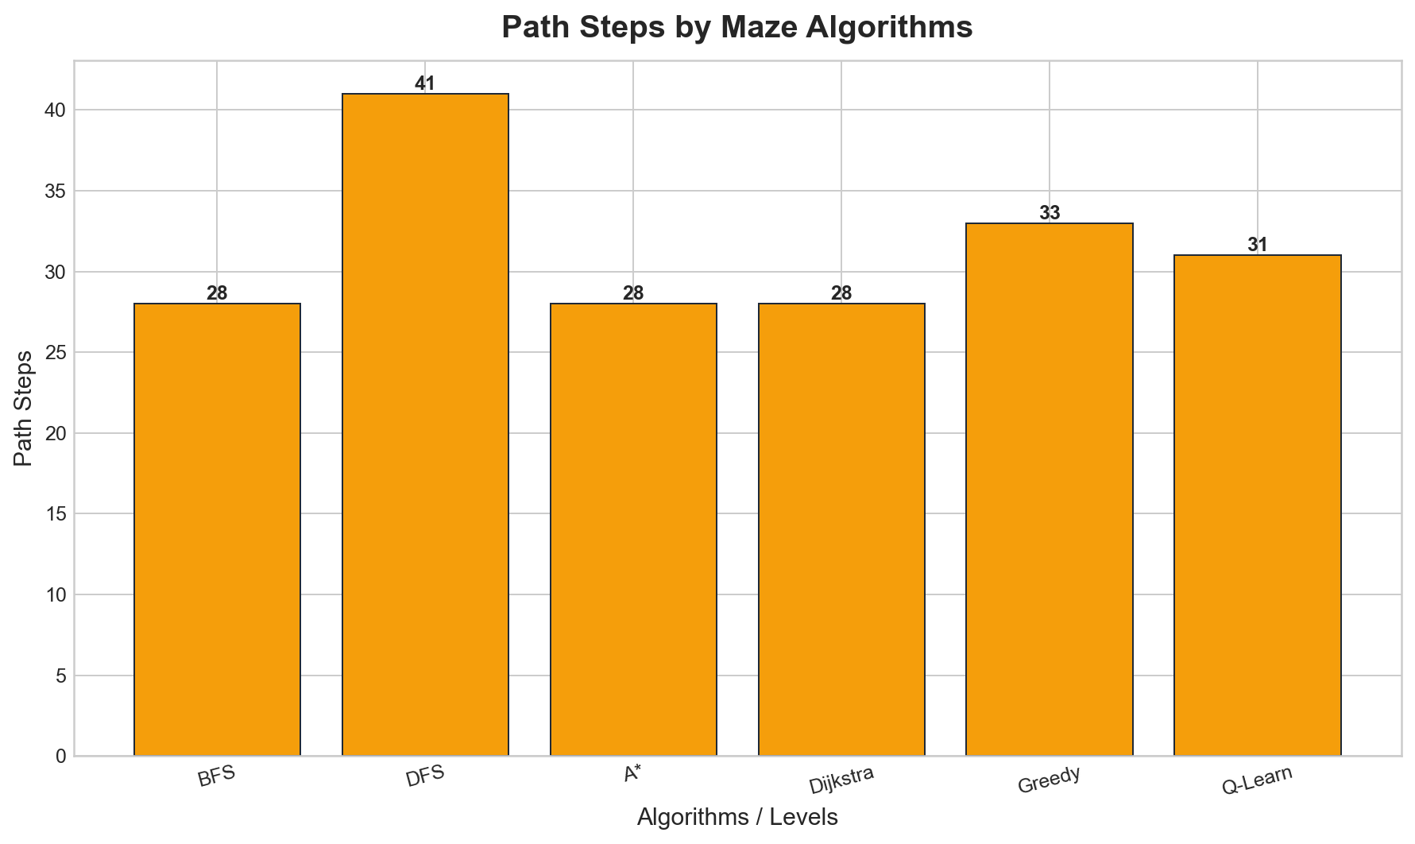
Figure 4: Path steps by maze algorithms
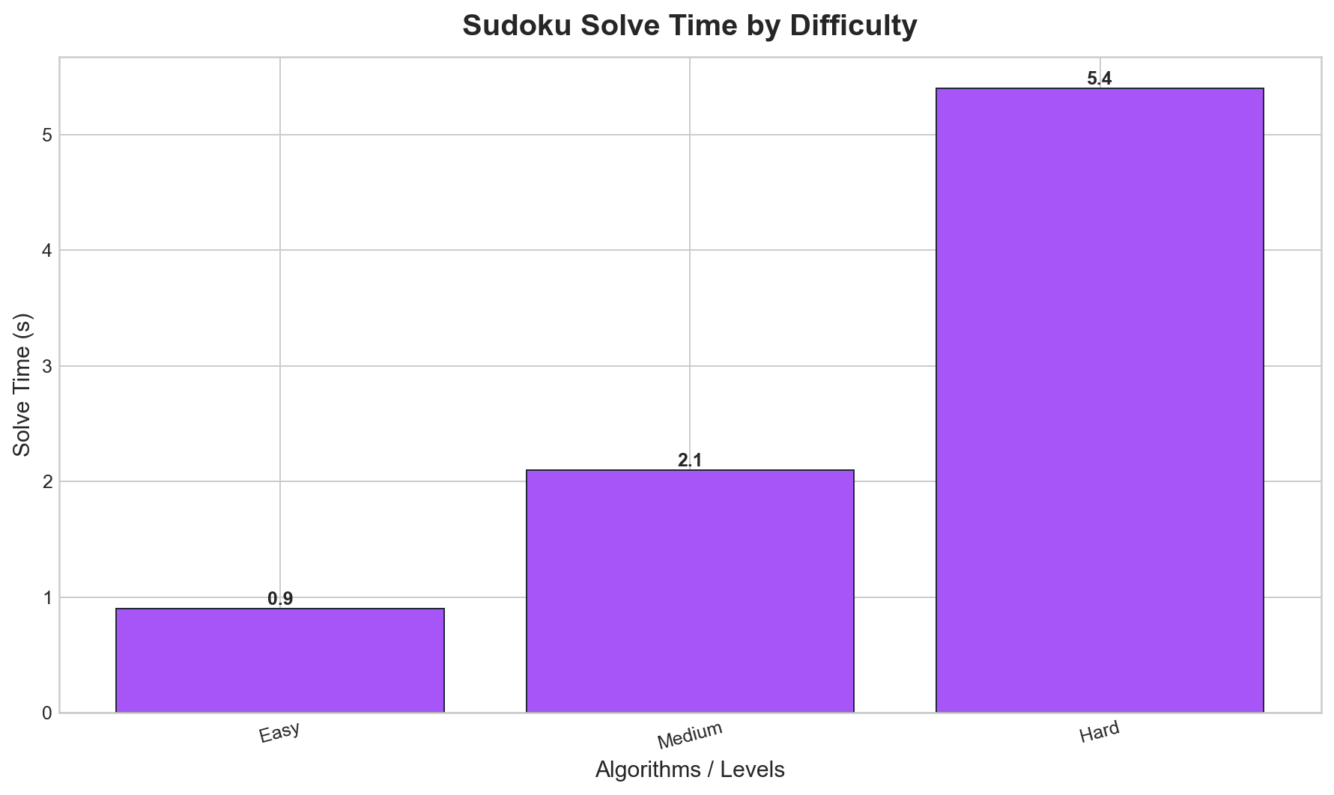
Figure 5: Sudoku solve time by difficulty

6. Conclusion
The project demonstrates how algorithm education can be made interactive and practical using a browser-first architecture. The system remains easy to maintain while still supporting rich visual analytics.

7. Future Scope
- User accounts and global leaderboard.
- Additional maze generation strategies and benchmark automation.
- Mobile-first UX optimization and expanded educational walkthroughs.

8. References
[1] Hart, P. E., Nilsson, N. J., & Raphael, B. (1968). "A Formal Basis for the Heuristic Determination of Minimum Cost Paths" IEEE Transactions on Systems Science and Cybernetics, 4(2), 100-107.
Note: Classic foundational work on the A* algorithm.
[2] Dijkstra, E. W. (1959). "A note on two problems in connexion with graphs" Numerische Mathematik, 1(1), 269-271.
Note: Original shortest-path algorithm (Dijkstra's algorithm).
[3] Watkins, C. J., & Dayan, P. (1992). "Q-learning" Machine Learning, 8(3), 279-292.
Note: Foundation for Q-learning reinforcement learning used in maze solver.
[4] Cormen, T. H., Leiserson, C. E., Rivest, R. L., & Stein, C. (2009). "Introduction to Algorithms" 3rd Edition. MIT Press.
Note: Standard reference covering BFS, DFS, and other graph traversal algorithms.
[5] Shaer, O., & Hornecker, E. (2010). "Tangible User Interfaces: Past, Present, and Future Directions" Foundations and Trends in Human–Computer Interaction, 3(1–2), 1–137.
Note: Research on interactive and tangible visualization systems for education.
[6] Yato, T., & Seta, T. (2003). "Complexity and Completeness of Finding Another Solution and Its Application to Puzzles" IEICE Transactions on Fundamentals of Electronics, Communications and Computer Sciences, E86-A(5), 1052-1060.
Note: Complexity analysis of Sudoku solving and constraint satisfaction methods.
[7] Hmelo-Silver, C. E., & Barrows, H. S. (2008). "Facilitating Collaborative Knowledge Building" Cognition and Instruction, 26(1), 48-94.
Note: Framework for interactive problem-solving learning environments.

