ESSA
Knowledge Transfer Document
for IT Operations & L3 Developers
C# / .NET Framework 4.8 — OPC UA Industrial Data Gateway
Document Type: Technical KT / Runbook
Audience: IT Operations (L1/L2 Application Support, SRE/DevOps, Windows/IIS admins) and L3 Developers (code owners, on-call engineers taking code-level incidents)
Status: Draft v1.0
Last updated: April 2026

Document Control
Field | Value
Document title | ESSA — Knowledge Transfer for IT Operations
Version | 1.0
Purpose | Enable the IT Operations team (and new developers) to install, operate, monitor and troubleshoot the ESSA application without prior knowledge of the codebase.
Intended readers | L1/L2 application support, Windows/IIS admins, DevOps engineers, on-call responders, AND L3 developers who own code-level escalations and feature work.
Prerequisite knowledge | Basic Windows Server / IIS administration, HTTP/REST concepts, Visual Studio 2022, and willingness to read C# code. No OPC UA background required — see the glossary.
Out of scope | Designing the industrial network, choosing PLC vendors, provisioning the OPC UA server itself.
Owners (fill in) | Application Owner: ______ • Tech Lead: ______ • Operations Lead: ______
Review cadence | Review every 6 months or when a major component (OPC UA server, .NET runtime) changes.

Revision History
Version | Date | Author | Summary of changes
1.0 | 2026-04-24 | Handover team | Initial KT document produced from source-code walkthrough of essa.sln.

Contents
1. Executive Summary (for managers and new staff)
2. System Context & Business Purpose
3. Solution Layout — the five projects
4. End-to-End Data Flow
5. Technology Stack & Dependencies
6. Configuration Reference
7. Environments & Deployment Topology
8. Build, Package & Release Procedure
9. Installation & First-Time Setup
10. Day-to-Day Operations Runbook
11. Monitoring, Logging & Alerting
12. Security & Compliance Notes
13. Backup, Restore & Disaster Recovery
14. Common Errors & Troubleshooting Matrix
15. Frequently Asked Questions (FAQ)
16. Recommendations to Improve
17. Developer Deep-Dive (L3 Support)
18. Handover Checklist
19. Glossary for New Team Members
20. Contacts & Escalation

1. Executive Summary
ESSA is a C# / .NET Framework 4.8 application that acts as a gateway between an OPC UA industrial server (used for SCADA, PLCs, sensors) and consumer-facing interfaces (REST API, legacy SOAP web service, console tool). It connects to an OPC UA server over opc.tcp://, browses its tag tree, and reads both current and historical time-series values, returning them as JSON over HTTP.
In one sentence: ESSA translates the 'factory floor' (OPC UA) into 'web language' (JSON/HTTP) so dashboards, reporting and analytics systems can consume plant data without knowing OPC UA.
Why this matters for Ops: If ESSA is down, any downstream dashboard or report that depends on plant tags will stop updating. Treat it as a Tier-2 integration service: not safety-critical, but important for operational visibility.

2. System Context & Business Purpose
ESSA sits between three worlds, as shown in Figure 2.1:
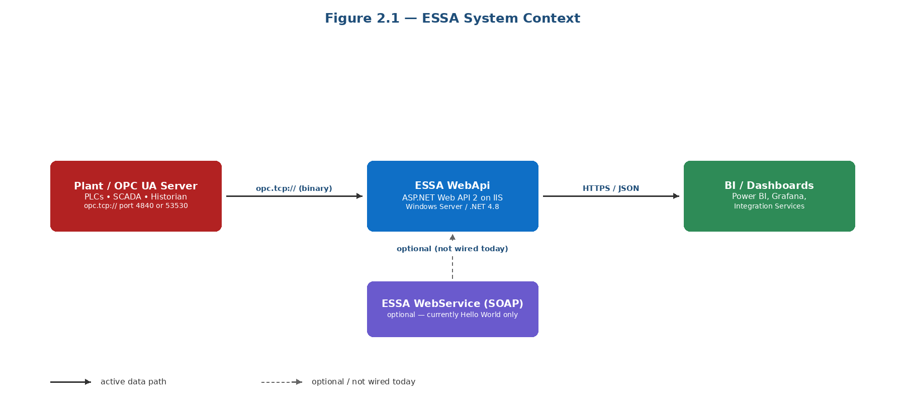
Figure 2.1 — ESSA System Context
Upstream it talks OPC UA (TCP, port typically 53530 for Prosys Simulation Server, 4840 for production servers). Downstream it talks HTTP/JSON over whichever port IIS is configured for (80/443 in production).

2.1 Who uses it
- Data consumers (downstream): reporting tools, Power BI / Grafana dashboards, historian loaders, any internal service that needs plant values.
- Developers: use ConsoleApp1 to test connectivity and tag browsing during development and troubleshooting.
- IT Operations (you): install, patch, monitor, restart, and handle incidents on the Windows server hosting IIS and the ESSA deployment.

3. Solution Layout — the Five Projects
The Visual Studio solution (essa.sln) contains five projects:
Project | Type | Purpose for Ops
Opc.Ua | Class Library (.NET 4.8) | Core library — wraps the OPC UA client, defines the tag model and read services. All other projects depend on this. No direct deployment artefact; built into WebApi/bin and ConsoleApp1/bin.
ConsoleApp1 | Console Application | Developer/Ops troubleshooting tool. Use it on the server to verify connectivity to the OPC UA server and list available tags without going through IIS.
WebApi | ASP.NET MVC 5 + Web API 2 | The main deployable artefact. Hosted in IIS. Exposes REST endpoints /opc-ua-api/history-raw-data and /opc-ua-api/current-raw-data.
WebService | Legacy ASMX (SOAP) | Legacy placeholder — currently only has a HelloWorld method. Optional deployment.
HistoricalAccess Client | External OPC UA sample project | Referenced from ../opc_ua_sample_code/... for reference only. Not deployed.

3.1 Internal module map
Figure 3.1 shows which projects reference the Opc.Ua class library and which NuGet packages each depends on. Red dashed lines mark tech-debt links (e.g., WebService currently has no reference to Opc.Ua).
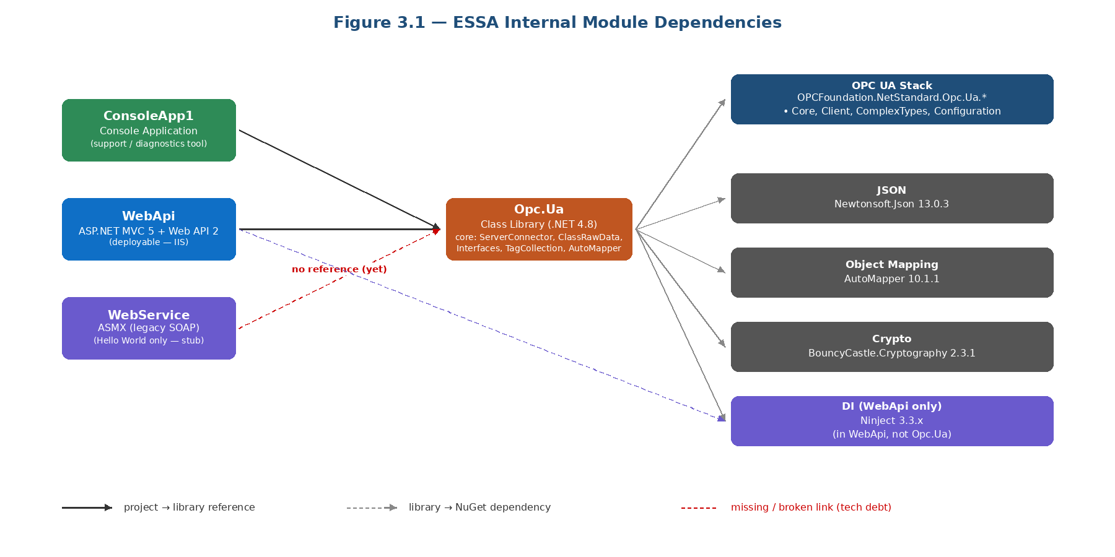
Figure 3.1 — ESSA Internal Module Dependencies

3.2 Key files by project

Opc.Ua (library)
- ServerConnector.cs — creates an OPC UA Session; handles endpoint selection, keep-alive and reconnection; auto-accepts untrusted certificates (see Security).
- Interfaces.cs — IHistoryRawData, ICurrentRawData, IRawDataValue — DI contracts.
- ClassRawData.cs — concrete HistoryRawData and CurrentRawData — browse tags, call session.HistoryRead(…), map results.
- TagCollection.cs — Tag, TagHistoryRawData, TagCurrentRawData model classes.
- DataValue.cs — RawDataValue DTO returned over JSON.
- AutoMapper.cs — MapperConfig.Initialize() — DataValue → RawDataValue mappings.
- AppSetting.cs — static OPCUA_TCP_CONNECTION_ADDRESS field populated at startup.

WebApi (deployable)
- Global.asax.cs — Application_Start registers areas, WebApi/MVC routes, filters, bundles and calls AppSetting.Initialize().
- App_Start/NinjectWebCommon.cs — Ninject DI container: binds IHistoryRawData→HistoryRawData and ICurrentRawData→CurrentRawData.
- App_Start/WebApiConfig.cs — attribute routing + default api/{controller}/{id} route.
- Controllers/OpcController.cs — the real endpoints: BulkHistoryRawData and CurrentRawData.
- Controllers/HomeController.cs — MVC home page + /Home/HelloWorld health-check JSON.
- Controllers/ValuesController.cs — scaffolded, unused.
- Models/ReadRawCriteriaDto.cs — request-body DTOs.
- Web.config — holds OPCUA_TCP_CONNECTION_ADDRESS and all binding redirects.
- Dockerfile — packages the app into a Windows Server Core container (mcr.microsoft.com/dotnet/framework/aspnet:4.8-windowsservercore-ltsc2019).

ConsoleApp1 (support tool)
- Program.cs — three routines: WriteTagChildNodes, WriteSingleTagHistoryRawDataValues, WriteMultipleTagHistoryRawDataValues (the last two are commented out in Main).
- Contains a local Connector class that duplicates ServerConnector (technical debt — see Recommendations).

WebService (legacy)
- WS_OPC_UA.asmx(.cs) — a single WebMethod returning 'Hello World'. Currently no real function.

4. End-to-End Data Flow
The sequence diagram below shows what happens when a downstream consumer calls POST /opc-ua-api/history-raw-data. Solid arrows are synchronous calls; dashed arrows are return values; numbered badges on the left of each arrow match the narrative steps after the diagram.
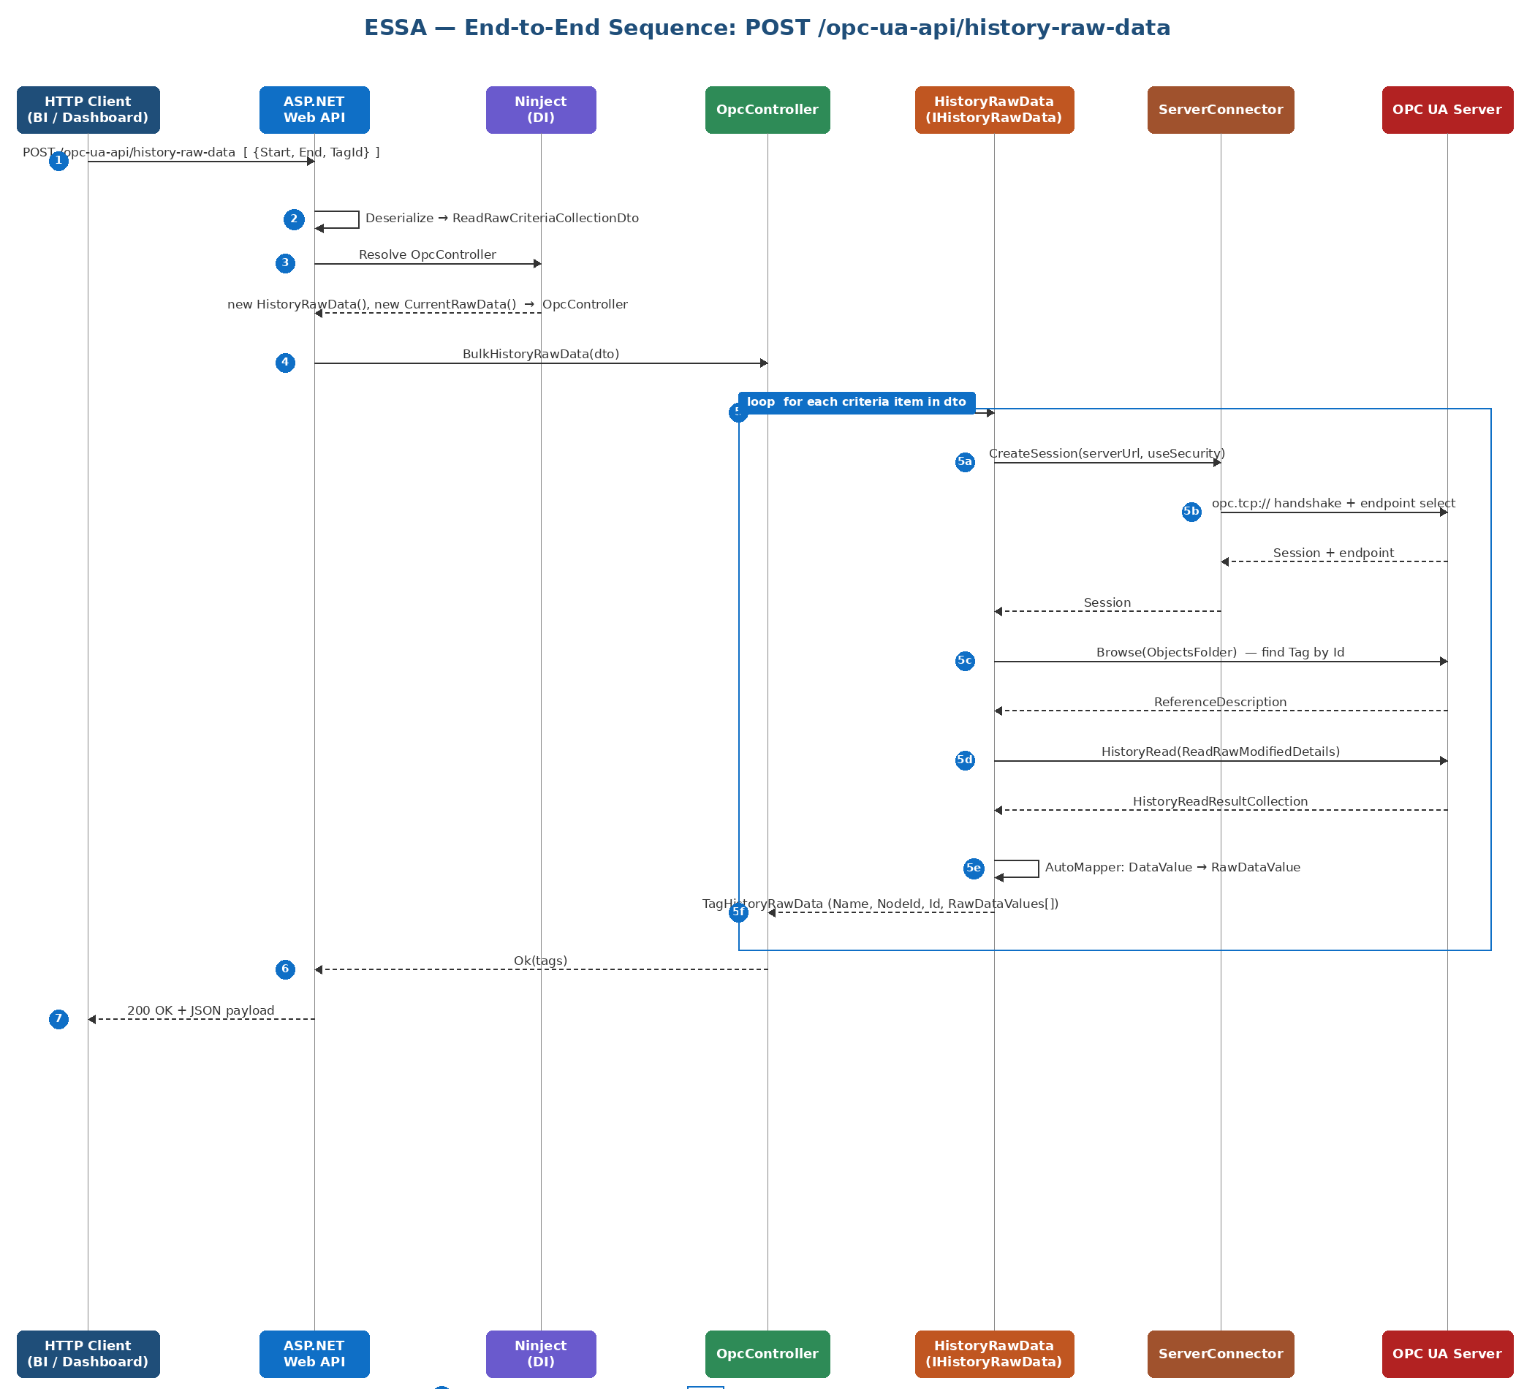
Figure 4.1 — End-to-end sequence for POST /opc-ua-api/history-raw-data

4.1 Narrative — step by step
- HTTP client sends the JSON body [ { StartDateTime, EndDateTime, TagId } ] to POST /opc-ua-api/history-raw-data.
- ASP.NET deserialises the body into ReadRawCriteriaCollectionDto.
- Ninject resolves OpcController and injects HistoryRawData (IHistoryRawData) and CurrentRawData (ICurrentRawData).
- OpcController.BulkHistoryRawData(dto) runs — it iterates the criteria collection.
- For each item the controller calls _iHistoryRawData.Read(start, end, tagId), which internally:
- 5a. ServerConnector.CreateSession(serverUrl, useSecurity) — opens a new OPC UA session.
- 5b. ServerConnector does the opc.tcp:// handshake and selects an endpoint from the server.
- 5c. HistoryRawData calls session.Browse(ObjectsFolder) to locate the tag that matches the TagId.
- 5d. session.HistoryRead(ReadRawModifiedDetails) is issued with the time window.
- 5e. AutoMapper converts each OPC UA DataValue into the lightweight RawDataValue DTO.
- 5f. HistoryRawData yield-returns TagHistoryRawData (Name, NodeId, Id, RawDataValues[]) back to the controller.
- Controller returns Ok(tags) — the Web API runtime serialises the list to JSON and sends 200 OK to the client.
Operational note: Every call currently opens a new OPC UA session. Under load this is expensive and can exhaust sessions on the OPC UA server. See Recommendations §16 — session reuse.

5. Technology Stack & Dependencies
Layer | Technology | Version | Why it's here
Runtime | .NET Framework | 4.8 | Required because ASMX and classic ASP.NET don't run on .NET 6/7/8.
Language | C# | 7.3 / 8.0 | Default for net48 projects.
Industrial protocol | OPC UA | 1.5.374.54 | OPCFoundation.NetStandard.Opc.Ua.* — official OPC Foundation stack.
Web API | ASP.NET Web API 2 | 5.2.9 | HTTP/JSON endpoints.
MVC (views/home) | ASP.NET MVC | 5.2.9 | Razor views, bundling.
Legacy SOAP | ASP.NET ASMX | System.Web.Services | WS_OPC_UA.asmx.
DI container | Ninject | 3.3.x | Wires IHistoryRawData / ICurrentRawData into OpcController.
JSON | Newtonsoft.Json | 13.0.3 | Serialization of Tag / RawDataValue.
Object mapping | AutoMapper | 10.1.1 | DataValue → RawDataValue, Tag → TagHistoryRawData.
Crypto | BouncyCastle.Cryptography | 2.3.1 | Required by the OPC UA stack for certificate handling.
Packaging | packages.config (classic NuGet) | - | Pre-PackageReference style; packages restored into /packages.
Containers | Windows Server Core | ltsc2019 | Dockerfile base image for WebApi and WebService.
Front-end (Home view) | Bootstrap 5.2.3, jQuery 3.4.1, Modernizr | - | Default MVC template — not really used.

5.1 Key NuGet Packages
Package | Where used | Role
OPCFoundation.NetStandard.Opc.Ua.Core | Opc.Ua, WebApi, ConsoleApp1 | Core types (NodeId, DataValue, ExtensionObject, StatusCode).
OPCFoundation.NetStandard.Opc.Ua.Client | Opc.Ua, ConsoleApp1 | Session, Browse, HistoryRead, KeepAlive.
OPCFoundation.NetStandard.Opc.Ua.Client.ComplexTypes | Opc.Ua, ConsoleApp1 | ComplexTypeSystem loader for user-defined structures.
OPCFoundation.NetStandard.Opc.Ua.Configuration | Opc.Ua, ConsoleApp1 | ApplicationConfiguration, endpoint selection.
AutoMapper 10.1.1 | Opc.Ua | Maps OPC UA DataValue → RawDataValue DTO.
Newtonsoft.Json 13.0.3 | All | JSON (de)serialization.
Ninject 3.3.x | WebApi | Constructor injection for controllers.
Microsoft.AspNet.WebApi 5.2.9 | WebApi | The Web API 2 runtime.
Microsoft.AspNet.Mvc 5.2.9 | WebApi | Razor views (HomeController).
BouncyCastle.Cryptography 2.3.1 | All | Certificate/crypto primitives.

6. Configuration Reference

6.1 Settings that Ops will change
Setting | File | Example value | Effect
OPCUA_TCP_CONNECTION_ADDRESS | WebApi/Web.config (<appSettings>) | opc.tcp://plc-server:4840/UA/Server | The OPC UA endpoint ESSA connects to. Change per environment.
useSecurity | Hard-coded in ClassRawData.cs / ConsoleApp1.Program.cs | false | Whether OPC UA connection is signed/encrypted. False is DEV-only.
TimeZone (console only) | ConsoleApp1/Program.cs | SE Asia Standard Time | Used to convert timestamps when printing to console.
compilation debug | WebApi/Web.config | true | Must be FALSE for production IIS deployment.
Binding redirects | WebApi/Web.config <runtime> | see file | Required — do not remove; the OPC UA stack pulls mixed assembly versions.

6.2 Current configured value (as seen in repo)
<!-- WebApi/Web.config -->
<appSettings>
<add key="OPCUA_TCP_CONNECTION_ADDRESS"
value="opc.tcp://DESKTOP-AMCOF2V:53530/OPCUA/SimulationServer" />
</appSettings>
Action for Ops: DESKTOP-AMCOF2V is a developer workstation hostname and must NOT be deployed. Before any UAT/PROD release, replace this with the environment-specific OPC UA endpoint via a Web.config transform or an environment variable.

7. Environments & Deployment Topology

7.1 Suggested environments
Env | Hostname (example) | OPC UA endpoint | Purpose
DEV | essa-dev.contoso.local | opc.tcp://sim-server:53530/OPCUA/SimulationServer | Developer integration, points to Prosys simulator.
UAT | essa-uat.contoso.local | opc.tcp://plc-uat:4840/UA/Server | Business testing with representative tag set.
PROD | essa.contoso.com | opc.tcp://plc-prod:4840/UA/Server | Live plant data; HTTPS only.

7.2 Runtime topology
Figure 7.1 shows the deployment topology across the consumer network, the Windows Server host, and the Plant / OT VLAN, plus the host-level concerns the Operations team owns.
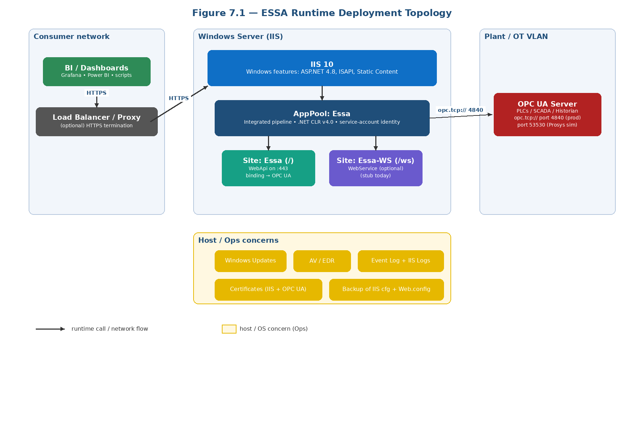
Figure 7.1 — ESSA Runtime Deployment Topology

7.3 Host requirements
- OS: Windows Server 2019 or 2022 (Standard/Datacenter).
- Web server: IIS 10+, ASP.NET 4.8 role, WebSocket + WebDeploy optional.
- .NET runtime: .NET Framework 4.8 Developer Pack on build server; .NET 4.8 runtime on target.
- Network: outbound access to the OPC UA server port (typically 4840 or 53530). Inbound on 443 from the client network.
- Certificates: IIS SSL cert for the public URL; OPC UA client cert in the Windows / OPC Foundation trust store once Security is enabled.
- Resource sizing (minimum): 2 vCPU, 4 GB RAM, 20 GB disk. Scale up if response payloads become large (history windows).

8. Build, Package & Release Procedure

8.1 Build prerequisites
- Visual Studio 2022 17.5+ OR MSBuild 17 + NuGet 6.x on a build agent.
- .NET Framework 4.8 Developer Pack.
- Internet access (or an internal NuGet mirror) so OPCFoundation / Ninject / AutoMapper packages restore.

8.2 Build steps (manual)
- Open essa.sln in Visual Studio 2022.
- Tools → NuGet Package Manager → Restore.
- Build → Rebuild Solution in Release configuration.
- Right-click WebApi → Publish → File system → produces a publish folder.

8.3 CI/CD (recommended)
- Pipeline: nuget restore → msbuild /p:Configuration=Release /p:DeployOnBuild=true /p:PublishProfile=FileSystem → artifact zip.
- Release: Web Deploy to the target IIS, or Docker build/push for Windows container hosts.
- Apply Web.config transforms per environment (Web.Release.config, Web.<Env>.config).

8.4 Docker packaging
docker build -t essa-webapi:1.0 -f WebApi/Dockerfile WebApi/
docker run -d -p 8080:80 --name essa essa-webapi:1.0
Note: The image is based on Windows Server Core (~4 GB). You need a Docker host running Windows containers — Linux nodes cannot run it unless the app is migrated to .NET 8.

9. Installation & First-Time Setup

9.1 Fresh server install (IIS)
- Install Windows roles: Web Server (IIS), Application Development → ASP.NET 4.8, ISAPI, Static Content.
- Install .NET Framework 4.8 runtime if missing.
- Copy publish folder to C:\inetpub\wwwroot\essa (or any preferred path).
- Create an AppPool 'Essa' — .NET CLR v4.0, Integrated pipeline, Identity = a dedicated service account that has read/write on %ProgramData%\OPC Foundation\CertificateStores.
- Create a Site 'Essa', bind HTTPS:443 with a valid cert, point to the publish folder, assign the Essa AppPool.
- Edit Web.config → set OPCUA_TCP_CONNECTION_ADDRESS and set compilation debug="false".
- Test in a browser: https://<host>/Home/HelloWorld should return {"x":"hello","y":"world"}.
- Test a real endpoint with Postman (see §10.4).

9.2 Deploying ConsoleApp1 to the server
Keep ConsoleApp1 as a support tool under C:\Tools\essa-console\. It doesn't need IIS.
- Copy ConsoleApp1\bin\Release\ to the server.
- Edit ConsoleApp1.exe.config (or App.config at source) to point to the right server URL.
- Run ConsoleApp1.exe from cmd/PowerShell — the list of tags is printed.

10. Day-to-Day Operations Runbook

10.1 Start / stop / restart
:: IIS — restart the AppPool (fastest, no full IIS restart)
C:\Windows\System32\inetsrv\appcmd.exe recycle apppool /apppool.name:"Essa"
:: Stop / start the site
C:\Windows\System32\inetsrv\appcmd.exe stop site /site.name:"Essa"
C:\Windows\System32\inetsrv\appcmd.exe start site /site.name:"Essa"

10.2 Health check
- Liveness URL: GET https://<host>/Home/HelloWorld — should return {"x":"hello","y":"world"}. If this fails, IIS/AppPool/ASP.NET is down.
- Upstream check: Run ConsoleApp1.exe on the server — it must print the Simulation child tags. If it hangs or errors out, the OPC UA server is unreachable or rejecting the connection.
- End-to-end check: POST a real payload (see §10.4).

10.3 Routine checks (suggested schedule)
Frequency | Check | Action if failing
Every 5 min (automated) | HTTP probe on /Home/HelloWorld | Page on-call if > 3 consecutive failures.
Hourly (automated) | Synthetic POST of a known tag | Create incident ticket; confirm OPC UA server health.
Daily | Review IIS logs for 5xx spikes | Open investigation if 5xx > 1% of traffic.
Weekly | Check disk, memory, AppPool worker memory | Recycle AppPool if w3wp.exe is approaching 2 GB.
Monthly | Patch Windows Server + .NET Framework | Schedule change window + smoke test after patches.
Quarterly | Review security certs, rotate service-account password | Follow cert renewal SOP.

10.4 Smoke-test requests
POST https://<host>/opc-ua-api/current-raw-data
Content-Type: application/json
[ { "TagId": "Simulation/Counter1" } ]
POST https://<host>/opc-ua-api/history-raw-data
Content-Type: application/json
[ { "StartDateTime": "2026-04-24T00:00:00Z",
"EndDateTime": "2026-04-24T00:05:00Z",
"TagId": "Simulation/Counter1" } ]

10.5 Change / release process
- Raise a Change Request referencing this KT.
- Deploy to DEV → UAT → PROD with the same artifact.
- After each deploy: hit /Home/HelloWorld and a current-raw-data smoke test.
- Rollback = re-deploy the previous build (keep last 3 versions retained on disk).

11. Monitoring, Logging & Alerting

11.1 Logs today
- IIS logs: %SystemDrive%\inetpub\logs\LogFiles\W3SVC<id>\ — HTTP access logs.
- Windows Event Log: Application + System — for AppPool crashes / ASP.NET errors.
- OPC UA stack log: written under %ProgramData%\OPC Foundation\... once enabled. Currently the code calls Utils.LogError(...) only in one place, so operational visibility is LOW.

11.2 Recommended monitoring
- APM agent (Application Insights / Dynatrace / New Relic) installed on the AppPool — gives request rate, latency, failures.
- Synthetic transaction every 1–5 minutes hitting /Home/HelloWorld and one /opc-ua-api/current-raw-data.
- Windows performance counters: w3wp Memory, %% CPU, IIS Current Requests, .NET CLR Exceptions.
- Disk free, AppPool identity login failures, Windows updates pending.

11.3 Recommended alerts
Metric | Threshold | Severity
HTTP 5xx rate | > 2% for 5 min | P2
Liveness probe fails | 3 consecutive | P1
w3wp private bytes | > 1.5 GB for 10 min | P3 (recycle)
OPC UA connection failures in app log | > 5 in 5 min | P2
Disk free (C:) | < 10% | P2
Certificate expiry (IIS or OPC UA) | < 30 days | P3

12. Security & Compliance Notes

12.1 Current posture
- OPC UA: useSecurity is hard-coded to false. Certificates are auto-accepted. This is lab-grade only.
- REST API: there is no authentication or authorisation on the endpoints — any network-reachable client can post queries.
- Transport: HTTPS is a deployment concern (IIS binding); the code itself does not enforce it.
- Secrets: no secrets are stored today (no DB, no API keys). The OPC UA URL is in Web.config.

12.2 Required hardening before PROD
- Put HTTPS-only bindings in IIS; add HSTS response headers.
- Add authentication — Windows Authentication for intranet or OAuth2 / JWT for external clients. Reject anonymous POSTs.
- Enable OPC UA security (Basic256Sha256, SignAndEncrypt) and replace AutoAcceptUntrustedCertificates with a trusted cert list.
- Run the AppPool under a dedicated least-privilege service account.
- Restrict outbound network to the OPC UA server host/port only (firewall rule).
- Enable audit logging: every successful and failed request.

13. Backup, Restore & Disaster Recovery
ESSA itself is stateless — it stores no data. Backup strategy therefore focuses on the deployment artefact and the configuration, not on application data.
- What to back up: the publish folder (IIS site content), Web.config per environment, the IIS site/AppPool export (appcmd list site /config /xml > essa.xml), any certificate .pfx files.
- RPO / RTO target (suggested): RPO 0 (no state), RTO < 1 hour — redeploy from last artifact.
- DR playbook: stand up a fresh Windows host, run §9 Installation, restore IIS configuration from XML, re-bind the certificate, verify health endpoints.

14. Common Errors & Troubleshooting Matrix
Error / Symptom | Likely cause | Resolution
BadNotConnected / 'Could not connect to server' | Wrong URL, OPC UA server not running, firewall blocks port. | Verify server is running; ping host; telnet port; check OPCUA_TCP_CONNECTION_ADDRESS. Use ConsoleApp1.exe to isolate.
BadSecurityChecksFailed | Certificate mismatch or security policy rejected. | In DEV keep useSecurity=false. In PROD import the server cert into pki\trusted; configure SecurityPolicy Basic256Sha256.
BadIdentityTokenRejected | Server requires username/password or cert identity. | Set Connector.UserIdentity = new UserIdentity("user","pass") before CreateSession; raise a code change.
TypeInitializationException / binding redirect errors | Two different versions of Newtonsoft.Json / System.Memory requested. | Keep <bindingRedirect> entries; do not downgrade Newtonsoft.Json below 13.0.3.
ConfigurationErrorsException: 'Required permissions cannot be acquired.' | AppPool identity can't access OPC UA PKI directory. | Grant service account rwx on %ProgramData%\OPC Foundation\CertificateStores\...
NullReferenceException at results[0].HistoryData.Body | Tag has no history in that window; Body is null. | Check the tag is history-enabled; caller should widen the window. Guard is partially in place already.
Deadlock / request hangs forever | Session.Create(...).Result inside ASP.NET sync context. | Short-term: recycle AppPool. Long-term: migrate controller chain to async (see Recommendations).
HTTP 500 — 'No parameterless constructor defined for this object' | Ninject isn't wired; controller can't be instantiated. | Confirm NinjectWebCommon.Start ran; confirm the WebActivatorEx attribute is intact; check all bindings.
Docker build fails with 'failed to compute cache key' | Running docker build on Linux without Windows container mode. | Switch Docker Desktop to Windows containers, or migrate app to .NET 8.
SerializationException / cyclic reference in JSON | Serializing raw DataValue instead of RawDataValue DTO. | Always return the POCOs (RawDataValue / TagHistoryRawData). AutoMapper is there for this.
w3wp.exe memory keeps growing | One-session-per-request pattern leaking under load. | Temporary: schedule AppPool recycle every N hours. Permanent: session caching (§16).
/Home/HelloWorld works but /opc-ua-api/* returns 404 | Attribute routing not picked up (config.MapHttpAttributeRoutes() missed). | Check WebApiConfig.Register ran; redeploy.
Clients see timeouts > 30s | HistoryRead range too wide / NumValuesPerNode too large (99,999,999 today). | Narrow the time window in the client; add server paging (see Recommendations).

15. Frequently Asked Questions (FAQ)
Q1. What is OPC UA?
OPC UA (Unified Architecture) is a machine-to-machine protocol used in industrial automation. It lets you read tags (like 'Tank1.Level') from PLCs, DCS, SCADA and historians in a standard way. Think of it as 'SQL for factories'.
Q2. What is a 'tag' / 'NodeId'?
A tag is a named data point on the server (Temperature, Counter1...). Each one has a NodeId such as ns=3;i=1002 where ns is a namespace index and i is a numeric identifier. The code also builds a friendly Id like 'Simulation/Counter1'.
Q3. Why does the app target .NET Framework 4.8 instead of .NET 8?
Because it uses ASMX (System.Web.Services) and classic ASP.NET MVC, which are Windows-only and not ported to modern .NET. The OPC UA stack itself works fine on .NET 8 — only the web hosting keeps you on 4.8.
Q4. What does Ninject do here?
It's a Dependency Injection (DI) container. It reads NinjectWebCommon.RegisterServices and, whenever ASP.NET needs an OpcController, it automatically supplies new HistoryRawData() and new CurrentRawData() for its constructor parameters.
Q5. What is AutoMapper mapping, exactly?
It turns the heavy OPC UA DataValue (nested types, server-specific fields) into a simple POCO RawDataValue with five fields. The Web API returns the POCO so JSON consumers get a clean shape.
Q6. What is the difference between 'current' and 'historical' raw data?
'Current' asks the server for the value right now (actually a 1-second window from now onward). 'Historical' asks the server's historian for everything between StartDateTime and EndDateTime — this only works if the OPC UA server has Historical Access (HA) enabled.
Q7. Why are there two identical-looking connectors (Connector in ConsoleApp1 and ServerConnector in Opc.Ua)?
Connector was the original prototype; ServerConnector is the library version. Technical debt — they should be merged.
Q8. Why is useSecurity = false?
Because the code currently targets a local Simulation Server on the developer's machine. You MUST turn this on (and configure certificates) for real deployments.
Q9. How do I add a new endpoint, e.g. 'write a value to a tag'?
Add a Write method on IHistoryRawData (or a new IWriteData), implement it via session.Write(...), register it in NinjectWebCommon, and add a POST action on OpcController.
Q10. Can I deploy this in Docker?
Yes — the Dockerfiles build on mcr.microsoft.com/dotnet/framework/aspnet:4.8-windowsservercore-ltsc2019. Only a Windows Docker host (or Windows nodes in Kubernetes) can run it. For Linux containers you have to migrate to .NET 8 first.
Q11. Which OPC UA server works out-of-the-box with this code?
Prosys OPC UA Simulation Server (free, Windows). Its 'Simulation' folder contains numeric tags with history enabled.
Q12. What does 'SE Asia Standard Time' in Program.cs mean?
It converts the server's UTC timestamps to UTC+7 (Jakarta/Bangkok). Hard-coded in ConsoleApp1 — a real deployment should return ISO-8601 UTC.
Q13. Who owns this application?
Fill in the Owners row in Document Control. Typically: the Plant Data Integration / OT-IT team owns the application; IT Operations owns the Windows hosts and network.
Q14. Can I run it without the plant network?
Yes — install Prosys OPC UA Simulation Server on localhost and point OPCUA_TCP_CONNECTION_ADDRESS to it. This is how DEV works.
Q15. Where do request logs go?
IIS access logs by default (inetpub\logs). There is currently no structured application-level log — see §16 for the recommendation to add one.

16. Recommendations to Improve

16.1 Architecture & code quality
- Unify the connectors. ConsoleApp1 has its own Connector class that is almost identical to Opc.Ua.ServerConnector. Delete it and reuse the library class.
- Async all the way. ServerConnector.CreateSession calls .Result on an async Session.Create. This can deadlock in ASP.NET classic. Make it async and await it (IHttpActionResult supports Task<IHttpActionResult>).
- Reuse the Session. Every call currently creates a fresh Session. Cache one Session per server URL and re-use it — faster and easier on the OPC UA server.
- Replace static AppSetting. Mutable public static fields are hard to test. Use IOptions<T> / constructor injection.
- Handle exceptions. Several catch blocks are empty. Add Serilog/NLog and log Exception.Message + StackTrace with a correlation id.
- Migrate to PackageReference. Classic packages.config is deprecated; the /packages folder also bloats the repo.
- Consider upgrading to .NET 8. The OPC UA stack runs on .NET Standard 2.0 and works on .NET 8. This unlocks Linux containers and better perf.

16.2 API & data model
- Version the API. /opc-ua-api/... is unversioned — add /v1/ for forward safety.
- Validate inputs. StartDateTime < EndDateTime, reasonable range, non-empty TagId; return 400 with a problem detail.
- Cap NumValuesPerNode. 99999999 can OOM the OPC UA server. Use continuation points + paging.
- Strongly-typed RawDataValue. Value/StatusCode/Timestamps are declared as object — use concrete types.
- Add GET /opc-ua-api/tags. So clients can discover what TagIds exist without out-of-band docs.

16.3 Security
- Do not auto-accept certificates. Import the server cert into the client trust list once and reject everything else.
- Enable OPC UA SignAndEncrypt. Basic256Sha256 at minimum.
- Authenticate the REST API. OAuth2/JWT or at least per-client API keys.
- Never commit DESKTOP-AMCOF2V. Use Web.config transforms or environment variables.

16.4 Operations
- Real /health endpoint. Return 200 only if an OPC UA session can be opened. Today /HelloWorld only proves IIS is up.
- Structured logging + correlation ID. Propagate a request id through the OPC UA call for faster RCA.
- Metrics. Expose Prometheus / App Insights counters: sessions_created_total, history_read_duration_seconds, opcua_reconnect_total.
- Remove or implement WebService. It is currently dead code.

17. Developer Deep-Dive (L3 Support)
This section is for L3 engineers — the people who get the ticket after Ops has exhausted the runbook. It assumes you can read C#, open the solution in Visual Studio, attach a debugger to w3wp.exe, and raise a code change.

17.1 How to set up a local developer loop
- Install Visual Studio 2022 17.5+ with workloads: ASP.NET and web development, .NET desktop development.
- Install .NET Framework 4.8 Developer Pack.
- Install Prosys OPC UA Simulation Server (or any OPC UA server with a 'Simulation' folder with history-enabled tags).
- Clone the repo, open essa.sln, right-click solution → Restore NuGet Packages, Rebuild.
- Set WebApi as the Startup Project and press F5 — it launches under IIS Express.
- Alternative: set ConsoleApp1 as startup and F5 — fastest feedback loop for OPC UA experiments (no IIS involved).

17.2 Key classes and their responsibilities
Class | File | What L3 needs to know
ServerConnector | Opc.Ua/ServerConnector.cs | Creates and owns the OPC UA Session. CreateSession() calls .Result on an async — potential deadlock point under ASP.NET sync context. Session_KeepAlive has empty branches; reconnect logic is effectively a stub.
HistoryRawData | Opc.Ua/ClassRawData.cs | IHistoryRawData implementation. Browses tags twice (two nested Browse calls) every request, then HistoryRead with NumValuesPerNode = 99,999,999. Returns IEnumerable<TagHistoryRawData> via yield.
CurrentRawData | Opc.Ua/ClassRawData.cs | ICurrentRawData implementation. Same browse logic; uses a 1-second HistoryRead window starting 'now' as a proxy for 'current value'. Not a true OPC UA Read — if a tag has no history, it returns nothing.
MapperConfig | Opc.Ua/AutoMapper.cs | One-shot static AutoMapper configuration. Maps OPC UA DataValue → RawDataValue (Value, ValueDataType, StatusCode, SourceTimestamp, ServerTimestamp).
NinjectWebCommon | WebApi/App_Start/NinjectWebCommon.cs | DI wiring. Any new interface you add must also be bound here or the controller will throw 'No parameterless constructor'.
OpcController | WebApi/Controllers/OpcController.cs | The REST surface. Two POST endpoints; synchronous; no validation; returns Ok(tags). New endpoints go here.
AppSetting (WebApi) | WebApi/AppSetting.cs | Reads Web.config at startup and copies OPCUA_TCP_CONNECTION_ADDRESS into Opc.Ua.AppSetting. Tight coupling — prefer IOptions<T> when refactoring.

17.3 Extension points — how to add a feature

A. Add a new REST endpoint
- Declare a new method on an existing interface (e.g., IWriteData.Write(tagId, value)) in Opc.Ua/Interfaces.cs.
- Implement it in Opc.Ua/ClassRawData.cs using session.Write(...) (OPC UA WriteValueCollection).
- Bind it in NinjectWebCommon.RegisterServices → kernel.Bind<IWriteData>().To<WriteData>();
- Add a DTO in WebApi/Models and a POST action on OpcController with a [Route("opc-ua-api/...")] attribute.
- Build, run, smoke-test with Postman.

B. Expose live value subscriptions
- Use OPC UA Subscription + MonitoredItems. Adds long-running callbacks — pair with SignalR to push to clients.
- Warning: the current Ninject scope is per-request. Subscriptions need singletons — adjust the binding (.InSingletonScope()).

C. Add a new tag browse endpoint
- Expose the existing GetVariableTags(session) enumerator through a new interface (ITagBrowser.BrowseAll()).
- This is the easiest useful win — today there is no way for clients to discover TagIds.

17.4 Debugging procedures

Local: attach debugger
- In Visual Studio: Debug → Attach to Process → select iisexpress.exe (local) or w3wp.exe (server, requires remote debug tools).
- Set a breakpoint in OpcController.BulkHistoryRawData and in HistoryRawData.Read.
- Fire a POST with Postman; step through to see which line throws/blocks.

On the server: enabling detailed OPC UA stack logs
- Add Opc.Ua.Utils.SetTraceMask(Opc.Ua.Utils.TraceMasks.All) at start-up (temporary diagnostic).
- Log file lands in %ProgramData%\OPC Foundation\Logs\Opc.Ua.Client.log (subject to write-permission on that folder).
- Tail it during the failing request: Get-Content Opc.Ua.Client.log -Wait in PowerShell.

On the server: production dump
- Use procdump (Sysinternals) to capture a memory dump when w3wp hits a deadlock: procdump -ma -w w3wp.exe.
- Open the dump in Visual Studio → Debug Managed Memory → look for lots of threads blocked on Task.Result / SemaphoreSlim (classic async-over-sync).

17.5 Known code-level risks (read before fixing)
- Async-over-sync deadlock risk (HIGH). ServerConnector.CreateSession calls Connect(...).Result synchronously. Any caller running under a single-threaded SynchronizationContext (classic ASP.NET) can deadlock. See Recommendation 16.1.
- Session-per-request (MEDIUM). HistoryRawData.Read and CurrentRawData.Read each create a fresh Session and never Close() it explicitly. Under load this leaks sockets on both sides.
- Unbounded history window (MEDIUM). NumValuesPerNode = 99,999,999 lets a malicious/careless caller pull huge result sets. Add a server-side cap (e.g., 10,000) and continuation-point paging.
- Empty catch blocks (MEDIUM). ServerConnector.Session_KeepAlive and CertificateValidator_CertificateValidation swallow exceptions silently. Replace with structured logging.
- Duplicate Connector in ConsoleApp1 (LOW). Technical debt — collapse into ServerConnector.
- Hard-coded timezone (LOW). Program.cs uses 'SE Asia Standard Time' — only affects the dev console but will bite if someone reuses that code path in a service.
- No input validation (MEDIUM/SECURITY). OpcController does not validate DTOs. A null TagId causes a NullReference inside GetVariableTags.

17.6 L3 triage cheat-sheet
Symptom | First diagnostics (5 min) | Likely root cause
All requests time out | Take a w3wp mini-dump; check Threads for Result/Wait/SemaphoreSlim. | Async-over-sync deadlock in Connect().
Empty arrays returned | Hit /current-raw-data with a tag you KNOW has history. | Tag has no HA; or Browse filter misses it; or server cert changed and session rejected.
Intermittent 500s | Check Event Viewer — Application log for .NET runtime errors. | NullReferenceException in ClassRawData when HistoryData.Body is null for some tags.
Works in DEV, fails in PROD with BadSecurityChecksFailed | Confirm OPC UA cert path and trust list. | useSecurity flipped to true, but trust store not seeded.
Slow response > 5s | Open an APM trace — is the time in session.HistoryRead or in Browse? | Session creation overhead; session-per-request pattern.
Controller 500 with ActivationException (Ninject) | Check NinjectWebCommon.RegisterServices binding list. | New interface added but not bound in DI.
Cannot bind cert on IIS after server move | certlm.msc → check private key access for AppPool identity. | AppPool identity lost private-key ACL after a cert re-import.

17.7 Suggested test harness for L3
- xUnit project targeting net48 referencing Opc.Ua.
- Add an interface around ServerConnector (ISessionFactory) so HistoryRawData can be unit-tested with a fake session (Moq).
- Integration tests run against Prosys Simulation Server in CI (Windows agent).
- Add a health-contract test that hits /Home/HelloWorld and one /opc-ua-api/current-raw-data — fail the build if either regresses.

17.8 Where to read more
- OPC Foundation .NET Standard reference: https://reference.opcfoundation.org/
- OPC UA .NET samples (the 'HistoricalAccess Client' that essa.sln references).
- Ninject docs: https://github.com/ninject/Ninject/wiki
- AutoMapper 10 docs: https://docs.automapper.org/en/stable/
- Classic ASP.NET Web API 2 attribute routing: https://learn.microsoft.com/en-us/aspnet/web-api/overview/web-api-routing-and-actions/attribute-routing-in-web-api-2

18. Handover Checklist
Use this checklist during KT sessions. Tick each item when the Operations team has seen it demonstrated and can reproduce it.
✓ | Item | Notes
☐ | Overview walk-through | Solution layout, 5 projects, what each does.
☐ | Data flow demo (Postman) | current-raw-data + history-raw-data against DEV.
☐ | Source code repository access | Ops team has at least read access + clone instructions.
☐ | CI/CD pipeline access | Can view build history and trigger a re-deploy.
☐ | IIS administration | Start/stop site + AppPool recycle demonstrated.
☐ | ConsoleApp1 on the server | Ops can run it for troubleshooting.
☐ | Config change process | How to change OPCUA_TCP_CONNECTION_ADDRESS safely.
☐ | Log locations | IIS + Event Log; where future application logs will land.
☐ | Monitoring dashboard link | APM / synthetic probes visible to the Ops team.
☐ | Alert routing | Pager duty / email DL configured; escalation tested.
☐ | Backup & DR drill | Fresh install from last artifact completed in < RTO.
☐ | Security posture reviewed | HTTPS, AppPool identity, OPC UA security, cert expiry.
☐ | Known issues list | Async-deadlock, session-per-call, empty catch blocks.
☐ | Contacts & escalation | Owners named in Document Control.
☐ | L3 dev environment set up | Clone, restore, build, F5 demonstrated (Visual Studio + Prosys simulator).
☐ | L3 can attach debugger | Attach to iisexpress.exe locally and w3wp.exe on a non-prod server.
☐ | L3 can reproduce prod-class issues | Replay a known incident (e.g., BadSecurityChecksFailed, empty result).
☐ | L3 has repo write access + CI/CD permissions | Can merge to main and trigger a Release pipeline.
☐ | L3 walked through 17.3 extension recipes | Adding endpoint, adding binding in Ninject, adding DTO.
☐ | L3 reviewed 17.5 known risks | Async-over-sync, session-per-request, unbounded window, empty catch.

19. Glossary for New Team Members
- OPC UA — Open Platform Communications Unified Architecture: an industrial protocol for reading/writing data from plant equipment.
- Session — a live connection to the OPC UA server; like a database connection.
- NodeId — unique id of a data point on the server (ns=3;i=1002).
- HistoryRead — an OPC UA call to read historical values for a node, bounded by start/end time.
- ExtensionObject — OPC UA's container for complex structured data (we wrap ReadRawModifiedDetails in one).
- Ninject Kernel — the DI registry object that returns instances of services.
- DTO — Data Transfer Object. A flat class used only to move data between layers / serialise to JSON.
- MVC 5 / Web API 2 — classic ASP.NET stacks. MVC for HTML views, Web API for HTTP/JSON endpoints.
- ASMX — legacy SOAP web service format (WS_OPC_UA.asmx). Replaced by WCF and then by gRPC/REST.
- AppPool — IIS isolation boundary; each AppPool is its own w3wp.exe process.
- PKI / Trust list — files on disk under %ProgramData%\OPC Foundation\... that decide which certificates are accepted.
- Prosys Simulation Server — a free OPC UA server commonly used in DEV; exposes a 'Simulation' folder of synthetic tags with history.

20. Contacts & Escalation
Replace the placeholders below with real names before the document is published.
Role | Name | Email / Phone | When to contact
Application Owner | ______ | ______ | Business-level decisions, scope changes.
Tech Lead | ______ | ______ | Architecture and code changes.
On-call Application Support (L2) | ______ rota | ______ | Incidents affecting the REST API or IIS.
L3 Developer / Engineering on-call | ______ rota | ______ | Code-level bugs, deadlocks, memory dumps, extension work, production hot-fixes.
OT / Plant Integration | ______ | ______ | OPC UA server / tag definitions / network.
Windows / IIS Admin | ______ | ______ | Host, patching, certificates, AppPool.
Security / Compliance | ______ | ______ | Cert issuance, audit, penetration tests.
— End of Document —

