# BCmodel

$∈$-profile’s property:

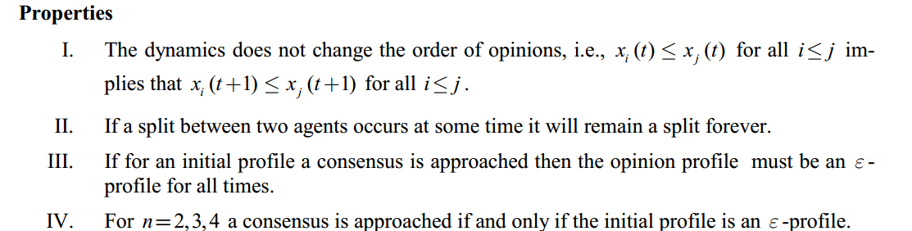

## Walking along the diagonal-simulation results

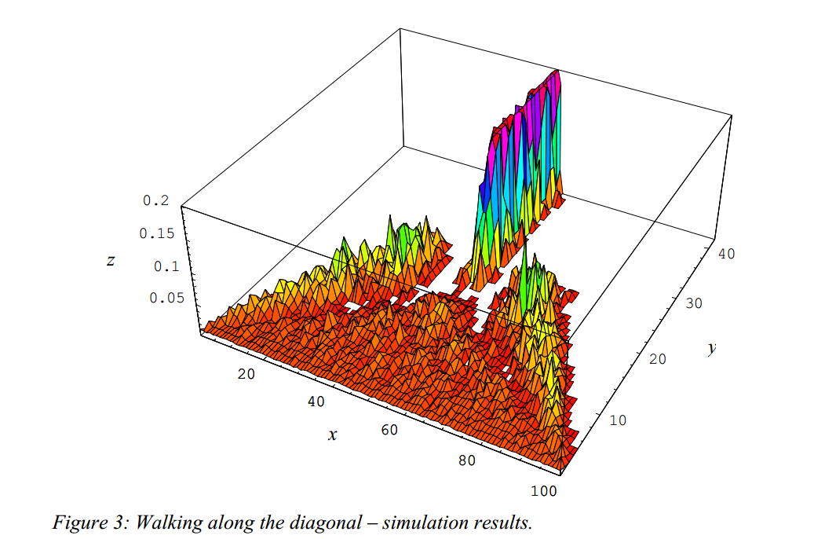

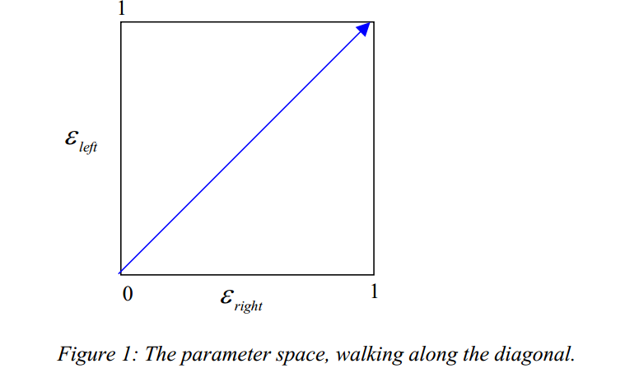x:opinion profile [0,1] to [0,100]

y：steps

z:average relative frequencies of opinions in the 100 opinion intervals of the opinion space after the dynamics has stabilised

# Consensus strikes back in the H-K model

## The role of the number of agents

Initial profile:

* Opinions with equivalent distance, xi=(i-1)/(n-1)
* Opinions with random distance
* Opinions with equal distribution [0,1]

Deduction

in simulations for equidistant or random initial profiles the relevant parameter that determines roughly the number of emerging clusters is the proportion of the bound of confidence at the range of initial opinions ε/(max xi - min xi), which we call ε/range

Conjecture (Hegselmann,2004)

For every bound of confidence there might be a number of agents n for which an equidistant opinion profile leads to consensus.(Figure 2)

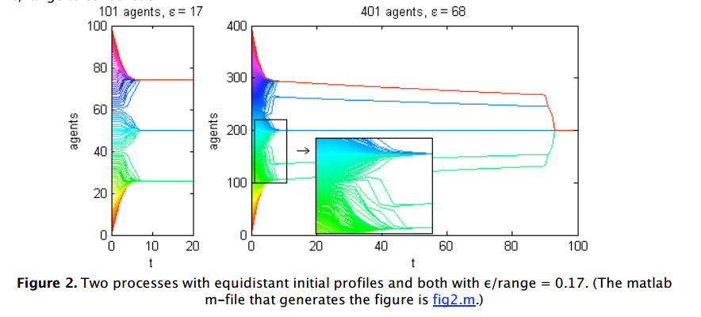

equidistant opinion profile



Opinion profile with random value in [0,1],the number of agents are different

## HK model and interactive Markov chain

## Interactive Markov chain