1.Write a C program to perform Matrix Multiplication

**Aim:**To write a C program to multiply two matrices and display the resultant matrix.

**Algorithm:**

1. Start the program.
2. Declare two matrices A and B with suitable sizes, and a result matrix C.
3. Input the order (rows and columns) of matrices A and B.
4. Check the condition: if the number of columns in A ≠ number of rows in B, then multiplication is not possible.
5. Read the elements of matrix A.
6. Read the elements of matrix B.
7. Initialize result matrix C with zeros.
8. For each row i of A and each column j of B:
   * Compute C[i][j] = Σ (A[i][k] * B[k][j]) where k iterates over columns of A (or rows of B).
9. Display the resultant matrix C.
10. Stop the program.

**Program**

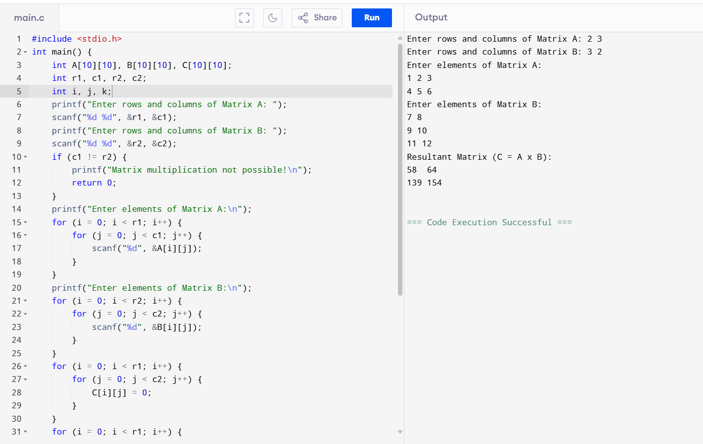

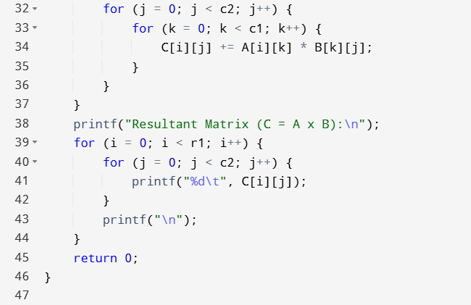

**Result:** Thus, the C program for matrix multiplication was successfully executed and the resultant matrix was obtained.