This is a core php based system for managing leads and opportunities. This tracks the journey of an opportunity from lead to closed sale.

This also has feature to contact leads through Web Whatsapp, the default login to web.whatsapp.com will be used to contact leads.

We have emptied all the tables of the database. Please fill them.

Setup –

1. Open the config.php file and set the username and passwords for
   1. PORTAL_USER_NAME : Username to login in to system
   2. PORTAL_USER_PASSWORD : Password to login in to system
   3. DB_USER_NAME : Database username
   4. DB_USER_PASSWORD : Database user password
   5. DB_NAME : Name of the database.
2. Dashboard looks like –

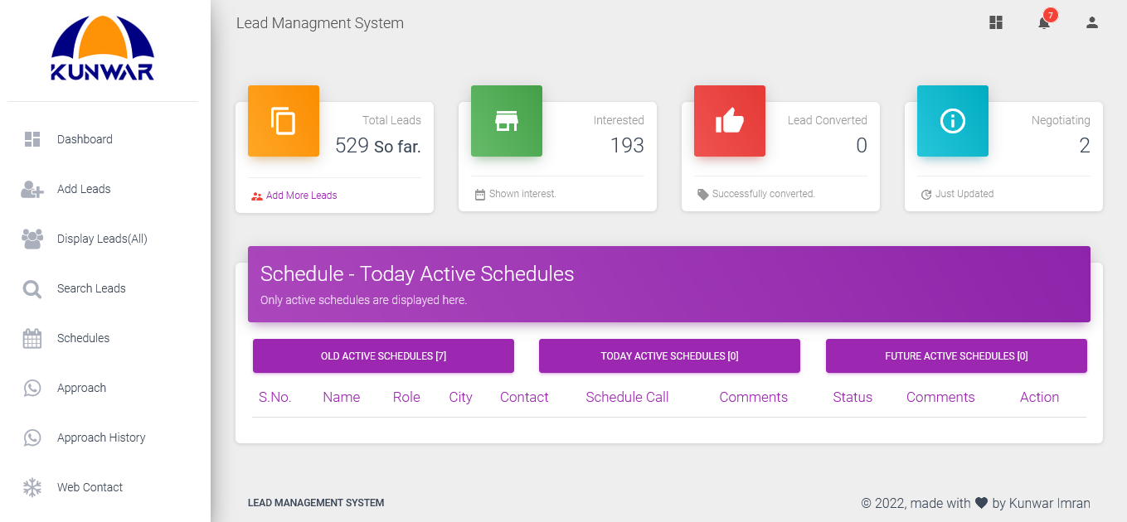

Notifications are shown here –

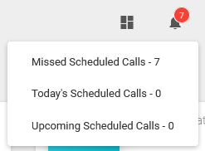

Leads are managed here – can be updated a lead by clicking on Call icon, can be contacted by clicking on Whatsapp icon through Whatsapp.

