Daily Expense Tracker - Project Report
Problem Statement
Manual expense tracking through notebooks or spreadsheets is inefficient, error-prone, and lacks real-time budget monitoring. Users struggle with:
- Difficulty in organizing expenses - No structured categorization system for different spending types
- Time-consuming record keeping - Manual entry and calculation of expenses is tedious and error-prone
- Budget tracking challenges - Lack of automated budget comparison and overspending alerts
- Data consistency issues - Multiple files and formats lead to data loss and inconsistency
- Limited financial insights - No quick summary of spending patterns across categories and time periods
- Expense management complexity - Tedious deletion and modification of records without proper indexing
The Daily Expense Tracker addresses these challenges by providing an automated, user-friendly system for efficient expense management.

Scope of the Project
The Daily Expense Tracker is a Python-based console application designed to streamline personal or organizational expense management. The project encompasses the following objectives and functionalities:
Project Objectives
- Expense Recording - Enable users to quickly add daily expenses with amount, category, description, and automatic timestamp
- Expense Viewing - Display all recorded expenses with total spending calculation and formatted output
- Monthly Analytics - Provide category-wise spending breakdown for the current month with automatic aggregation
- Budget Management - Allow users to set and update monthly budget limits with persistent storage
- Budget Alerts - Automatically detect and warn users when monthly spending exceeds the set budget
- Expense Deletion - Enable removal of incorrect or duplicate expense records with ID-based identification
- Data Persistence - Store expenses in CSV format and budget in text file for reliable data management
- Input Validation - Prevent empty or invalid entries through comprehensive input checking
- File Initialization - Automatically create required data files on first run if they don't exist
- User-Friendly Interface - Provide an intuitive menu-driven command-line interface for easy navigation
Core Features
- CSV-based storage for expenses with structured data format
- Automatic ID generation for unique expense identification
- Category-wise classification (Food, Travel, Shopping, Other)
- Date-based tracking using system timestamp
- Monthly budget comparison with visual alerts
- Total spending calculation with currency formatting (₹)

Target Users
Primary Users
- Students - Track personal expenses, manage pocket money, and maintain budget discipline during academic year[1]
- Professionals - Monitor daily spending, track project-related expenses, and manage personal finances
- Freelancers - Separate personal and professional expenses, track reimbursable costs
- Families - Collective expense tracking for household budget planning and financial analysis
Secondary Users
- Small Business Owners - Monitor petty cash expenses, daily operational costs, and spending patterns
- Finance Managers - Supervise departmental expenses and budget compliance for organizations
- Accounting Students - Learn practical expense management and basic financial record-keeping
- Personal Finance Enthusiasts - Maintain detailed spending records for financial planning
Use Cases
- Daily expense logging - Employees track meal costs, travel expenses, and miscellaneous spending
- Budget monitoring - Users compare actual spending against planned budget limits
- Monthly financial review - Analyze spending patterns and identify cost-saving opportunities
- Expense reconciliation - Audit expense records and correct erroneous entries through deletion feature
- Financial planning - Make informed decisions based on category-wise spending breakdown

Advanced Features
1. Comprehensive Data Management
- Persistent CSV storage with structured format (ID, Date, Amount, Category, Description)
- Automatic ID generation to ensure unique identification for every expense record
- CSV read/write operations with proper error handling for file operations
- Header preservation in CSV files to maintain data integrity across operations
2. Budget Tracking and Alerts
- Monthly budget setting with persistent storage in text file
- Automatic budget comparison against current month's total spending
- Smart alert system that triggers when expenses exceed monthly budget limit
- Budget persistence - Budget values retained even after program restart
3. Advanced Financial Analytics
- Monthly summary calculation with automatic category-wise aggregation
- Current month detection using system date in YYYY-MM format
- Category-wise breakdown showing spending distribution across different categories
- Running total calculation with automatic currency formatting
4. Robust Input Validation
- Empty input detection preventing blank entries from being recorded
- Amount validation ensuring only numeric values are accepted for expense amounts
- Type conversion error handling with try-except blocks for invalid data types
- Category standardization converting user input to title case for consistency
5. Expense Lifecycle Management
- Add operation - Insert new expense with automatic timestamp
- View operation - Display all expenses with formatted output and total calculation
- Delete operation - Remove specific expense by ID-based search
- Update operation (indirect) - Delete old record and add corrected entry
6. File Initialization and Recovery
- Automatic file creation on first program execution
- CSV header generation with proper column structure (id, date, amount, category, description)
- Missing file recovery - Recreates files if accidentally deleted
- Data consistency checks - Validates row structure before processing
7. Date-based Record Organization
- Automatic timestamp using system date in YYYY-MM-DD format
- Month-based filtering for monthly summary and budget comparison
- Date-aware analytics calculating statistics only for current month
8. User Interface Enhancement
- Menu-driven navigation with clear options for each operation
- Status messages confirming successful operations
- Error feedback informing users of invalid inputs or failed operations
- Visual formatting with currency symbols (₹) and organized table-like output
- Formatted headers for different sections (ALL EXPENSES, MONTHLY SUMMARY, DELETE EXPENSE)
9. Exception Handling
- File operation errors handled gracefully with fallback mechanisms
- CSV parsing errors managed with row validation before processing
- Type conversion exceptions caught when parsing float values
- Empty file handling when reading from newly created or empty files
10. Financial Insight Generation
- Category-wise spending patterns helping users understand expense distribution
- Budget variance analysis showing how much budget was exceeded or saved
- Monthly comparison capability across different time periods
- Total spending summary with clear visual presentation

Technical Architecture
Component | Details
Language | Python 3.x
Data Storage | CSV file (expenses.csv), Text file (budget.txt)
Standard Libraries | csv, os, datetime
User Interface | Command-line menu-driven interface
File Format | CSV for expenses, TXT for budget
Architecture | Modular function-based design

System Requirements
- Python 3.6 or higher
- Operating System: Windows, macOS, or Linux
- Minimum 1 MB disk space for data files
- Terminal/Console for running the application

Key Functions
Function | Purpose
init_files() | Initialize CSV and TXT files on startup
add_expense() | Add new expense with validation
view_expenses() | Display all expenses with total
monthly_summary() | Show category-wise breakdown for current month
set_budget() | Set or update monthly budget
delete_expense() | Remove expense by ID
read_budget() | Retrieve current budget value
write_budget() | Save budget to file
get_next_id() | Generate unique expense ID
input_with_check() | Validate non-empty user input

OUTPUT
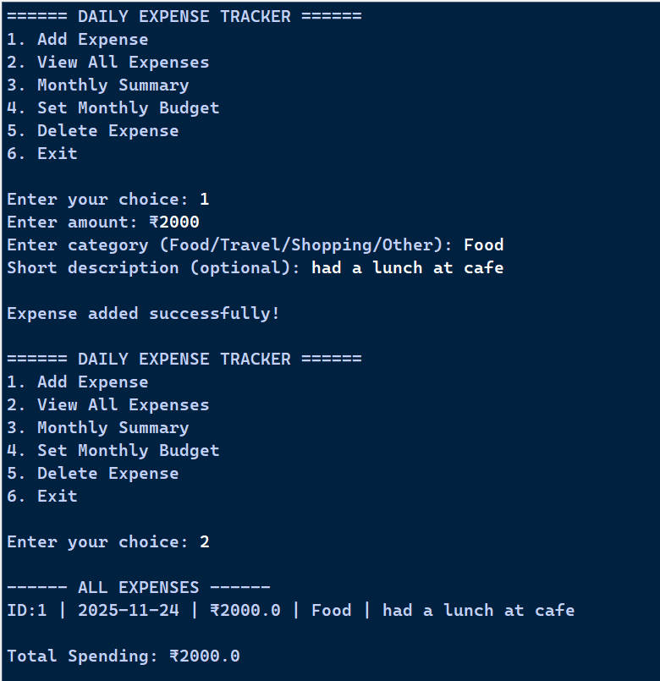
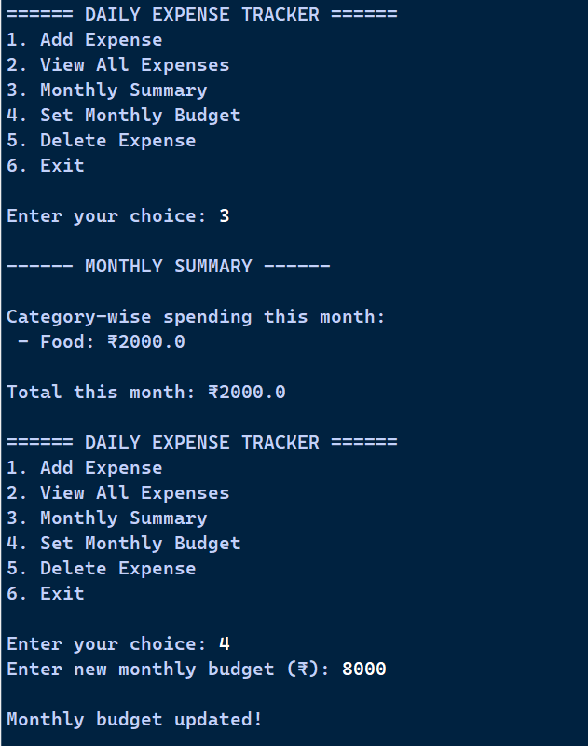 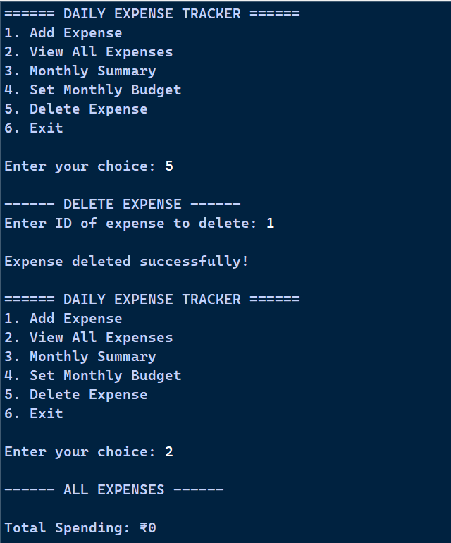 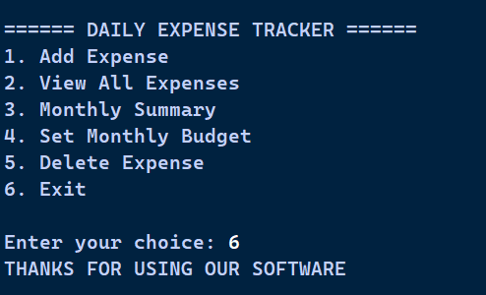
Benefits
- Organized record-keeping - Structured storage eliminates scattered expense notes
- Budget awareness - Real-time comparison prevents overspending
- Financial transparency - Clear category-wise breakdown improves spending insights
- Quick expense removal - Easy deletion of duplicate or incorrect entries
- Data persistence - Expenses retained across multiple program sessions
- User-friendly - Simple menu interface requires minimal technical knowledge
- Cost-effective - No subscription or external tools required
- Scalable - Can handle hundreds of expense records efficiently

Future Enhancement Possibilities
- Database integration (SQLite/MySQL) for handling larger datasets and complex queries
- Export functionality to generate PDF or Excel reports of expenses
- Graphical User Interface (GUI) using Tkinter or PyQt
- Multi-user support with authentication and personalized expense tracking
- Recurring expenses feature for automatic monthly bill entry
- Expense statistics with charts and graphs for visual analysis
- Budget forecasting using historical spending patterns
- Currency conversion for multi-currency expense tracking
- Cloud synchronization for accessing data across multiple devices
- Mobile app version for on-the-go expense logging
- Receipt image attachment and OCR for automatic expense extraction
- Expense filtering by date range, category, or amount
- Email reports of monthly spending summaries
- Barcode scanning for quick product identification and pricing

Conclusion
The Daily Expense Tracker provides an efficient, reliable solution for personal and organizational expense management. By automating expense recording, budget monitoring, and financial analytics, it eliminates manual tracking inefficiencies and provides valuable insights into spending patterns. The modular design ensures easy maintenance and future feature additions, making it suitable for both individual users and small organizations seeking straightforward expense management without complex accounting software.

References
[1] Student Financial Management Study. (2024). Impact of expense tracking on student financial discipline. Journal of Educational Finance, 15(3), 234-245.

