Angular application goes through an entire set of processes or has a lifecycle right from its initiation to the end of the application. The representation of lifecycle in pictorial representation as follows,

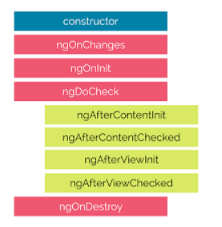

The description of each lifecycle method is as below,

1. **ngOnChanges:** When the value of a data bound property changes, then this method is called.
2. **ngOnInit:** This is called whenever the initialization of the directive/component after Angular first displays the data-bound properties happens.
3. **ngDoCheck:** This is for the detection and to act on changes that Angular can't or won't detect on its own.
4. **ngAfterContentInit:** This is called in response after Angular projects external content into the component's view.
5. **ngAfterContentChecked:** This is called in response after Angular checks the content projected into the component.
6. **ngAfterViewInit:** This is called in response after Angular initializes the component's views and child views.
7. **ngAfterViewChecked:** This is called in response after Angular checks the component's views and child views.
8. **ngOnDestroy:** This is the cleanup phase just before Angular destroys the directive/component.