Name: Vimal Kunwar

Sec: K20YK

Roll no.: 36

Set: 4

Ques1

<!DOCTYPE html>

<html lang="en" dir="ltr">

<head>

<meta charset="utf-8">

<title>CA 1</title>

<link rel="stylesheet" href="styles1.css">

</head>

<body>

<center>

<h1>Student Details</h1>

<div class="container">

<p>Name: Vimal Kunwar</p>

<p>Reg. No : 12002762</p>

<p>Branch : Computer Science and Engineer</p>

<p>Subject : Full Stack Web Development</p>

</div>

</center>

</body>

</html>

body {

background-image: url('logo1.jpg');

background-repeat: no-repeat;

}

.container {

font-style: italic;

font-weight: bold;

size: 24px;

color: blue;

padding: 30px;

border: solid 10px green;

margin: 0 200px 200px 200px;

}

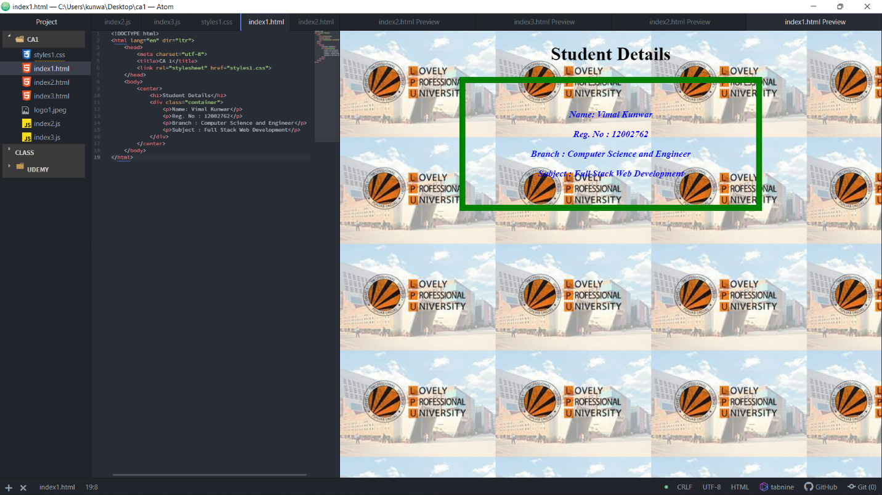

Ques2

<!DOCTYPE html>

<html lang="en" dir="ltr">

<head>

<meta charset="utf-8">

<title></title>

<style>

td,

tr {

border: 1px solid black;

padding: 0 10px;

}

</style>

<script src="index2.js" charset="utf-8" defer="defer"></script>

</head>

<body>

<center>

<h2>Number to Text Converter</h2>

<table>

<tr>

<td colspan="4">&nbsp</td>

</tr>

<tr>

<td id="0">0</td>

<td id="1">1</td>

<td id="2">2</td>

<td id="3">3</td>

</tr>

<tr>

<td id="4">4</td>

<td id="5">5</td>

<td id="6">6</td>

<td id="7">7</td>

</tr>

<tr>

<td id="8">8</td>

<td id="9">9</td>

<td id="0">0</td>

<td></td>

</tr>

</table>

</center>

</body>

</html>

const numbers = document.querySelectorAll(td);

const values = [

"zero",

"one",

"two",

"three",

"four",

"five",

"six",

"seven",

"eight",

"nine",

"zero"

];

for (let i = 1; i < numbers.length; i++) {

numbers[i].addEventListener("click", function() {

const s = values[i.innerHTML];

numbers[0].innerHTML = s;

});

}

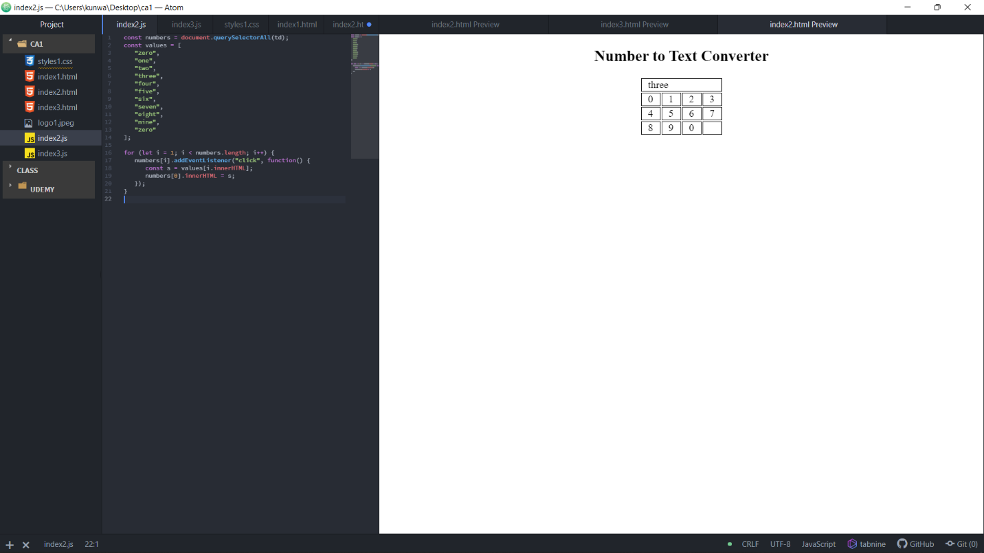

Ques3

<!DOCTYPE html>

<html lang="en" dir="ltr">

<head>

<meta charset="utf-8">

<title></title>

<style>

div {

border: 1px solid black;

padding: 30px;

}

</style>

</head>

<body>

<div id="form">

<h3 classname="form">Form</h3>

<form action="">

<div id="div">

<h3 classname="div">Div</h3>

<div id="p">

<h3>Paragraph</h3>

<p classname="p"></p>

</div>

</div>

</form>

</div>

</body>

<script src="index3.js" charset="utf-8"></script>

</html>

document.querySelector("#form").addEventListener("click", function(e) {

alert("Course Name: Full Stack");

e.stopPropagation();

});

document.querySelector("#div").addEventListener("click", function(e) {

alert("Reg. No: 12002762");

e.stopPropagation();

});

document.querySelector("#p").addEventListener("click", function(e) {

alert("Student Name: Vimal Kunwar");

e.stopPropagation();

});

