1. **Hard copy of the program source (exported from NODE-RED as a json)**

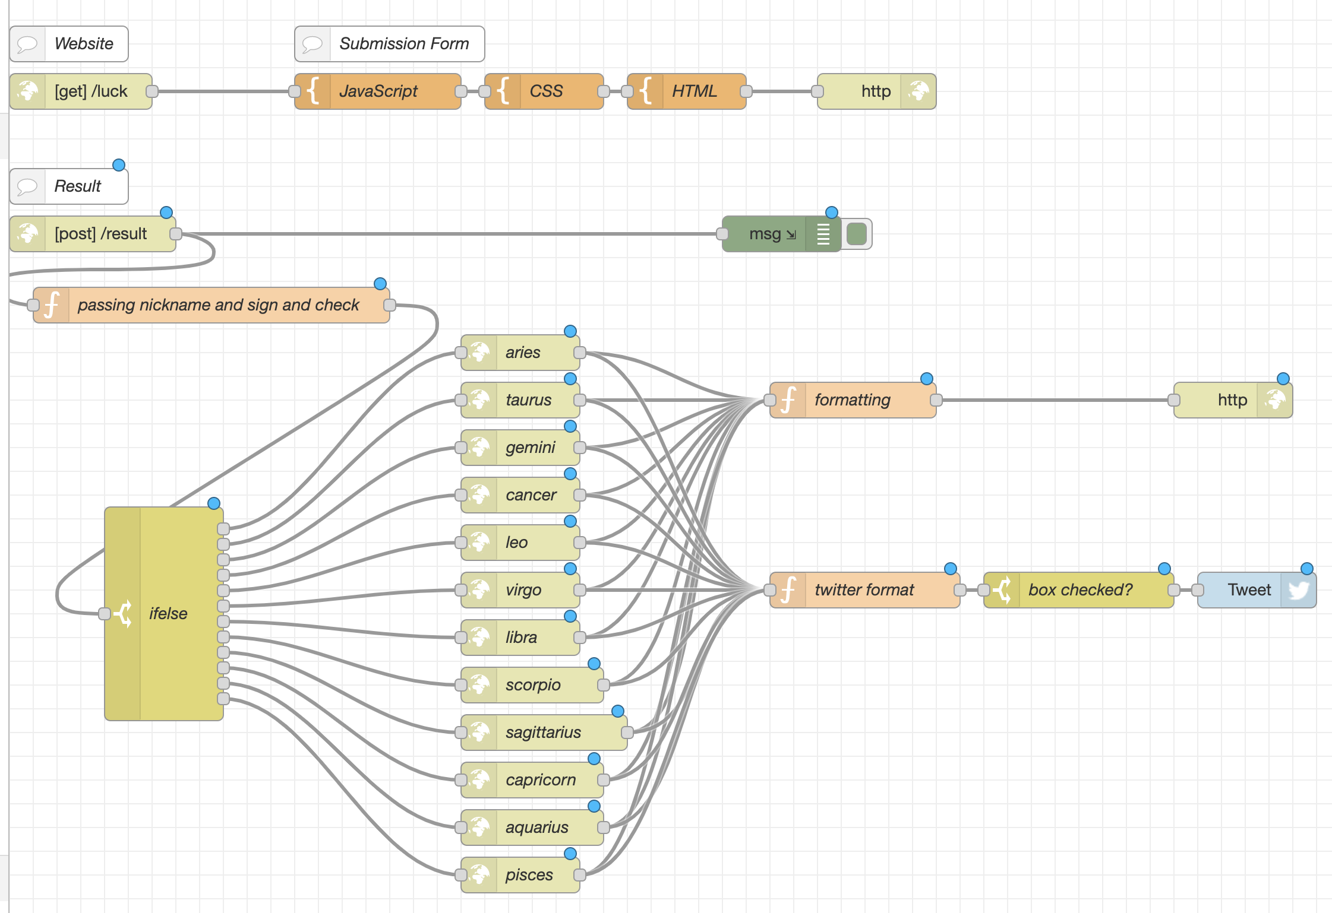

Node-Red Diagram 1

[

{

"id": "1fde196def17a93f",

"type": "tab",

"label": "working on",

"disabled": false,

"info": ""

},

{

"id": "1e0841f1.ac68fe",

"type": "http in",

"z": "1fde196def17a93f",

"name": "",

"url": "/luck",

"method": "get",

"upload": false,

"swaggerDoc": "",

"x": 60,

"y": 280,

"wires": [

[

"b2f5bdf9.e09f1"

]

]

},

{

"id": "80321000.f2dc5",

"type": "debug",

"z": "1fde196def17a93f",

"name": "",

"active": true,

"tosidebar": true,

"console": true,

"tostatus": false,

"complete": "true",

"targetType": "full",

"statusVal": "",

"statusType": "auto",

"x": 650,

"y": 500,

"wires": []

},

{

"id": "b2972258.ecf54",

"type": "template",

"z": "1fde196def17a93f",

"name": "CSS",

"field": "payload.style",

"fieldType": "msg",

"format": "html",

"syntax": "mustache",

"template": "h2 {\n font-family: fantasy;\n}\n\nform {\n font-family: fantasy;\n}\n\ninput[type=text], select {\n width: 100%;\n padding: 12px 20px;\n margin: 8px 0;\n display: inline-block;\n border: 1px solid #ccc;\n border-radius: 4px;\n box-sizing: border-box;\n}\n\ninput[type=submit] {\n width: 100%;\n background-color: #65acca;\n color: white;\n padding: 14px 20px;\n margin: 8px 0;\n border: none;\n border-radius: 4px;\n cursor: pointer;\n font-family: fantasy;\n}\n\ninput[type=submit]:hover {\n background-color: #2f97c4;\n}\n\ndiv {\n border-radius: 5px;\n background-color: #f2f2f2;\n padding: 20px;\n}\n\n#read { \n margin-right:-4px; \n width: 50%;\n background-color: #80d038;\n color: white;\n padding: 14px 20px;\n border: none;\n border-top-left-radius: 4px; \n border-bottom-left-radius: 4px;\n cursor: pointer;\n font-family: fantasy;\n } \n#read:hover {\n background-color: #66ab28;\n}\n#stop { \n margin-left:-3px; \n width: 50%;\n background-color: #b40000;\n color: white;\n padding: 14px 20px;\n border: none;\n border-top-right-radius: 4px; \n border-bottom-right-radius: 4px;\n cursor: pointer;\n font-family: fantasy;\n }\n\n#stop:hover {\n background-color: #900000;\n}\n\n#result {\n font-family: fantasy;\n}\n\n\n",

"x": 450,

"y": 280,

"wires": [

[

"f3b55ea2.f4d51"

]

]

},

{

"id": "b2f5bdf9.e09f1",

"type": "template",

"z": "1fde196def17a93f",

"name": "JavaScript",

"field": "payload.script",

"fieldType": "msg",

"format": "javascript",

"syntax": "plain",

"template": "$(document).ready(function(e) {\n \n $(\"form[ajax=true]\").submit(function(e) {\n \n e.preventDefault();\n \n var form_data = $(this).serialize();\n var form_url = $(this).attr(\"action\");\n var form_method = $(this).attr(\"method\").toUpperCase();\n \n $(\"#loadingimg\").show();\n \n $.ajax({\n url: form_url, \n type: form_method, \n data: form_data, \n cache: false,\n success: function(returnhtml){ \n $(\"#result\").html(returnhtml); \n $(\"#loadingimg\").hide(); \n } \n }); \n \n });\n \n});\n\n",

"x": 310,

"y": 280,

"wires": [

[

"b2972258.ecf54"

]

]

},

{

"id": "d2c0bc2a.05a02",

"type": "http response",

"z": "1fde196def17a93f",

"name": "",

"statusCode": "",

"headers": {},

"x": 730,

"y": 280,

"wires": []

},

{

"id": "f3b55ea2.f4d51",

"type": "template",

"z": "1fde196def17a93f",

"name": "HTML",

"field": "payload",

"fieldType": "msg",

"format": "handlebars",

"syntax": "mustache",

"template": "<html>\n <head>\n <title>Astrology Site</title>\n <meta name=\"viewport\" content=\"width=device-width, initial-scale=1.0\">\n <meta charset=\"utf-8\">\n <script src=\"https://code.responsivevoice.org/responsivevoice.js?key=fBdxjflR\"></script>\n <script src=\"http://cdnjs.cloudflare.com/ajax/libs/jquery/2.1.0/jquery.min.js\"></script>\n <style>{{{payload.style}}}</style> \n </head>\n \n\n <h2>Check your luck of the day!</h2>\n \n\n<div>\n <form method=\"POST\" ajax=\"true\" action=\"/result\"> \n <label for=\"nickname\">Nick name</label>\n <input type=\"text\" id=\"nickname\" name=\"nickname\">\n<br>\n <label for=\"zodiac\">Zodiac Sign</label>\n <select id=\"zodiac\" name=\"zodiac\">\n <option value=\"aries\">Aries 양자리</option>\n <option value=\"taurus\">Taurus 황소</option>\n <option value=\"gemini\">Gemini 쌍둥이</option>\n <option value=\"cancer\">Cancer 게자리</option>\n <option value=\"leo\">Leo 사자자리</option>\n <option value=\"virgo\">Virgo 처녀자리</option>\n <option value=\"libra\">Libra 천칭자리</option>\n <option value=\"scorpio\">Scorpio 전갈자리</option>\n <option value=\"sagittarius\">Sagittarius 궁수자리</option>\n <option value=\"capricorn\">Capricorn 염소자리</option>\n <option value=\"aquarius\">Aquarius 물병자리</option>\n <option value=\"pisces\">Pisces 물고기자리</option>\n </select>\n<br>\n <label><input type=\"checkbox\" id=\"tweet\" name=\"tweet\">Tweet the Result?</label>\n<br>\n <input type=\"submit\" value=\"Submit\">\n </form>\n <button id=\"read\" onclick=\"responsiveVoice.speak(document.getElementById('result').textContent);\n\">Read</button>\n <button id=\"stop\" onclick=\"responsiveVoice.cancel();\">Stop</button>\n \n \n\n</div>\n<div>\n <span id=\"result\"></span>\n</div>\n</body>\n</html>\n<script>{{{payload.script}}}</script>",

"x": 570,

"y": 280,

"wires": [

[

"d2c0bc2a.05a02"

]

]

},

{

"id": "57316751.8bd948",

"type": "comment",

"z": "1fde196def17a93f",

"name": "Submission Form",

"info": "",

"x": 320,

"y": 240,

"wires": []

},

{

"id": "86c08a83.385758",

"type": "comment",

"z": "1fde196def17a93f",

"name": "Website",

"info": "",

"x": 50,

"y": 240,

"wires": []

},

{

"id": "111485fa.14c4aa",

"type": "comment",

"z": "1fde196def17a93f",

"name": "Result",

"info": "",

"x": 50,

"y": 460,

"wires": []

},

{

"id": "6bd70789ec2ecb0d",

"type": "http in",

"z": "1fde196def17a93f",

"name": "",

"url": "/result",

"method": "post",

"upload": false,

"swaggerDoc": "",

"x": 70,

"y": 500,

"wires": [

[

"80321000.f2dc5",

"7a7c8f696250b5f1"

]

]

},

{

"id": "ebe90a906344db6f",

"type": "http response",

"z": "1fde196def17a93f",

"name": "",

"statusCode": "",

"headers": {},

"x": 1050,

"y": 880,

"wires": []

},

{

"id": "be40f2ee8148e4d9",

"type": "switch",

"z": "1fde196def17a93f",

"name": "ifelse",

"property": "payload.zodiac",

"propertyType": "msg",

"rules": [

{

"t": "eq",

"v": "aries",

"vt": "str"

},

{

"t": "eq",

"v": "taurus",

"vt": "str"

},

{

"t": "eq",

"v": "gemini",

"vt": "str"

},

{

"t": "eq",

"v": "cancer",

"vt": "str"

},

{

"t": "eq",

"v": "leo",

"vt": "str"

},

{

"t": "eq",

"v": "virgo",

"vt": "str"

},

{

"t": "eq",

"v": "libra",

"vt": "str"

},

{

"t": "eq",

"v": "scorpio",

"vt": "str"

},

{

"t": "eq",

"v": "sagittarius",

"vt": "str"

},

{

"t": "eq",

"v": "capricorn",

"vt": "str"

},

{

"t": "eq",

"v": "aquarius",

"vt": "str"

},

{

"t": "eq",

"v": "pisces",

"vt": "str"

}

],

"checkall": "true",

"repair": false,

"outputs": 12,

"x": 110,

"y": 880,

"wires": [

[

"e42d5b48be6a1c8e"

],

[

"2aeab3775a8e42cb"

],

[

"2b420c41f070ff33"

],

[

"61790b9fe8cbd942"

],

[

"691e1606e818ac3a"

],

[

"4f472276f279e449"

],

[

"f07c94c6b3d79891"

],

[

"3928a2a0066ffef0"

],

[

"aa3c9cf76301905e"

],

[

"ea53e07dbba02451"

],

[

"51e4a0693090ecbe"

],

[

"bca04ec58d3701bf"

]

]

},

{

"id": "e42d5b48be6a1c8e",

"type": "http request",

"z": "1fde196def17a93f",

"name": "aries",

"method": "POST",

"ret": "obj",

"paytoqs": "ignore",

"url": "https://aztro.sameerkumar.website?sign=aries&day=today",

"tls": "",

"persist": false,

"proxy": "",

"authType": "",

"x": 410,

"y": 660,

"wires": [

[

"bcfe2d3038eed099",

"2e6db7860ad00a67"

]

]

},

{

"id": "2b420c41f070ff33",

"type": "http request",

"z": "1fde196def17a93f",

"name": "gemini",

"method": "POST",

"ret": "obj",

"paytoqs": "ignore",

"url": "https://aztro.sameerkumar.website?sign=gemini&day=today",

"tls": "",

"persist": false,

"proxy": "",

"authType": "",

"x": 410,

"y": 740,

"wires": [

[

"bcfe2d3038eed099",

"2e6db7860ad00a67"

]

]

},

{

"id": "2aeab3775a8e42cb",

"type": "http request",

"z": "1fde196def17a93f",

"name": "taurus",

"method": "POST",

"ret": "obj",

"paytoqs": "ignore",

"url": "https://aztro.sameerkumar.website?sign=taurus&day=today",

"tls": "",

"persist": false,

"proxy": "",

"authType": "",

"x": 410,

"y": 700,

"wires": [

[

"bcfe2d3038eed099",

"2e6db7860ad00a67"

]

]

},

{

"id": "61790b9fe8cbd942",

"type": "http request",

"z": "1fde196def17a93f",

"name": "cancer",

"method": "POST",

"ret": "obj",

"paytoqs": "ignore",

"url": "https://aztro.sameerkumar.website?sign=cancer&day=today",

"tls": "",

"persist": false,

"proxy": "",

"authType": "",

"x": 410,

"y": 780,

"wires": [

[

"bcfe2d3038eed099",

"2e6db7860ad00a67"

]

]

},

{

"id": "691e1606e818ac3a",

"type": "http request",

"z": "1fde196def17a93f",

"name": "leo",

"method": "POST",

"ret": "obj",

"paytoqs": "ignore",

"url": "https://aztro.sameerkumar.website?sign=leo&day=today",

"tls": "",

"persist": false,

"proxy": "",

"authType": "",

"x": 410,

"y": 820,

"wires": [

[

"bcfe2d3038eed099",

"2e6db7860ad00a67"

]

]

},

{

"id": "4f472276f279e449",

"type": "http request",

"z": "1fde196def17a93f",

"name": "virgo",

"method": "POST",

"ret": "obj",

"paytoqs": "ignore",

"url": "https://aztro.sameerkumar.website?sign=virgo&day=today",

"tls": "",

"persist": false,

"proxy": "",

"authType": "",

"x": 410,

"y": 860,

"wires": [

[

"bcfe2d3038eed099",

"2e6db7860ad00a67"

]

]

},

{

"id": "f07c94c6b3d79891",

"type": "http request",

"z": "1fde196def17a93f",

"name": "libra",

"method": "POST",

"ret": "obj",

"paytoqs": "ignore",

"url": "https://aztro.sameerkumar.website?sign=libra&day=today",

"tls": "",

"persist": false,

"proxy": "",

"authType": "",

"x": 410,

"y": 900,

"wires": [

[

"bcfe2d3038eed099",

"2e6db7860ad00a67"

]

]

},

{

"id": "3928a2a0066ffef0",

"type": "http request",

"z": "1fde196def17a93f",

"name": "scorpio",

"method": "POST",

"ret": "obj",

"paytoqs": "ignore",

"url": "https://aztro.sameerkumar.website?sign=scorpio&day=today",

"tls": "",

"persist": false,

"proxy": "",

"authType": "",

"x": 420,

"y": 940,

"wires": [

[

"bcfe2d3038eed099",

"2e6db7860ad00a67"

]

]

},

{

"id": "aa3c9cf76301905e",

"type": "http request",

"z": "1fde196def17a93f",

"name": "sagittarius",

"method": "POST",

"ret": "obj",

"paytoqs": "ignore",

"url": "https://aztro.sameerkumar.website?sign=sagittarius&day=today",

"tls": "",

"persist": false,

"proxy": "",

"authType": "",

"x": 430,

"y": 980,

"wires": [

[

"bcfe2d3038eed099",

"2e6db7860ad00a67"

]

]

},

{

"id": "ea53e07dbba02451",

"type": "http request",

"z": "1fde196def17a93f",

"name": "capricorn",

"method": "POST",

"ret": "obj",

"paytoqs": "ignore",

"url": "https://aztro.sameerkumar.website?sign=capricorn&day=today",

"tls": "",

"persist": false,

"proxy": "",

"authType": "",

"x": 420,

"y": 1020,

"wires": [

[

"bcfe2d3038eed099",

"2e6db7860ad00a67"

]

]

},

{

"id": "51e4a0693090ecbe",

"type": "http request",

"z": "1fde196def17a93f",

"name": "aquarius",

"method": "POST",

"ret": "obj",

"paytoqs": "ignore",

"url": "https://aztro.sameerkumar.website?sign=aquarius&day=today",

"tls": "",

"persist": false,

"proxy": "",

"authType": "",

"x": 420,

"y": 1060,

"wires": [

[

"bcfe2d3038eed099",

"2e6db7860ad00a67"

]

]

},

{

"id": "bca04ec58d3701bf",

"type": "http request",

"z": "1fde196def17a93f",

"name": "pisces",

"method": "POST",

"ret": "obj",

"paytoqs": "ignore",

"url": "https://aztro.sameerkumar.website?sign=pisces&day=today",

"tls": "",

"persist": false,

"proxy": "",

"authType": "",

"x": 410,

"y": 1100,

"wires": [

[

"bcfe2d3038eed099",

"2e6db7860ad00a67"

]

]

},

{

"id": "bcfe2d3038eed099",

"type": "function",

"z": "1fde196def17a93f",

"name": "formatting",

"func": "msg.payload = msg.nname+\"'s luck of the day(\" + msg.payload.current_date + ') as a(n) ' +msg.sign+ ': <br><br>' + msg.payload.description + '<br> <br>You will get along well with a(n) ' + msg.payload.compatibility + '.<br><br>Your lucky color is '+ msg.payload.color + '. Maybe wear '+ msg.payload.color + ' colored items today! <br><br>Your lucky number is ' + msg.payload.lucky_number + ' and your lucky time is '+ msg.payload.lucky_time + '. <br><br>Have a great day!' ;\n\nreturn msg;",

"outputs": 1,

"noerr": 0,

"initialize": "",

"finalize": "",

"libs": [],

"x": 730,

"y": 880,

"wires": [

[

"ebe90a906344db6f"

]

]

},

{

"id": "b8e5d78826489481",

"type": "twitter out",

"z": "1fde196def17a93f",

"twitter": "",

"name": "Tweet",

"x": 1050,

"y": 1180,

"wires": []

},

{

"id": "2e6db7860ad00a67",

"type": "function",

"z": "1fde196def17a93f",

"name": "twitter format",

"func": "msg.payload = msg.nname +\"'s luck as a(n) \" + msg.sign + \" on \" + msg.payload.current_date + ': ' + msg.payload.description; \n\nreturn msg;",

"outputs": 1,

"noerr": 0,

"initialize": "",

"finalize": "",

"libs": [],

"x": 720,

"y": 1180,

"wires": [

[

"e9817cf7deae2be4"

]

]

},

{

"id": "7a7c8f696250b5f1",

"type": "function",

"z": "1fde196def17a93f",

"name": "passing nickname and sign and check",

"func": "msg.nname = msg.payload.nickname;\nmsg.sign = msg.payload.zodiac;\nmsg.tweet = msg.payload.tweet;\nreturn msg;",

"outputs": 1,

"noerr": 0,

"initialize": "",

"finalize": "",

"libs": [],

"x": 150,

"y": 620,

"wires": [

[

"be40f2ee8148e4d9"

]

]

},

{

"id": "e9817cf7deae2be4",

"type": "switch",

"z": "1fde196def17a93f",

"name": "box checked?",

"property": "tweet",

"propertyType": "msg",

"rules": [

{

"t": "eq",

"v": "on",

"vt": "str"

}

],

"checkall": "true",

"repair": false,

"outputs": 1,

"x": 900,

"y": 1180,

"wires": [

[

"b8e5d78826489481"

]

]

}

]