**Practice #2**

Kunyoung Jung

20150894

Professor Ko

CS459

**Zodiac luck of the day**

1. **Brief explanation about the Web services used for the mashup**

I used total of three web services to create my own mash-up service. They are a) Aztro, which is an astrology API that tells your luck of the day depending on your zodiac sign, b) ResponsiveVoice, which is a TTS API, and the c) Twitter API so the mashup can allow users to tweet the result if the user wants to.

1. **Explanation about the mashup application**

I really enjoyed this account called ‘보조오하아사’ on twitter, which allows its followers to receive information about their daily luck each day. My mashup is similar to that account except it only shows the luck description for your zodiac sign. By utilizing ResponsiveVoice, it also allows users to listen to the result with computer-generated voice. If a user wants to receive the result via Twitter, he or she can do that as well by checking the checkbox on the webpage. The shorter version of the result will be posted on the service account (@kj_testbot) for those users.

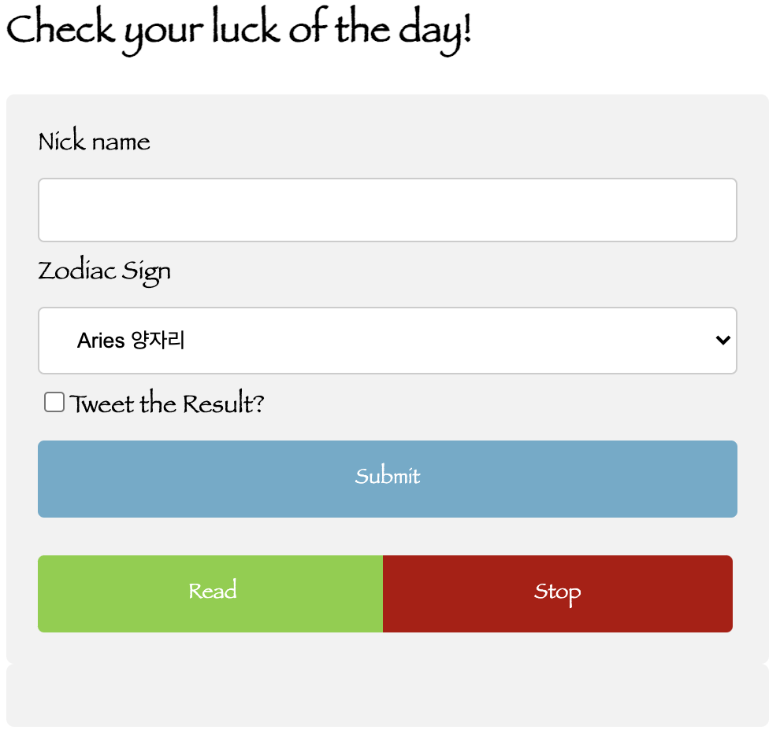

Picture 1 User Access Page

By accessing the site, users can submit their nicknames, zodiac signs with the intention of tweeting the result. Then the service will return the result. Users can then decide to listen to the result via TTS.

1. **Sample results**

User input: Kunyoung for the nick name field, and Libra for Zodiac Sign field. ‘Tweet the Result?’ box was also checked.

Output:

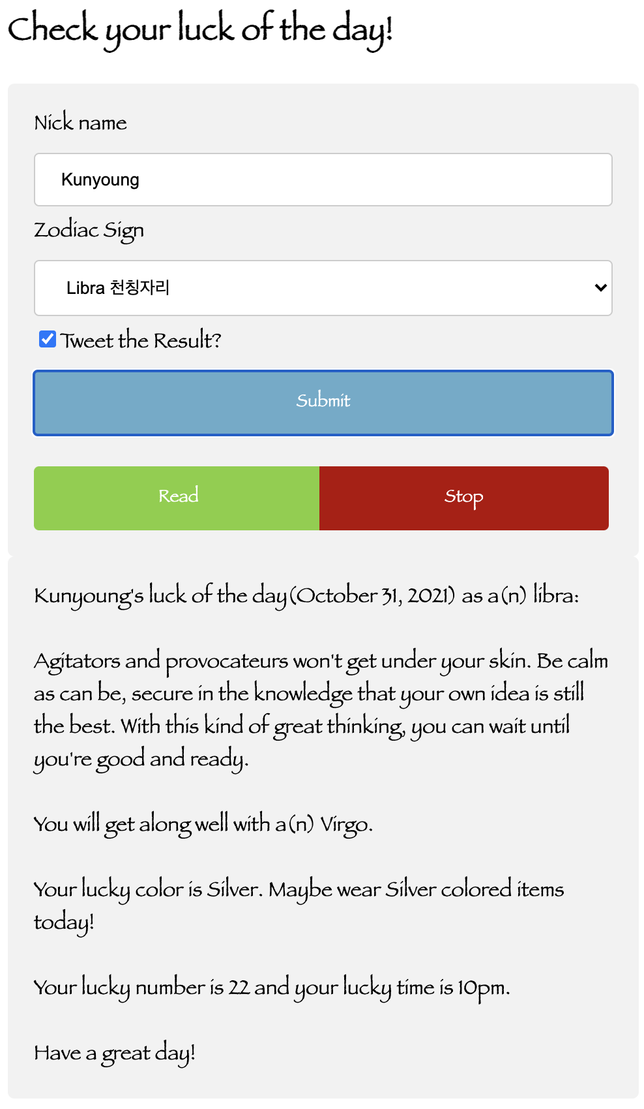

Picture 2 User Input/Output Example

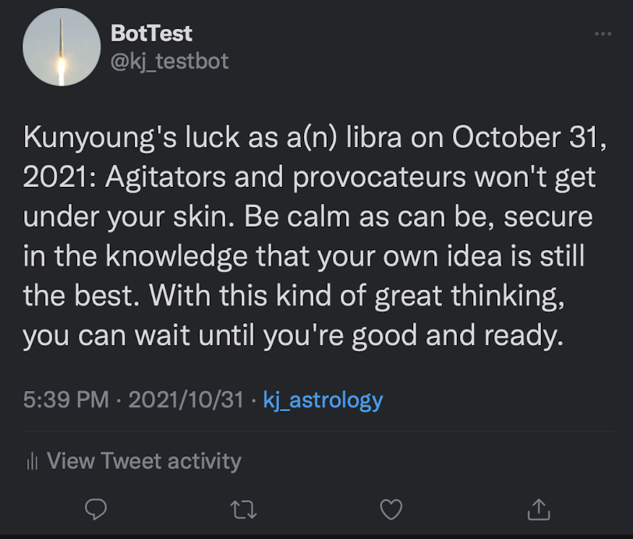

Picture 3 User Output example - Twitter