Life expectancy vs GDP per capita scatter plot by Continent

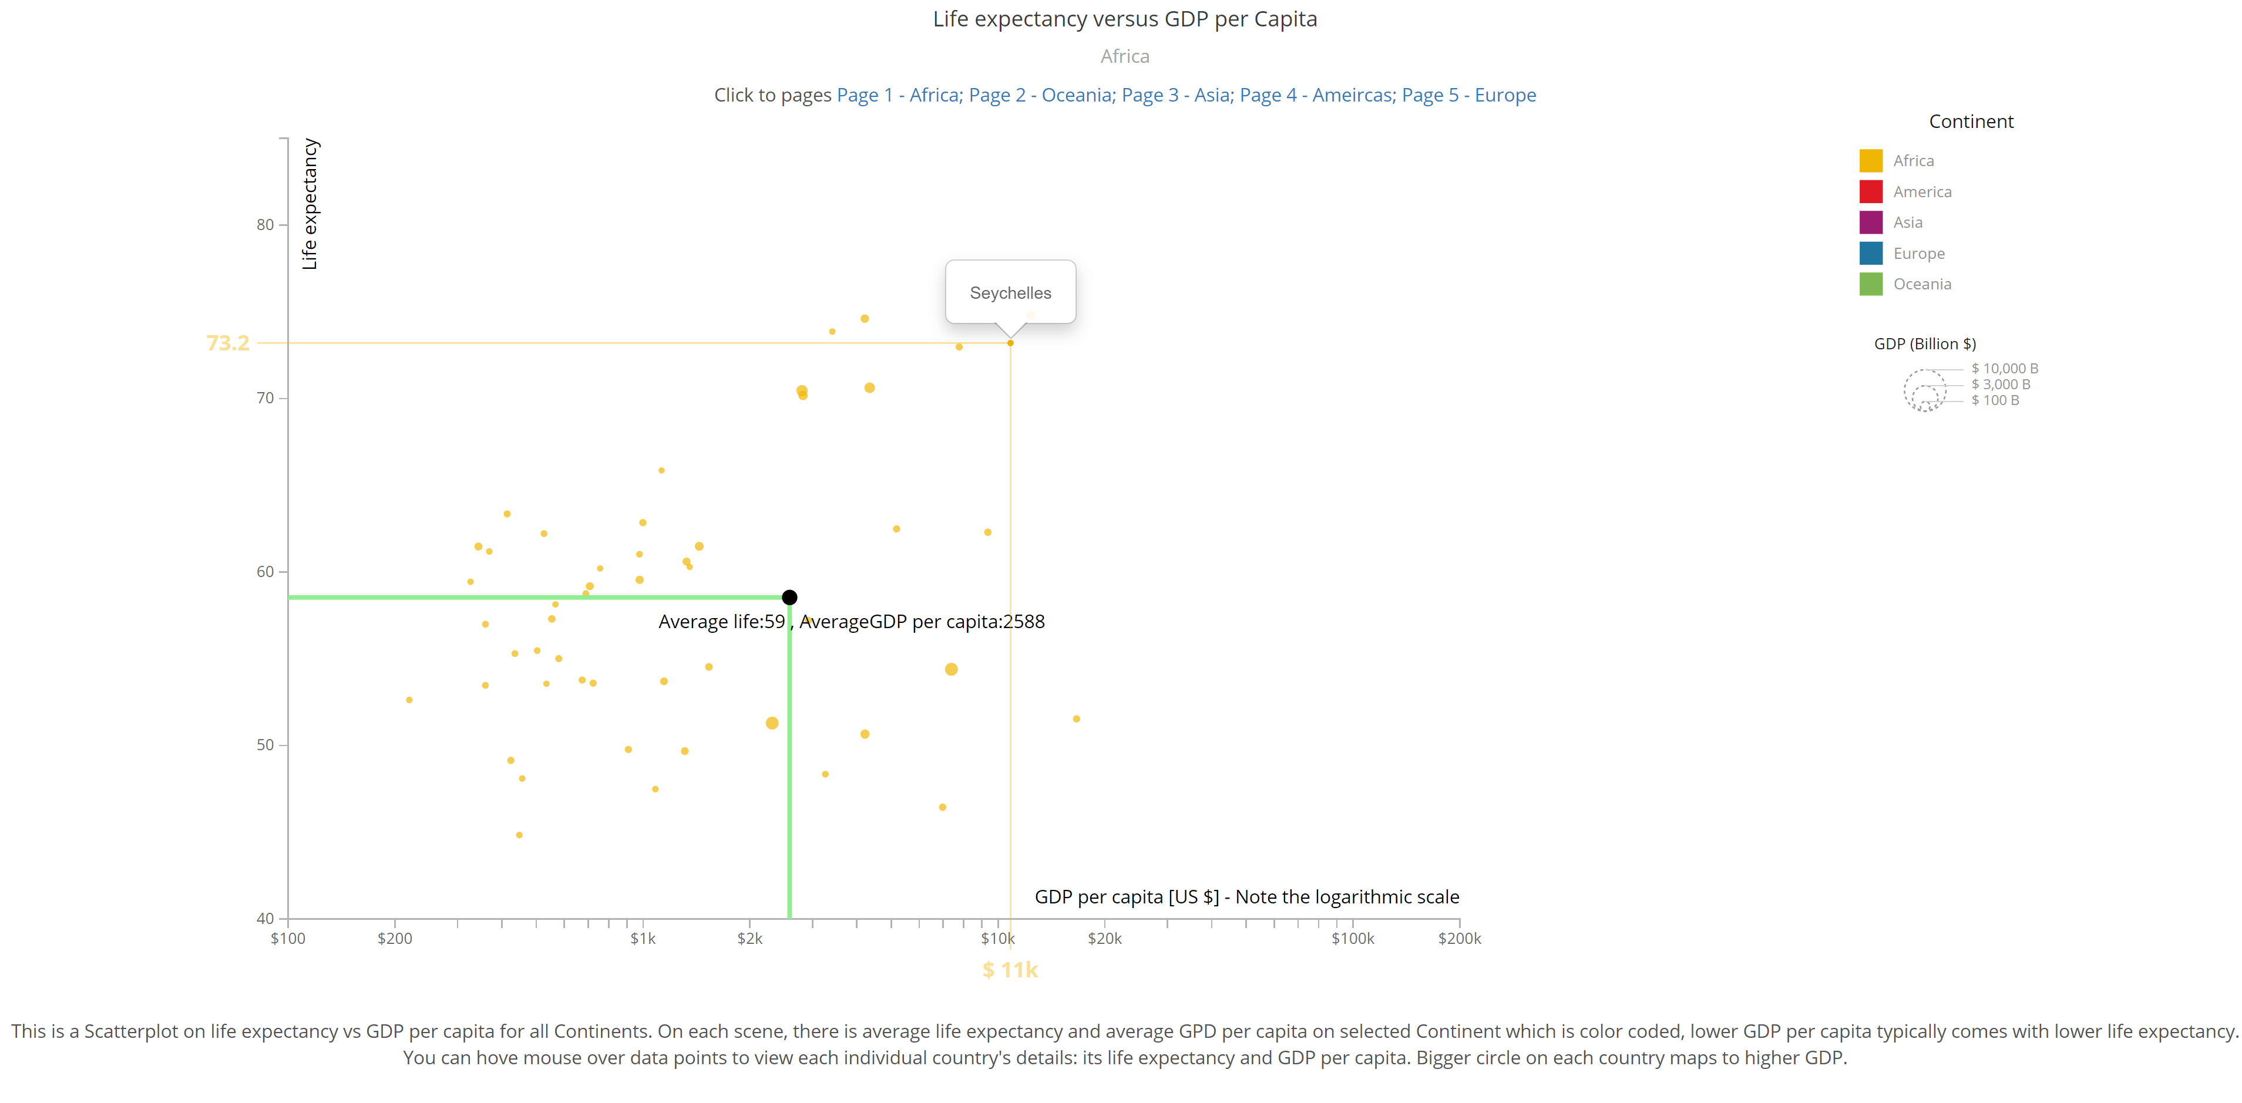

1. Messaging. What is the message you are trying to communicate with the narrative visualization?

There is a correlation between Life expectancy and GDP per capita. In Africa, average GDP per capita is low and average life expectancy is also low. In Europe, countries have higher GDP per capita and higher life expectancy.

1. Narrative Structure. Which structure was your narrative visualization designed to follow (martini glass, interactive slide show or drop-down story)? How does your narrative visualization follow that structure? (All of these structures can include the opportunity to "drill-down" and explore. The difference is where that opportunity happens in the structure.)

Interactive slideshow. The slides start from Africa, which has lowest average life expectancies and average GDP per capita counties, then Oceania, Asia, Americas, and Europe which has highest average life expectancies and GDP per capita. The slide sequence is designed by the author. On each slide, the viewer can explore each country on that continent by demand, such as checking each country on that continent, which has a Voronoi diagram based tooltip. By mouse over a relatively big area the viewer can see the closest country and lines which indicates the exact life expectancy and GDP per capita. Or the viewer can go to the next slide.

1. Visual Structure. What visual structure is used for each scene? How does it ensure the viewer can understand the data and navigate the scene? How does it highlight to urge the viewer to focus on the important parts of the data in each scene? How does it help the viewer transition to other scenes, to understand how the data connects to the data in other scenes?

The scatter plot of each country on the selected continent, with x-axis as log plot of GDP per capita, y-axis as life expectancy is used for each scene. Each scene has its title of continent, legend, color code, etc, which makes the viewer easily get familiar with the scene. Each scene only focuses on countries on one continent. On each scene there is one annotation which highlights the average life expectancies and average GDP per capita. For every scene, the axis scale, color codes and annotations content/style are the same, following the same template, only changing the continent and its countries, which makes transition for the viewer easier.

1. Scenes. What are the scenes of your narrative visualization?  How are the scenes ordered, and why?

Five continents are on five scenes, each scene has a scatter plot of each country on the selected continent, with X-axis as log plot of GDP per capita, Y-axis as life expectancy is used for each scene. The scenes are ordered by lowest average life expectancy (Africa) to highest life expectancy (Europe). In this order, the viewer can see the data points moving toward up and right, with annotations of average also following the same trend. So the author can guide viewers to see the correlation between life expectancy and GDP per capita, along with the scene’s ordering.

1. Annotations. What template was followed for the annotations, and why that template? How are the annotations used to support the messaging? Do the annotations change within a single scene, and if so, how and why?

On each slide, there is a horizontal line which represents the average life expectancy of countries on the continent. There is also a vertical line which represents the average GDP per capita of countries on the continent. There is a block circle with the coordinates and associated text annotation which has an exact number on it. This template can show the viewer exact average life expectancy and GDP per capita on the scatter plot, with a straightforward black circle and X, Y lines to indicate position. This way, the viewer can see the lines moving towards up and to the right, with clear numbers, with slides going to the next pages, so that supports the message: There is correlation between Life expectancy and GDP per capita. In Africa, average GDP per capita is low and average life expectancy is also low. In Europe, countries have higher GDP per capita and higher life expectancy.

The annotations don’t change within a single scene, only change between each scene, and follow the same template.

1. Parameters. What are the parameters of the narrative visualization? What are the states of the narrative visualization? How are the parameters used to define the state and each scene?

Page number, each slide number has its continent to show the data. For example, page 3 corresponds to Asia. Current state is the current continent on that page number. Each page defines the continent, which only shows the countries in that continent, and its unique annotation on the scatter plot.

1. Triggers. What are the triggers that connect user actions to changes of state in the narrative visualization? What affordances are provided to the user to communicate to them what options are available to them in the narrative visualization?

When a user selects a page number, it triggers the continent changes according to the selection, and the calculated annotation will also change. When a user hovers their mouse over the data point, the tooltip will show up with the country name and an X/Y line with its life expectancy and GDP per capita, the scatter plot uses Voronoi diagram to hint that options are available.