# Power losses

The output current $i$ of the PWM-inverter can be assumed to be sinusoidal with a peak value $I_{peak}$

$$i=I_{peak}\cos{(θ-φ)}$$

where $φ$ is the phase-angle difference between output voltage and current, $θ$ is the phase angle of the voltage.

The conduction loss of one IGBT is

$$P_{con, 1}=\frac{V_{FI}I_{peak}}{2π}\int_{-\frac{π}{2}+φ}^{\frac{π}{2}+φ}{D\cos{(θ-φ)} dθ}$$

where $V_{FI}$ is the forward voltage of the IGBT and D is the duty cycle

The conduction loss of one bootstrapping diode is

$$P_{con, 2}=\frac{V_{FD}I_{peak}}{2π}\int_{-\frac{π}{2}+φ}^{\frac{π}{2}+φ}{(1-D)\cos{(θ-φ)} dθ}$$

where $V_{FD}$ is the forward voltage of the bootstrapping diode

The duty cycle at a given $θ$ can be obtained by

$$D=\frac{V_{P}\cos{θ}+0.5V_{DC}}{V_{DC}}$$

where $V_{P}$ is the peak of the output phase voltage and VDC is the DC link voltage

Eventually, the conduction losses is given by

$$P_{con}=P_{con, 1}+P_{con, 2}=\frac{I_{peak}}{2π}\left(V_{FI}+V_{FD}\right)+\frac{I_{peak}V_{p}}{4V_{DC}}\left(V_{FI}-V_{FD}\right)\cos{φ}$$

Assume $I_{peak}=20$

The switching energy losses L of the IGBTs and diodes can be calculated using the linear equations

$$L=(E_{sw(on)}+E_{sw(off)})×i$$

where, Eon is the switching loss (on) characteristic and Eoff is the switching loss (off) characteristic of the semiconducting devices.

The conduction loss of one IGBT and one diode is

$$P_{sw}=\frac{1}{2π}\int_{-\frac{π}{2}+φ}^{\frac{π}{2}+φ}{(E_{sw(on)}+E_{sw(off)})I_{peak}\cos{(θ-φ)}f_{sw} dθ}$$

where fsw is the switching frequency

By integration, we have

$$P_{sw}=\frac{(E_{sw(on)}+E_{sw(off)})× f_{sw}I_{peak}}{π}$$

The values of the switching loss characteristics can be found in the datasheet

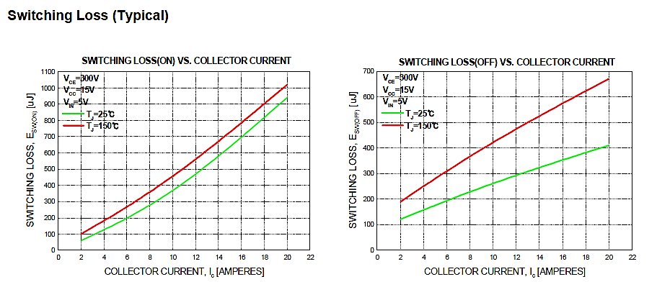

$$C=\frac{1}{2πfR}=\frac{1}{2π×400×18}=22 uF$$

$$f_{sw}=\frac{1}{t_{loop}*\left(Count_{Max}-1\right)+t_{loop_ADC}}$$

where $Count_Max$ is the maximum value of the counter

$$f_{sw}=\frac{1}{t_{loop}*Count_Max}$$

$$f_{sin}=f_{sw}*\frac{M}{NT}=\frac{M}{t_{loop}*Count_Max*NT}$$

$$Number of Table Values \left(NT\right)=f_{PWM}/f_{MODMAX}$$

$$θ=0.0032×108.7×360=125.2$$