Filtration

Abstract
This document details the filtration design of electric protection of the inverter, which incorporates the following parts:
- Background Knowledge
  - Filtration Options
  - DC-link filters
  - Output sine-wave filters
  - Source Filters
  - Line Reactor
  - dv/dt filters
  - Common mode voltage
  - Regenerative braking
  - Shaft voltage and bearing failure
- Design Requirements
- Possible Filters
- Input choke filters
- Sine-wave Output filters
- High-frequency noise filters

1. Background Knowledge

1.1 Filtration Options ^{[2]}
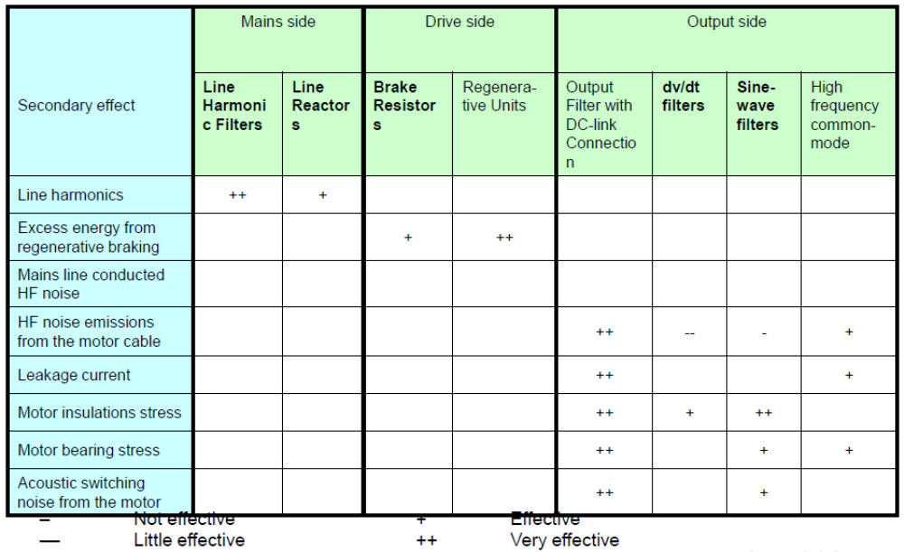

1.2 DC-link filters ^{[1]}
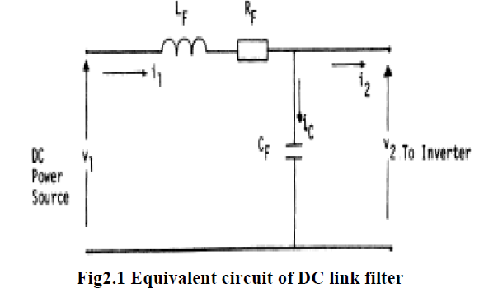
The main component in a DC link filter is the capacitors which usually in the range of mF.

1.3. Output sine-wave filters
A LC sine-wave filter reduces the harmonics of the sinusoidals.
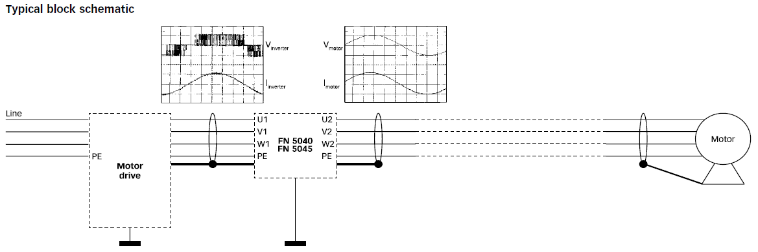

1.4 Source Filters (before rectifier, passive filter)
A source filter reduces noises existing in the AC supply. These filters are generally cheaper than sine-wave filters
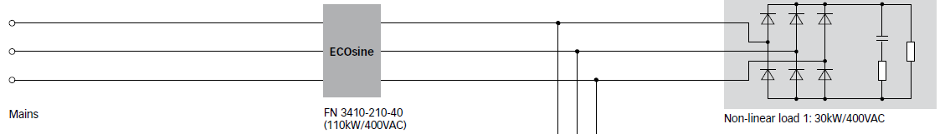

The distortion at the motor is decreased by 5%-8%

1.5 Line reactor
A line reactor is in essence an inductor which reduces harmonics. Possible functions for line reactors.
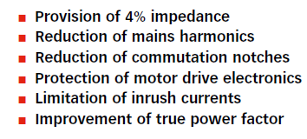

1.6 dv/dt filters
dv/dt filters reduces the values of dv/dt. Compared to sine-wave filters, the dv/dtfilters have a cut-off frequency above the switching frequency. These filters also reduce the motor insulations stress. [6]
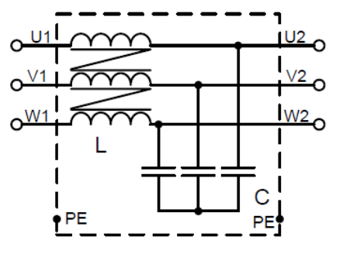

Figure 7. A typical schematic of a dv/ds filter

1.7 Common mode voltage ^{[2]}
Common mode voltage on a motor when applied with a drive is when both conductors experience the same or common voltage level. This can happen when the input voltage on a system is on an ungrounded wye or delta secondary. The voltage input can drift, and neutral is no longer referenced at zero. This results in a higher line to neutral voltage stress on the winding insulation within the motor
The common mode voltage is calculated by Va + Vb + Vc = Vm
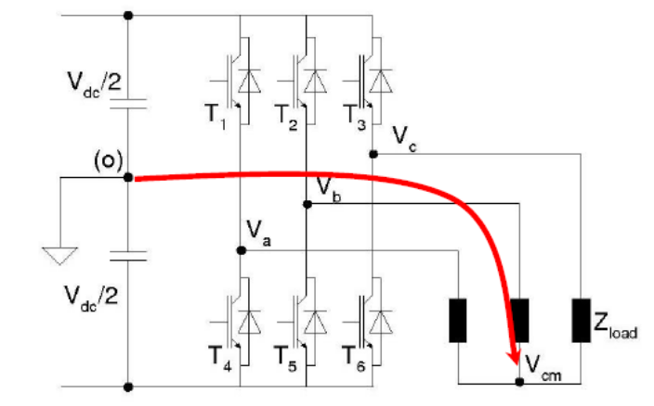

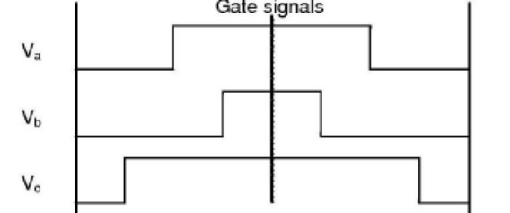

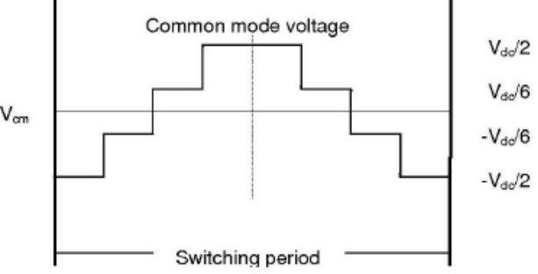

Grounding
For safe and dependable operation, all VFDs must be properly grounded. This normally calls for a grounding conductor (a wire) to be brought back to a single-point grounding location. In this way, the oscilating neutral point becomes static.

1.8 Regenerative braking and braking unit
A regenerative brake slows down a motor by converting its kinetic energy into another form other than dissipated as heat. The most common form of regenerative brake is using an electric motor to generate electricity

In some circumustances, a braking unit is used to dissipate the excess regenerative current. A simple braking unit is merely a resistor that will dissipate the energy as heat. The purpose of using a braking unit is to prevent the excess regenrative current flowing back to the mains or power supply, which will cause undesrible effect, such as noises.

1.9 Shaft Voltage and Bearing failure
Shaft voltage occurs in electric motors and generators due to leakage, induction, or capacitive coupling with the windings of the motor. It can occur in motors powered by variable-frequency drives
Specifically, There is capacitance between the stator windings and the rotor and between the stator windings and the motor frame. The rotor can become “charged” due to this capacitance above can discharge through the motor bearings to ground or through the connected load to ground.
The shaft voltage causes electrical discharges in the bearing. Eventually the bearing fails because of electrical discharge machining
It can be prevented with a grounding brush on the shaft, grounding of the motor frame, insulation of the bearing supports, or shielding

2. Design Requirements
Rated Current (all working temperatures) | 6 A
Application Frequency | 0 - 500 Hz
THD | 5%
Application Power Ratings | 2 kW – 20 kW
It is suggested that three filters are to be implemented: a sine-wave output filter, an input choke filter and a high-frequency noise filter.

3. Possible Filters

3.1 Input choke filters
3.1.1 EMHEATER EM-RAI3-011
The input choke filter is used to minimize noises and surges from the mains. The input choke can reduce distortion to 15% THD. The dimension is shown as follow
Application Power Ratings (kW) | 0.4 - 400
Weight (kg) | 6 (approx.)
Dimensions (L*W*H) (mm) | 130*105*140
Price (USD) | 77.68
Operating Frequency (Hz) | 0 - 60

3.2 Sine-wave Output filters

3.2.1 EMHEATER EM-SWF3-011 Sine-wave Filters
The sine-wave filter has a THD of 3% to 5% for sinusoids.
Application Power Ratings (kW) | 11
Weight (kg) | 20 (approx.)
Dimensions (L*W*H) (mm) | 210*130*135
Price (USD) | 310.51
Operating Frequency (Hz) | 0 - 200
Switching Frequency (kHz) | 4 - 16

3.2.2 EMHEATER EM-RAO3-011 Output Choke
The input choke filter is used to minimize noises and surges from the mains. The input choke can reduce distortion to 10% to 15% THD. The dimension is shown as follow
Application Power Ratings (kW) | 0.4 - 400
Weight (kg) | 6 (approx.)
Dimensions (L*W*H) (mm) | 130*105*140
Price (USD) | 85.86
Operating Frequency (Hz) | 0 - 60

3.2.3 Comparison of Sine-wave filters and Output chokes
The Sine-wave filters are much more expensive than the output chokes. However, they provide several irreplaceable functions:
- Lower THD: 3 – 5 % comparing to 10 – 15% in chokes
- Higher operating frequency range: up to 200 Hz comparing to 60

3.2.4 Schaffner FN 5040-24-84 LC Sine-wave filters
Application Power Ratings (kW) | 11
Rated Current (A) | 21.6 - 24
Weight (kg) | 14.4
Dimensions (L*W*H) (mm) | 330*100*165
Price (USD) | 663.38
Operating Frequency (Hz) | 0 – 200*
Switching Frequency (kHz) | 4 - 16
Overload protection | Yes
* Performance degrades beyond 70 Hz
Schaffner sine-wave filters are more comprehensive in functions. They incorporate overload capability which allows 1.5× rated current for 1 minute. The protection level is 0 for FN5040 and 20 for 5050, which is the same as that of EMHeater one. The weight is lower with a larger size. However, the price is significantly higher.

3.3 High-frequency noise filters

3.3.1 EMHEATER EM-FOT3-011
The filter is used to eliminate noises and dv/dt for the output end.
Application Power Ratings (kW) | 11
Weight (kg) | 5 (approx.)
Dimensions (L*W*H) (mm) | 186*108*256
Price (USD) | 53.15
Operating Frequency (Hz) | 0 - 120
Switching Frequency (kHz) | 0 - 16

3.3.2 FILTEMC FT320FT
Application Power Ratings (kW) | 440V *50A
Weight (kg) | 1.6 (approx.)
Dimensions (L*W*H) (mm) | 135*190*60
Price (USD) | 32.5
Operating Frequency (Hz) | 50/60
FT320FT has similar functions but less bandwidth. The advantage is that the price is lower.

Reference
[1] Schaffner, Output Filters FN 5040 / FN 5045 datasheet, 2012
[2] Danfoss, Secondary effects of variable speed drives, 2011

