Simulations

Abstract
Several simulation models using MATLAB Simulink have been developed

Simulations 1
Abstract 1
1. Filters 1
Input AC Choke 1
EMC Filters 2
Input filters 3
2. Rectification 3
Results 4
3. PWM Generation 4
Triangular wave algorithm 4
Principle of PWM algorithm 6
Look-up Table algorithm 7
Number of Table Values 7
Reference 7
Appendices 8
Appendix 1 Triangular wave algorithm 8

1. Filters
There are three filters implemented in the system to minimize harmonics. They are:
- An input AC choke
- An EMC input filter
- An EMC output filter
These filters are purchased from a manufacturer, EMHeater and hence the filter models in the simulation are developed basing on the datasheets of these filters.

Input AC Choke
The Input AC choke is simply a three-phase inductor with an inductance of 1.5 mH. Internal resistances for the filters and cables have been taken into account by modelling them with resistors in series with the inductors.
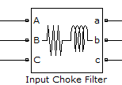
Figure 1 Input AC Choke Model

EMC Filters
EMC input filter and EMC output filter share the same schematic as shown in Figure 2.
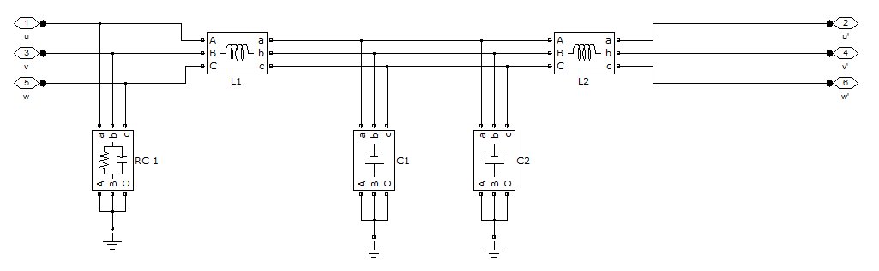

Figure 2 EMC filters schematics

The filters consist of several capacitors and inductors connecting either in series or in parallel with the three-phase input. From left to right, they are:
Label | Storage elements structure | Values
RC 1 | Three-phase parallel RC | R=1.5 MΩ, C= 0.47 μF
L1 | Three-phase inductor | L=0.15 mH
C1 | Three-phase capacitor | C=0.47 μF
C2 | Three-phase capacitor | C=20 nF
L2 | Three-phase inductor | L=0.15 mH
Table 1 Storage elements in EMC filters

The output EMC filter is directly connected to the output of the inverter and its output is fed to the induction motor.

Input filters
The input filters are connected in series with input choke preceding input EMC filter.
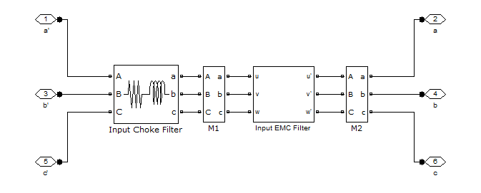

Figure 3 Input filter schematic

2. Rectification
During the rectification section of the system, the AC from the mains is converted into DC feeding into the DC-link capacitor as shown in Figure 4.
- The AC source has been configured in a way that it contains certain odd-order harmonics in addition to 240V AC.
- The rectifier Vrec3 is modelled with a six-diode universal bridge with RC snubbers
- The DC link is composed of an inductor and a large polarized capacitor.

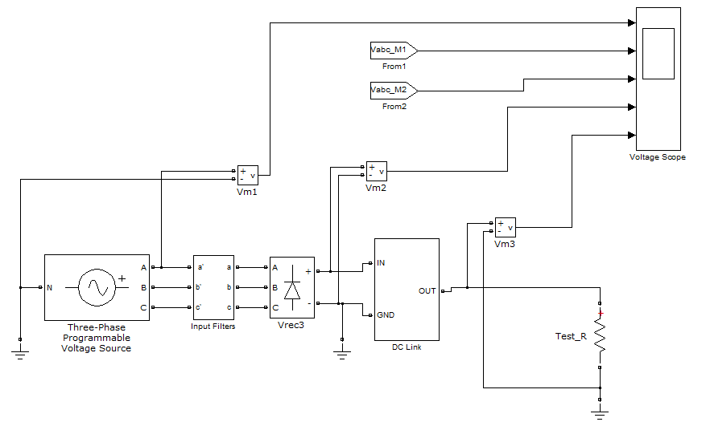

Figure 4 Rectification phase

Results
The measurements were taken at the voltage source and the output of the DC link. It is observed the rectification phase produces a stabilized output containing mainly DC with minimal distortions after 0.02 s. The output voltage in steady state is 160V.
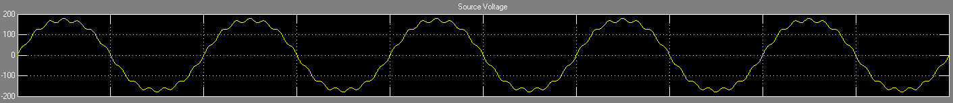

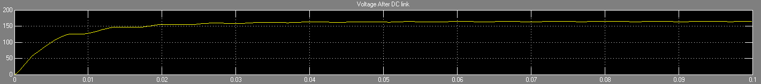

Figure 5 a) Source voltage b) DC output voltage

3. PWM Generation
The PWM is used to control the universal bridge (IGBT power module) with a configuration as shown below
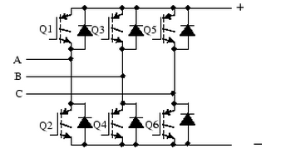

Figure 6 Bridge configuration for IGBT power module

Two algorithms have been proposed for the generation of PWM waveforms
- Triangular wave algorithm
- Principle of PWM algorithm

Triangular wave algorithm
The simplest way to generate a PWM signal is by using a triangular wave. It requires three inputs: two reference signals and a digital clock signal.

The triangular wave can be generated with respect to time (clock) by
tri_wav= (2*amp/(tri_per/2))*abs(mod(t,tri_per)-tri_per/2)-amp;
where tri_per is the period of the triangular wave and amp is the amplitude of the reference signal.
Then, reference signals are compared with the triangular wave in a way that if the reference signal is greater, the PWM control signal becomes 1; otherwise, 0.
The PWM control signals are pairwise inverted signals: the PWM signal for the upper switch in one leg is inverted to the PWM for the lower switch in the same leg.
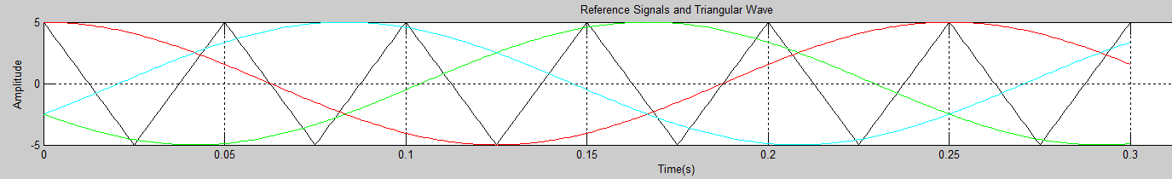

Figure 7 Reference signals and triangular wave

Dead time of switches must be taken into consideration. In this algorithm, a delay has been set for the two switches on each leg. An incrementing timer variable has been used to keep track of the delay time. While any of the two switches on one leg transits from 1 to 0, the other switch would remain at 0 until the preset delay elapses. After the 1-to-0 transition has completed, the other switch is allowed to initiate its 0-to-1 transition. As a result, short circuits would be effectively avoided.
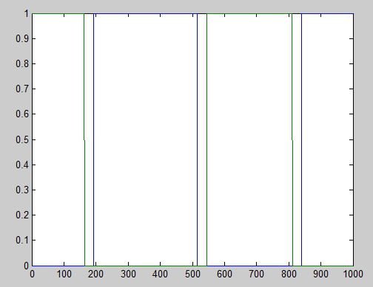

Figure 8 PWM for switch 1 and 2, triangular wave algorithm

The code using triangular wave algorithm can be viewed in Appendix I.

Principle of PWM algorithm
This algorithm bases on the principle of PWM which states the average value of the waveform can be approximated by

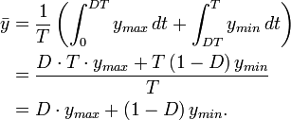

where D is the duty cycle and is given by
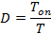

In our case, y_{min} is zero, so the formula is simplified to
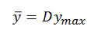

We can obtain the value of y from the reference signal with a predefined period of T. If y is known, we can easily calculate D and Ton. The PWM can thus be generated with Tons in a way that the signal is set for a time Ton within one period. It can be seen that the smaller the period T, the more accurate the PWM.

To implement the algorithm, two clocks are needed with one faster than the other. The slower clock, Timer1, is used to ‘sample’ the reference signal to obtain the y value described above. The faster clock, Timer2, is also necessary to generate the PWM pulse periods as explained later. The ratio of the clock speed R can thus be calculated. R is used to scale the reference signals so that they range from 0 to R. Then it runs through the following routine:
- The counter is reset to 0 when at the positive edge of Timer1. The scaled reference signal X is read.
- Next the counter value C increases its value at a speed of Timer2 until the end of the period
- As long as the counter value C is less than the scaled reference value X, the PWM is set.
- The PWM becomes when the counter value grows greater than the scaled reference value until the period (given by Timer1) ends.

Look-up Table algorithm
One practical way to generate sinusoidal waveform is to use a look-up table, as illustrated by [1]. A look-up table contains discrete values of a sine wave, which are read at periodic interval.
A sine pointer is maintained that defines the present location in the table.

Number of Table Values
A good ‘rule of thumb’ to determine how many values should be used in the look-up table is to divide the PWM carrier frequency by the maximum desired modulation frequency

In our applications, the maximum desired modulation frequency f_{MODMAX} = 400 Hz. The PWM carrier frequency f_{PWM} is chosen to be 16 kHz, above which no audible noises can occur.
Hence the number of values used in the look-up table is
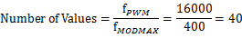

In general, the look-up table length is set to an even power of 2, so a sine table with 64 (=2⁶) would suffice.

Reference
[1] S, Bowling, An Introduction to AC Induction Motor Control Using the dsPIC30F MCU, Microchip Technology, 2005

Appendices

Appendix 1 Triangular wave algorithm

