# My Blog

This repository contains the source code for my personal blog. The blog application allows users to write, post and manages articles. A new article can be created either by writing it directly in Markdown format, or by uploading an existing Markdown file. A Markdown preview is provided alongside with the markdown input, making it easier for users to write or edit. Markdown images syntax is supported so that users can upload a Markdown file with accompanied images together.

The blog is developed with React as frontend and ASP.NET Core as backend.

## Getting Started

Clone the repository and run in development mode in Visual Studio.

## Description

### Create and Edit Articles

To create or edit an article, a user can follow the steps below:

1. Log into the application and go to Create or Edit page.
2. Drag Markdown file and images folder together and drop onto the page.

1. When texts and images are uploaded, add tags if required.

1. Check if images are well-displayed, add/change images if required.

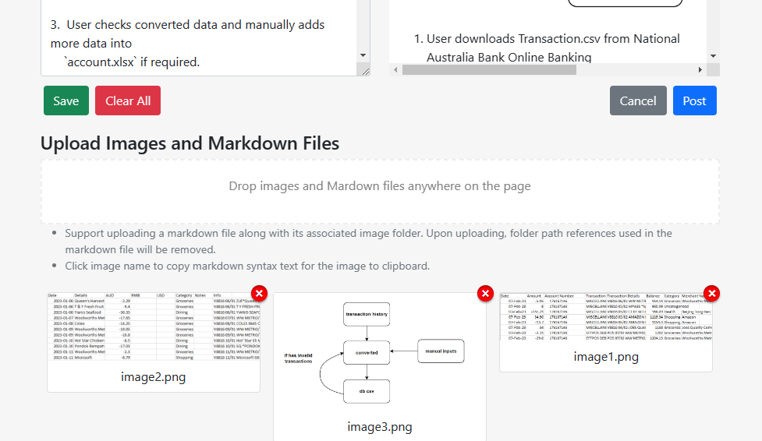

1. Post the article.

It may come handy to use *pandoc* to convert articles in .docx to .md and extract embedded images. An example of pandoc command can be:

pandoc ./README.docx –to=gfm -o README.md –extract-media=_readme

Note:

* Users can download written markdown text by clicking “Save” button.
* Clicking image names copy image name in markdown format, such as ![example_1]( example_1.png), to clipboard.

### Markdown Format

GitHub Flavored Markdown (gfm) is chosen as the dialect for Markdown format. Code snippets, math equations and raw html tags are also supported.

### Security

A user needs to be logged in as administrator to be able to perform CRUD operations.

### Other Features

* Abstract of articles are loaded and displayed initially, full articles can be fetched and displayed by clicking “more” button. The full articles can be collapsed.
* Clicking tags will filter articles by tags’ names.
* Clicking sidebar’s email address will copy it to clipboard.
* Users can choose to be “stayed logged in.”

Technologies Used

* React 17.0.2
* ASP.NET Core 6.0.13
* .NET Packages: ASP.NET Core Identity, EF Core, etc.
* React Packages: react-markdown, react-icons, react-router, rectstrap, remark, rehype, etc.