**一，压缩包形式安装**

1，下载地址：

<https://github.com/docker/compose/releases/tag/1.24.1>

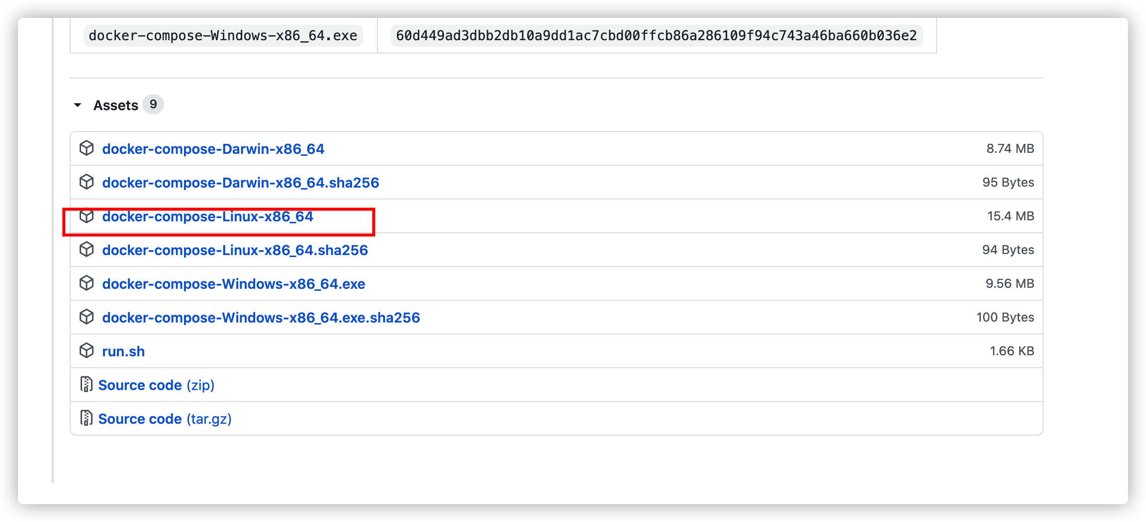

2，下载后拷贝在/usr/local/bin下，重命名为docker-compose

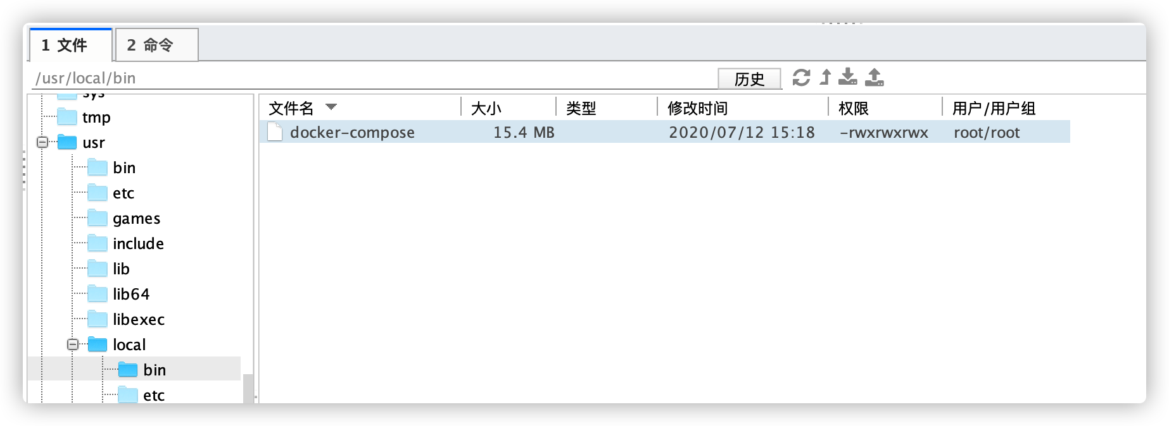

3，加权限

chmod +x /usr/local/bin/docker-compose

4，验证

docker-compose -v

**二，yum安装docker-compose(不建议这么安装，会造成版本问题)**

**参考：**https://www.cnblogs.com/JustToDoIt/p/12266420.html

1**.安装EPEL yum源**

yum install epel-release -y

**2.安装pip**

yum install python-pip -y

**3.升级pip**

pip install --upgrade pip

**4.安装docker-compose**

pip install docker-compose

但是第四步安装时发生error  
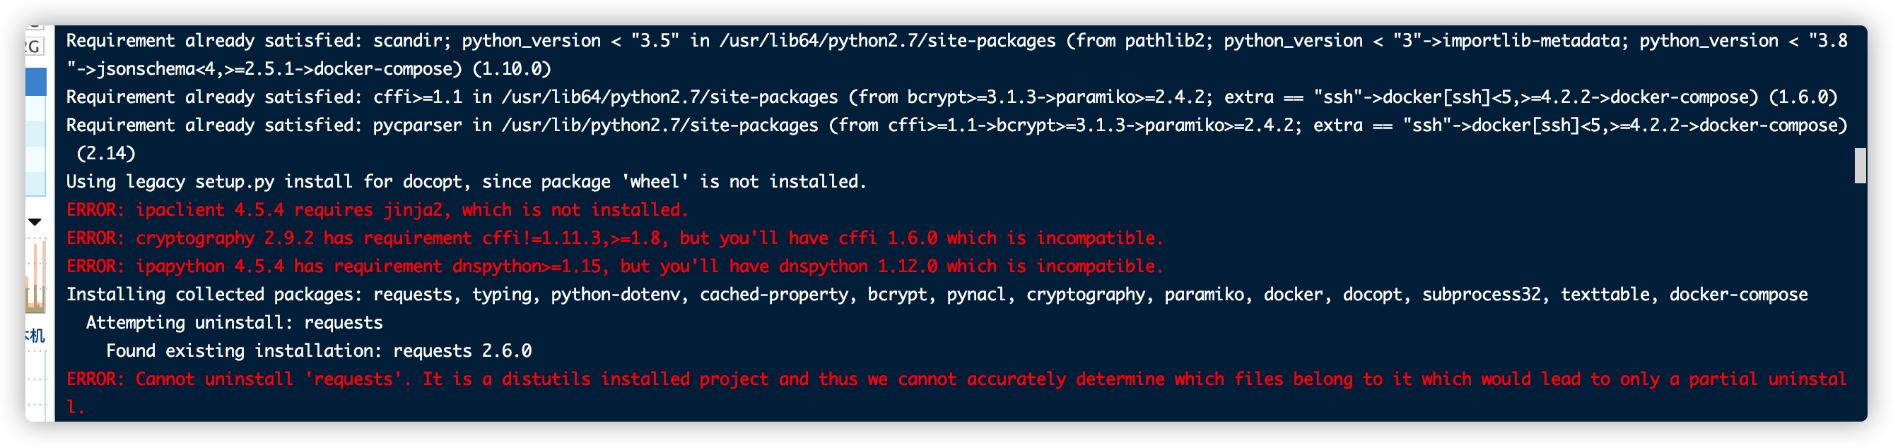  
以下是遇到的几个报错及解决措施(执行解决代码后要继续安装docker-compose)

Error1：

**ERROR: cryptography 2.8 has requirement cffi!=1.11.3,>=1.8, but you'll have cffi 1.6.0 which is incompatible.**

执行代码

pip install cffi --user -U

Error2：

**ERROR: Cannot uninstall 'requests'. It is a distutils installed project and thus we cannot accurately determine which files belong to it which would lead to only a partial uninstall.**

执行代码

pip install --ignore-installed requests