TSMC Cross-Market Pricing and Overnight Information
Lead Signals from ADR, SOX, and FX: Forecasting, Execution, and Backtest Robustness
Quantitative Trading Course Final Report · AlphaEdge

Generated: May 09, 2026

Executive Summary
This report finds statistically strong overnight lead information in TSM ADR, SOX, and USD/TWD, but not robust tradable alpha under the lot-based, fee-realistic execution tested here. The vectorized full-notional backtest is used only as a diagnostic contrast, not as a standalone profitability claim. Ridge serves as an interpretable linear forecasting baseline, while simpler directional benchmarks may deliver stronger realized performance under the same execution assumptions. Therefore, the core finding is the gap between statistical predictability and implementable trading performance.
Disclaimer: For academic use only; not investment advice. Live trading involves liquidity, fees, regulation, and execution gaps.

1. Research Question and Economic Rationale
Research question: after U.S. overnight information is embedded in prices, do TSM, SOX, and USD/TWD jointly contain lead information for the Taiwan-session return of TSMC? Economic rationale: ADR and sector proxies summarize global demand and risk appetite; FX links cross-market valuation. Cross-market studies emphasize price discovery and lead-lag structure across venues (Hasbrouck 1995); we treat U.S. overnight information as a candidate lead set for same-day Taiwan returns and corroborate timing with placebo-shift IC checks.

2. Data, Timing, and Feature Alignment
Training: calendar 2020. Validation: 2021 for Ridge lambda. Test OOS: 2022-01-01 through the last available TW close (2026-04-24), matching run_meta.test_end_effective_last_tw_close. The download upper bound is recorded as data_end_requested = 2026-04-25 (may differ by one calendar day from the last bar).
Dataset Item | Specification
Data download request | See run_meta: data_end_requested = 2026-04-25
Training set | 2020-01-01 to 2020-12-31
Validation set | 2021-01-01 to 2021-12-31
Test set (OOS) | 2022-01-01 to 2026-04-24 (last TW close in sample)
Sources | Taiwan close: project SQLite; U.S./FX: yfinance daily, auto_adjust
Benchmarks | Primary: 2330.TW buy-and-hold; optional market benchmark: 0050 ETF

3. Execution Timing and Return Definition (Limitation)
Lead variables are observable before the Taiwan open. For strict tradability, the natural target is Taiwan open-to-close return. This report uses close-to-close as a daily proxy aligned with closing prices. Limitation: close-to-close embeds the overnight gap; part of that move may be difficult to capture with an open fill. Statistical IC can still hold while open-to-close alpha differs. Execution friction and microstructure considerations are discussed broadly in Harris (2003); this report nonetheless adopts close-to-close as the common statistical proxy. Next step: retarget to open-to-close (or open fills).

4. Model Design
Ticker (yfinance) | Role
TSM | TSMC ADR, prior U.S. session return
2330.TW | Target and primary buy-and-hold benchmark
^SOX | Semiconductor sector proxy
TWD=X | USD/TWD spot (simplified)

Ridge with intercept; L2 on slopes only. Lambda from 2021 validation MSE; coefficients re-fit on train+val.
Coefficient (re-fit on train+val) | Value
intercept | -0.000053
r_tsm_us | 0.265687
r_sox_us | -0.041514
r_twd | 0.516389

Penalty: validation-selected lambda = 0.0009236708571873865 is small, so Ridge is close to OLS in this sample. We retain Ridge as the stated specification for shrinkage comparability and mildly stabilized slopes.
Coefficient narrative: TSM and USD/TWD load positively; SOX loads negatively-consistent with ADR absorbing sector beta so SOX behaves like a residual control under multicollinearity (signs are conditional, not causal). Directional baselines may achieve higher realistic cumulative returns under the same execution mapping; logistic or TSM-sign implementations may be preferred operationally. This pattern suggests the overnight signal may be more useful for directional classification than for continuous return forecasting under the pred>0 rule.

4.1 Baseline models (test-set results)
Model | Test IC | Vectorized cum. return | Realistic cum. return | Vectorized Sharpe | Realistic Sharpe
Ridge | 0.4553 | 1162.99% | -14.96% | 2.842 | -0.347
OLS | 0.4396 | 1015.47% | -14.66% | 2.693 | -0.381
Logistic (direction) | 0.5281 | 1764.45% | 9.74% | 3.469 | 0.081
TSM sign only | 0.5208 | 1729.31% | 9.08% | 3.335 | 0.073

Interpret tradable outcomes using the realistic column. Vectorized metrics are diagnostic only. When logistic or TSM-sign rules outperform Ridge on realistic cum. return, treat it as evidence that the signal may pack more information in direction than in continuous point forecasts under this mapping.

4.2 Passive benchmarks (test window)
Benchmark (test window) | Cumulative return
2330.TW buy-and-hold (test window) | 255.28%
Cash (flat, zero daily return) | 0.00%

5. Backtest Implementation and Trading Costs
Primary result engine (realistic): initial cash 1000000.0 TWD; Taiwan common stocks trade in integer lots of 1000.0 shares; odd lots are not modeled. If long is desired but cash cannot afford one lot, the strategy stays flat that day (signal vs execution gap). The 1M TWD baseline intentionally stresses implementability for a small-account profile; institutional-scale capital or odd-lot policies would change which constraint binds.
Daily close-booking pseudo-code: (1) Compute pred; default rule long if pred > 0 else flat. (2) If target long and currently flat: buy maximum affordable lots; pay buy-side fee. (3) If target flat and currently long: sell entire position at close; pay sell fee plus transaction tax. (4) If target equals yesterday's position: no trade, no fee. (5) Mark equity with cash plus marked-to-market stock.
Close-price booking matches the close-to-close return specification used throughout this report; it is not asserted as an executable open-session fill on the Taiwan cash session. Future work should prioritize open-to-close targeting or a small open-print AB test against this proxy.
Fees: buy fee rate 0.001425 (~0.1425%); combined sell fee plus tax 0.004425 (~0.4425%). Accounting: buy cash need ≈ price × shares × (1 + buy fee); sell proceeds ≈ price × shares × (1 - sell-side fee rate).
Vectorized diagnostic: continuous notionals, same-day signal times close-to-close return, fees only on 0↔1 switches.

6. Vectorized Backtest (Diagnostic Contrast, Not Primary)
Metric | Vectorized (idealized)
Trading days (test set) | 1041.0
Strategy cumulative return (wealth ratio - 1) | 11.6299 (wealth approx 12.63x)
Buy and hold cumulative return | 2.5528 (wealth approx 3.55x)
Strategy CAGR | 80.26%
Buy and hold CAGR | 34.25%
Strategy annualized volatility | 21.74%
Strategy Sharpe (daily, Rf approx 2% p.a.) | 2.842
Buy and hold Sharpe | 1.075
Strategy max drawdown (MDD) | -12.07%
Buy and hold MDD | -45.68%
Calmar ratio (est.) | 6.65
Hit rate on long days | 63.79%
Ridge penalty lambda (from validation) | 0.000924
Buy-side fee rate | 0.14%
Sell fee plus transaction tax | 0.44%

7. Realistic Backtest (Integer Lots — Primary)
Metric | Realistic / lot-based
Trading days (test set) | 1041.0
Strategy cumulative return (wealth ratio - 1) | -0.1496 (wealth approx 0.85x)
Buy and hold cumulative return | 2.5528 (wealth approx 3.55x)
Strategy CAGR | -3.69%
Buy and hold CAGR | 34.25%
Strategy annualized volatility | 14.16%
Strategy Sharpe (daily, Rf approx 2% p.a.) | -0.347
Buy and hold Sharpe | 1.075
Strategy max drawdown (MDD) | -25.89%
Buy and hold MDD | -45.68%
Calmar ratio (est.) | -0.14
Hit rate on long days | 33.13%
Ridge penalty lambda (from validation) | 0.000924
Buy-side fee rate | 0.14%
Sell fee plus transaction tax | 0.44%

8. Reconciling Vectorized and Realistic Results
The table below decomposes why two engines fed by the same signal can flip sign on cumulative performance. When the gap is large, the first response should be to audit fills, cost accounting, and the position path-not to reinterpret the signal in isolation.
Item | Vectorized backtest | Realistic backtest | Potential impact
Fill / return definition | Continuous compounding; same-day signal times close-to-close return | Integer lots, close prints, cash and fees/taxes booked per trade | Holding-period and investable cash differ materially
Transaction costs | Fees on discrete 0↔1 position toggles only | Same rule family, but cash constraints may skip desired long exposure | High turnover amplifies friction and lot discreteness
Position path | Ideal binary daily exposure | Actual holdings constrained by lot size and affordability | Cannot replicate full-notional scaling
Capital / lot constraint | Full-notional exposure to the signal is always feasible under continuous capital | May stay flat when desired long but one board lot is unaffordable | Explains part of the IC-PnL gap (signal long but flat); ties to capital sensitivity
Headline metrics (cum. / CAGR / Sharpe / MDD) | 11.6299 (wealth ~12.63x) / 80.26% / 2.842 / -12.07% | -0.1496 (wealth ~0.85x) / -3.69% / -0.347 / -25.89% | When signs disagree, favor the execution-faithful path and explain the gap

9. Signal Diagnostics: IC, IC–PnL Gap, Thresholds, Stability
Diagnostic | Value
Test-set IC (Pearson, pred vs realized return) | 0.4553
Approximate t-statistic for IC (diagnostic) | 16.483
Test-set trading days n | 1041

Note: the headline test-set IC (0.4553) comes from signal_ic_test.csv-Pearson correlation on the test-window **full Taiwan-session calendar** used for execution (`exec_df`), where dates without a merged feature row carry pred filled as zero. The Section 9.1 placebo baseline IC (0.4676) uses the same coefficients but evaluates predictions only on the **strict merged feature panel** (`panel_test`). The small gap reflects different effective row sets and missing-row handling, not two IC formulas or mixed report versions. In plain English: the two IC figures use different valid daily row sets, not different forecasting models.
An unusually high daily IC warrants skepticism beyond favorable interpretation: manually audit matched U.S.-Taiwan calendar dates in future work. The placebo-shift table below provides a fast screen against alignment artifacts.

9.1 Feature-shift placebo (±1 TW panel row)
Alignment variant | Pearson IC
Baseline (correct alignment) | 0.4676
Placebo: U.S. features shifted -1 TW row | 0.0360
Placebo: U.S. features shifted +1 TW row | 0.2420

Interpretation: if IC collapses under misalignment but stays high under correct joins, the ranking signal is more credible; persistently high placebo ICs would warrant revisiting merge logic and holidays. The +1 row-shift placebo IC remains positive (see table), which suggests that some return persistence or residual calendar overlap may remain. Therefore, the placebo test reduces alignment concerns but does not fully eliminate them; a manual audit of matched U.S.-Taiwan dates remains necessary.

9.2 IC versus realistic PnL (gap decomposition)
IC ranks forecasts; it does not guarantee profitability after fees, discrete lots, or missed strong days when flat. Days with desired long signal but flat holdings: ~18.3% of the sample (~190 days). In the 2026 partial sample: 71 sessions, pred>0 on ~39 days, yet held-long days = 0 because cash could not afford one lot-explaining ~0% strategy return despite a rising benchmark.
Capital sensitivity (same fee rules; only initial cash varies) isolates how much headline realistic performance depends on lot affordability rather than the signal alone.
Initial capital (sensitivity) | Realistic cum. return | Realistic Sharpe | Realistic MDD
1M TWD | -14.96% | -0.347 | -25.89%
3M TWD | -12.26% | -0.162 | -41.98%
5M TWD | -7.41% | -0.083 | -39.43%
10M TWD | -15.35% | -0.166 | -44.42%

Capital sensitivity does not improve monotonically as initial capital increases. This indicates that lot affordability explains part of the IC-PnL gap, but the larger issue remains the realized timing path and the mismatch between close-to-close statistical prediction and executable trading returns. Larger capital increases affordable position size and exposure to adverse timing, so more capital does not mechanically improve risk-adjusted returns.

9.3 Ridge forecast threshold sweep (realistic)
Tau is the minimum predicted daily return required to go long (5 bp = 0.05% = 0.0005).
Threshold τ on forecast return | Realistic cum. return | Realistic Sharpe | Realistic MDD
0 (baseline) | -14.96% | -0.347 | -25.89%
5 bp | -19.86% | -0.595 | -31.95%
10 bp | -24.67% | -0.780 | -34.01%
20 bp | -3.54% | -0.229 | -28.01%

Raising tau reduces turnover and losses versus the baseline, but Ridge remains negative across this sweep-suggesting the gap is not only overtrading but also signal-to-execution mismatch (including the close-to-close target).

9.4 Year-by-year breakdown
Year | IC | Strategy cum. | 2330 B&H cum. | Approx. round trips | Strategy MDD
2022 | 0.4767 | -14.24% | -27.07% | 62.5 | -25.89%
2023 | 0.4643 | -5.25% | 32.22% | 58.5 | -23.05%
2024 | 0.5404 | 26.19% | 81.28% | 41.0 | -22.93%
2025 | 0.3489 | -17.06% | 44.19% | 5.0 | -20.10%
2026 YTD (partial) | 0.4269 | 0.00% | 40.97% | 0.0 | -20.10%

Approx. round trips: add 0.5 on each day the discrete position flips between flat and long; stable long or stable flat contributes 0. The annual sum is a round-trip proxy, not traded share volume.

10. Robustness and Sanity Checks

10.1 Methods used in this report
Method | Purpose
Ridge regression (L2 regularization) | Controls overfitting and multicollinearity, producing more stable coefficients and better out-of-sample robustness.
Train / validation / test split | Separates tuning from final evaluation to reduce leakage and optimistic bias.
Log-grid search for lambda | Systematically selects regularization strength to balance bias and variance.
Long-or-flat signal mapping | Converts continuous forecasts into executable positions while reducing shorting and friction constraints.
Transaction cost modeling (fees, tax) | Transforms gross returns into net returns closer to realistic implementation.
Equity curve | Shows capital growth path and compounding behavior over time.
Maximum drawdown (MDD / underwater) | Measures worst peak-to-trough loss and downside tolerance.
Rolling Sharpe ratio | Monitors persistence of risk-adjusted performance through time.
Annual IC and rolling IC | Evaluates predictive signal relevance and stability, including potential alpha decay.
Monthly return heatmap | Visualizes return clustering and regime sensitivity by calendar month.
Buy-and-hold benchmark comparison | Checks whether the strategy adds alpha and improves risk control versus passive exposure.

Validation-driven lambda selection carries mild multiple-testing / data-snooping risk; Lo & MacKinlay (1990) formalize why small-sample tuning can inflate apparent predictability-consistent with treating Ridge as a disciplined baseline rather than a standalone discovery claim.

10.2 Sanity checks (with status)
Check | Status | Result | Remaining risk
Look-ahead (features vs TW date) | Pass (by construction) | Each TW row uses the last completed U.S. session strictly before the TW calendar date. | Manually audit several matched U.S.-Taiwan calendar dates in future work.
Test-set IC magnitude (sanity) | Computed - unusually high for daily equity | Pearson IC ≈ 0.4553 over n=1041 days. | High IC can reflect alignment artifacts; cross-check with placebo shifts below and raw calendars.
Alignment placebo (±1 TW-row feature shift) | Computed | Baseline IC 0.4676; lag-1 feature placebo 0.0360; lead-1 feature placebo 0.2420. | If placebo ICs do not collapse vs baseline, revisit merge logic and holidays.
Cash vs desired long (execution gap) | Measured | Share of days with signal long but flat ≈ 18.25%. | Integer lots + commission can block full-notional replication.
Survivorship (single-name TSMC) | Acknowledged | Single liquid mega-cap; no universe screening bias in the narrow sense. | Results may not transfer to smaller names or crisis liquidity regimes.
Adjusted prices (yfinance auto_adjust) | Acknowledged | Adjusted series reinvest dividends into prices; daily returns are comparable for prediction but differ from cash-account cash flows. | Trade-level PnL can be biased vs adjusted closes (typically smoother long-run paths); prefer raw tradable prints plus explicit dividends for ticket-level simulation.

Other microstructure risks (limits, liquidity, slippage) are listed qualitatively for transparency; see Harris (2003) for execution-level discussion beyond this close-to-close proxy.

11. Limitations
- Close-to-close is a holding-period proxy, not a fully executable open-to-close target-the dominant limitation for tradability in this study; an open-to-close or open-print AB test is the first extension.
- No rolling refit or walk-forward design; regime shifts may destabilize fixed 2020-2021 estimation.
- FX spot proxy; long-or-flat only; validation-driven lambda implies mild data-mining risk (Lo & MacKinlay 1990).

12. Conclusion
Statistical predictability (IC) does not imply tradable alpha; placebo-shift checks help separate genuine timing structure from alignment artifacts. Final interpretation must follow the realistic lot-based path; vectorized results are only a stress illustration. The gap between IC and tradable PnL is driven mainly by execution assumptions, lot constraints, and capital sizing-not merely model choice. Under the current Ridge rule and lot-based execution assumptions, the strategy should not be interpreted as economically tradable alpha, despite strong statistical IC. Operational next steps: open-to-close targeting, threshold tuning with costs, and simpler directional models where appropriate.

Appendix: Charts (test window)
Each figure includes a one-line interpretation.
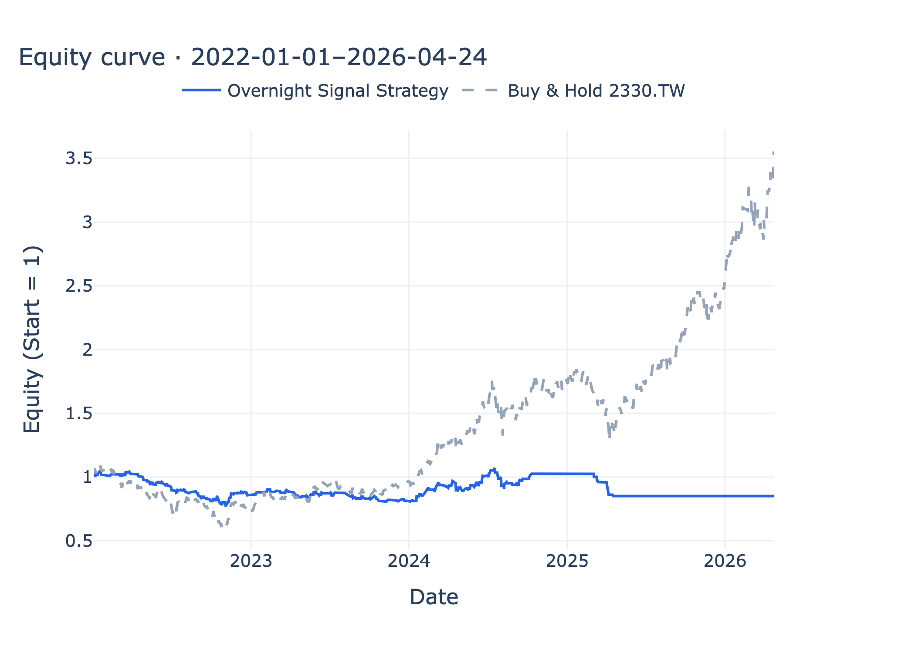
Figure 1 Equity (realistic)
The realistic strategy fails to participate in much of the 2024-2026 benchmark rally, highlighting the cost of flat exposure and lot constraints.

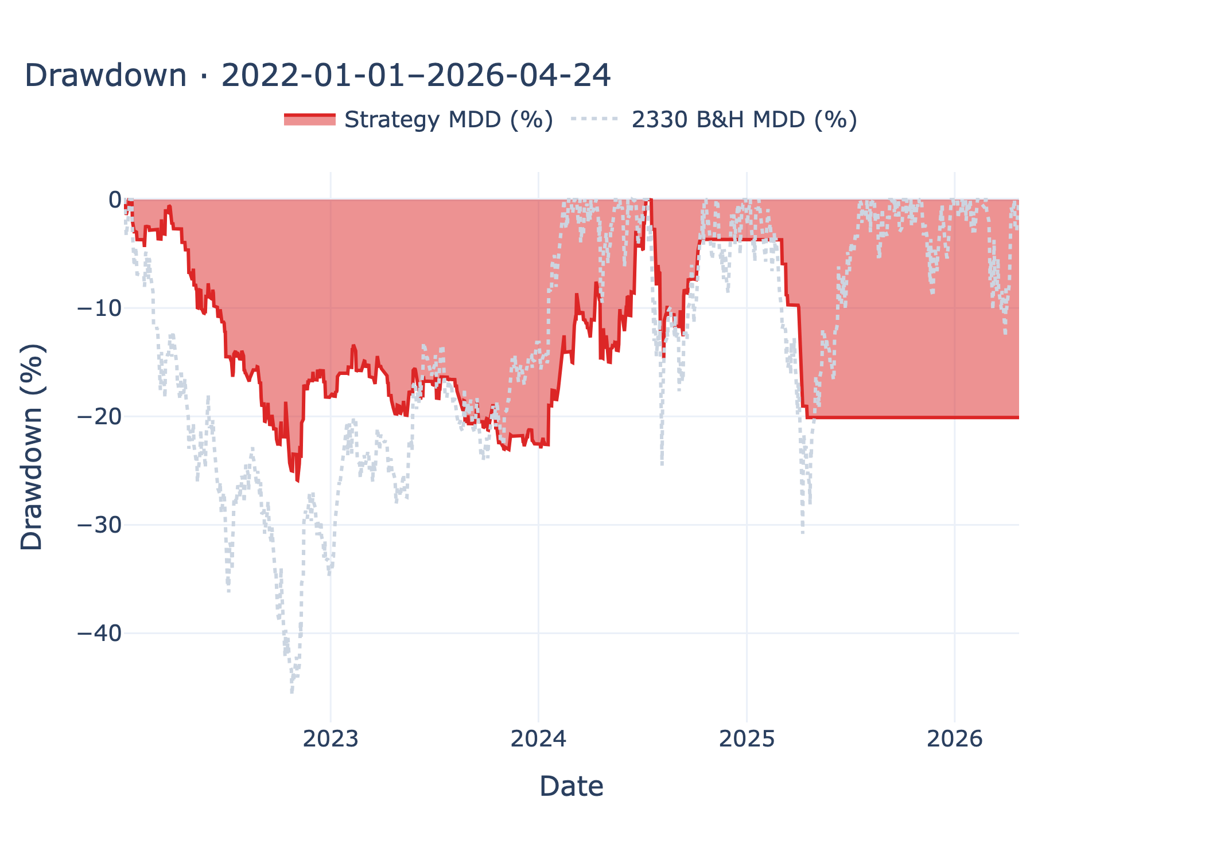
Figure 2 Drawdown (realistic)
Drawdown moderates after 2024 in places, but benchmark-relative underperformance may not fully recover.

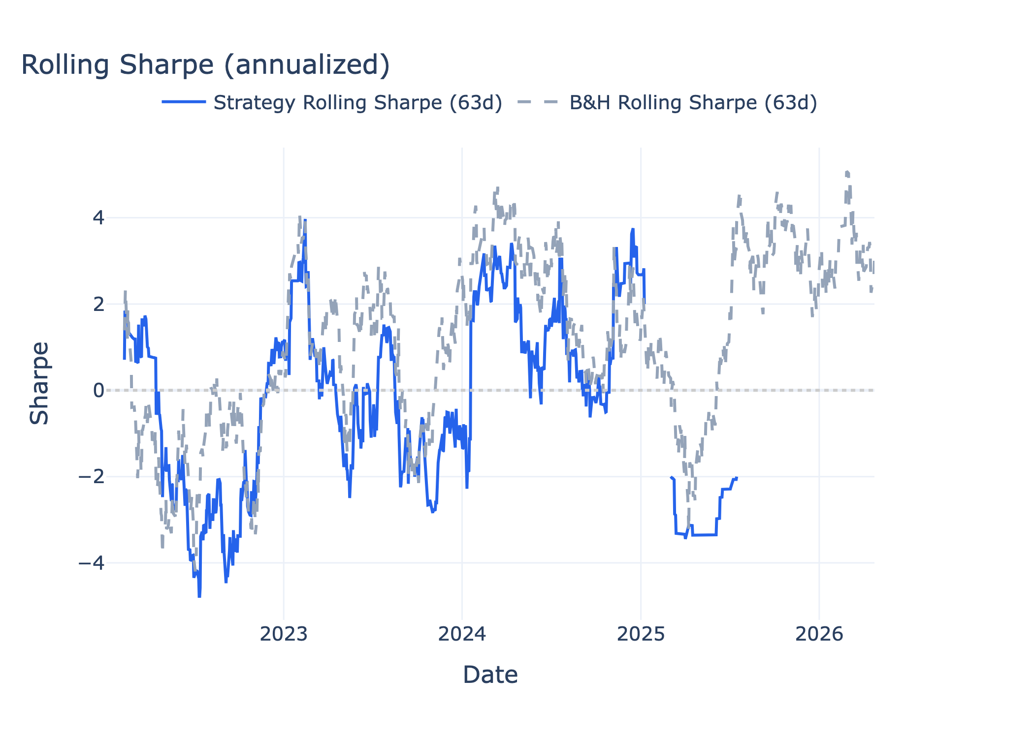
Figure 3 Rolling Sharpe (realistic)
Rolling Sharpe turning negative again after 2025 indicates unstable risk-adjusted performance under realistic execution.

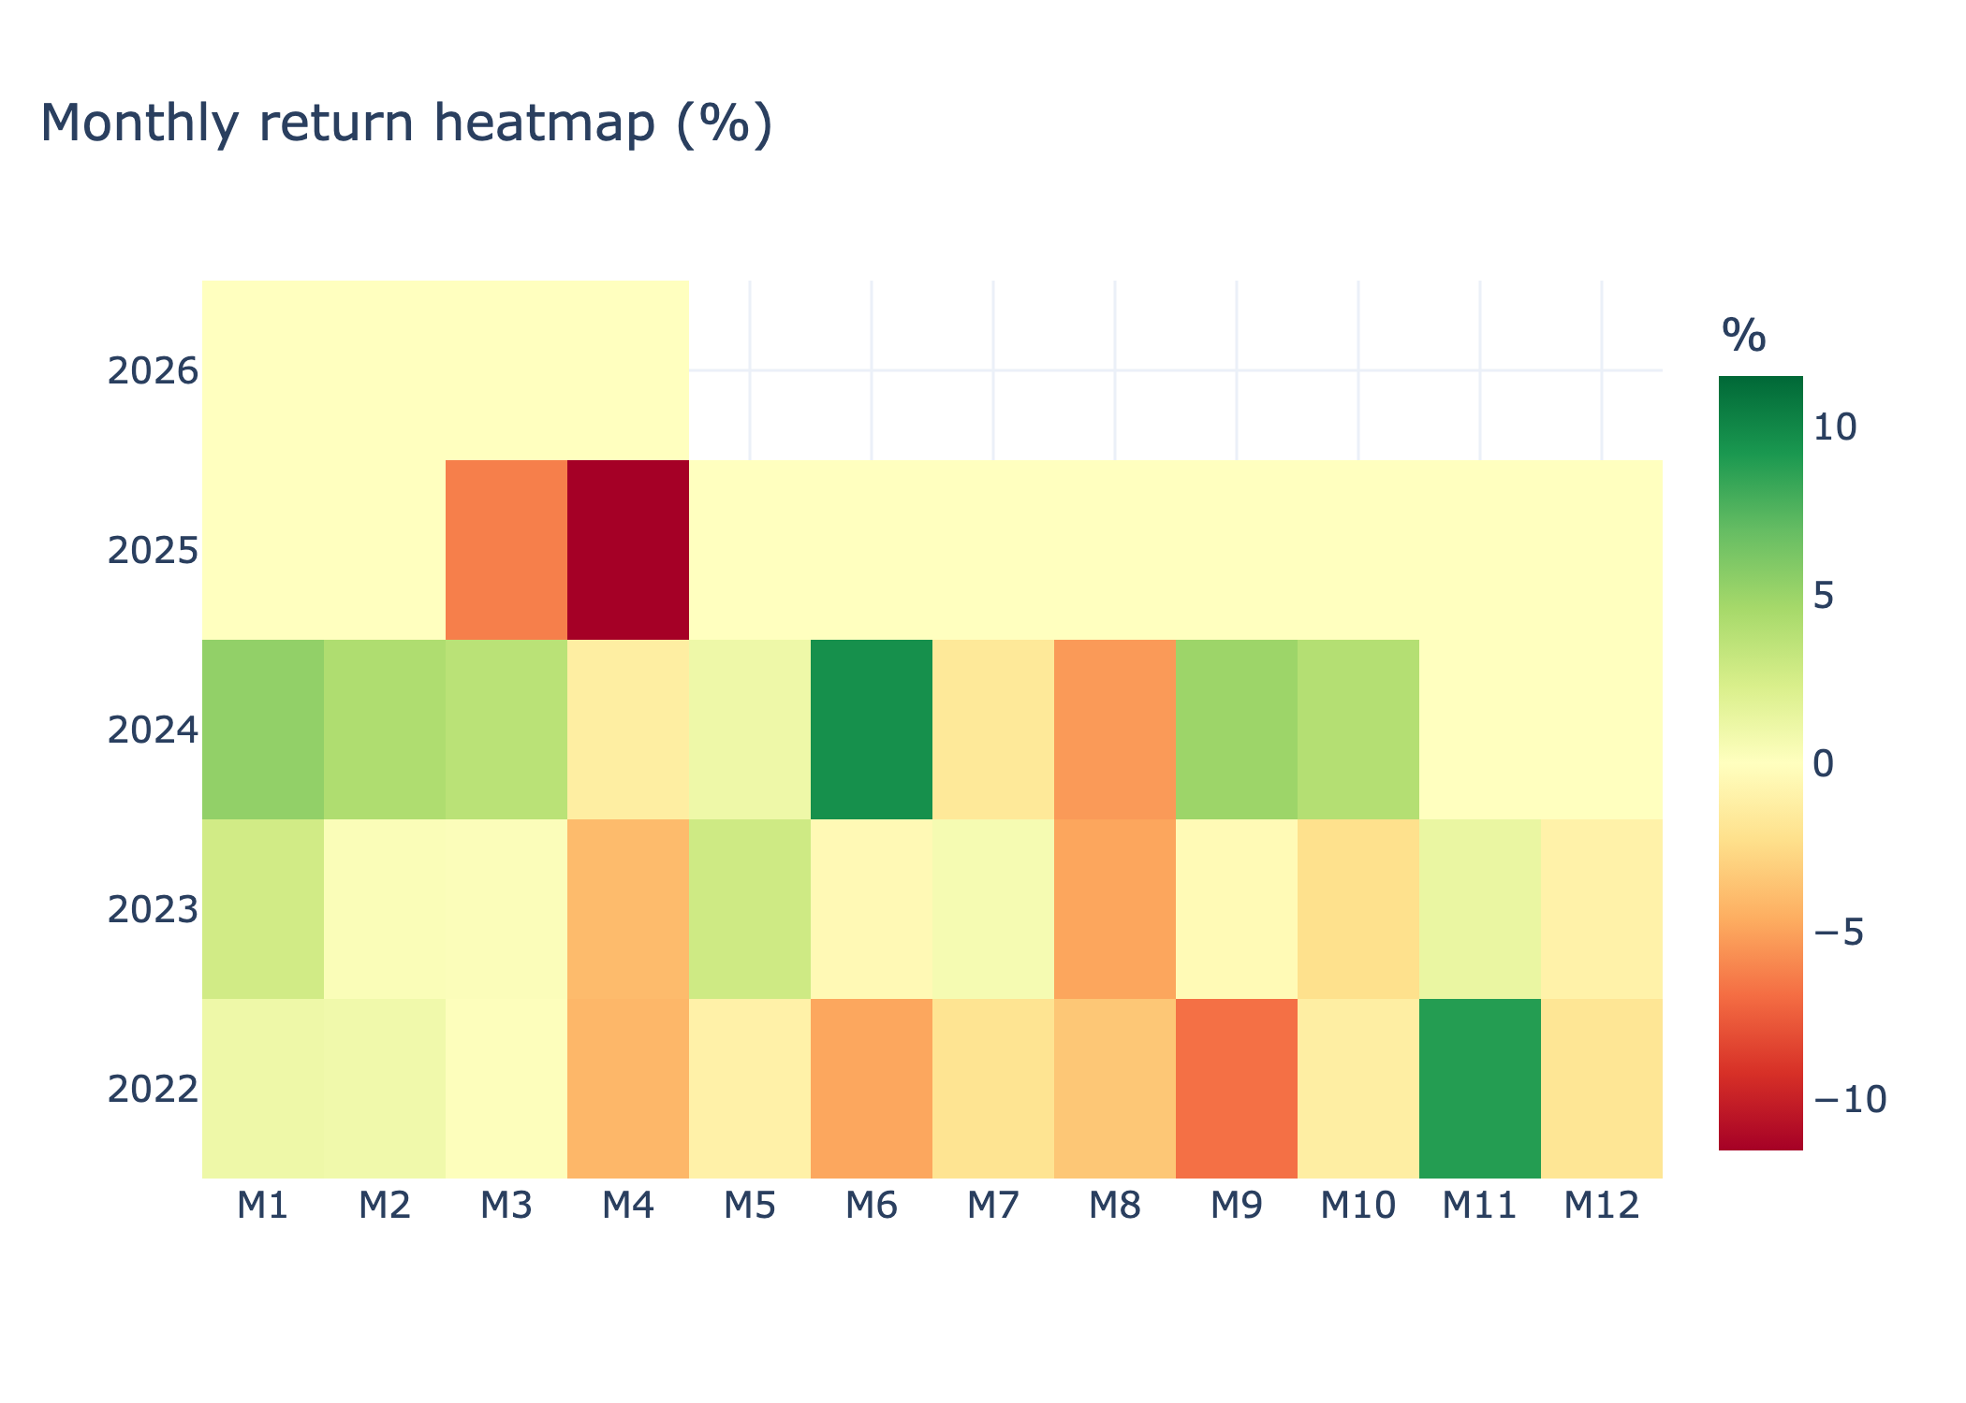
Figure 4 Monthly heatmap (realistic)
Losses concentrated around 2025 M3-M4 explain much of the annual decline.

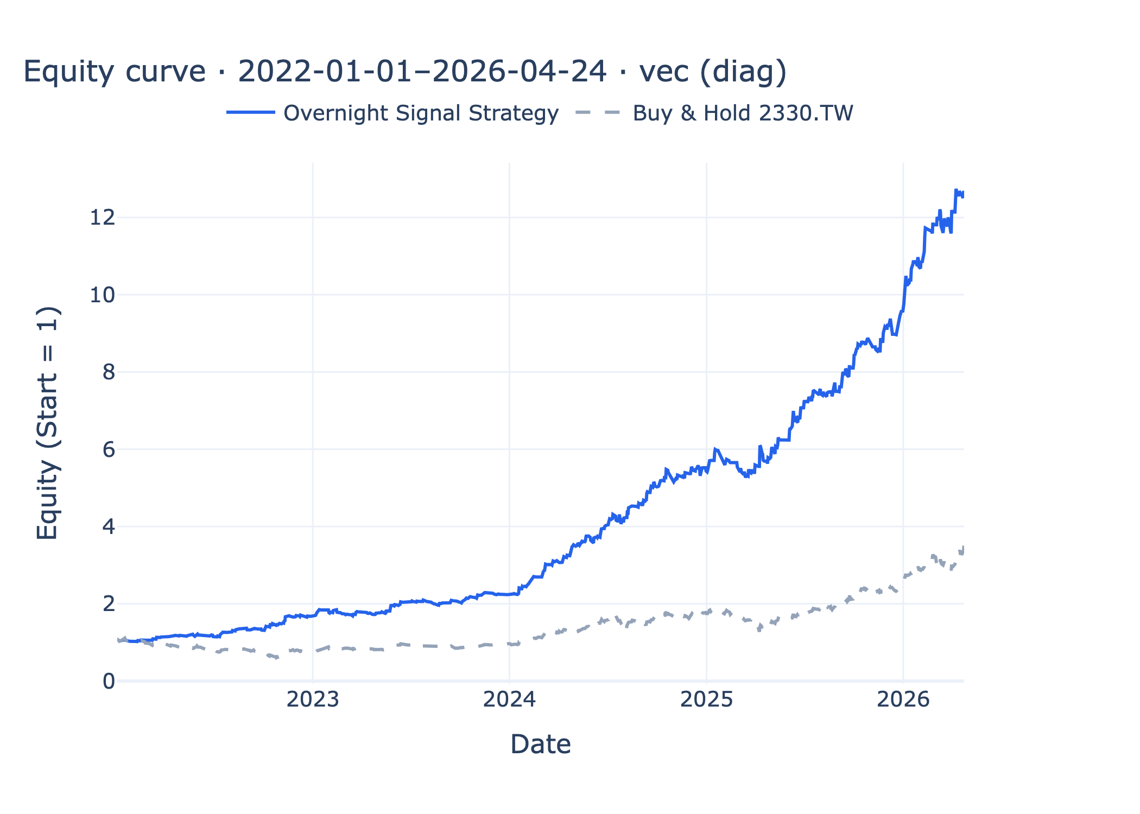
Figure 5 Equity (vectorized)
Diagnostic only-full-notional assumption.

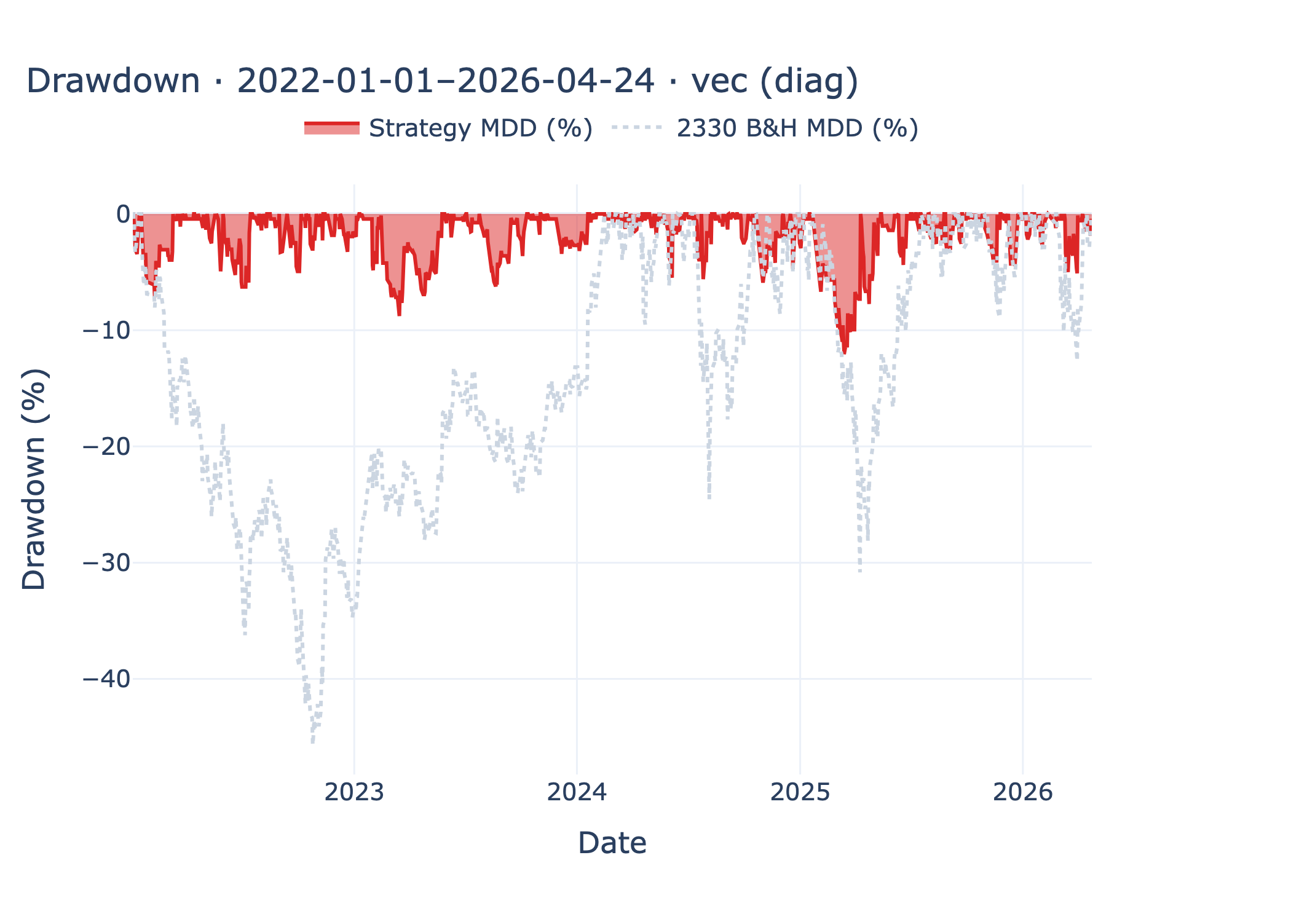
Figure 6 Drawdown (vectorized)
Contrast; often optimistic vs realistic.

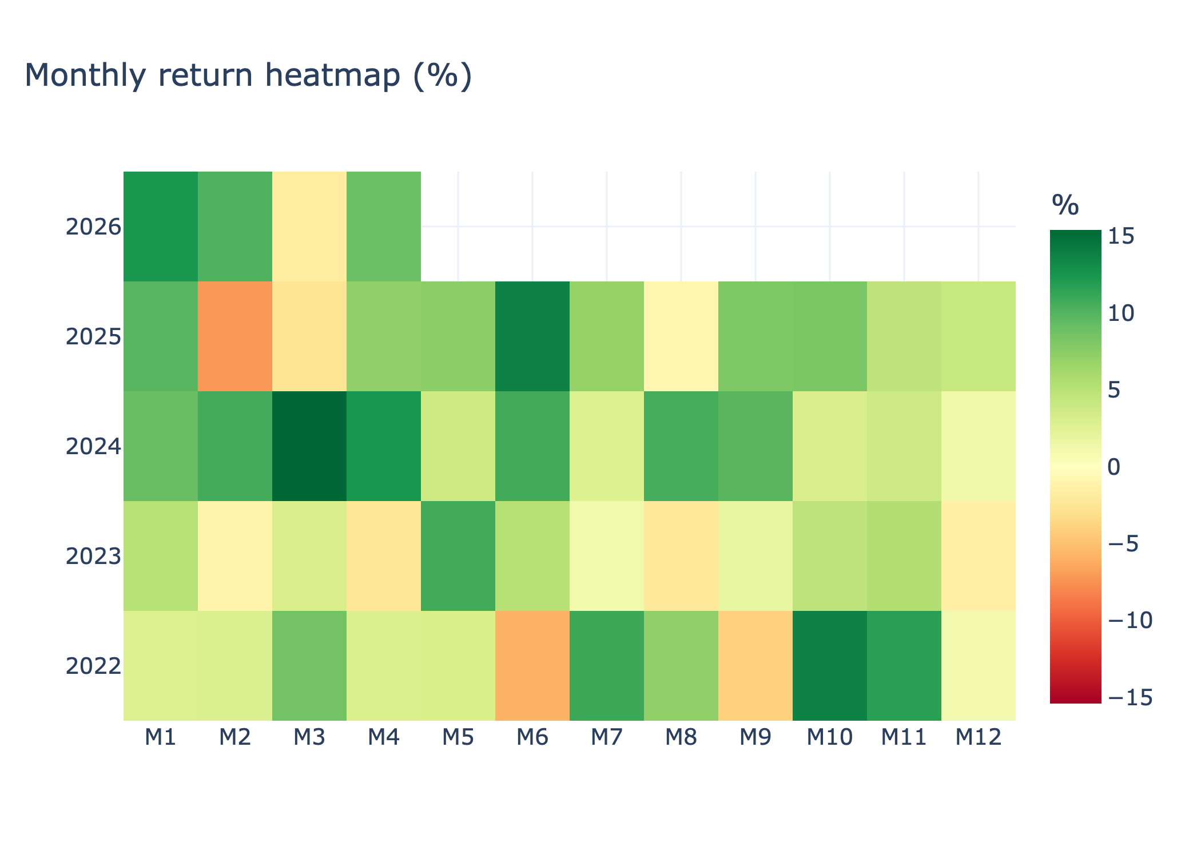
Figure 7 Monthly heatmap (vectorized)
Diagnostic contrast only-do not mix with realistic conclusions.

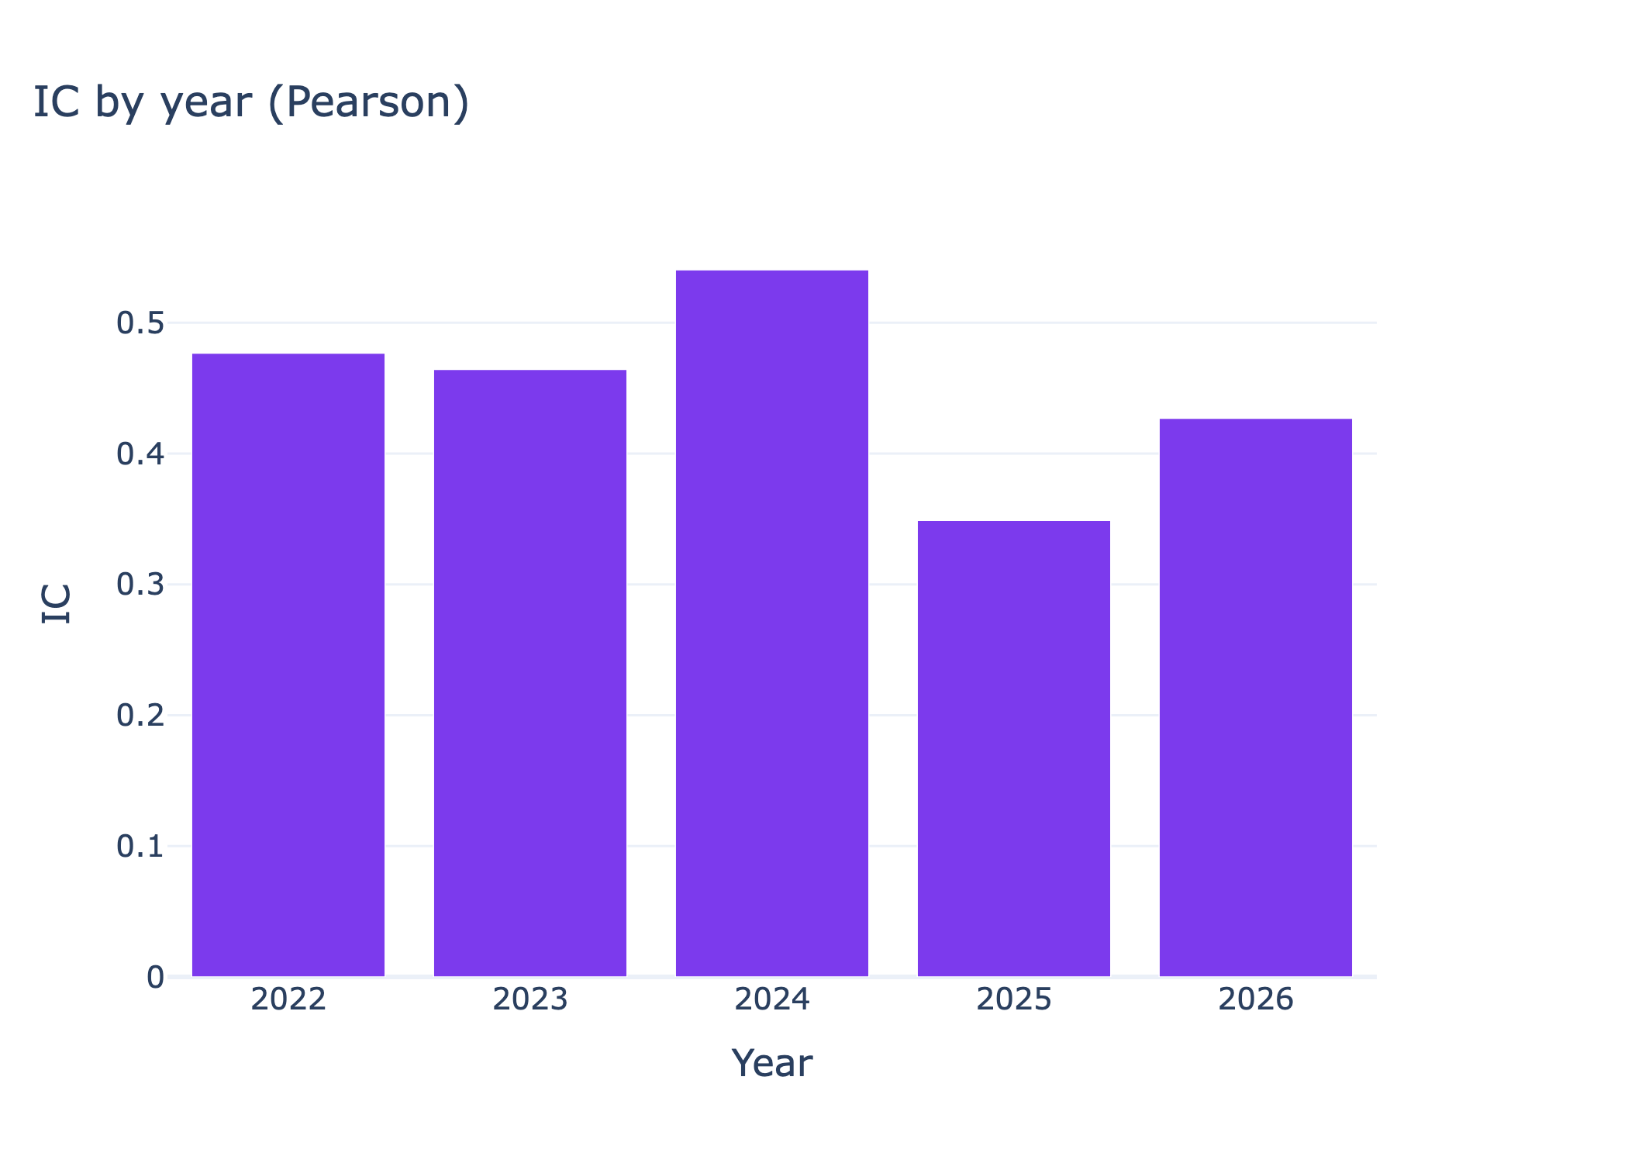
Figure 8 IC by year
Positive IC does not guarantee profitable realistic years.

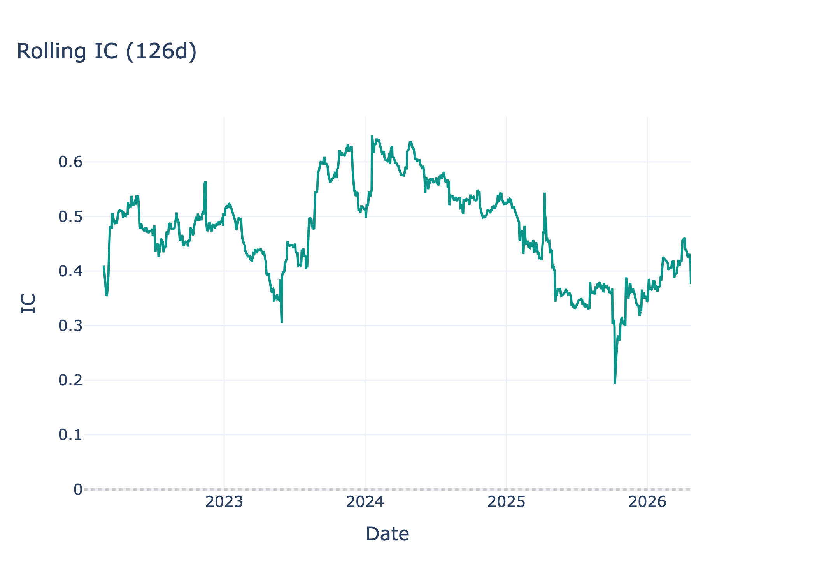
Figure 9 Rolling IC
Tracks stability of ranking power.

Reproducibility
From the AlphaEdge repo root: .venv/bin/python strategy_lab/run_overnight_signal.py then .venv/bin/python strategy_lab/generate_quant_report_docx.py [--lang zh|en|both]. For PDF submission, re-export appendix figures at roughly 200-300 dpi for crisp text.

References
- Hasbrouck, J. (1995). One security, many markets: Determining the contributions to price discovery. Journal of Finance.
- Eun, C. S., & Sabherwal, S. (2003). Cross-border listings and price discovery: Evidence from U.S.-listed Canadian stocks. Journal of Finance.
- Harris, L. (2003). Trading and Exchanges: Market Microstructure for Practitioners. Oxford University Press.
- Lo, A. W., & MacKinlay, A. C. (1990). Data-snooping biases in tests of financial asset pricing models. Review of Financial Studies.
- yfinance (data vendor for U.S. and FX daily series; accessed May 2026).
- AlphaEdge core/backtest/README.md.
- Course manuscript (fees and sample assumptions).

