TSMC Cross-Market Pricing and Overnight Information
Lead Signals from ADR, SOX, and FX: Ridge Forecast and Backtest
Quantitative Backtest Report · AlphaEdge RAST Module

Generated: April 30, 2026

Executive Summary
This study examines cross-market information flow for TSMC between the U.S. ADR and the Taiwan listing. Because the U.S. session ends before the Taiwan cash market opens, returns of TSMC ADR (TSM), the PHLX Semiconductor Index (SOX), and USD/TWD (TWD=X) are used as lead features available prior to the Taiwan open. A Ridge regression forecasts the same-day close-to-close return of 2330.TW; the trading rule is long the stock when the forecast is positive and flat otherwise. Data are from yfinance; metric names follow the AlphaEdge backtest conventions.
Disclaimer: For academic use only; not investment advice. Live trading involves liquidity, fees, regulation, and execution gaps.

1. Research Design and Sample Split
Training: through 2020-12-31. Validation: calendar year 2021 (grid search for Ridge penalty lambda). Test: from 2022-01-01 to 2026-04-25. Alignment: for each Taiwan trading day t, features use the last U.S. trading day strictly before t, to avoid look-ahead bias.
Dataset Item | Specification
Backtest horizon | 2020-01-01 to 2026-04-25
Training set | 2020-01-01 to 2020-12-31
Validation set | 2021-01-01 to 2021-12-31
Test set | 2022-01-01 to 2026-04-25
Data source | yfinance (daily bars, auto-adjusted)
Target and features | Target: 2330.TW; Features: TSM, ^SOX, TWD=X

2. Strategy Logic
(1) Economic rationale: Overnight information is embedded in U.S. prices and FX before the Taiwan session opens, and may predict the next Taiwan session return for TSMC.
(2) Timing: For each day d when 2330.TW trades, features are returns from the most recent U.S. session that ends before d (calendar ordering).
(3) Variables: Predictors are same-day percentage returns of TSM, SOX, and TWD=X on that U.S. date; the target is the close-to-close return of 2330.TW on the Taiwan date (daily holding-period proxy).
(4) Estimation: Ridge regression with intercept; L2 shrinkage on slopes only. Lambda is searched on a log grid and chosen by validation MSE in 2021; coefficients are re-estimated on training plus validation before scoring the test period.
(5) Trading rule: If the predicted return is positive, invest fully in 2330; otherwise hold cash (zero return, no margin financing modeled).
(6) Costs: Buy fee when increasing long exposure; sell fee and transaction tax when reducing or exiting, consistent with the course report assumptions.
(7) Operational buy/sell timing: when pred_t > 0 and the previous position is flat, the day is treated as a buy/open-long action; when pred_t <= 0 and the previous position is long, the day is treated as a sell/exit action. If position state does not change between two consecutive days, no turnover cost is charged.
(8) Why Ridge is used: to mitigate multicollinearity among correlated predictors (for example TSM and SOX), shrink unstable coefficients via L2 regularization, and improve out-of-sample robustness while retaining linear interpretability.

3. Data and Model
Ticker (yfinance) | Role
TSM | TSMC ADR, prior U.S. session return
2330.TW | Taiwan listing return; buy-and-hold benchmark
^SOX | Semiconductor sector sentiment / beta proxy
TWD=X | USD/TWD spot (simplified proxy vs. NDF hedging)

The model is Ridge regression. After lambda is fixed, coefficients are fit on training plus validation, then forecasts and PnL are computed on the held-out test sample.

4. Methods and Their Purpose
Method | Purpose
Ridge regression (L2 regularization) | Controls overfitting and multicollinearity, producing more stable coefficients and better out-of-sample robustness.
Train / validation / test split | Separates tuning from final evaluation to reduce leakage and optimistic bias.
Log-grid search for lambda | Systematically selects regularization strength to balance bias and variance.
Long-or-flat signal mapping | Converts continuous forecasts into executable positions while reducing shorting and friction constraints.
Transaction cost modeling (fees, tax) | Transforms gross returns into net returns closer to realistic implementation.
Equity curve | Shows capital growth path and compounding behavior over time.
Maximum drawdown (MDD / underwater) | Measures worst peak-to-trough loss and downside tolerance.
Rolling Sharpe ratio | Monitors persistence of risk-adjusted performance through time.
Annual IC and rolling IC | Evaluates predictive signal relevance and stability, including potential alpha decay.
Monthly return heatmap | Visualizes return clustering and regime sensitivity by calendar month.
Buy-and-hold benchmark comparison | Checks whether the strategy adds alpha and improves risk control versus passive exposure.

5. Test-Set Performance
Metric | Value
Trading days (test set) | 1000.0
Strategy cumulative return (wealth ratio - 1) | 27.0631 (wealth approx 28.06x)
Buy and hold cumulative return | 4.0604 (wealth approx 5.06x)
Strategy CAGR | 117.01%
Buy and hold CAGR | 45.75%
Strategy annualized volatility | 23.05%
Strategy Sharpe (daily, Rf approx 2% p.a.) | 3.678
Buy and hold Sharpe | 1.410
Strategy max drawdown (MDD) | -9.43%
Buy and hold MDD | -38.55%
Calmar ratio (est.) | 12.41
Hit rate on long days | 64.98%
Ridge penalty lambda (from validation) | 0.025929
Buy-side fee rate | 0.14%
Sell fee plus transaction tax | 0.44%

6. Charts
Figures below are exported as PNG by the pipeline: equity, drawdown, rolling Sharpe, monthly heatmap, annual IC, rolling IC.
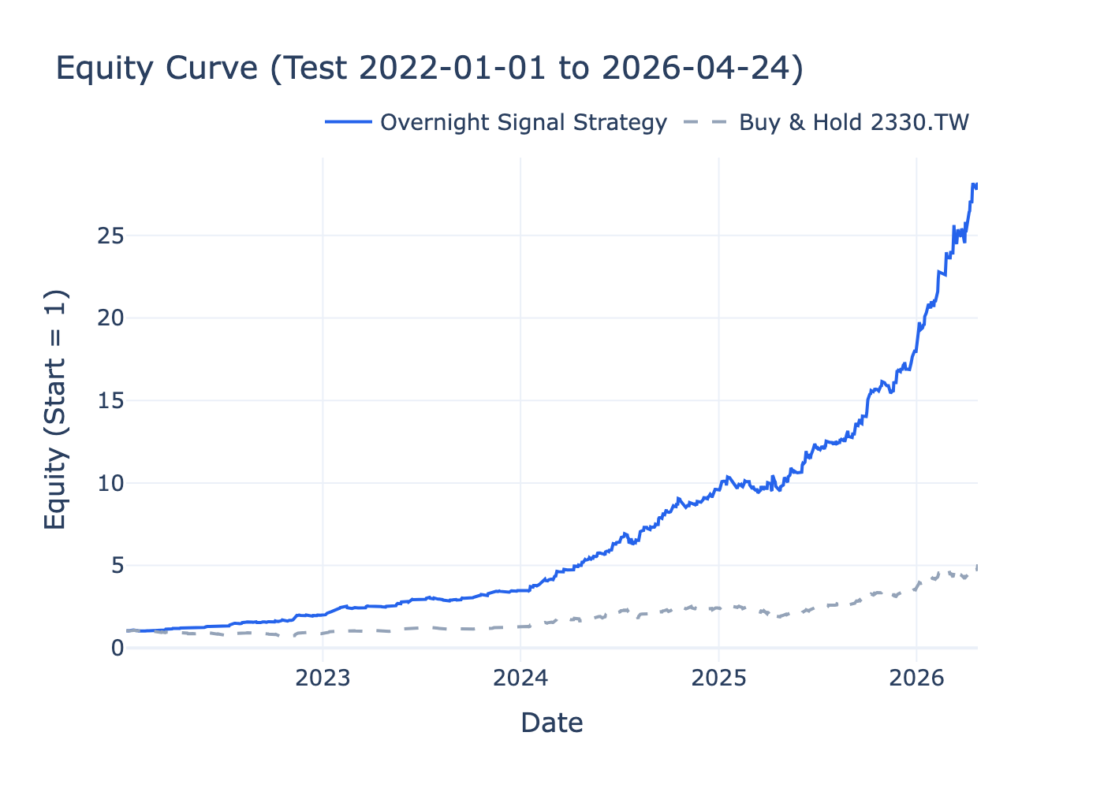
Figure 1 Equity curve: strategy vs. buy-and-hold 2330.TW

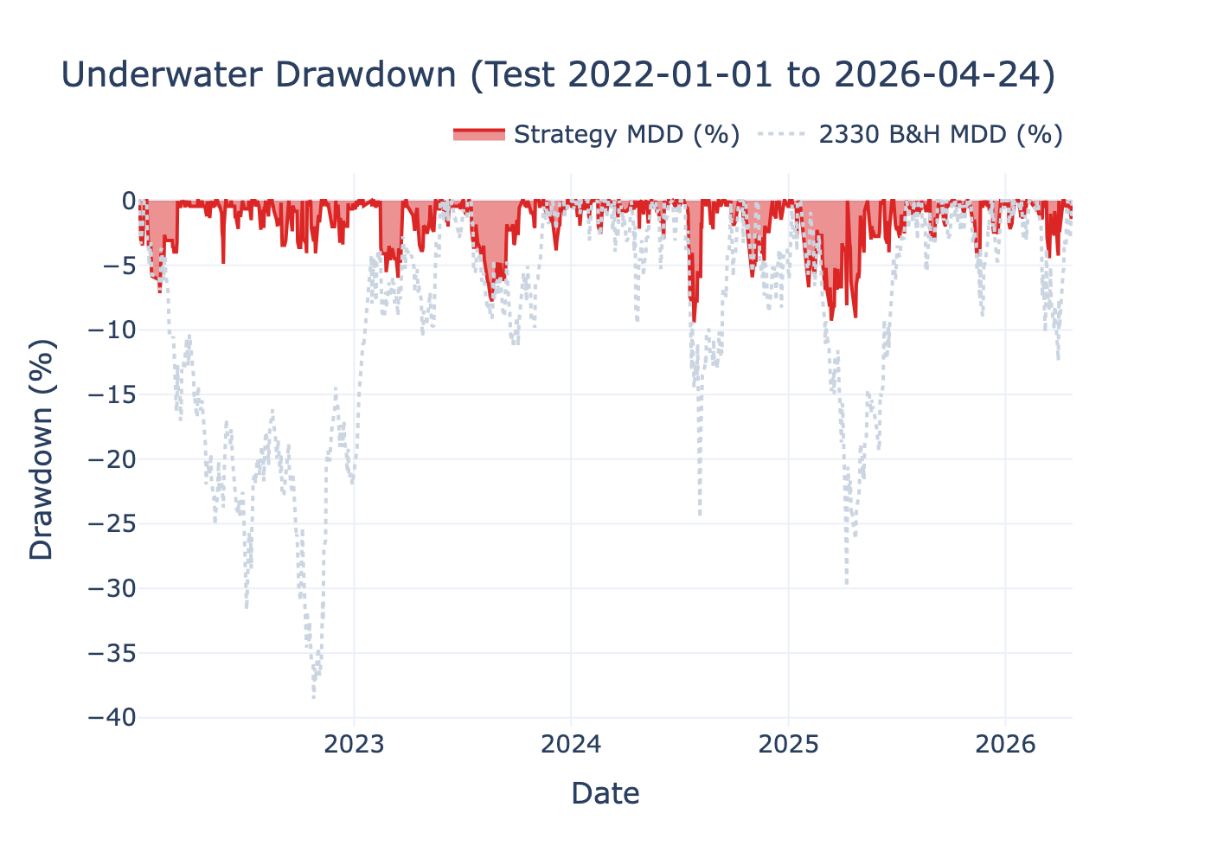
Figure 2 Drawdown (underwater): strategy vs. benchmark

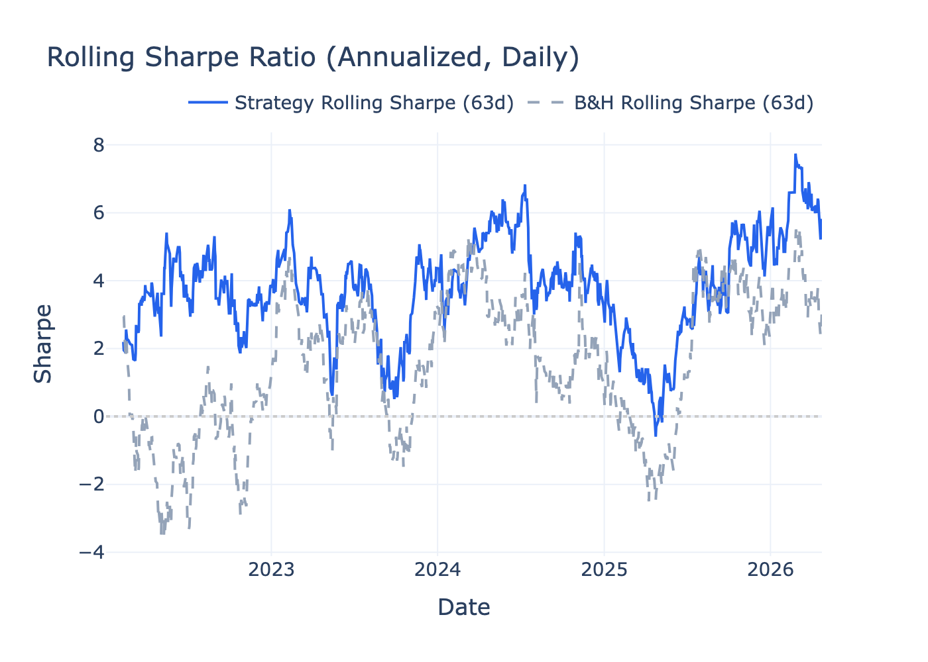
Figure 3 Rolling Sharpe ratio (approx. 63 trading days, annualized)

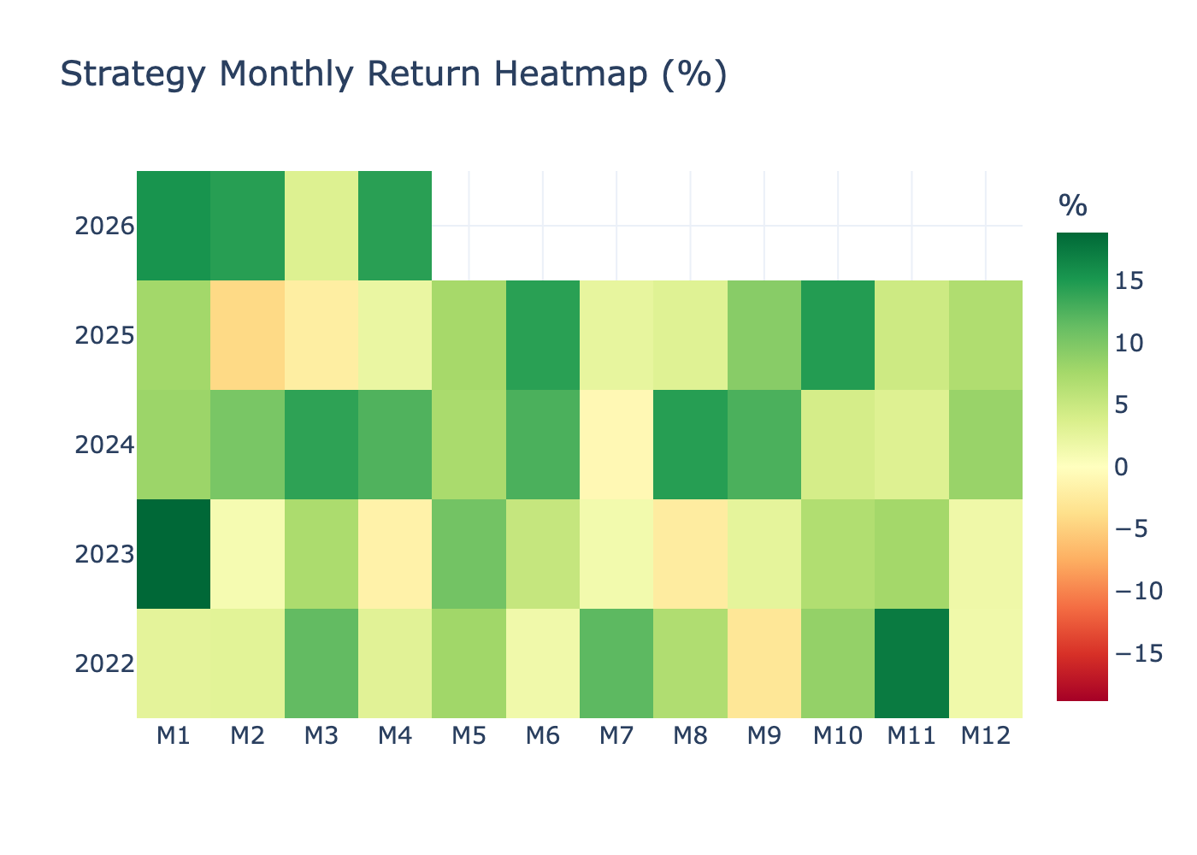
Figure 4 Monthly return heatmap (percent)

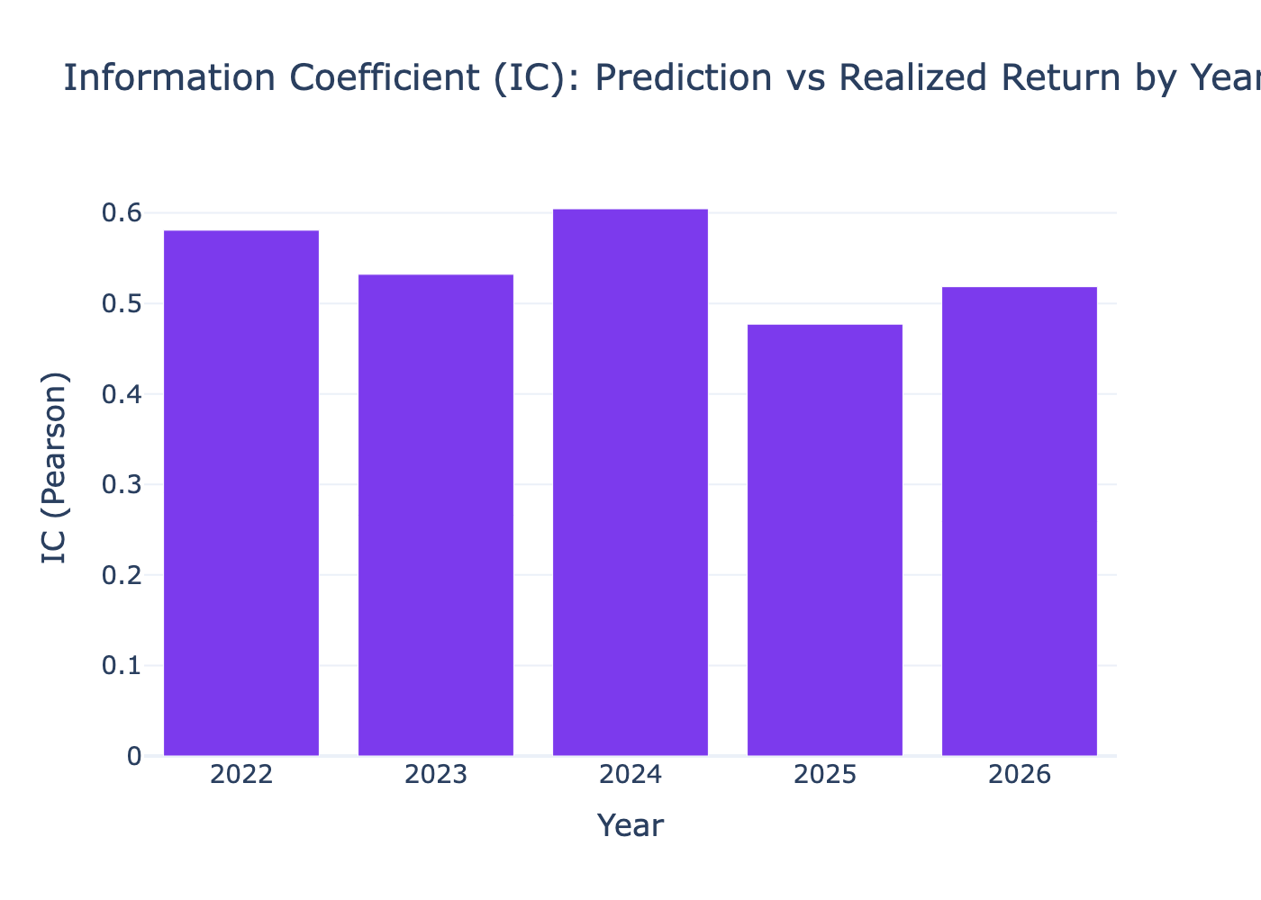
Figure 5 Annual information coefficient (IC)

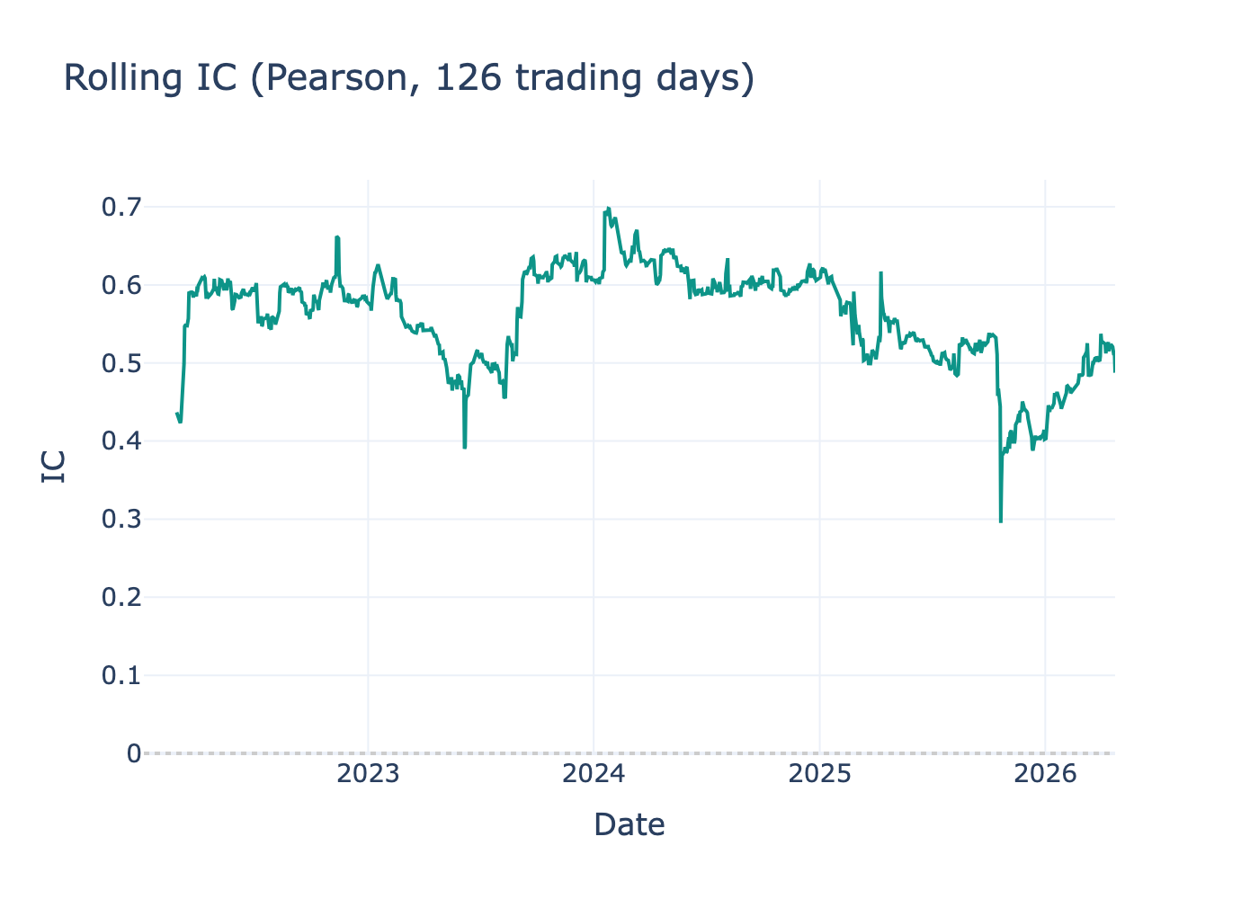
Figure 6 Rolling IC (126 trading-day window)

7. Risks and Limitations
- Linear Ridge may miss nonlinearity and structural breaks; tree models and rolling re-fit are not implemented.
- FX uses a spot proxy, not a full NDF hedge.
- No limit-up/down, auction microstructure, slippage, or futures margin/roll.
- Long-or-flat only; short selling and index futures are out of scope.
- Choosing lambda on the validation set implies mild data mining risk.

8. Reproducibility
From the AlphaEdge repo root: run .venv/bin/python RAST/run_overnight_signal.py then .venv/bin/python RAST/generate_quant_report_docx.py [--lang zh|en|both].

References
- yfinance; AlphaEdge core/backtest/README.md; course report manuscript (fee and sample assumptions).

