電通二乙微處理器實驗 實驗結報

實驗名稱 | LCD 顯示器
組別 | 27 | 組員 | 郭子齊

- 實驗目的
使用 Arduino LCD 程式庫, 於 16x2 LCD 顯示器上顯示特 定文字?
1. Arduino 與 LCD 如何接線?
2. 如何使用 LCD library?
3. 如何清除螢幕?
4. 如何顯示文字?
- 實驗步驟
The circuit:
* LCD RS pin to digital pin 12
* LCD Enable pin to digital pin 11
* LCD D4 pin to digital pin 5
* LCD D5 pin to digital pin 4
* LCD D6 pin to digital pin 3
* LCD D7 pin to digital pin 2
* LCD R/W pin to ground
* 10K resistor:
* ends to +5V and ground
* wiper to LCD VO pin (pin 3)
- 程式碼
#include <LiquidCrystal.h> // include the library code
LiquidCrystal lcd(12, 11, 5, 4, 3, 2); // initialize interface pins
void setup() {
lcd.begin(16, 2); // set up the LCD's number of columns and rows:
lcd.print("05050333 qi"); // Print a message to the LCD.
}
void loop() {
// set the cursor to column 0, line 1
// (note: line 1 is the second row, since counting begins with 0):
lcd.setCursor(0, 1);
lcd.print(millis()/1000); // print the number of seconds since reset:
}
- 實驗結果及分析
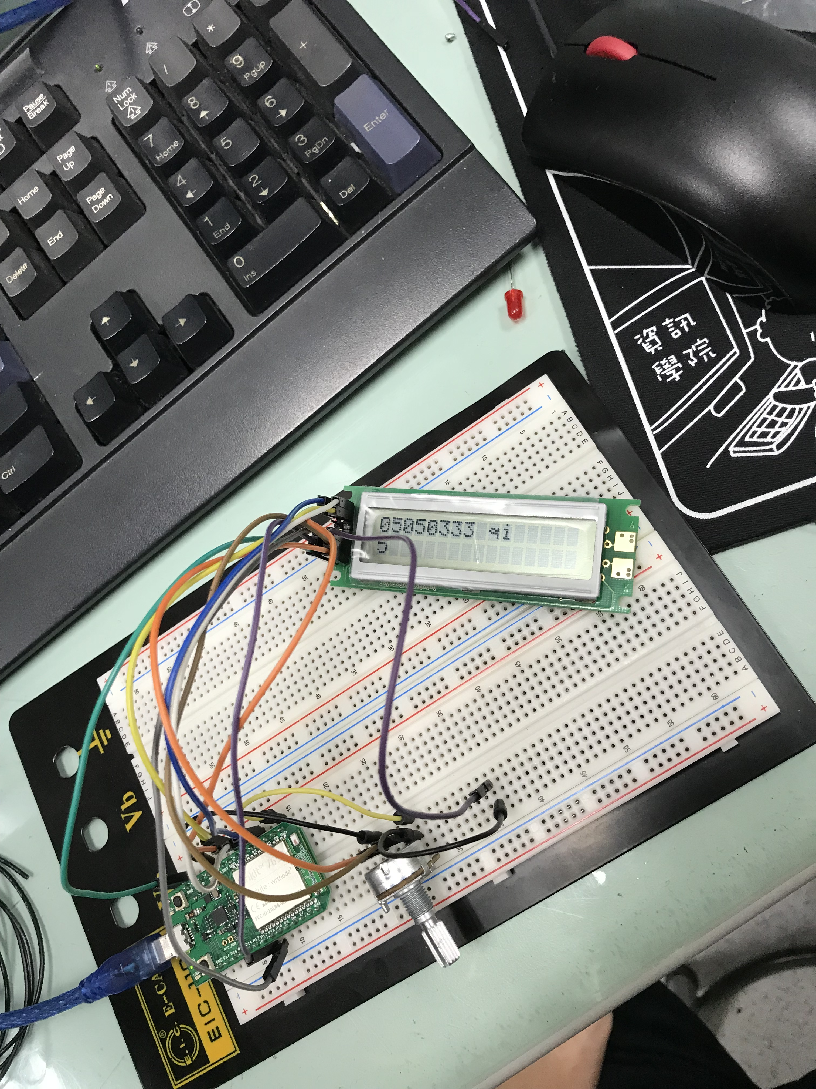
- 心得討論
杜邦線接觸不良

