# 每个程序员都应该收藏的算法复杂度速查表

### 算法复杂度这件事

这篇文章覆盖了计算机科学里面常见算法的时间和空间的 复杂度。我之前在参加面试前，经常需要花费很多时间从互联网上查找各种搜索和排序算法的优劣，以便我在面试时不会被问住。最近这几年，我面试了几家硅谷的初创企业和一些更大一些的公司，如 Yahoo、eBay、LinkedIn 和 Google，每次我都需要准备这个，我就在问自己，“为什么没有人创建一个漂亮的大 O 速查表呢？”所以，为了节省大家的时间，我就创建了这个，希望你喜欢！

--- [Eric](https://twitter.com/ericdrowell)

### 图例

|  |  |  |  |  |
| --- | --- | --- | --- | --- |
| 绝佳 | 不错 | 一般 | 不佳 | 糟糕 |

### 数据结构操作

| 数据结构 | 时间复杂度 | | | | | | | | 空间复杂度 |
| --- | --- | --- | --- | --- | --- | --- | --- | --- | --- |
|  | 平均 | | | | 最差 | | | | 最差 |
|  | 访问 | 搜索 | 插入 | 删除 | 访问 | 搜索 | 插入 | 删除 |  |
| [Array](http://en.wikipedia.org/wiki/Array_data_structure) | O(1) | O(n) | O(n) | O(n) | O(1) | O(n) | O(n) | O(n) | O(n) |
| [Stack](http://en.wikipedia.org/wiki/Stack_(abstract_data_type)) | O(n) | O(n) | O(1) | O(1) | O(n) | O(n) | O(1) | O(1) | O(n) |
| [Singly-Linked List](http://en.wikipedia.org/wiki/Singly_linked_list#Singly_linked_lists) | O(n) | O(n) | O(1) | O(1) | O(n) | O(n) | O(1) | O(1) | O(n) |
| [Doubly-Linked List](http://en.wikipedia.org/wiki/Doubly_linked_list) | O(n) | O(n) | O(1) | O(1) | O(n) | O(n) | O(1) | O(1) | O(n) |
| [Skip List](http://en.wikipedia.org/wiki/Skip_list) | O(log(n)) | O(log(n)) | O(log(n)) | O(log(n)) | O(n) | O(n) | O(n) | O(n) | O(n log(n)) |
| [Hash Table](http://en.wikipedia.org/wiki/Hash_table) | - | O(1) | O(1) | O(1) | - | O(n) | O(n) | O(n) | O(n) |
| [Binary Search Tree](http://en.wikipedia.org/wiki/Binary_search_tree) | O(log(n)) | O(log(n)) | O(log(n)) | O(log(n)) | O(n) | O(n) | O(n) | O(n) | O(n) |
| [Cartesian Tree](https://en.wikipedia.org/wiki/Cartesian_tree) | - | O(log(n)) | O(log(n)) | O(log(n)) | - | O(n) | O(n) | O(n) | O(n) |
| [B-Tree](http://en.wikipedia.org/wiki/B_tree) | O(log(n)) | O(log(n)) | O(log(n)) | O(log(n)) | O(log(n)) | O(log(n)) | O(log(n)) | O(log(n)) | O(n) |
| [Red-Black Tree](http://en.wikipedia.org/wiki/Red-black_tree) | O(log(n)) | O(log(n)) | O(log(n)) | O(log(n)) | O(log(n)) | O(log(n)) | O(log(n)) | O(log(n)) | O(n) |
| [Splay Tree](https://en.wikipedia.org/wiki/Splay_tree) | - | O(log(n)) | O(log(n)) | O(log(n)) | - | O(log(n)) | O(log(n)) | O(log(n)) | O(n) |
| [AVL Tree](http://en.wikipedia.org/wiki/AVL_tree) | O(log(n)) | O(log(n)) | O(log(n)) | O(log(n)) | O(log(n)) | O(log(n)) | O(log(n)) | O(log(n)) | O(n) |

### 数组排序算法

| 算法 | 时间复杂度 | | | 空间复杂度 |
| --- | --- | --- | --- | --- |
|  | 最佳 | 平均 | 最差 | 最差 |
| [Quicksort](http://en.wikipedia.org/wiki/Quicksort) | O(n log(n)) | O(n log(n)) | O(n^2) | O(log(n)) |
| [Mergesort](http://en.wikipedia.org/wiki/Merge_sort) | O(n log(n)) | O(n log(n)) | O(n log(n)) | O(n) |
| [Timsort](http://en.wikipedia.org/wiki/Timsort) | O(n) | O(n log(n)) | O(n log(n)) | O(n) |
| [Heapsort](http://en.wikipedia.org/wiki/Heapsort) | O(n log(n)) | O(n log(n)) | O(n log(n)) | O(1) |
| [Bubble Sort](http://en.wikipedia.org/wiki/Bubble_sort) | O(n) | O(n^2) | O(n^2) | O(1) |
| [Insertion Sort](http://en.wikipedia.org/wiki/Insertion_sort) | O(n) | O(n^2) | O(n^2) | O(1) |
| [Selection Sort](http://en.wikipedia.org/wiki/Selection_sort) | O(n^2) | O(n^2) | O(n^2) | O(1) |
| [Shell Sort](http://en.wikipedia.org/wiki/Shellsort) | O(n) | O((nlog(n))^2) | O((nlog(n))^2) | O(1) |
| [Bucket Sort](http://en.wikipedia.org/wiki/Bucket_sort) | O(n+k) | O(n+k) | O(n^2) | O(n) |
| [Radix Sort](http://en.wikipedia.org/wiki/Radix_sort) | O(nk) | O(nk) | O(nk) | O(n+k) |

### 图操作

|  |  |  |  |  |  |  |
| --- | --- | --- | --- | --- | --- | --- |
| 节点 / 边界管理 | 存储 | 增加顶点 | 增加边界 | 移除顶点 | 移除边界 | 查询 |
| [Adjacency list](http://en.wikipedia.org/wiki/Adjacency_list) | O(|V|+|E|) | O(1) | O(1) | O(|V| + |E|) | O(|E|) | O(|V|) |
| [Incidence list](http://en.wikipedia.org/wiki/Incidence_list) | O(|V|+|E|) | O(1) | O(1) | O(|E|) | O(|E|) | O(|E|) |
| [Adjacency matrix](http://en.wikipedia.org/wiki/Adjacency_matrix) | O(|V|^2) | O(|V|^2) | O(1) | O(|V|^2) | O(1) | O(1) |
| [Incidence matrix](http://en.wikipedia.org/wiki/Incidence_matrix) | O(|V| ⋅ |E|) | O(|V| ⋅ |E|) | O(|V| ⋅ |E|) | O(|V| ⋅ |E|) | O(|V| ⋅ |E|) | O(|E|) |

### 堆操作

| 类型 | 时间复杂度 | | | | | | |
| --- | --- | --- | --- | --- | --- | --- | --- |
|  | Heapify | 查找最大值 | 分离最大值 | 提升键 | 插入 | 删除 | 合并 |
| [Linked List (sorted)](http://en.wikipedia.org/wiki/Linked_list) | - | O(1) | O(1) | O(n) | O(n) | O(1) | O(m+n) |
| [Linked List (unsorted)](http://en.wikipedia.org/wiki/Linked_list) | - | O(n) | O(n) | O(1) | O(1) | O(1) | O(1) |
| [Binary Heap](http://en.wikipedia.org/wiki/Binary_heap) | O(n) | O(1) | O(log(n)) | O(log(n)) | O(log(n)) | O(log(n)) | O(m+n) |
| [Binomial Heap](http://en.wikipedia.org/wiki/Binomial_heap) | - | O(1) | O(log(n)) | O(log(n)) | O(1) | O(log(n)) | O(log(n)) |
| [Fibonacci Heap](http://en.wikipedia.org/wiki/Fibonacci_heap) | - | O(1) | O(log(n)) | O(1) | O(1) | O(log(n)) | O(1) |

### 大 O 复杂度图表

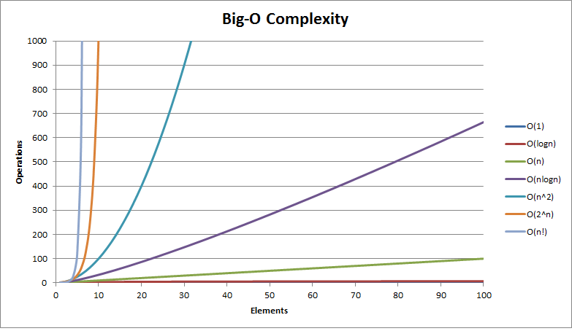

Big O Complexity Graph