Quarterly Report: Q3 2026
Prepared by the Finance and Operations teams

Summary
Revenue grew 14% over the previous quarter, driven by the new subscription plans.
Support response times stayed within the agreed limits.
Two new regional offices opened in September: Denver and Lisbon.

Highlights
- Subscription revenue passed one million for the first time.
- Churn fell to 1.8%.
  - Monthly plans: 1.9%
  - Annual plans: 0.4%
- Net promoter score unchanged at 41.

Figures
Table 1. Revenue and customers by area and region
Area | Region | Revenue (USD) |  | Customers
Area | Region | Q2 | Q3 | Q2 | Q3
Americas | North | 1,180,000 | 1,240,000 | 3,010 | 3,120
Americas | South | 940,000 | 1,015,000 | 2,470 | 2,540
Americas | West | 350,000 | 410,000 | 960 | 1,050
EMEA | East | 720,000 | 760,000 | 1,900 | 1,980
EMEA | Central | 510,000 | 545,000 | 1,340 | 1,390
APAC | Pacific | 300,000 | 320,000 | 800 | 870
Total |  | 4,000,000 | 4,290,000 | 10,480 | 10,950
Figures are unaudited. West opened in September and reports one month.

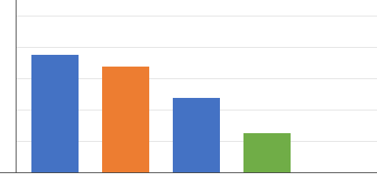
Figure 1. Q3 revenue by area, with the new West region

Figure 2. Sales regions

Milestones
Quarter | Milestone | Owner | Status
Q3 | Subscription plans launched | Product | Done
Q3 | Support portal redesign | Support | Done
Q4 | Starter plan pricing review | Finance | Planned
Q4 | Legacy reporting portal | Retired

Next steps
- Hire three support engineers.
- Review pricing for the starter plan.
The full data set is on the reports site.

