Range disjunctions, genetic mixing, and reintroduction shape the conservation strategy for the endangered Physaria globosa (Brassicaceae)

Wen-Hsi Kuo¹, Clara Landon ^{1,2, 3}, Burgund Bassüner¹, Alexander G. Linan¹, Tara R. Littlefield^{4,5}, Matthew A. Albrecht¹, Christine E. Edwards¹*

¹Missouri Botanical Garden, 4344 Shaw Blvd., St. Louis MO 63110, USA
²Oberlin College Biology Department, 119 Woodland St., Oberlin, OH 44074
³Current address: Lady Bird Johnson Wildflower Center, 4801 La Crosse Ave. Austin, TX 78739
⁴ Office of Kentucky Nature Preserves, 300 Sower Blvd, Frankfort, KY 40601
⁵ University of Kentucky, Lexington, KY

*Correspondence: Christine.Edwards@mobot.org

Abstract (257 words)
Population genetic analyses of endangered species can directly inform management strategies to help conserve their genetic diversity and increase their long-term chances of survival. Physaria globosa, a federally endangered mustard, has a geographically restricted and disjunct distribution across river systems in Indiana, Kentucky, and Tennessee, USA. We genotyped 332 individuals at 20 microsatellite loci across the species’ range, including 14 wild and 2 translocated populations. The genetic structure of wild populations showed two major geographic groups with little to no gene flow between them: a northern group in Indiana and Kentucky (IN-KY) and a southern group in Tennessee (TNE-TNW). Genetic diversity is still preserved among and within geographic regions; however, several local populations showed evidence of reduced genetic diversity, inbreeding, or recent bottlenecks, consistent with demographic decline and ongoing pressures from habitat degradation and competition from invasive plants. Two translocated and interbreeding populations showed clear genetic mixing of source populations. One was derived from mixing two nearby Kentucky populations with natural gene flow. The other was derived from mixing Kentucky and Tennessee wild populations, which have little to no natural gene flow. The two translocated populations have comparable allelic richness to their source populations but show depletion of private alleles. Our results suggest that conservation actions for P. globosa should prioritize the protection of multiple populations within each major geographic region. In the absence of immediate extinction risk, translocations and interbreeding programs should only be conducted within geographic regions in order to rescue local populations from habitat degradation and restore or augment natural gene flow and local genetic diversity.

Keywords: Genetic structure; genetic mixing; conservation management; microsatellites; translocation

Introduction (881 words)
Genetic diversity is widely recognized as the raw material underlying phenotypic and functional variation within species, and its maintenance is a central goal of biodiversity conservation (Shaw et al., 2025). Higher levels of genetic diversity are often associated with greater resilience, evolutionary potential, and individual fitness, and can also improve the establishment and persistence of reintroduced populations (Hoelzel et al., 2019; Van Rossum & Le Pajolec, 2021). For endangered species with narrow distributions and habit degradations, preserving genetic diversity therefore requires consideration of both natural populations and ex situ collections, as well as any reintroductions derived from them (Mashburn et al., 2023; Linan et al., 2024; Aguilar-Gómez et al., 2025; Edwards et al., 2025; Van Rossum et al., 2025).
Conservation strategies for rare plant species generally span a continuum from conserving extant natural populations to more interventionist approaches involving the establishment of ex situ populations and translocations into suitable habitats (Bucharova, 2017; Gaitán-Espitia & Hobday, 2021). In plants, these interventions can include controlled crosses among wild populations, augmentations to promote interbreeding and restore genetic variation (Edwards et al., 2025). Such actions can be valuable when fragmentation, demographic decline, or habitat degradation have reduced effective population sizes and limited natural gene flow, as they can increase genetic diversity, reduce inbreeding, and potentially enhance fitness and longer-term adaptive potential. However, outcomes are often context-dependent and not always predictable, thus their application remains debated (MacDonald et al., 2025).
Using mixed source materials for controlled crosses, population augmentations or introductions and other forms of assisted migration raise several general questions in conservation genetics. Do disjunct populations represent distinct historical or adaptive components that should be protected separately (Fraser & Bernatchez, 2001)? Under what conditions does the risk of loss of genetic diversity due to inbreeding or genetic drift in an isolated population exceed the risk associated with admixture? Can mixed populations capture sufficient genetic diversity to maintain their persistence in local or changing environments? The major concerns are well known: introduced gene flow may cause outbreeding depression, disrupt local adaptation, or generate maladapted genotypes (Hufford & Mazer, 2003; MacDonald et al., 2025); hybridization can also lead to genetic or demographic swamping if rare lineages are overwhelmed by admixture (Aguilar-Gómez et al., 2025); and translocations may generate ecological mismatches in recipient environments (Bucharova, 2017). In addition, small, inbred but viable populations may have already purged some deleterious recessive alleles, such that genetic rescue could introduce new genetic load and reduce fitness (Dussex et al., 2023). These risks do not preclude intervention but underscore the need in identifying a clear biological and demographic rationale, carefully evaluate risks of both source and recipient populations, and conduct post-release genetic monitoring to assess outcomes (Linan et al., 2024; Aguilar-Gómez et al., 2025).
Globe bladderpod, Physaria globosa (Desv.) O’Kane & Al-Shehbaz, is a federally endangered annual to biennial herbaceous species in the Brassicaceae with a geographically restricted and discontinuous distribution in the southeastern United States (Fuentes-Soriano & Kellogg, 2021). It occurs on steep, rocky bluff and talus slopes, usually on calcareous substrates with south- to west-facing slopes near rivers or streams. The species is distributed across four disjunct regions: the confluence of the Wabash and Ohio Rivers in Indiana (IN), the Kentucky River watershed in Kentucky (KY), and the Cumberland River watershed in Tennessee (TN), which is separated into eastern (TNE) and western (TNW) groups, divided by the Nashville metropolitan area. Physaria globosa is threatened by habitat loss and degradation, soil erosion, and woody encroachment, particularly from invasive nonnative shrubs (Long et al., 2021; Kallison et al., 2026). However, it remains unclear how genetic variation is distributed across these disjunct regions and whether individual populations are experiencing genetic risks such as bottlenecks, inbreeding, or genetic erosion.
Climate change may further intensify these threats as extended summer droughts and extreme precipitation events can increase both physiological stress and flood- or erosion-related habitat disturbance (Donat et al., 2016; Xu et al., 2019). Together, these ecological and genetic vulnerabilities make P. globosa a useful system for evaluating whether conservation efforts should prioritize preserving existing population structure or restoring genetic diversity through ex situ conservation and translocation using mixed-source material to facilitate admixture. Although such interventions may help maintain genetic diversity and promote long-term persistence, they also carry risks, including outbreeding depression, disruption of adaptive differentiation, and incomplete representation of natural genetic diversity in ex situ collections. Management decisions should therefore be guided by range-wide data on genetic diversity, population structure, and the consequences of using multiple sources for translocated, and ex situ populations.
This study addresses these questions using a comprehensive range-wide analysis of genetic diversity and structure in P. globosa. We sampled 14 natural populations spanning the species’ distribution, and 2 translocated populations of mixed sources. We genotyped 332 individuals at 20 microsatellite loci. Our goals were to: 1) determine whether genetic structure corresponds to the species’ disjunct distribution, 2) assess genetic diversity in populations and whether bottlenecks, drift, or inbreeding led to present levels of genetic diversity; and 3) to evaluate the conservation implications of these patterns for both in situ protection and ex situ management. We also assessed whether existing translocations of mixed sources can help retain species-wide genetic variation while remaining consistent with the broader recovery goal of conserving representation, resiliency, and redundancy across the range of this endangered species.

Materials and Methods (1434 words)

Study species
Physaria globosa is a member of the mustard family (Brassicaceae). It is morphologically distinct from other eastern and south-central U.S. congeners, including P. ouachitensis and P. filiformis, which are annual plants with fibrous or slender root systems, whereas P. globosa is most frequently biennial or sometimes annual, and often develops a woody caudex (Flora of North America, 2010; Fuentes-Soriano & Al-Shehbaz, 2013; Fuentes-Soriano & Kellogg, 2021; Kallison et al., 2026). Plants may produce multiple stems and grow up to 50 cm tall. Small yellow flowers are produced in April and May and are pollinated primarily by small native bees and flies (Krosnick et al., 2022). In June and July, the species produces distinctive globular fruits that give bladderpods their common name. Seeds are thought to be dispersed by water and gravity along the rivers (Long et al., 2021), or transported by small mammals (Tara Littlefield’s observation). We have observed that Physaria globosa seeds can persist in soil for at least five years (unpublished data), which is common in the genus Physaria (Elberling, 2000).

Sample collection and DNA extraction
We sampled Physaria globosa across its known geographic range in May 2021, with sampling effort proportional to the number of known occurrences in each of the four main geographic regions (Table 1). In total, we collected 332 individuals from 16 populations. These included the only known wild population in Indiana, USA (IN_01); seven wild populations in Tennessee, USA, including two eastern Tennessee populations (TNE_01, TNE_02) and five western Tennessee populations (TNW_01, TNW_02, TNW_03, TNW_04, TNW_05); six wild populations in Kentucky, USA (KY_01, KY_02, KY_03, KY_04, KY_05, KY_06); and two translocated populations in Kentucky, USA (TR_01, TR_02).
The two translocated populations had distinct establishment histories. The TR_01 was established by Tara Littlefield using two sources of introduced material. The first source was from a road-cut rescue at Cove Spring, Kentucky, USA (KY_02) in 2014. Approximately 100 seeds were collected and moved to a suitable habitat on the east end of Cove Spring Park, approximately one mile away from the original site. The introduction site had recently been cleared of honeysuckle prior to seed addition, within an approximately 5 × 5 m managed area. The habitat included limestone rock outcrops and associated woody species such as Juniperus virginiana, Quercus muehlenbergii, Fraxinus quadrangulata, Cercis canadensis, and Ostrya virginiana. The second source consisted of seeds collected from Woodford County, Kentucky, USA (KY_05) in 2015. Approximately 200 additional seeds were introduced to the site. Honeysuckle removal continued in winter 2015, with management focused on expanding the original cleared area where Physaria globosa was introduced. Therefore, the TR_01 population could be described as a field-established introduction with mixed seed-source origins. The TR_01 has been monitored annually by Tara Littlefield, local volunteers, and staffs from Kentucky Department of Fish & Wildlife Resources. No plants were observed outside the original 5 × 5 m managed area in 2014, followed by two vegetative plants in 2015, six vegetative and one flowering plant in 2016, and continued increases in flowering plants through 2025. Later increases appear to coincide with continued habitat management and expansion of honeysuckle removal at the site. The TR_01 population reached 238 vegetative and 29 flowering plants in 2025.
The TR_02 at Jessamine Creek Gorge Preserve is a human-assisted interbreed population established by a local conservation enthusiast. To the best of our knowledge, the source parental plants were sampled from Kentucky and Tennessee populations since early 1990s. The parental plants of multiple sources were mixed and allowed natural pollination for multiple generations at a private locality. The harvested seeds were arbitrarily sprayed at Jessamine Creek Gorge Preserve from 2010 to 2020, approximately three times. Unfortunately, the status of interbreeding, specific source locations, and the number of seeds used in introduction have not been recorded.
Between 10 and 24 individuals were sampled per population, depending on population size and site accessibility, and one herbarium voucher specimen per population was deposited in the Missouri Botanical Garden Herbarium (MO). The sampling locations, adjacent rivers, main cities, and human footprint (Gassert et al., 2023) were plotted in Fig. 1. To provide genus-level context for genetic diversity estimates, we also included 17 individuals from three populations of P. filiformis (Rollins) O’kane and Al-Shehbaz in Missouri, USA, 19 individuals from three populations of P. ouachitensis Kallison and Edwards in the Ouachita Mountains of Arkansas, USA, and 12 individuals from one population of P. gracilis (Hook.) O’kane and Al-Shehbazin Texas, USA (Table 2), all previously included in Edwards et al. (2021). The final dataset comprised 406 individuals. Leaf tissue was dried in silica gel in the field, and DNA was extracted from silica-dried tissue using a modified CTAB protocol (Allen et al., 2006).

Microsatellite markers and genotyping
We used 20 microsatellite markers to genotype P. globosa. We first tested 16 microsatellite markers previously developed for Physaria filiformis (Edwards et al., 2021), of which 10 produced polymorphic PCR bands of the expected size in P. globosa. We then developed 10 additional microsatellite markers for P. globosa following Swift et al. (2016). Briefly, whole-genome libraries were prepared for two P. globosa individuals, one from Tennessee and one from Kentucky, using Nextera DNA Sample Prep Kits and sequenced on an Illumina MiSeq platform with 2 × 150 bp reads. Sequencing yielded 1,049,048 and 1,163,933 paired-end reads, which were assembled de novo into 585,371 contigs using the medium sensitivity/fast setting in Geneious v.7.1.9 (Biomatters, Auckland, New Zealand). MSATCOMMANDER (Faircloth, 2008) identified 2,054 unique microsatellites from the contig consensus sequences, and PRIMER3 (Rozen & Skaletsky, 1999) identified 324 unique primer pairs. An M13 tag (5′-CACGACGTTGTAAAACGAC-3′) was added to the 5′ end of each forward primer to enable universal dye labeling (Boutin-Ganache et al., 2001). Of 48 primer pairs tested, 10 additional polymorphic loci showed reliable amplification in P. globosa. These 20 loci (Appendix 1, Table 1) were used to genotype 406 samples.
PCR amplifications were performed in 10 μL reactions containing 0.5 U GoTaq Flexi DNA polymerase (Promega, Madison, WI, USA), 1× Colorless GoTaq Flexi Buffer (Promega, Madison, WI, USA), 1.5 mM MgCl2, 4.5 pmol each of the reverse primer and one of four fluorescently labeled M13 primers (6-FAM, VIC, NED, or PET; Applied Biosystems, Foster City, CA, USA), 0.18 pmol of the M13-tagged forward primer, and 0.5 mM of each dNTP. Thermal cycling consisted of an initial denaturation at 94 °C for 3 min; 35 cycles of 94 °C for 30 s, 52 °C for 30 s, and 72 °C for 45 s; and a final extension at 72 °C for 20 min. Genotyping was conducted by capillary electrophoresis on an Applied Biosystems 3730xl (Applied Biosystems, Foster City, CA, USA) at the Cornell Biotechnology Resource Center, and raw trace files were scored in GeneMarker v.2.6.2 (SoftGenetics, State College, PA, USA).

Analysis of genetic diversity
Samples with >50% missing data were excluded, removing nine P. globosa individuals and leaving a final dataset of 397 individuals. The mean number of alleles per population (A), observed and expected heterozygosity (H_{O}, H_{E}), and the inbreeding coefficient (F_{IS}) were calculated by Genodive (Meirmans & Van Tienderen, 2004). Private alleles (A_{P}) were identified by GenAlEx (Peakall & Smouse, 2012), and allelic richness (A_{R}) was estimated by HP-Rare (Kalinowski, 2005). Null allele frequency (N), genotyping error (b), and the inbreeding coefficient corrected for null alleles (F_{B}) were estimated by INEST v.2.2 (Chybicki & Burczyk, 2009) under a Bayesian MCMC framework with 5,000,000 cycles, sampling every 250 cycles after a burn-in of 500,000. Recent bottlenecks were assessed by the bottleneck function in INEST v.2.2 based on heterozygosity excess and M-ratio deficiency, each evaluated with a Z-test and a Wilcoxon signed-rank test. Populations were considered to show evidence of a recent bottleneck when at least three of the four tests were significant (p < 0.05).

Analysis of population structure
Population genetic structure was characterized by Nei’s standard genetic distance among populations, pairwise F_{ST}, and pairwise G_{ST}, calculated in Genodive. The Nei’s D matrix was used to construct a neighbor-joining tree in R using the ape package (Paradis et al., 2004), rooted with P. gracilis as the outgroup. Genetic structure within P. globosa was also examined by PCA in the R package adegenet (Jombart, 2008) and by Bayesian clustering in STRUCTURE v.2.3.4 (Pritchard et al., 2000). We ran five replicate analyses for each K from 1 to 13, using a burn-in of 600,000 generations and a run length of 1,000,000 generations, and evaluated the most likely number of clusters in STRUCTURE HARVESTER (Earl & vonHoldt, 2012). The result was visualized on map by R package scatterpie (Yu, 2025). Hierarchical genetic structure was further quantified by AMOVA in GenAlEx (Peakall & Smouse, 2012).

Results (1027 words)

Interspecific and intraspecific differentiations
We sampled P. globosa from 1 natural population in the Indiana region (IN), 6 natural populations in the Kentucky region (KY), 5 natural populations in western Tennessee (TNW), 2 natural populations in eastern Tennessee (TNE), and 2 translocated populations (Fig. 1A, B; Fig. 2). Broad-scale population structure was consistent across the neighbor-joining tree, STRUCTURE, PCA, and pairwise differentiation analyses. The neighbor-joining tree (Fig. 1C), rooted with P. gracilis, placed the 3 P. filiformis populations in a group next to P. gracilis, while the 3 P. ouachitensis populations formed a sister group to P. globosa. Within P. globosa, populations were divided into 2 major groups: an IN–KY group and a TNE–TNW group. Pairwise F_{ST} and G_{ST} showed a similar pattern (Fig. 3C), further supporting this major split among natural populations. Consistent with this result, PCA separated IN–KY populations from TNE–TNW populations along PC1, which explained 16.7% of the variance (Fig. 3B).
STRUCTURE analyses provided additional resolution of this pattern. Across analyses of K = 1–13, the Evanno method identified K = 2 as the best-supported number of clusters. At K = 2, the IN and KY populations formed a genetic cluster, and were separated from the 2nd genetic cluster composed of TNE and TNW populations (Fig. 3A). Exploration of higher K values revealed finer-scale structure. At K = 3, a gradient-like pattern was evident among the TNE and TNW populations, except for the TNW_04 and TNW_05, which remained genetically distinct and largely unadmixed through the highest K examined. The Nashville (TN) cosmopolitan area did not block the natural gene flow between the TNE and TNW populations (Fig. 2). Instead, the genetic distinctness of the TNW_04 and TNW_05 populations could be a result of elevated inbreeding (Fig. 4D). At K = 5, the IN population formed its own genetic cluster, although it still remained more similar to the KY than to the TNE and TNW populations, and a gradient-like pattern was also visible among the KY populations (Fig. 3A). PCA supported these finer-scale results: PC2, which explained 6.7% of the variance, further separated TNE and TNW populations, except for TNW_03, which clustered with the TNE populations (Fig. 3B).
The translocated and ex situ populations also showed genetic patterns consistent with their documented origins. The TR_01 clustered with the KY populations in both STRUCTURE and PCA, consistent with its origin from the KY_02 and KY_05 populations (Fig. 3A, B). At K = 4-5, 4 individuals (16.7%) of the TR_01 population showed potential admixture between the two source populations while 16 individuals (66.7%) were KY_02-like and 4 individuals (16.7%) were KY_05-like (Fig. 3A). The sourced KY_02 population had more genetic contributions to the TR_01 population than the other sourced KY_05 population (Fig. 3C). The TR_02 population was intermediate between the IN-KY and TNE-TNW populations in PCA and showed admixed ancestry in STRUCTURE (Fig. 3A, B). At K = 5, STRUCTURE indicated that the TR_02 population included individuals with varying degrees of admixture, including putative F₁ hybrids and backcrosses (Fig. 3A). In addition, G_{ST} indicated that the TR_02 population received stronger genetic contributions from the TNW_04 and TNW_05 populations than from other Tennessee populations (Fig. 3C).
Among natural populations, we detected significant isolation by geographic distance (IBD) (Mantel’s r = 0.505, p = 0.001). AMOVA further showed that genetic variation was partitioned across multiple hierarchical levels (Table 2): 21% of the variation occurred among regions (IN, KY, TNE, and TNW), 21% among populations within regions, and 64% within populations.

Genetic diversity, inbreeding, and bottleneck
Populations of P. globosa varied in their genetic diversity (Table 3). The average number of alleles per locus (A) in P. globosa ranged from 2.278 – 6.5, the number of private alleles per population (A_{P}) ranged from 1-12, and the allelic richness (A_{R}) ranged from 2.14 – 4.52 (Table 3). P. globosa had slightly lower A_{R} than its rare sister species, P. filiformis and P. ouachitensis, and much lower A_{R} than the widespread species, P. gracilis. The P. gracilis has an extraordinarily high private alleles (A_{P}) because we only sampled from one population. Within P. globosa, both private alleles per population (A_{P}) and the allele richness (A_{R}) were lowest in the population TNW_01 from western Tennessee (TNW), and greatest in population KY_04 from Kentucky (KY) (Fig. 4). The translocated (TR) populations had medium A_{R} but low A_{P}, which is consistent with the consequence of genetic mixing of two or more populations.
In Physaria globosa, observed heterozygosity (H_{O}) ranged from 0.323 – 0.596, and expected heterozygosity (H_{E}) ranged from 0.323 – 0.620, which is similar to P. filiformis and P. gracilis, but higher than P. ouachitensis. Within P. globosa, most populations from Kentucky (KY) exhibited greater than average H_{O} and H_{E}, and populations from both eastern Tennessee (TNE) and western Tennessee (TNW) exhibited lower than average H_{O} and H_{E} (Table 3). Generally, H_{E} was slightly greater than H_{O} in most populations, such that the average inbreeding coefficient (F) was slightly positive (overall mean = 0.08, range -0.036 to 0.227) (Table 3). However, these positive inbreeding coefficients are likely due in part to null alleles rather than inbreeding, as the INEST analysis revealed that the percentage of null alleles (% null) ranged from 0.0771 - 0.4694 (overall mean = 0.2648) (Table 3). After correcting for null alleles, inbreeding coefficients (F_{B}) were generally very close to zero (range 0 – 0.1481; overall mean = 0.04; Table 3), indicating that most populations have not experienced inbreeding. However, three populations (TNW_04, TNW_03, and TNW_01), all from TNW region, exhibited inbreeding coefficients greater than >0.10 even when corrected for null alleles, suggesting that they may have experienced some inbreeding.
We used HP-rare to test for genetic bottlenecks and considered populations to show significant evidence for a genetic bottleneck when three out of the four tests were statistically significant. This revealed that the following six populations, representing three geographic regions, had undergone recent bottlenecks: populations KY_02, KY_05, TR_02 from KY region; population TNE_01 from the TNE region; and population TNW_01 and TNW_02 from TNW region (Fig. 4). Generally, populations with the lowest A_{R} also exhibited significant evidence of either genetic bottlenecks (TNE_01, TNW_01, TNW_02), inbreeding (TNW_01 and TNW_03), or both (TNW_01).

Discussion (1682 words)
Our results indicate that conservation planning for Physaria globosa must balance two genetic realities: the species retains strong regional genetic structure that warrants conservation, but genetic vulnerability is unevenly distributed and may require population-specific interventions. Physaria globosa is neither genetically homogeneous across its range nor uniformly genetically depauperate across populations. Instead, the species exhibits strong regional differentiation, substantial variation in within-population diversity, but with some populations displaying extremely low levels of genetic diversity and recent bottlenecks. The translocated populations exhibit clear genetic mixing, indicating that mixing material from different source populations can successfully produce viable offspring and increase genetic variation. However, the fitness consequences of genetic mixing remain unknown for this species. The necessity and long-term effects of genetic mixing, especially between naturally disjunct populations, must therefore be carefully evaluated before such mixing is conducted. Taken together, these findings suggest that a multi-pronged conservation strategy involving both protection of natural regional genetic structure and mixed-source translocated populations may help maintain genetic variation in P. globosa.
Physaria globosa exhibits strong genetic structure across its disjunct geographic range, a pattern similar to that reported for the geographically proximate and closely related species Physaria filiformis (Edwards et al., 2021). Neighbor-joining analysis, PCA, STRUCTURE, and pairwise genetic differentiation consistently support a major split between the IN–KY and TNE–TNW groups, with additional substructure within each group. This pronounced spatial structure is likely reinforced by discrete habitats and limited dispersal. Seed movement in P. globosa appears to be largely gravity-mediated, and pollen dispersal may also be spatially restricted by localized pollinator activity involving bees, flies, and other invertebrates (Waters et al., 2025). In addition, facultative self-compatibility in P. globosa may further promote localized genetic structure and elevated inbreeding within populations (Powell, 2023). Significant isolation-by-distance and AMOVA results are consistent with this interpretation, indicating that genetic differentiation is structured both among regions and among populations within regions. However, genetic structure was not fully explained by geographic distance alone. Two Tennessee populations (TNE_02 and TNW_03) were genetically similar despite occurring on opposite sides of the greater Nashville metropolitan area (Fig. 2). Given these populations both occur along the Cumberland River, their similarity may reflect rare dispersal events via hydrological processes, flooding, animal vectors, human activity, or transportation corridors. For example, historical connectivity via the Tennessee Central Railway may have facilitated low levels of gene flow or movement of propagules (Hicks, 2023). Thus, although P. globosa populations are strongly genetically structured overall, occasional dispersal or historical connectivity may contribute to genetic similarity among geographically distant populations.
Genetic diversity in P. globosa was unevenly distributed across its range. Allelic richness (A_{R}) was generally lower in P. globosa than in its congeners, but diversity also varied substantially among populations. KY_04 exhibited the highest allelic richness and number of private alleles, whereas TNW_01 had the lowest. Bottleneck and inbreeding analyses support this pattern, indicating that genetic risk is localized rather than pervasive across the species. Spatial variation in genetic diversity may, in part, reflect differences in disturbance and management histories. In the southern portion of the range, construction of locks and dams along the Cumberland River (Olson, 2021), historical railroad development (Hicks, 2023), roadside herbicide use, recreation, and development (Long et al., 2021) may have reduced population sizes and altered connectivity. Invasive Lonicera maackii may further contribute to local genetic erosion by reducing light availability and decreasing native plant growth (McNeish & McEwan, 2016), a threat particularly relevant for a species potentially dependent on high-light conditions maintained by periodic disturbance (Long et al., 2021; Krosnick et al., 2022). Conversely, KY_04, which is regularly managed with fire and L. maackii removal, exhibited among the highest genetic diversity of all sampled populations. Although our data cannot directly test whether these management practices promoted high diversity, this pattern is consistent with the hypothesis that active habitat management may promote recruitment and help maintain genetic variation, possibly through contributions from a persistent soil seed bank.
Genetic mixing of multiple source populations can be used in ex situ and translocated populations to reduce inbreeding and increase genetic diversity, but such intervention should be guided by regional genetic structure, source-population history, local adaptation, and post-translocation monitoring rather than treated as universally beneficial (Van Rossum & Le Pajolec, 2021; Van Rossum et al., 2025). In Physaria globosa, this concern is particularly relevant because genetic mixing and translocation efforts have been conducted for decades without prior genetic assessment or long-term genetic monitoring. This study documented the genetic composition of two genetically mixed populations whose genetic sources originate at different geographic scales. One genetically mixed population (TR_01) has genetic sources from within the same geographic region, where gene flow between the source populations can occur naturally. In contrast, the other genetically mixed population (TR_02) has genetic sources from two geographically distinct regions, between which natural gene flow rarely occurs.
Assisted migration that promotes genetic mixing and increases genetic diversity may be less controversial when the intervention focuses on augmentation of existing natural processes, because it is less likely to disrupt natural population structure, demographic history, or local adaptation, if present. The TR_01 population was initially established using seeds from the KY_02 population and was subsequently augmented with seeds from the KY_05 population. Based on our population structure analysis, natural gene flow occurs between these two source populations. There is no sign of population bottleneck in the TR_01 population, suggesting that the founder population of 100-200 seeds as an acceptable population size for maintaining a comparable level of genetic diversity to natural populations. When we sampled the TR_01 population in 2021, it had been 7 years since the introduction of the KY_02 population and 6 years since the introduction of the KY_05 population. However, we only detected that 16.7% of the population was admixed. The low proportion of admixture could be attributable to the facultative self-compatibility and the mostly biennial life history of the species. As most of the KY_02 and KY_05 sourced individuals flowered in different years, this likely limited the rate of genetic mixing. Although flowering time incongruence is expected to degrade due to genetic mixing and variation in seed dormancy, we demonstrate that additional considerations are needed for manipulating biennial species in conservation.
On the contrary, although assisted migration that mixes naturally isolated populations can effectively restore genetic diversity and alleviate inbreeding depression, its long-term consequences remain uncertain because it can irreversibly alter natural population structure, demographic history, expression of genetic load, or local adaptation, if present (Sexton et al., 2011; Frankham, 2015; Bell et al., 2019; Pérez-Pereira et al., 2022). It should therefore be considered only after careful evaluation and when the target species faces a high risk of extinction without intervention. Our genetic analysis indicated that the TR_02 population is a mixture of genotypes from the IN–KY and TNE–TNW regions, which are geographically distinct and experience little natural gene flow. Although this result demonstrates that individuals from these geographically distinct regions can produce viable offspring, for the reasons discussed above, we do not recommend such a high-risk intervention without careful evaluation of necessity, genetic compatibility, and the long-term monitoring program after genetic mixing. Moreover, this population also showed significant recent bottleneck with a deficit of rare alleles at segregation sites, which implies this population was constructed from very few founder individuals instead of a well-planned interbreeding program. For the necessity alone, although some local populations of P. globosa have experienced demographic bottlenecks and reduced genetic diversity, substantial genetic diversity is still maintained within geographic regions, and there are no clear signs that the species faces imminent extinction.
These findings support a risk-benefit framework for conservation management for P. globosa. Strong regional structure (IN-KY vs. TNE-TNW) argues against treating all populations as interchangeable seed sources, as such practices could erode historic genetic differentiation. Conversely, reduced diversity, bottleneck signals, localized inbreeding, and ongoing habitat threats suggest that current management practices alone may be insufficient in some cases. The most defensible interpretation is therefore not that management must choose between conserving population structure or restoring/creating gene flow, but that both goals must be balanced. In situ conservation should remain the primary focus because it maintains the geographic distribution of genetic diversity and supports representation and redundancy across the range. However, ex situ conservation and reintroduction efforts using multiple source populations with natural gene flow may serve as complementary approaches when guided by genetic data and coupled with continued monitoring and evaluation.
From a conservation perspective, efforts should prioritize the protection and management of multiple populations within major geographic regions (IN, KY, TNE, TNW). At present, Indiana (IN) may be the only region where this goal is largely met, because its single-known population is both protected and actively managed. In eastern Tennessee (TNE), several populations along the Cumberland River are protected, and populations associated with cliff-faces and ledges may be less vulnerable to invasion by L. maackii; however, the genetic status of these sites remains uncertain due to limited access during this study. Many populations in Kentucky (KY) and western Tennessee (TNW) occur on private land and are not currently being actively managed, making them important targets for future conservation. Populations showing low allelic richness, bottleneck signatures, elevated inbreeding, or severe habitat degradation should therefore be prioritized for closer demographic and genetic monitoring, habitat management, and, where appropriate, demographic or genetic augmentation. However, these efforts may be logistically challenging because P. globosa often occurs on cliff tops, ledges, and steep slopes that are difficult and potentially dangerous to access, making them important targets for ex situ conservation, such as translocation.
Finally, this study highlights the limitation of inference based solely on neutral microsatellite markers. Although these data effectively characterize genetic structure, relative diversity, and admixture, they do not provide insight into adaptive variation among regional groups or the fitness consequences of genetic mixing for reintroduction. This uncertainty is particularly relevant for a species in which conservation decisions may involve translocating genotypes among historically differentiated populations. Future work integrating demographic data, common-garden or fitness experiments, seed-bank dynamics, and genome-scale markers will be necessary to determine whether management interventions and multi-source conservation translocations enhance long-persistence and evolutionary potential in P. globosa.

Acknowledgements
Funding for this project was provided through a cooperative agreement (F19AC00621) with the US Fish and Wildlife Service. We thank Geoff Call, Caitlin Elam, Noah Dell, Julian Campbell, Shawn Krosnick, Scott Namestnik, and John Malone for assistance with funding, collection permits, and sampling.

Data availability
All raw data and analyzing scripts were archived at GitHub (https://github.com/kuowenhsi/Physaria_SSR) and at DRYAD (DOI: 10.5061/dryad.k98sf7mnw).

Literature cited
2010. Flora of North America. New York and Oxford: Oxford University Press.
Aguilar-Gómez D, Yuan L, Zhang Y, Ochoa A, Culver M, Fitak RR, Onorato D, Lohmueller KE, Nielsen R. 2025. Genetic rescue of Florida panthers reduced homozygosity but did not swamp ancestral genotypes. Proceedings of the National Academy of Sciences 122(31): e2410945122.
Allen GC, Flores-Vergara MA, Krasynanski S, Kumar S, Thompson WF. 2006. A modified protocol for rapid DNA isolation from plant tissues using cetyltrimethylammonium bromide. Nat Protoc 1(5): 2320–2325.
Bell DA, Robinson ZL, Funk WC, Fitzpatrick SW, Allendorf FW, Tallmon DA, Whiteley AR. 2019. The Exciting Potential and Remaining Uncertainties of Genetic Rescue. Trends in Ecology & Evolution 34(12): 1070–1079.
Boutin-Ganache I, Raposo M, Raymond M, Deschepper CF. 2001. M13-tailed primers improve the readability and usability of microsatellite analyses performed with two different allele-sizing methods. BioTechniques 31: 24–25.
Bucharova A. 2017. Assisted migration within species range ignores biotic interactions and lacks evidence. Restoration Ecology 25(1): 14–18.
Chybicki IJ, Burczyk J. 2009. Simultaneous estimation of null alleles and inbreeding coefficients. J Hered 100: 106–113.
Donat MG, Lowry AL, Alexander LV, O’Gorman PA, Maher N. 2016. More extreme precipitation in the world’s dry and wet regions. Nature Climate Change 6(5): 508–513.
Dussex N, Morales HE, Grossen C, Dalen L, van Oosterhout C. 2023. Purging and accumulation of genetic load in conservation. Trends Ecol Evol 38(10): 961–969.
Earl DA, vonHoldt BM. 2012. STRUCTURE HARVESTER: a website and program for visualizing STRUCTURE output and implementing the Evanno method. Conservation Genetics Resources 4(2): 359–361.
Edwards CE, Bassüner B, David AS, Dell N, Foye CJ, Herron S, Koontz S, Peterson C, Smith SA, Weekley CW, et al. 2025. Parentage analysis of conservation translocations in the endangered, self-incompatible shrub Pseudoziziphus celata reveals reproductive constraints, variable survival and a case for genetics-driven conservation. Annals of Botany.
Edwards CE, Tessier BC, Swift JF, Bassüner B, Linan AG, Albrecht MA, Yatskievych GA. 2021. Conservation genetics of the threatened plant species Physaria filiformis (Missouri bladderpod) reveals strong genetic structure and a possible cryptic species. PLoS One 16: e0247586.
Elberling H. 2000. Spatial pattern of Lesquerella arctica: effects of seed bank and desiccation cracks. Ecoscience 7: 86–91.
Faircloth BC. 2008. MSATCOMMANDER: detection of microsatellite repeat arrays and automated, locus-specific primer design. Mol Ecol Res 8: 92–94.
Frankham R. 2015. Genetic rescue of small inbred populations: meta-analysis reveals large and consistent benefits of gene flow. Molecular Ecology 24(11): 2610–2618.
Fraser DJ, Bernatchez L. 2001. Adaptive evolutionary conservation: towards a unified concept for defining conservation units. Molecular Ecology 10(12): 2741–2752.
Fuentes-Soriano S, Al-Shehbaz I. 2013. Phylogenetic Relationships of Mustards with Multiaperturate Pollen (Physarieae, Brassicaceae) based on the Plastid <I>ndhF</I> gene: Implications for Morphological Diversification. Systematic Botany 38(1): 178–191.
Fuentes-Soriano S, Kellogg EA. 2021. Molecular Systematics of Tribe Physarieae (Brassicaceae) Based on Nuclear ITS, LUMINIDEPENDENS, and Chloroplast ndhF. Systematic Botany 46(3): 611–627.
Gaitán-Espitia JD, Hobday AJ. 2021. Evolutionary principles and genetic considerations for guiding conservation interventions under climate change. Global Change Biology 27(3): 475–488.
Gassert F, Venter O, Watson JEM, Brumby SP, Mazzariello JC, Atkinson SC, Hyde S. 2023. An operational approach to near real time global high resolution mapping of the terrestrial Human Footprint. Frontiers in Remote Sensing Volume 4 - 2023.
Hicks JA. 2023. A Brief History of the Tennessee Central Railway Company.
Hoelzel AR, Bruford MW, Fleischer RC. 2019. Conservation of adaptive potential and functional diversity. Conservation Genetics 20(1): 1–5.
Hufford KM, Mazer SJ. 2003. Plant ecotypes: genetic differentiation in the age of ecological restoration. Trends in Ecology & Evolution 18(3): 147–155.
Jombart T. 2008. adegenet: a R package for the multivariate analysis of genetic markers. Bioinformatics 24: 1403–1405.
Kalinowski ST. 2005. hp-rare 1.0: a computer program for performing rarefaction on measures of allelic richness. Mol Ecol Notes 5: 187–189.
Kallison ER, Hettihewa B, Mashburn B, O'Kane SL, Jr., Albrecht MA, Edwards CE. 2026. Morphological and Phylogenomic Analyses Support the Recognition of a Cryptic New Species of Physaria (Brassicaceae) Endemic to the Ouachita Mountains of Arkansas, USA. Systematic Botany.
Krosnick SE, Thacker JH, Mattingly HT, Call GP, Maynord SC, Adams DS, Wheeler K. 2022. Ecological Correlates of Reproductive Output in a Tennessee Population of Short's Bladderpod, Physaria globosa (Brassicaceae). Castanea 87: 20–38.
Linan AG, Gereau RE, Sucher R, Mashimba FH, Bassuner B, Wyatt A, Edwards CE. 2024. Capturing and managing genetic diversity in ex situ collections of threatened tropical trees: A case study in Karomia gigas. Applications in Plant Sciences 12(3): e11589.
Long Q, Albrecht M, Call G, Region S. 2021. Recovery Implementation Strategy for Short’s Bladderpod (Physaria globosa).
MacDonald ZG, Dupuis JR, Glasier JRN, Sissons R, Moehrenschlager A, Shaffer HB, Sperling FAH. 2025. Whole-Genome Evaluation of Genetic Rescue: The Case of a Curiously Isolated and Endangered Butterfly. Molecular Ecology 34(4): e17657.
Mashburn B, Jhangeer-Khan R, Bégué A, Tatayah V, Olsen KM, Edwards CE. 2023. Genetic assessment improves conservation efforts for the critically endangered oceanic island endemic Hibiscus liliiflorus. Journal of Heredity 114(3): 259–270.
McNeish RE, McEwan RW. 2016. A review on the invasion ecology of Amur honeysuckle (Lonicera maackii, Caprifoliaceae) a case study of ecological impacts at multiple scales1. The Journal of the Torrey Botanical Society 143: 367–385.
Meirmans PG, Van Tienderen PH. 2004. GENOTYPE and GENODIVE: two programs for the analysis of genetic diversity of asexual organisms. Mol Ecol Notes 4: 792–794.
Olson K. 2021. Cumberland River Resource Stewardship and Protection: Managing the Cumberland River and the Land Between the Lakes Landscapes. Journal of Water Resource and Protection 13: 92–111.
Paradis E, Claude J, Strimmer K. 2004. APE: Analyses of Phylogenetics and Evolution in R language. Bioinformatics 20(2): 289–290.
Peakall R, Smouse PE. 2012. GenAlEx 6.5: genetic analysis in Excel. Population genetic software for teaching and research--an update. Bioinformatics 28(19): 2537–2539.
Pérez-Pereira N, Caballero A, García-Dorado A. 2022. Reviewing the consequences of genetic purging on the success of rescue programs. Conservation Genetics 23(1): 1–17.
Powell ED. 2023. Ecology and Reproductive Dynamics of Physaria globosa (Brassicaceae).M.S., Tennessee Technological University United States -- Tennessee.
Pritchard JK, Stephens M, Donnelly P. 2000. Inference of Population Structure Using Multilocus Genotype Data. Genetics 155(2): 945–959.
Rozen S, Skaletsky H. 1999. Primer3 on the WWW for general users and for biologist programmers. Methods Mol Biol 132: 365–386.
Sexton JP, Strauss SY, Rice KJ. 2011. Gene flow increases fitness at the warm edge of a species’ range. Proceedings of the National Academy of Sciences 108(28): 11704–11709.
Shaw RE, Farquharson KA, Bruford MW, Coates DJ, Elliott CP, Mergeay J, Ottewell KM, Segelbacher G, Hoban S, Hvilsom C, et al. 2025. Global meta-analysis shows action is needed to halt genetic diversity loss. Nature 638(8051): 704–710.
Swift JF, Smith SA, Menges ES, Bassuner B, Edwards CE. 2016. Analysis of mating system and genetic structure in the endangered, amphicarpic plant, Lewton's polygala (Polygala lewtonii). Conserv Genet: 1–16.
Van Rossum F, Buisson D, Le Péchon T, Daco L, Hermant S, Dahlem R, Colling G, Bardin P. 2025. Taxonomic and genetic assessment of disjunct populations of the threatened plant Arnica montana (Asteraceae) from central France. Perspectives in Plant Ecology, Evolution and Systematics 67: 125873.
Van Rossum F, Le Pajolec S. 2021. Mixing gene pools to prevent inbreeding issues in translocated populations of clonal species. Molecular Ecology 30(12): 2756–2771.
Waters C, Hurt C, Krosnick S. 2025. Looking to the past to inform the future: What eDNA from herbarium specimens can tell us about plant–animal interactions. Applications in Plant Sciences 13(2): e11633.
Xu C, McDowell NG, Fisher RA, Wei L, Sevanto S, Christoffersen BO, Weng E, Middleton RS. 2019. Increasing impacts of extreme droughts on vegetation productivity under climate change. Nature Climate Change 9(12): 948–953.
Yu G 2025. scatterpie: Scatter Pie Plot.

Tables

Table 1. Information about the populations and samples of Physaria globosa included in the study, including voucher number, collection locality, ecoregion, GPS coordinates, and number of samples collected per site.
Population | Collector¶ | Species | State, County, Locality  (Element Occurrence number) | Ecoregion | Latitude | Longitude | Number of samples
IN_01 | Edwards and Linan 346 (MO) | P. globosa | IN, Posey, Big Cypress Slough | Shawnee Hills | 37.82 | -88.00 | 24
KY_01 | Edwards, Linan and Littlefield 349 (MO) | P. globosa | KY, Franklin. Near intersection of Camp Pleasant Rd. and Gregory Woods Rd. (EO-23a) | Bluegrass | 38.31 | -84.80 | 24
KY_02 | Edwards, Linan and Littlefield 347 (MO) | P. globosa | KY, Franklin, Cove Spring. Area north of parking lot on 127, just north of its intersection with 421 (EO18) | Bluegrass | 38.22 | -84.85 | 11
KY_03 | Edwards, Linan and Littlefield 350 (MO) | P. globosa | KY, Franklin. Bald Knob (EO-07) | Bluegrass | 38.20 | -84.88 | 23
KY_04 | Edwards, Linan and Littlefield 351 (MO) | P. globosa | KY, Franklin. Ninevah Rd. (EO-04) | Bluegrass | 38.11 | -84.87 | 24
KY_05 | Edwards, Linan and Littlefield 352 (MO) | P. globosa | KY, Woodford. Off Delaney Ferry Rd. (Murphy property, EO-28) | Bluegrass/ partially cultivated | 37.97 | -84.69 | 24
KY_06 | Edwards, Linan and Littlefield 354 (MO) | P. globosa | KY, Madison. Valley view on bluff over Tate Creek. In thick honeysuckle (EO10a) | Bluegrass | 37.84 | -84.42 | 11
TR_01 | Edwards, Linan and Littlefield 348 (MO) | P. globosa | KY, Franklin. Cove Spring (EO30).  Source: KY_02 and KY_05 | Translocation | 38.22 | -84.84 | 24
TR_02 | Edwards, Linan and Littlefield 353 (MO) | P. globosa | KY, Jessamine. Jessamine Creek Gorge Preserve, at the entrance to the parking area | Translocation | 37.83 | -84.64 | 24
TNE_01 | Edwards, Albrecht, and Elam 357 (MO) | P. globosa | TN, Trousdale. East of Hartsville Boat Ramp (EO03) | Nashville Basin | 36.38 | -86.17 | 24
TNE_02 | Edwards, Albrecht, and Elam 356 (MO) | P. globosa | TN, Smith. North of Cordell Hull Dam, bluffs over Cumberland River (EO24) | Nashville Basin | 36.31 | -85.94 | 24
TNW_01 | Edwards, Linan and Dell 362 (MO) | P. globosa | TN, Montgomery. King and Queen's Bluff (EO 12) | Highland Rim | 36.50 | -87.32 | 14
TNW_02 | Edwards, Linan and Dell 368 (MO) | P. globosa | TN, Montgomery. Jarrell Ridge Road (EO28) | Highland Rim | 36.39 | -87.26 | 9
TNW_03 | Edwards, Linan and Dell 367 (MO) | P. globosa | TN, Cheatham. Lock B Rd., near a recycle center/train tracks (EO01) | Highland Rim | 36.24 | -87.04 | 24
TNW_04 | Edwards, Linan and Dell 365 (MO) | P. globosa | TN, Davidson. McMinn’s bluff (EO04) | Highland Rim | 36.21 | -86.98 | 24
TNW_05 | Edwards, Linan and Dell 366 (MO) | P. globosa | TN, Davidson/Cheatham. McMinn’s bluff (EO10) | Highland Rim | 36.21 | -86.96 | 24
AR_01* | Yatskievych 15-003 (MO) | P. ouachitensis | AR, Garland. Cedar Fourche Recreation Area | Ouachita mountains | 34.67 | -93.28 | 5
AR_02* | Yatskievych 15-009 (MO) | P. ouachitensis | AR, Garland. North side of Lake Ouachita | Ouachita mountains | 34.66 | -93.27 | 9
AR_03* | Yatskievych 15-012 (MO) | P. ouachitensis | AR, Hos Spring. Ross Foundation property | Ouachita mountains | 34.35 | -93.07 | 4
MO_06* | Rimer s.n. (MO) | P. filiformis | MO, Greene. Seepside Glade | Ozark Plateau | 37.30 | -93.41 | 4
MO_10* | Edwards 281 | P. filiformis | MO, Greene. Wilsons Creek, Wire Road | Ozark Plateau | 37.09 | -93.42 | 6
MO_11* | Edwards 282 | P. filiformis | MO, Greene. Wilsons Creek, Bloody Hill | Ozark Plateau | 37.10 | -93.41 | 7
TX_01* | Yatskievych 16-110 (TEX) | P. gracilis | TX, Williamson. Near San Gabriel River | Coastal Plains | 30.66 | -97.46 | 11
* Samples collected as part of a previous study on Physaria filiformis (Edwards et al. 2021)
¶ Links to Tropicos system if available

Table 2. AMOVA summary table with populations divided into groups by the four regions they occupy: Indiana (IN), Kentucky (KY), Tennessee east (TNE), and Tennessee west (TNW)
Source of variation | df | SS | MS | Est. Var. (%) | F-statistic
Among Regions | 3 | 640.363 | 213.454 | 1.084 (15%) | F_{RT}=0.145
Among pops within regions | 10 | 646.048 | 64.605 | 1.591 (21%) | F_{SR}=0.245
Within populations | 540 | 2584.181 | 4.786 | 0.825 (64%) | F_{ST}=0.358
Total | 553 | 3870.592 |  | 7.459 (100%)

Table 3. Genetic diversity metrics for Physaria globosa and related species.
Population | Region | n | A | A_{R} | A_{P} | Ho | He | F_{IS} | % null | F^{B}
P. globosa
TR_01 | KY | 24 | 4.72 | 3.73 | 1 | 0.48 | 0.53 | 0.08 | 0.46 | 0.06
TR_02 | KY | 24 | 4.39 | 3.54 | 1 | 0.55 | 0.62 | 0.09 | 0.18 | 0.07
IN_01 | IN | 24 | 3.28 | 2.82 | 2 | 0.4 | 0.45 | 0.08 | 0.16 | 0
KY_01 | KY | 22 | 4.11 | 3.43 | 7 | 0.55 | 0.56 | 0 | 0.22 | 0
KY_02 | KY | 10 | 4 | 3.74 | 1 | 0.5 | 0.51 | 0.05 | 0.18 | 0
KY_03 | KY | 20 | 5.33 | 4.1 | 4 | 0.56 | 0.6 | 0.07 | 0.3 | 0
KY_04 | KY | 24 | 6.5 | 4.52 | 12 | 0.6 | 0.62 | 0.03 | 0.26 | 0
KY_05 | KY | 24 | 3.94 | 3.32 | 1 | 0.51 | 0.53 | 0.03 | 0.18 | 0.05
KY_06 | KY | 11 | 4.06 | 3.7 | 4 | 0.53 | 0.55 | 0.06 | 0.28 | 0
TNE_01 | TNE | 23 | 3.22 | 2.64 | 10 | 0.38 | 0.41 | 0.11 | 0.15 | 0
TNE_02 | TNE | 24 | 4.17 | 3.23 | 9 | 0.41 | 0.43 | 0.02 | 0.33 | 0
TNW_01 | TNW | 14 | 2.28 | 2.14 | 1 | 0.32 | 0.32 | 0.03 | 0.08 | 0.14
TNW_02 | TNW | 9 | 2.78 | 2.69 | 1 | 0.48 | 0.46 | -0.04 | 0.17 | 0
TNW_03 | TNW | 24 | 3.28 | 2.69 | 3 | 0.37 | 0.44 | 0.23 | 0.47 | 0.11
TNW_04 | TNW | 24 | 4.72 | 3.62 | 6 | 0.4 | 0.5 | 0.16 | 0.33 | 0.15
TNW_05 | TNW | 24 | 5.44 | 3.87 | 6 | 0.48 | 0.55 | 0.11 | 0.36 | 0.07
Average across P. globosa |  |  | 4.2 | 3.38 | 4.24 | 0.47 | 0.51 | 0.08 | 0.26 | 0.04
P. ouachitensis
AR_01 | AR | 5 | 1.79 | 7.14 | 3 | 0.17 | 0.27 | 0.37 | 0.45 | 0
AR_02 | AR | 9 | 2.4 | 5.52 | 2 | 0.16 | 0.3 | 0.46 | 0.53 | 0.38
AR_03 | AR | 4 | 1.85 | 6.37 | 2 | 0.15 | 0.4 | 0.61 | 0.57 | 0
Average across P. ouachitensis |  |  | 2.01 | 6.34 | 2.33 | 0.16 | 0.32 | 0.48 | 0.52 | 0.13
P. filiformis
MO_06 | MO | 4 | 2.53 | 5.95 | 4 | 0.45 | 0.49 | 0.08 | 0.24 | 0
MO_10 | MO | 6 | 3.18 | 4.38 | 8 | 0.42 | 0.61 | 0.32 | 0.54 | 0
MO_11 | MO | 7 | 2.81 | 4.25 | 5 | 0.35 | 0.48 | 0.29 | 0.42 | 0
Average across P. filiformis |  |  | 2.84 | 4.86 | 5.67 | 0.4 | 0.53 | 0.23 | 0.4 | 0
P. gracilis
TX_01 | TX | 11 | 5 | 8.42 | 42 | 0.534 | 0.711 | 0.249 | 0.77 | 0
Column definitions: n=number of individuals; A=average alleles per locus; A_{R}=allelic richness; A_{P}=private alleles per population; H_{O}=observed heterozygosity; H_{E}=expected heterozygosity; F=fixation index; % null=percentage of null alleles; F_{B}=fixation index adjusted for null alleles.

Figures
A   | B  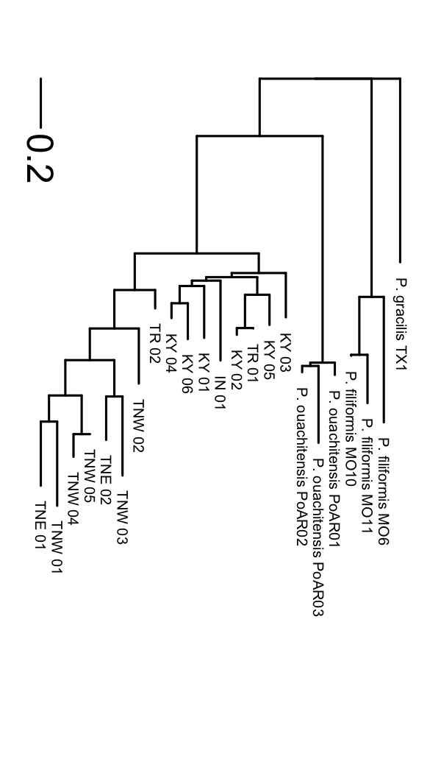

Figure 1. Photos of Physaria globosa and genetic distance tree.
(A), Native habitat. (B), Neighbor-Joining tree based on Nei’s genetic distances. The tree was rooted at P. gracilis.

Figure 2. Map of P. globosa collection localities, with population structure K = 3 shown in pie charts.
The size of the pie chart reflects the sampling size per population. See Table 1 for detailed information.

A
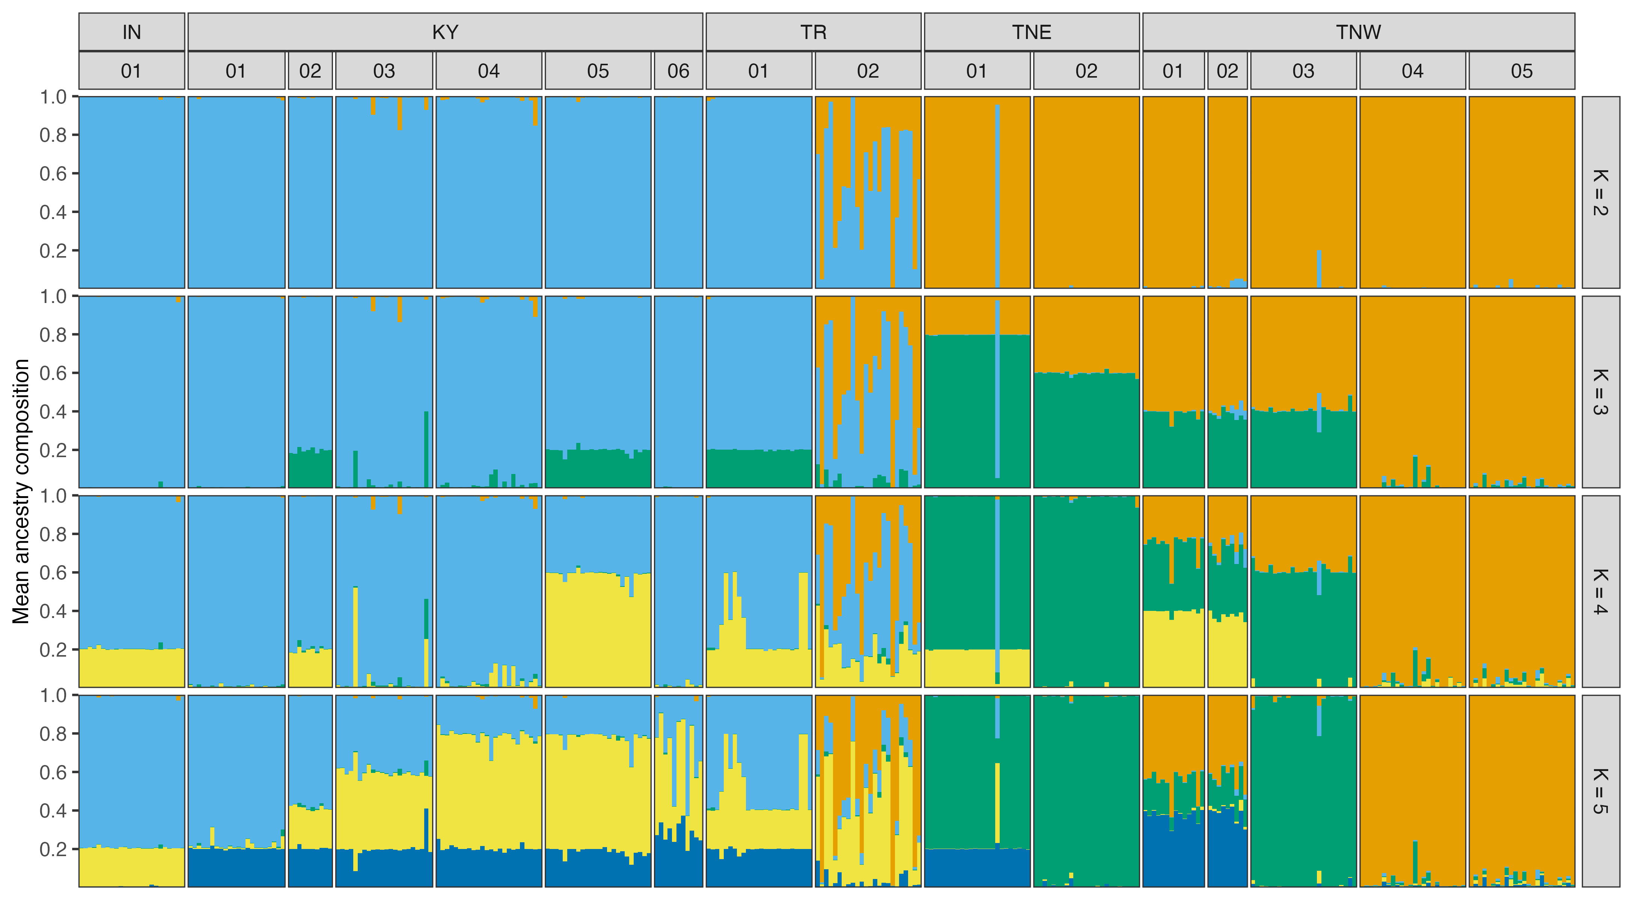
B  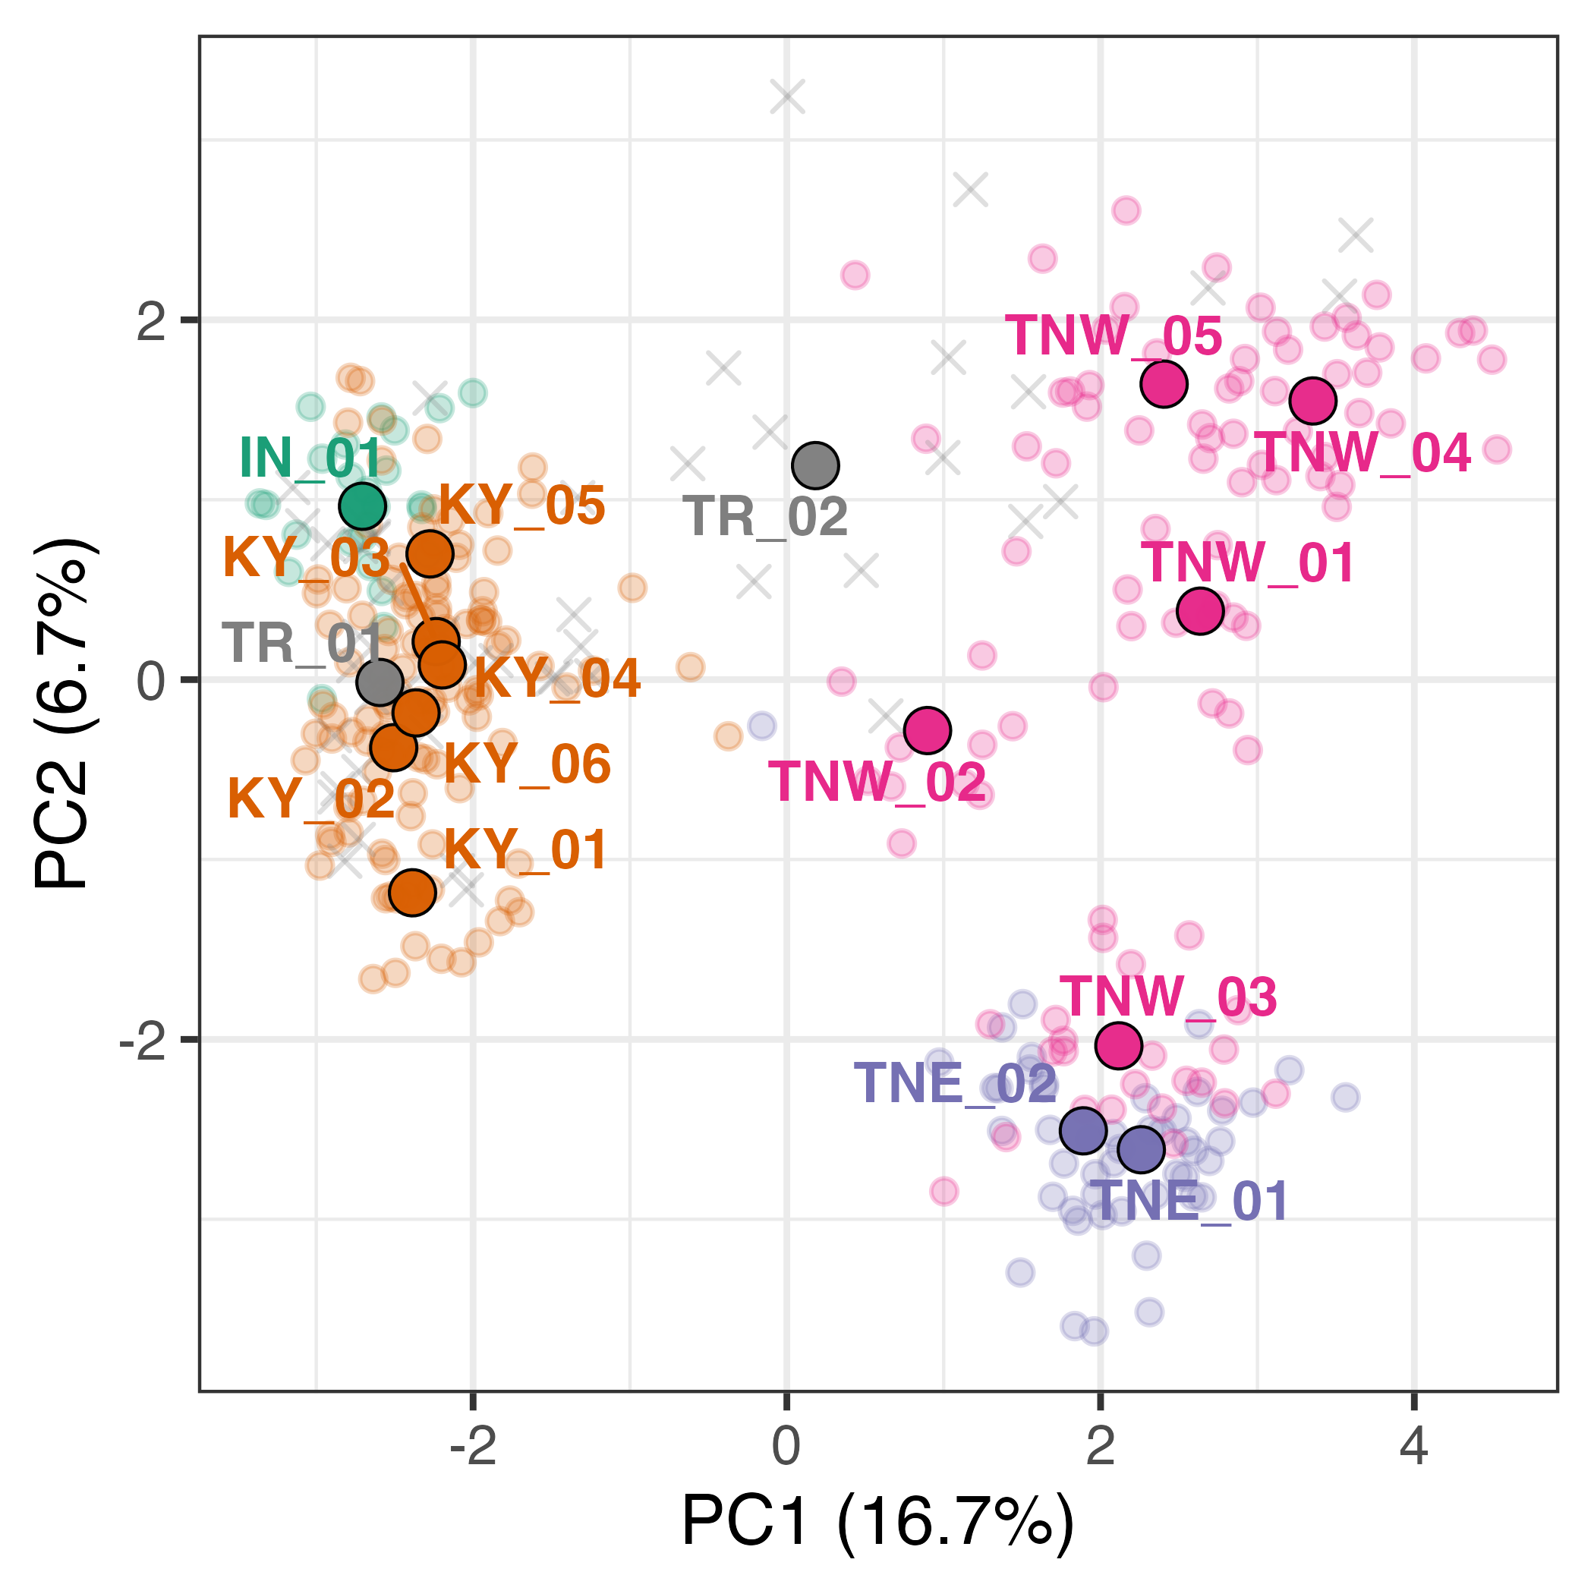 | C  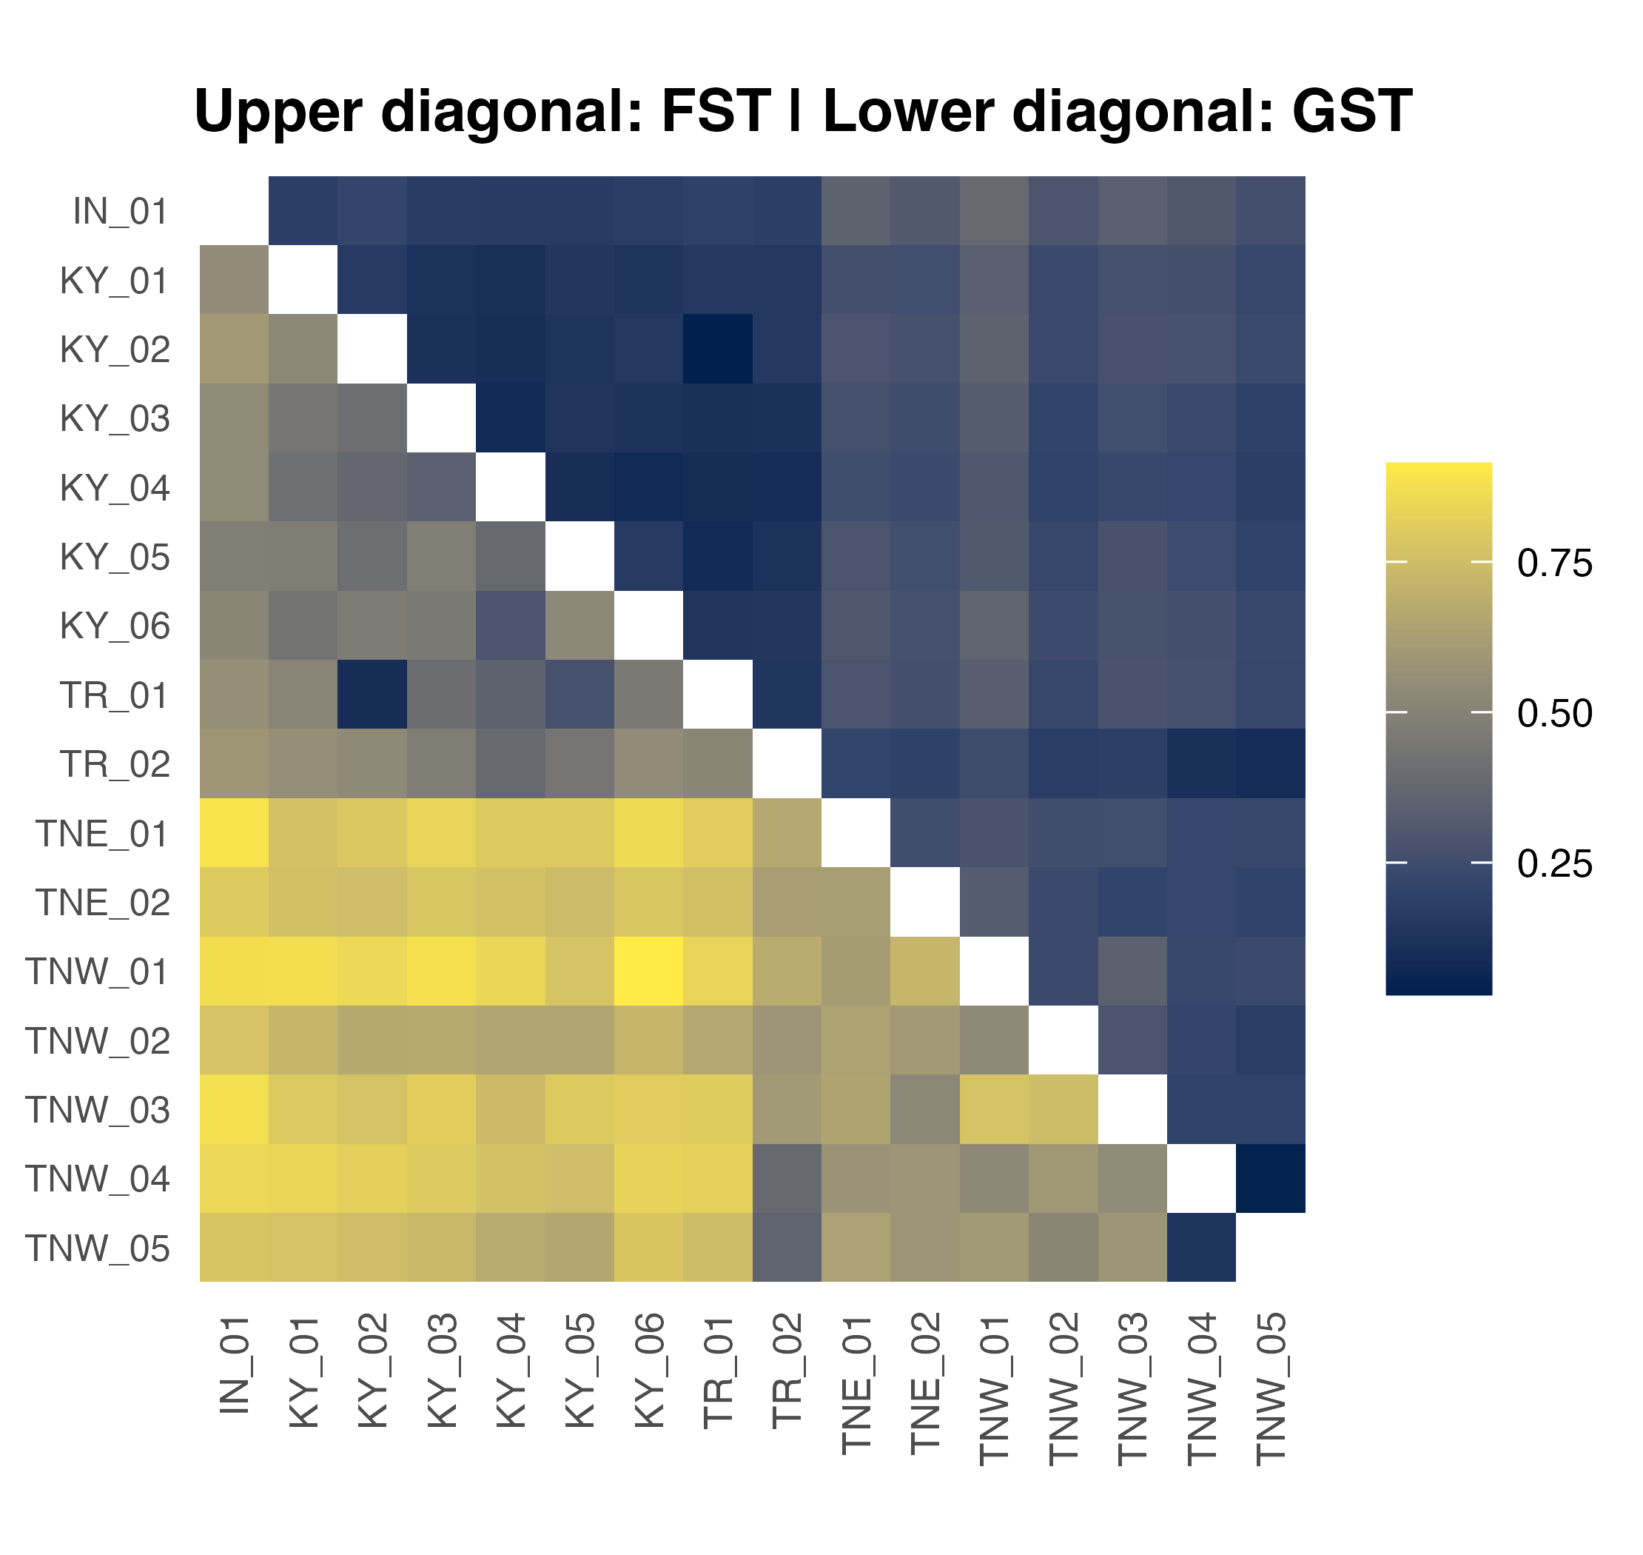

Figure 3. PCA of all wild P. globosa populations, with location and species indicated.
(A) STURCTURE analysis result (K = 2-5). (B) PCA plot. The big points with black stroke outline are population means. The small points without black stroke outline are individuals from natural populations. The crosses are individuals from ex situ populations. Points are colored by regions and population codes are labeled. (C), heatmap of F_{ST} and G_{ST}. See Table 1 for the population codes.
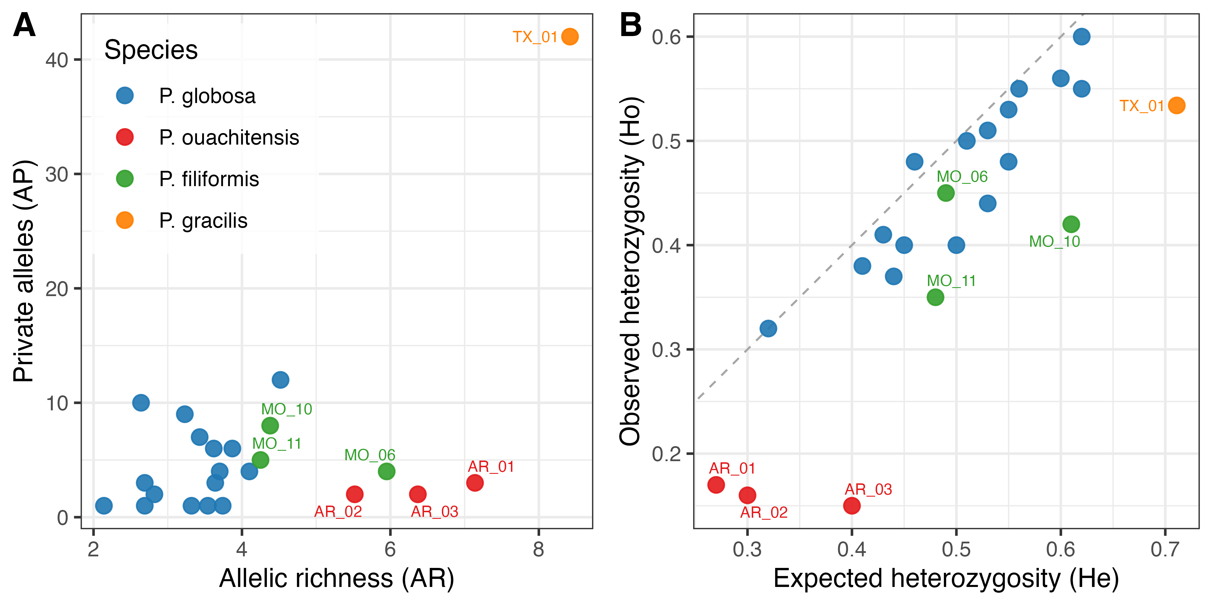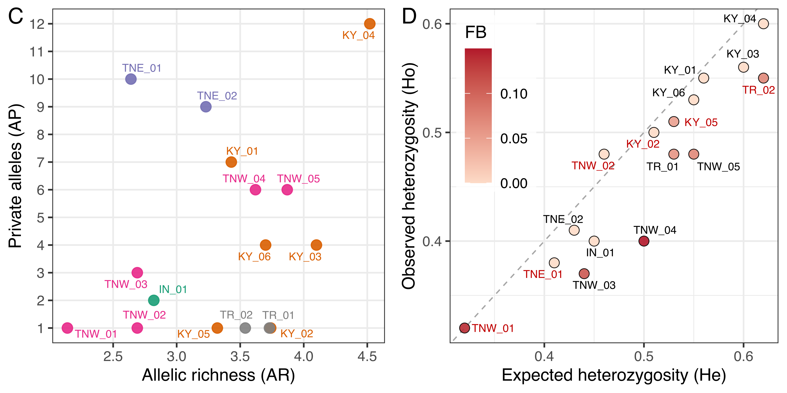

Figure 4. Genetic diversity analyses plots.
(A-B), Physaria globosa and outgroup species. (C-D), Physaria globosa with population labels. F_{B}., inbreeding coefficient after correction for null alleles. The six populations with excessive heterozygosity are labeled in red in (D). See Table 1 for the population codes.

