A disjunct distribution and population fragmentation shape rangewide genetic diversity and structure of the endangered Physaria globosa (Brassicaceae)

Christine E. Edwards¹*, Clara Landon ^{1,2, 3}, Burgund Bassüner¹, Alex G. Linan¹, and Matthew A. Albrecht¹

¹Center for Conservation and Sustainable Development, Missouri Botanical Garden, 4344 Shaw Blvd., St. Louis MO 63110, USA
²Oberlin College Biology Department, 119 Woodland St., Oberlin, OH 44074
³Current address: Lady Bird Johnson Wildflower Center, 4801 La Crosse Ave. Austin, TX 78739

*Correspondence: Christine.Edwards@mobot.org

Abstract
Population genetic analysis of species of conservation concern provides information to devise management plans to effectively conserve the genetic variation of endangered species. One such endangered plant, Physaria globosa is a federally endangered species in the mustard family with a geographically restricted range that occurs in four disjunct locations in Indiana, Kentucky, and Tennessee along the watersheds of the Wabash, Kentucky, Cumberland Rivers. In this study, we sampled populations from throughout the range of P. globosa, genotyped them using 20 microsatellite loci, and assessed genetic diversity and structure within and among populations. The goals of the study were to understand: 1) levels of genetic diversity in P. globosa and whether populations show evidence of having experienced reductions in genetic diversity as the result of genetic bottlenecks, genetic drift, or inbreeding, 2) rangewide genetic diversity and structure in P. globosa and how genetic structure is affected by the disjunctions in the species range, and 3) implications for prioritization of in-situ and ex-situ conservation efforts. On average, P. globosa showed comparable levels of genetic diversity to other species of Physaria. However, some populations showed evidence of inbreeding, genetic bottlenecks, or decreases in genetic diversity, possibly due to anthropogenic or climate-related pressures and decreases in population size due to competition with invasive bush honeysuckle. Genetic variation was strongly structured into two main geographic groups, one in the northern part of the species range (KY and IN), and the other in the southern part of the species range (TN), but some populations likely originated via long-distance dispersal. We also found significant isolation by distance, likely due to both life history characteristics and physical barriers associated with the complex topological structure of the landscape occupied by P. globosa, limiting population connectivity. Given the strong genetic structure found in P. globosa, several populations should be protected and managed within each geographic region to conserve genetic variation. Ex situ conservation will also be important to protect genetic diversity, particularly for populations that are difficult to access and manage.
Keywords: Genetic diversity; genetic structure; geographic range disjunctions; microsatellites,

Introduction
Genetic diversity is thought to be the raw material underlying the physical and functional differences among individuals in a species. It is important because greater genetic diversity is associated with increased ecosystem stability, resilience, and function (Hughes & Stachowicz 2004; Reusch et al. 2005; Hughes et al. 2008), greater potential for a species or population to adapt to environmental change (Sgro et al. 2011), increased individual-level fitness (Reed & Frankham 2003; Leimu et al. 2006), and greater success rates in reintroduced populations (Godefroid et al. 2011), all of which can enable a species to withstand and adapt in response to environmental variation and stress. For the most endangered species, it is therefore important to protect the full range of genetic diversity in a species to ensure its resilience and persistence (Petit et al. 1998; Fraser & Bernatchez 2001; Caballero & Toro 2002; Linan et al. 2024).
To effectively protect the genetic diversity in a species, however, it is necessary to sample populations from throughout the geographic range of a species, measure the genetic diversity present in populations, and analyze how genetic variation is structured across populations. Overall, genetic structure is created by limited migration among populations together with genetic drift (i.e., random changes in allele frequency from generation to generation due to stochastic factors) and different selection regimes acting to cause differences among populations (Wright 1949). Migration in plants occurs through the movement of seeds or pollen across the landscape and is affected by life-history traits such as mating system, pollinator, seed dispersal mechanism, and continuity of geographic distribution (Hamrick et al. 1993; Hamrick & Godt 1996; Gamba & Muchhala 2020). Plant populations that are spaced farther apart than the distances that pollen and seed can travel will have restricted migration. Without migration, populations will experience differential effects of natural selection and genetic drift; together these forces cause differences in gene frequencies between populations, resulting in genetic structure. Understanding patterns of genetic structure in a plant species of conservation concern can identify unique segments of genetic variation within a species, which can be used to devise conservation strategies to protect as much genetic diversity as possible.
Populations that are small and geographically isolated also have a greater risk of experiencing losses in genetic diversity through processes such as genetic drift, genetic bottlenecks, and inbreeding. Genetic drift generally acts to reduce genetic variation and is more pronounced in populations with small effective population sizes (Ellstrand & Elam 1993). Because gene flow also acts to prevent losses of genetic variation, isolated populations are more susceptible to losses in genetic diversity due to genetic drift. Small, isolated populations are also often at greater risk of inbreeding, simply because there may be few non-related individuals with whom to mate. Because losses in genetic diversity may eventually reduce the viability of a population, it is therefore important for conservationists to identify these losses quickly and to take steps to minimize their effects. For example, if populations are experiencing major losses of genetic diversity due to genetic drift, it may be possible to minimize these losses by translocating individuals among populations to increase both population size and genetic diversity.
Short’s bladderpod (Physaria globosa (Desv) O’Kane and Al-Shebaz; Brassicaceae) is a federally endangered, biennial/perennial plant species (Long et al. 2017). It has yellow flowers that are pollinated by small insects (Thacker et al. 2019) and gravity or water-dispersed seeds. The species typically grows on steep, rocky, wooded slopes and talus (sloping mass of rock fragments below a bluff or ledge) areas along the tops, bases, and ledges of bluffs. It is typically found on south- to west-facing slopes along rivers or streams (Long et al. 2017). Given its association with rivers, the distribution of the species is discontinuous, with populations occupying the following four disjunct locations: in sites near the Kentucky river in north-central KY (around Frankfort/Lexington KY), near the Ohio River in the extreme southwestern tip of IN, and along the Cumberland River in two discontinuous areas (Highland Rim in the west and Nashville basin the east) in central TN (Long et al. 2017), which are separated by the Nashville metropolitan area (Fig. 1). Because the four main groups of populations of P. globosa are spatially isolated by up to hundreds of kilometers and their pollinators and seeds are likely capable of traveling only limited distances, it is very likely that the species exhibits genetic structure, which is relevant for developing a strategy to protect the full range of genetic variation in the species (i.e., for ensuring good representation of genetic diversity in protected populations); however, no study has thus far analyzed patterns of genetic structure in P. globosa.
A recent analysis of P. globosa showed that only 31 populations of the species remained, and of these, 23 had fewer than 100 individuals (Long et al. 2017). Given the small size and isolation of some populations, it is possible that they may have experienced reductions in genetic diversity due to genetic bottlenecks or drift, which can affect the long-term resilience of populations. Although inbreeding can have strongly negative effects on small, isolated populations, Physaria globosa is thought to have a genetic system of self-incompatibility (sporophytic self-incompatibility) in which individuals can only successfully mate with individuals that differ at two S-alleles, such that inbreeding is unlikely in P. globosa. Instead, the erosion of genetic variation by genetic drift in a rare species may cause the loss of mating types, thereby reducing the ability of self-incompatible individuals to find compatible mates (Byers & Meagher 1992). However, genetic diversity has not been measured previously in populations of P. globosa, such that it is unknown whether populations have experienced reductions in their levels of genetic diversity, and whether these losses are severe enough to cause problems with mate availability.
The goal of this study was to conduct a comprehensive rangewide study of patterns of genetic diversity and structure in P. globosa to identify priority populations that should be protected to preserve genetic diversity and to identify and potentially mitigate any losses of genetic diversity due to processes associated with small population size, such as genetic drift or population bottlenecks. We collected leaf samples for DNA analysis of populations of P. globosa from throughout its geographic range and genotyped them at 20 microsatellite loci. The main goals of the study were to use the genetic data to understand: 1) levels of genetic diversity in P. globosa and whether populations show evidence of having experienced reductions in genetic diversity as the result of genetic bottlenecks, genetic drift, or inbreeding, 2) rangewide patterns of structure in P. globosa and how it is affected by the disjunctions in the species range, and 3) implications for prioritization of in-situ and ex-situ conservation efforts for the species.

Materials and Methods

Study species
Physaria globosa (Desvaux) O’Kane & Al-Shehbaz is a member of the mustard family (Brassicaceae). It is quite distinctive morphologically from other species of Physaria in the eastern U.S., which all have an annual life history and fibrous roots, whereas P. globosa is biennial or perennial with a woody caudex. Each plant can have several stems and can reach up to 50 cm tall. It has small yellow flowers that open in April and May that are pollinated primarily by small insects (Thacker et al. 2019). In June and July, the distinctive globular seeds form that give this genus of bladderpods their name. The seeds are thought to be water and gravity-dispersed along the rivers that P. globosa grows (Long et al. 2017).

Sample collection and DNA extraction
Our goal was to sample from populations of P. globosa from throughout the species’ range, with sampling effort proportional to the number of occurrences in each of the four main locations. Field collections were completed in May of 2021 (Table 1). In total, we collected plants from 17 sites, including the one and only wild population in IN, seven wild populations in TN, and six wild populations (one of which is partially cultivated) and three ex-situ populations in KY (one that is cultivated in a private yard, and two reintroductions); this represents all known populations that were accessible at the time of sampling. We sampled between 10 and 24 individuals per population based on the population size and accessibility of samples in each site, resulting in a total of 358 samples of P. globosa (Table 1). We also collected one herbarium voucher specimen per population, which was deposited in the Missouri Botanical Garden Herbarium (MO).
We also included populations of three related Physaria species to gain an understanding of typical levels of genetic diversity in the genus against which the genetic diversity of populations of P. globosa were compared to infer whether populations have experienced losses in genetic diversity. We included 17 individuals from three populations of P. filiformis O’Kane and Al-Shebaz from Missouri, 19 individuals from three population of a putative new species, Physaria ouachitensis ined., from the Ouachita mountains in Arkansas, and 12 individuals from one population of Physaria gracilis (Hook) O’Kane and Al-Shebaz from Texas (Table 2), which were previously included in a study focusing on P. filiformis (Edwards et al. 2021). In total, we included a total of 406 samples, including 358 individuals of P. globosa, 17 individuals of P. filiformis, 19 individuals of P. ouachitensis, and 12 individuals of P. gracilis.

During sampling, leaf tissue was placed into silica gel for subsequent DNA extraction. Silica-dried leaf tissue was brought back to the lab, where DNA was extracted from each sample using a modified CTAB protocol (Doyle & Doyle 1987).

Microsatellite markers and genotyping
Our goal was to develop 20 microsatellite markers to genotype P. globosa. We first tested the 16 microsatellite markers previously developed for Physaria filiformis (Edwards et al. 2021) for amplification in seven individuals of P. globosa (from TN and KY) and one individual of P. pallida. PCR amplifications were performed in 10 μL reactions containing 0.5 U of GoTaq Flexi DNA polymerase (Promega), 1× Promega Colorless GoTaq Flexi Buffer, 1.5 mM MgCl₂, 4.5 pmol each of the reverse primer and one of four fluorescently labeled M13 primers (6-FAM, VIC, NED, or PET; Applied Biosystems), 0.18 pmol of the M13-tagged forward primer, and 0.5 mM of each dNTP. PCR temperature cycling conditions were as follows: (I) 3 min at 94 °C, (II) denaturation for 30 s at 94 °C, (III) annealing for 30 s at 52 °C, (IV) extension for 45 s at 72 °C, (V) 35 repetitions of steps 2–4, and (VI) a final elongation at 72 °C for 20 min. We used 2% agarose gel electrophoresis of 5ul of each PCR product to conduct a preliminary test of amplification.
Of the 16 primers tested, 11 primers from P. filiformis successfully produced PCR bands of the expected size in P. globosa (see Table 2 for details). These 11 were subjected to tests of polymorphism by genotyping them using fragment analysis on a capillary sequencer. In PCR, each marker was labeled with one of four fluorescently labeled M13 primers, which were then pooled for analysis. All genotyping was carried out using capillary electrophoresis on an Applied Biosystems 3730xl at Cornell Institute of Biology’s Biotechnology Resource Center. Polymorphism was analyzed using visual analysis of electropherograms in GeneMarker version 2.6.2 (Soft Genetics LLC). Of the 11 loci that successfully produced a PCR band, ten were polymorphic in P. globosa and were employed to genotype the samples in the present study (i.e., markers beginning with “pf” in Table 2).
To develop a set of markers specifically for P. globosa, we also used a next-generation DNA sequencing approach to identify additional microsatellite loci. We conducted shotgun sequencing of genomic DNA to identify microsatellites following the protocol described in Swift et al. (2016). Briefly, genomic DNA of two individuals of P. globosa (one each from TN and KY) was prepared for DNA sequencing using Nextera DNA sample prep kits and Nextera index kits (Illumina) and sequenced using 2×150 bp reads on an Illumina MiSeq. Reads were trimmed and assembled de novo into contigs using the Medium sensitivity/fast setting using Geneious version 7.1.9 (Biomatters Inc.). Microsatellites were identified and polymerase chain reaction (PCR) primers were designed using MSATCOMMANDER (Faircloth 2008) and PRIMER3 (Rozen & Skaletsky 1999; Faircloth 2008). We added an M13 tag (5'-CACGACGTTGTAAAACGAC-3') to the 5' end of each forward primer to employ a universal dye-labeling approach (Boutin-Ganache et al. 2001).

The MiSeq run of the two samples resulted in 1,049,048 and 1,163,933 paired-end reads. The reads of the two individuals were assembled de novo into 585,371 contigs. MSATCOMMANDER identified 2054 unique microsatellites in contig consensus sequences, from which PRIMER3 identified 324 unique microsatellite primers. We tested 48 of these primers for amplification using genomic DNA from the same two samples of P. globosa used for shotgun sequencing, with PCR and genotyping protocols described above. In this initial screening, 22 loci amplified in both individuals of P. globosa and were selected for further testing for amplification and polymorphism in eight samples (six samples of P. globosa, including two each from IN, KY, TN, one sample of P. filiformis, and one sample of a putative new species from Arkansas, P. ouachitensis). Based on these tests, we identified ten additional polymorphic loci that showed reliable amplification in P. globosa (i.e., those beginning with “pg” in Table 2). Thus, a total of 20 loci were used to genotype the 406 samples in this study using the genotyping protocols described above. Fragment analysis and scoring were conducted using automated fragment scoring panels developed for each locus in GeneMarker version 2.6.2 (Soft Genetics LLC), and then the data were checked manually.

Analysis of genetic diversity
We first removed samples showing >50% missing data, resulting in the removal of nine samples of P. globosa from the analysis and a final data set of 397 individuals. Population genetic diversity summary statistics were calculated using GenAlEx, Genodive, INEST, and HP-Rare. Genodive (Meirmans & Van Tienderen 2004) was used to calculate average number of alleles per population (A), observed and expected heterozygosity (H_{O} and H_{E}, respectively) and the inbreeding coefficient (F_{IS}) in each population. We used GenAlEx (Peakall & Smouse 2012) to identify private alleles (A_{P}) in each population and HP-Rare (Kalinowski 2005) to calculate allelic richness. We used the program INEST ver. 2.2 (Chybicki & Burczyk 2009) to analyze the percentage of null alleles (N) and genotyping errors (b) for each population, and to calculate a revised inbreeding coefficient (F^{B}) after taking null alleles into account. INEST was run using a Bayesian MCMC approach with 5,000,000 cycles, keeping every 250, and a burn-in of 500,000.
To test for any recent bottlenecks in the populations, we used the bottleneck test function of INEST 2.2, using a combination of two types of tests (excess in heterozygosity and Deficiency in M-Ratio) with two types of significance testing (Z-test and Wilcoxin signed-rank test); we considered populations to have experienced a bottleneck if at least three of the four tests had a statistically significant p-value (p<0.05). To identify populations that may have experienced declines in genetic diversity, we compared inbreeding coefficients and levels of genetic diversity in populations of P. globosa to each other and to populations of our three outgroup species to identify populations that have either greater than average inbreeding coefficients or lower than average genetic diversity to identify population may have experienced inbreeding or genetic drift, respectively.
Analysis of genetic structure
To investigate patterns of genetic structure, we calculated Nei’s standard genetic distance among populations (Nei’s D; Nei, 1972), pairwise F_{ST}, and pairwise G’_{ST}, a standardized measure of pairwise population differentiation, between all possible pairs of populations using Genodive. The Nei’s D matrix was used to build an unrooted neighbor joining phylogram in PAUP* (Swofford 2021). We also analyzed whether populations exhibited isolation by distance using Mantel tests (Mantel 1967). We used the Geographic Distance Calculator to calculate pairwise geographic distances between the GPS points (Erst, 2015) and assessed the correlation between the geographic distance matrix and the pairwise F_{ST} matrix using a standard Mantel test with 10,000 permutations in Genodive.
To investigate patterns of genetic structure in P. globosa without a priori grouping of individuals into populations, we analyzed the data using both a PCA and a DAPC in adagenet (Jombart 2008). We also analyzed the data using the Bayesian program STRUCTURE version 2.3.4 (Pritchard et al. 2000). We varied the number of groups in the data set (K) and assigned admixture proportions to these groupings for each individual. We used an admixture model, assumed correlated allele frequencies, used a flat prior of K, and did not incorporate population information into the analyses. We ran analyses following the recommendations of Gilbert et al. (2012); after preliminary analyses to determine the adequate burn-in and number of iterations, we ran 10 separate runs at each K from 1 to 15, with a burn-in of 500,000 generations and a run length of 1,000,000 generations. We examined the groupings across all runs at each K to ensure that the results were consistent using CLUMPAK (Kopelman et al. 2015). To determine the appropriate value of K, we plotted the average natural logarithmic probability (-ln prob) of the data across multiple replicates of each K using structure harvester.
Finally, we analyzed the hierarchical partitioning of genetic diversity within and among ecoregions and populations. We grouped populations into the four main ecoregions as shown in Fig. 1 and conducted an AMOVA using GenAlEx.

Results

Genetic diversity in P. globosa
Populations of P. globosa showed variation in their genetic diversity. The average number of alleles per locus (A) in P. globosa ranged from 2.278 – 6.5 (overall mean = 4.196), and A_{R} ranged from 2.14 – 4.52 (overall mean = 3.38) (Table 3). Both allelic richness (A_{R}) and the mean number of alleles across all loci (A) were lowest in population 362 from W-TN and greatest in population 351 from KY (Table 3). The number of private alleles per population (A_{p}) ranged from 1-12, with four populations in KY and two populations in W-TN with one private allele and populations 351 (KY) and both populations from E-TN (357, 356) showing the greatest number of private alleles, with 12, 10 and 9 private alleles, respectively (Table 3). Observed heterozygosity (H_{O}) ranged from 0.323 – 0.596 (overall mean = 0.467) and expected heterozygosity (H_{E}) ranged from 0.323 – 0.620 (overall mean = 0.506), with most populations from KY showing greater than average H_{O} and H_{E} and populations from both E-TN and W-TN showing lower than average H_{O} and H_{E} (Table 3). H_{E} was generally slightly greater than H_{O} in most populations, such that the average inbreeding coefficient (F) was slightly positive (overall mean = 0.08, range -0.036 to 0.227) (Table 3). However, these positive inbreeding coefficients are likely due in part to null alleles rather than inbreeding, as INEST analyses revealed that the percentage of null alleles (% null) ranged from 0.0771 - 0.4694 (overall mean = 0.2648) (Table 3). After correcting for null alleles, inbreeding coefficients (F_{B}) were generally very close to zero (range 0 – 0.1481; overall mean = 0.04; Table 3), indicating that most populations have not experienced inbreeding. However, three populations (358 [McMinn’s Bluff], 360 [Lock B Rd.], and 362 [King and Queen’s Bluff]) all from W-TN exhibited inbreeding coefficients greater than >0.10 even when corrected for null alleles, suggesting that they may have experienced some inbreeding.
We used INEST to test for genetic bottlenecks test and considered populations to show significant evidence for a genetic bottleneck when three out of the four tests were statistically significant. This revealed that following six populations representing three out of the four ecoregions had undergone recent bottlenecks: populations 347 (Cove Spring), 352 (Delaney Ferry Rd), 353 (Jessamine Creek Gorge) from KY; population 357 from E-TN (Hartsville boat ramp); and population 361 (Jarrell Ridge Rd.) and 362 (King and Queen’s bluff) from W-TN (Table 4). To understand whether populations have experienced genetic drift, we also inspected levels of genetic diversity in each population and compared them to those in other populations of P. globosa and the outgroups and to identify populations that show low genetic diversity that could not be explained by other factors such as inbreeding or bottlenecks. Generally, populations with the lowest genetic diversity also exhibited significant evidence of either genetic bottlenecks (i.e., 347, 352, 353, 357, 361), inbreeding (i.e., 358 and 360), or both (i.e., 362).

Genetic structure
Analyses of genetic structure revealed considerable structuring of genetic variation across the landscape in P. globosa, generally grouping populations in Kentucky and Indiana together and separating them from the populations in Tennessee. The neighbor joining tree based on Nei’s genetic distances was rooted using P. gracilis, and it placed P. filiformis in a group with P. gracilis and P. ouachitensis populations as the sister to P. globosa (Fig. 2). P. globosa was divided into two groups, with one group containing populations from TN and one group containing populations from KY, with the population from IN nested within it, clustered with KY population 352 (Fig. 2). We did not include ex situ populations in this analysis because they are derived from both KY and TN, which may affect the structure of the genetic distance tree. Pairwise F_{ST} and G_{ST} generally showed similar patterns, with greater values found between the outgroups and P. globosa and between the TN vs. KY/IN populations of P. globosa, and lower values between populations within TN or KY/IN (Table 5) To test for isolation by distance, s Mantel’s test to understand the correlation between geographic and genetic distance showed Mantel’s r as 0.505 with a p-value of 0.001, indicating a pattern of isolation by distance in P. globosa.
We next analyzed patterns of genetic structure using PCA, which was used to understand whether the samples would fall into four genetic groups corresponding to the four ecoregions occupied by P. globosa. Like the genetic distance tree, PC1 generally separated the TN P. globosa from the populations in KY/IN, whereas PC2 separated the outgroups from P. globosa (Fig.3).
For STRUCTURE analyses, the Mean LnP(K) plateaued around K= 11, (Fig. 4). Populations were grouped into the following clusters 1) the IN population grouped with KY population 349; 2) KY populations 347 (ex situ), 348, and 352; 3) KY population 352; 4) KY populations 352 and 354, plus some admixture from this cluster in the ex situ populations KY 353 and 355; 5) TN population 356 from the Nashville Basin and TN population 360 from the Highland rim; 6) TN population 357; 7) TN population 358 and 359, plus some admixture from this cluster in the ex situ populations KY 353 and 355; 8) TN population 361 and 362, and 9), one cluster each for P. ouachitensis, P. filiformis, and P. gracilis (Fig. 4). Generally, a population or pairs of geographically proximal populations were grouped into clusters, with the following two exceptions in which populations from different regions were grouped together: 1) cluster 1 above that included the IN population and one KY population, 2) cluster 5 above, which included populations from east and west of Nashville, TN. In terms of the genetic source of the ex situ populations, STRUCTURE results suggest that populations 353 and 355 were sourced from genetic clusters 5 and 7, representing both KY and TN, respectively, whereas population 347 in KY was sourced from populations 348 or 352 in KY.
AMOVA was used to analyze hierarchical partitioning of genetic diversity for all of P. globosa with populations grouped into the ecoregions indicated in Fig. 1. Results showed that that 15% of the variation was among partitioned among regions, whereas 21% of the variation was partitioned among populations within groups, 64% was partitioned within populations (Table 6). Additional analyses are needed to understand how placing populations into the groups revealed by PCA or STRUCTURE may affect the results of AMOVA results.

Discussion

Factors Affecting Genetic Diversity in P. globosa
The first goal of the study was to measure levels of genetic diversity in P. globosa and to infer whether populations show evidence of having experienced reductions in genetic diversity as the result of inbreeding, genetic bottlenecks, or genetic drift. On average, levels of genetic diversity in P. globosa were comparable to or even greater than those found in populations of P. filiformis, P. ouachitensis, and P. gracilis. For example, average values of H_{O} and H_{E} across the three populations of P. filiformis were 0.40 and 0.53, respectively, and in P. globosa, they were 0.47 and 0.51 (Table 3). These estimates are directly comparable to each other with little ascertainment bias because the microsatellite markers were developed in both species. Thus, we did not find evidence that P. globosa’s specific life-history characteristics have led to wholesale declines in its genetic diversity relative to its congeners.
Although P. globosa overall has comparable levels of genetic diversity to it congeners, levels of genetic diversity in populations of P. globosa differed across its geographic range, with populations in the southern part of its range in TN exhibiting lower genetic diversity than those found in the northern part of the species’ range in KY and IN (average H_{O} and H_{E} of 0.40 and 0.44, respectively, in TN, versus 0.512 and 0.55, respectively, in KY and IN). This is the opposite of the pattern found in another endangered mustard, Boechera perstellata, which occupies a similar geographic range (Baskauf et al. 2013). The lower genetic diversity in the southern part of P. globosa’s range is likely partially due to population-specific factors such as genetic bottlenecks or inbreeding in specific questions (see below). However, even the sites with the greatest genetic diversity in TN had lower genetic diversity than almost all of those in KY/IN (Table 3), suggesting that population-specific declines in genetic diversity cannot fully explain why genetic diversity is lower in the southern part of the range. Another explanation for why the genetic diversity in the northern and southern portions of the species’ range differs is because of differences in the extent to which they have been exposed to long-term stressors, either as the result of anthropogenic activities or climate stress. In the KY and IN populations, most sites occupied by P. globosa have largely intact habitat, whereas in the southern part of the range, populations overall have experienced greater long-term anthropogenic pressures. For example, historically, a series of locks and dams was constructed to deepen the channel of Cumberland River (Olson 2021), a railroad was constructed that once ran through P. globosa habitat in TN (Hicks 2023). Currently, several populations in TN occur on roadsides that are managed with herbicides, and some are impacted by development or recreation (Long et al. 2017). It is possible that these long-term anthropogenic disturbances have slowly eroded genetic diversity in the southern part of P. globosa’s range.
The lower genetic diversity in the southern part of P. globosa’s range is also consistent with the pattern expected in species experiencing leading edge/trailing edge dynamics in response to warming climates (Hampe & Petit 2005). Under this hypothesis, leading edges of a species’ range (at the highest latitudes or elevations) represent areas where climate warming is causing population expansions due to increases in range-limiting low temperatures, whereas trailing edges (at the lowest elevations or latitudes) represent older areas of the species range where climate warming may impose new, range-contracting stresses (Hampe & Petit 2005). In the southern part of P. globosa’s range, previous research found that populations have experienced a greater total number of weeks of drought and droughts of considerably longer duration than those in Indiana and Kentucky (Long et al. 2017). Furthermore, many species of Physaria reproduce in spring, avoiding hot summer temperatures (Rollins & Shaw 1973); It is also possible that greater climate warming or shorter duration of spring in the southern populations of P. globosa have led to decreases in fecundity and genetic diversity. Additional research is needed to determine which factors are the underlying causes of these declines in P. globosa so that they can be properly addressed.
In addition to lower genetic diversity observed in the more southern populations of P. globosa, several populations exhibited evidence for declines in genetic diversity associated with small population size. Six populations showed evidence of recent genetic bottlenecks, three each in KY and TN. One was found in an ex-situ population, population 353 (Jessamine Creek Gorge in KY), which is logical as it was recently seeded from population 355 (Private yard). The remaining bottlenecks were found in five wild populations, including populations 347 (Cove Spring--KY), 352 (Delaney Ferry Rd.--KY), 357 (Hartsville--TN), 361 (Jarrell Ridge Rd--TN), and 362 (King and Queen’s Bluff--TN). One possible explanation for these bottlenecks is that these populations are some of the most severely impacted by the invasive species, bush honeysuckle (Lonicera maackii). In heavily invaded sites, L. maackii forms a dense shrub layer that reduces light availability, alters soil chemistry, and dramatically decreases the growth and abundance of native plants (McNeish & McEwan 2016). Given P. globosa’s preference for sites with high light and shallow soils with frequent disturbance regimes that help maintain an open canopy (Long et al. 2017; Krosnick et al. 2022), declines in habitat quality caused by the invasion of Bush honeysuckle may have led to losses in genetic diversity, possibly through declines both in fecundity and seedling recruitment. However, it appears that management may help counteract these effects; for example, population 351 (Ninevah Rd.) is regularly managed with fire and removal of Lonicera maackii, and it had among the greatest genetic diversity of all populations of P. globosa, possibly via recruitment from a persistent seed bank, which is common in the genus Physaria (Elberling 2000). However, an experiment to investigate how genetic diversity in populations of P. globosa changes before and after management is needed to test this hypothesis. Because L. maackii invasion represents a serious threat to the persistence of P. globosa, management activities to remove Bush honeysuckle from P. globosa populations are critical to maintain population sizes and prevent losses in the genetic diversity of the species.
Finally, several populations of P. globosa exhibited greater-than-expected inbreeding coefficients, which could be of concern in this endangered species. Because P. globosa is thought to exhibit sporophytic self-incompatibility (Long et al. 2017), we expected populations to show little evidence of inbreeding. Although most populations showed inbreeding coefficients approaching zero, which is generally indicative of random mating, inbreeding coefficients were greater than expected for three populations from W-TN (358, McMinn’s Bluff; 360, Lock B Rd.; and 362, King and Queen’s Bluff), even after correction for null alleles. Generally, self-incompatibility limits inbreeding, raising the question of whether these populations could be self-compatible. However, the more important question is whether inbreeding is detrimental to these populations, which depends on the history of inbreeding in a species. Biparental inbreeding and self-fertilization increase homozygosity within a genome, increasing the likelihood of inbreeding depression, which occurs when individuals are homozygous for recessive deleterious alleles (Charlesworth & Charlesworth 1987; Charlesworth & Willis 2009). In species that are strongly selfing, purifying selection purges these highly deleterious alleles from a population, reducing inbreeding depression (Charlesworth & Charlesworth 1987; Charlesworth & Willis 2009). In contrast, outcrossing species tend to maintain recessive deleterious alleles in a heterozygous state, such that inbreeding in these species is more likely produce offspring that are homozygous for these deleterious alleles and thus suffer reduced viability and fecundity (Charlesworth & Charlesworth 1987; Charlesworth & Willis 2009). Because P. globosa is self-incompatible and normally reproduces through outcrossing, inbreeding may lead to inbreeding depression in the species; however, additional research is needed to test the effects of inbreeding in P. globosa. If inbreeding does cause inbreeding depression, then actions such as conservation augmentations or translocations may be needed to increase mate availability and reduce inbreeding depression in populations with positive inbreeding coefficients.

Genetic structure across the range of P. globosa
The second goal of the study was to analyze rangewide patterns of genetic structure in P. globosa to understand how it is affected by disjunctions in the species range. Both the genetic distance tree and DAPC grouped populations into two major groups, one containing populations in the northern part of the species range in KY and IN, and the other containing populations from TN, including those from both the Nashville Basin and Highland Plateau ecoregions. Within the northern and southern groups, populations were further divided into several distinct subgroups, indicating extensive genetic structure. At K=11, STRUCTURE grouped the eight wild northern populations into four genetic groups and the seven TN populations into four genetic clusters. These overall strong patterns of genetic structure are likely due to barriers to gene flow, created both by the complex topological structure of the landscape occupied by P. globosa as well as the short flight patterns of the ground-nesting bees and flies that serve as pollinators of the species (Thacker, 2018).
Generally, most populations placed into the same genetic cluster were found within the same ecoregion and were geographically proximal to one another, suggesting limited migration has occurred between these proximal populations. For example, the genetic distance tree and STRUCTURE placed the geographically proximal populations 358 and 359 from western TN in the same genetic cluster. However, we observed three notable exceptions to this. The first involves the IN population, which was nested within the KY populations in the genetic distance tree, suggesting that they arose via dispersal from KY, with estimates of genetic distance placing it closest to population 352 (Delaney Ferry Rd—KY) and STRUCTURE placing it in a genetic cluster with population 349 (Camp Pleasant). In terms of timing, the fact that the IN populations have two private alleles and a slightly higher F_{ST} value with the KY populations (range 0.537-0.637) relative to that found between KY populations (range 0.378-0.555) suggests that it may have dispersed many generations ago with no ongoing gene flow. Whether it was human-mediated or natural dispersal is unknown, but demographic modeling would likely provide additional resolution to clarify the source and timing of dispersal from KY to IN.
The second two instances where genetically similar populations were geographically separated are two pairs of TN populations, 356/360 and 357/362, which occur on opposite sides of the greater Nashville metropolitan area. These geographically separated populations all occur along the Cumberland River and it is possible that seed dispersal has occurred naturally between these geographically distant sites through water dispersal or flooding events. It is also possible that these dispersed through small amounts being transferred on the hooves of animals, in the treads of boots, or on boats. Moreover, populations 356 and 360 were historically connected by the Tennessee Central Railway (Hicks 2023), which could have carried plant matter and created gene flow. Additional demographic modeling is needed to understand the timing and directionality of these dispersal events.

Conservation recommendations
Because P. globosa exhibits relative strong among-population genetic structure, it will be necessary to conserve multiple populations throughout its geographic range to conserve its genetic variation. Ideally, this would involve public protection and habitat management of multiple populations within each ecoregion, whenever possible. Currently, likely the only region to meet these criteria is in IN, where the single population is protected and well managed. In eastern TN, quite a few populations that occur along the Cumberland River are protected, and because they occur on rock faces and ledges, they are resistant to invasion by bush honeysuckle; however, the genetic diversity of many of these sites is unknown because we were unable to access many of them during the study. Many of the populations in KY and eastern TN occur on private land, need management, and are therefore important targets for future conservation and management efforts. However, it is worth nothing that management of P. globosa is often complicated by the fact that plants occur on the tops of cliffs, which are difficult and dangerous to access and manage.
Given the lack of accessibility and difficulty managing many wild populations, another strategy that can be used to conserve the genetic diversity of P. globosa is ex situ conservation. For example, seeds could be harvested from hard-to access sites, and then used to establish new populations in more easily accessible protected areas. One example of this is in KY population 348, where seeds were harvested from the difficult-to-access Cove Spring population (Population 347) and used to establish a population in a neighboring protected area (Population 348), which is more accessible and easier to manage. P. globosa has successfully been introduced in several new locations, indicating that ex situ conservation efforts and introductions are a feasible option for conservation of P. globosa. However, currently, much of the source material used for the ex situ conservation efforts originated from a small number of locations (i.e., both KY 353 and 355 were sourced from a mixture of material from KY 351/354 and TN 358/359). To increase the conservation value of these introduced populations, seeds should be collected from wild populations from throughout the range of the species so that new introductions can use locally collected material to help ensure that the plants are well adapted to the local environment. This same strategy could also be used for augmentations if they are needed to help alleviate inbreeding depression. In summary, much needs to be done to help conserve and maintain genetic diversity in P. globosa, including additional research to understand climate stress and inbreeding depression, additional management to improve habitat quality throughout the range (but particularly in TN), and both in situ and ex situ conservation of extant populations.

Acknowledgements
Funding for this project was provided through a cooperative agreement (F19AC00621) with the US Fish and Wildlife Service. We thank Geoff Call, Tara Littlefield, Caitlin Elam, Noah Dell, Julian Campbell, Shawn Krosnick, Scott Namestnik, and John Malone for assistance with funding, collection permits, and sampling.

Data availability

Literature cited
Baskauf CJ, Jinks NC, Mandel JR, McCauley DE (2013) Population Genetics of Braun’s Rockcress (Boechera perstellata, Brassicaceae), an Endangered Plant with a Disjunct Distribution. J Hered, 105, 265-275.
Boutin-Ganache I, Raposo M, Raymond M, Deschepper CF (2001) M13-tailed primers improve the readability and usability of microsatellite analyses performed with two different allele-sizing methods. BioTechniques, 31, 24-25.
Byers DL, Meagher TR (1992) Mate availability in small populations of plant species with homomorphic sporophytic self-incompatibility. Heredity, 68, 353-359.
Caballero A, Toro MA (2002) Analysis of genetic diversity for the management of conserved subdivided populations. Conserv Genet, 3, 289-299.
Charlesworth D, Charlesworth B (1987) Inbreeding Depression and Its Evolutionary Consequences. Annu Rev Ecol Syst, 18, 237-268.
Charlesworth D, Willis JH (2009) FUNDAMENTAL CONCEPTS IN GENETICS The genetics of inbreeding depression. Nat Rev Genet, 10, 783-796.
Chybicki IJ, Burczyk J (2009) Simultaneous estimation of null alleles and inbreeding coefficients. J Hered, 100, 106-113.
Doyle JJ, Doyle JL (1987) A rapid isolation procedure for small quantities of fresh tissue. Phytochemical Bulletin, 19, 11-15.
Edwards CE, Tessier BC, Swift JF, Bassüner B, Linan AG, Albrecht MA, Yatskievych GA (2021) Conservation genetics of the threatened plant species Physaria filiformis (Missouri bladderpod) reveals strong genetic structure and a possible cryptic species. PLoS One, 16, e0247586.
Elberling H (2000) Spatial pattern of Lesquerella arctica: effects of seed bank and desiccation cracks. Ecoscience, 7, 86-91.
Ellstrand NC, Elam DR (1993) Population genetic consequences of small population size: implications for plant conservation. Annu Rev Ecol Syst, 24, 217-242.
Faircloth BC (2008) MSATCOMMANDER: detection of microsatellite repeat arrays and automated, locus-specific primer design. Mol Ecol Res, 8, 92-94.
Fraser DJ, Bernatchez L (2001) Adaptive evolutionary conservation: towards a unified concept for defining conservation units. Mol Ecol, 10, 2741-2752.
Gamba D, Muchhala N (2020) Global patterns of population genetic differentiation in seed plants. Mol Ecol, 29, 3413-3428.
Gilbert KJ, Andrew RL, Bock DG, Franklin MT, Kane NC, Moore JS, Moyers BT, Renaut S, Rennison DJ, Veen T, Vines TH (2012) Recommendations for utilizing and reporting population genetic analyses: the reproducibility of genetic clustering using the program STRUCTURE. Mol Ecol, 21, 4925-4930.
Godefroid S, Piazza C, Rossi G, Buord S, Stevens A-D, Aguraiuja R, Cowell C, Weekley CW, Vogg G, Iriondo JM (2011) How successful are plant species reintroductions? Biol Conserv, 144, 672-682.
Hampe A, Petit RJ (2005) Conserving biodiversity under climate change: the rear edge matters. Ecol Lett, 8, 461-467.
Hamrick JL, Godt MJW (1996) Effects of life history traits on genetic diversity in plant species. Philos T Roy Soc B, 351, 1291-1298.
Hamrick JL, Murawski DA, Nason JD (1993) The influence of seed dispersal mechanisms on the genetic structure of tropical tree populations. Vegetatio, 108, 281-297.
Hicks JA (2023) A Brief History of the Tennessee Central Railway Company. https://www.tcry.org/tcry-history. Accessed April 30, 2023
Hughes AR, Inouye BD, Johnson MTJ, Underwood N, Vellend M (2008) Ecological consequences of genetic diversity. Ecol Lett, 11, 609-623.
Hughes AR, Stachowicz JJ (2004) Genetic diversity enhances the resistance of a seagrass ecosystem to disturbance. Proceedings of the National Academy of Sciences of the United States of America, 101, 8998-9002.
Jombart T (2008) adegenet: a R package for the multivariate analysis of genetic markers. Bioinformatics, 24, 1403-1405.
Kalinowski ST (2005) hp‐rare 1.0: a computer program for performing rarefaction on measures of allelic richness. Mol Ecol Notes, 5, 187-189.
Kopelman NM, Mayzel J, Jakobsson M, Rosenberg NA, Mayrose I (2015) Clumpak: a program for identifying clustering modes and packaging population structure inferences across K. Mol Ecol Res, 15, 1179-1191.
Krosnick SE, Thacker JH, Mattingly HT, Call GP, Maynord SC, Adams DS, Wheeler K (2022) Ecological Correlates of Reproductive Output in a Tennessee Population of Short's Bladderpod, Physaria globosa (Brassicaceae). Castanea, 87, 20-38.
Leimu R, Mutikainen P, Koricheva J, Fischer M (2006) How general are positive relationships between plant population size, fitness and genetic variation? J Ecol, 94, 942-952.
Linan AG, Gereau RE, Sucher R, Mashimba FH, Bassuner B, Wyatt A, Edwards CE (2024) Capturing and managing genetic diversity in ex situ collections of threatened tropical trees: A case study in Karomia gigas. Applications in Plant Sciences, 12, e11589.
Long Q, Albrecht M, Call G (2017) Species Status Assessment Short’s Bladderpod (Physaria globosa). United States Fish and Wildlife Service.
Mantel N (1967) Detection of disease clustering and a generalized regression approach. Cancer Res, 27, 209-&.
McNeish RE, McEwan RW (2016) A review on the invasion ecology of Amur honeysuckle (Lonicera maackii, Caprifoliaceae) a case study of ecological impacts at multiple scales1. The Journal of the Torrey Botanical Society, 143, 367-385.
Meirmans PG, Van Tienderen PH (2004) GENOTYPE and GENODIVE: two programs for the analysis of genetic diversity of asexual organisms. Mol Ecol Notes, 4, 792-794.
Olson K (2021) Cumberland River Resource Stewardship and Protection: Managing the Cumberland River and the Land Between the Lakes Landscapes. . Journal of Water Resource and Protection, 13,, 92-111.
Peakall R, Smouse PE (2012) GenAlEx 6.5: genetic analysis in Excel. Population genetic software for teaching and research-an update. Bioinformatics, 28, 2537-2539.
Petit RJ, El Mousadik A, Pons O (1998) Identifying populations for conservation on the basis of genetic markers. Conserv Biol, 12, 844-855.
Pritchard JK, Stephens M, Donnelly P (2000) Inference of population structure using multilocus genotype data. Genetics, 155, 945-959.
Reed DH, Frankham R (2003) Correlation between fitness and genetic diversity. Conserv Biol, 17, 230-237.
Reusch TBH, Ehlers A, Hammerli A, Worm B (2005) Ecosystem recovery after climatic extremes enhanced by genotypic diversity. Proceedings of the National Academy of Sciences of the United States of America, 102, 2826-2831.
Rollins RC, Shaw EA (1973) The genus Lesquerella (Cruciferae) in North America. Harvard University Press.
Rozen S, Skaletsky H (1999) Primer3 on the WWW for general users and for biologist programmers. Methods Mol Biol, 132, 365-386.
Sgro CM, Lowe AJ, Hoffmann AA (2011) Building evolutionary resilience for conserving biodiversity under climate change. Evol Appl, 4, 326-337.
Swift JF, Smith SA, Menges ES, Bassuner B, Edwards CE (2016) Analysis of mating system and genetic structure in the endangered, amphicarpic plant, Lewton's polygala (Polygala lewtonii). Conserv Genet, 1-16.
Swofford DL (2021) PAUP*. Phylogenetic Analysis Using Parsimony (* and other methods). Sinauer Associates, Sunderland.
Thacker JH, Krosnick SE, Maynord SC, Call GP, Perkin JS (2019) Pollination biology and reproductive phenology of the federally endangered endemic <i>Physaria globosa</i> (Brassicaceae) in Tennessee<sup></sup>. The Journal of the Torrey Botanical Society, 146, 27-40, 14.
Wright S (1949) The genetical structure of populations. Ann Hum Genet, 15, 323-354.

Table 1. Information about the populations and samples of Physaria globosa included in the study, including voucher number, collection locality, ecoregion, GPS coordinates, and number of samples collected per site.
Population code | Collector | Species name | State, County, Locality (Element Occurrence number) | Ecoregion | Lat | Long | Number of samples
Pgl346_IN | Edwards and Linan 346 (MO) | P. globosa | IN, Posey, Big Cypress Slough | Shawnee Hills | 37.82 | -88.00 | 24
Pgl347_KY | Edwards, Linan and Littlefield 347 (MO) | P. globosa | KY, Franklin, EO 18, Cove Spring, Area North of parking lot on 127, just north of its intersection with 421 (EO18) | Bluegrass | 38.22 | -84.85 | 11
Pgl348_EXS | Edwards, Linan and Littlefield 348 (MO) | P. globosa | KY, Franklin, Cove Spring reintroduction (EO30), source: KY EOs18 and 28 | Ex situ | 38.22 | -84.84 | 24
Pgl349_KY | Edwards, Linan and Littlefield 349 (MO) | P. globosa | KY, Franklin, Near intersection of Camp Pleasant Rd. and Gregory Woods Rd. (EO23a) | Bluegrass | 38.31 | -84.80 | 24
Pgl350_KY | Edwards, Linan and Littlefield 350 (MO) | P. globosa | KY, Franklin, Bald Knob (EO07) | Bluegrass | 38.20 | -84.88 | 23
Pgl351_KY | Edwards, Linan and Littlefield 351 (MO) | P. globosa | KY, Franklin, Ninevah Rd. (EO 04) | Bluegrass | 38.11 | -84.87 | 24
Pgl352_KY | Edwards, Linan and Littlefield (MO) | P. globosa | KY, Woodford, off Delaney Ferry Rd (Murphy property, EO28) | Bluegrass/ partially cultivated | 37.97 | -84.69 | 24
Pgl353_EXS | Edwards, Linan and Littlefield (MO) | P. globosa | KY, Jessamine Creek Gorge Preserve source: Julian Campbell’s yard (see 355) | Ex situ | 37.83 | -84.64 | 24
Pgl354_KY | Edwards, Linan and Littlefield (MO) | P. globosa | KY, Madison, Valley View (EO10a) | Bluegrass | 37.84 | -84.42 | 11
Pgl355_EXS | Edwards, Linan and Littlefield (MO) | P. globosa | KY—Julian Campbell's yard in Lexington KY source: IN, KY (Jessamine county), TN (Davidson Co) | Ex situ | 37.98 | -84.49189 | 26
Pgl356_TNE | Edwards, Albrecht, and Elam | P. globosa | TN, Smith, North of Cordell Hull Dam, Bluffs over Cumberland river (EO24) | Nashville Basin | 36.3058 | -85.9404 | 24
Pgl357_TNE | Edwards, Albrecht, and Elam (MO) | P. globosa | TN, Troutsdale, East of Hartsville Boat Ramp (EO03) | Nashville Basin | 36.3736 | -86.172 | 24
Pgl358_TNW | Edwards, Linan and Dell (MO) | P. globosa | TN, Davidson, McMinn’s bluff #1 (EO04) | Highland Rim | 36.208363 | -86.980126 | 24
Pgl359_TNW | Edwards, Linan and Dell (MO) | P. globosa | TN, Davidson/Cheatham, McMinn’s bluff #3 (EO10) | Highland Rim | 36.213167 | -86.961927 | 24
Pgl360_TNW | Edwards, Linan and Dell (MO) | P. globosa | TN, Cheatham, Lock B Rd. near Recycle Center/train tracks (EO01) | Highland Rim | 36.242107 | -87.042081 | 24
Pgl361_TNW | Edwards, Linan and Dell | P. globosa | TN, Montgomery, Jarrell Ridge Road (EO28) | Highland Rim | 36.39425 | -87.262326 | 9
Pgl362_TNW | Edwards, Linan and Dell | P. globosa | TN, Montgomery, King and Queen's Bluff (EO 12) | Highland Rim | 36.501393, - | -87.318045 | 14
PoAR01* | Yatskievych 15-003 (MO) | “P. ouachitensis” | Garland county AR; Cedar Fourche Recreation Area | Ouachita mountains | 34.666 | -93.283472 | 5
PoAR02* | Yatskievych 15-009 (MO) | “P. ouachitensis” | Garland county AR; North side of Lake Ouachita | Ouachita mountains | 34.663528 | -93.268444 | 9
PoAR03* | Yatskievych 15-012 (MO) | “P. ouachitensis” | Hos Spring county, AR; Ross Foundation Property | Ouachita mountains | 34.350361 | -93.067444 | 4
PfMO6* | Rimer s.n. (MO) | P. filiformis | Greene County, MO; Seepside Glade | Ozark Plateau | 37.296224 | -93.406067 | 4
PfMO10* | Edwards 281 | P. filiformis | Greene County, MO; Wilsons Creek - Wire Road | Ozark Plateau | 37.092 | -93.415 | 6
PfMO11* | Edwards 282 | P. filiformis | Greene County, MO; Wilsons Creek - Bloody Hill | Ozark Plateau | 37.1044 | -93.41138 | 7
PgrTX1* | Yatskievych 16-110 (TEX) | P. gracilis | Williamson county, TX; near San Gabriel River | Coastal Plains | 30.656944 | -97.415278 | 11
*Samples collected as part of a previous study on Physaria filiformis (Edwards et al. 2021)

Table 6. AMOVA summary table with populations divided into groups by the four ecoregions they occupy: Shawnee hills (IN), Bluegrass (KY), Highland rim (E-TN), and Nashville basin (W-TN)
Source of variation | df | SS | MS | Est. Var. (%) | F-statistic
Among Regions | 3 | 640.363 | 213.454 | 1.084 (15%) | FRT=0.145
Among pops within regions | 10 | 646.048 | 64.605 | 1.591 (21%) | FSR=0.245
Within populations | 540 | 2584.181 | 4.786 | 0.825 (64%) | FST=0.358
Total | 553 | 3870.592 |  | 7.459 (100%)

Figure 1. Map of P. globosa collection localities, with the main geographic region indicated. Numbers refer to populations listed in Table 1.

A   | B  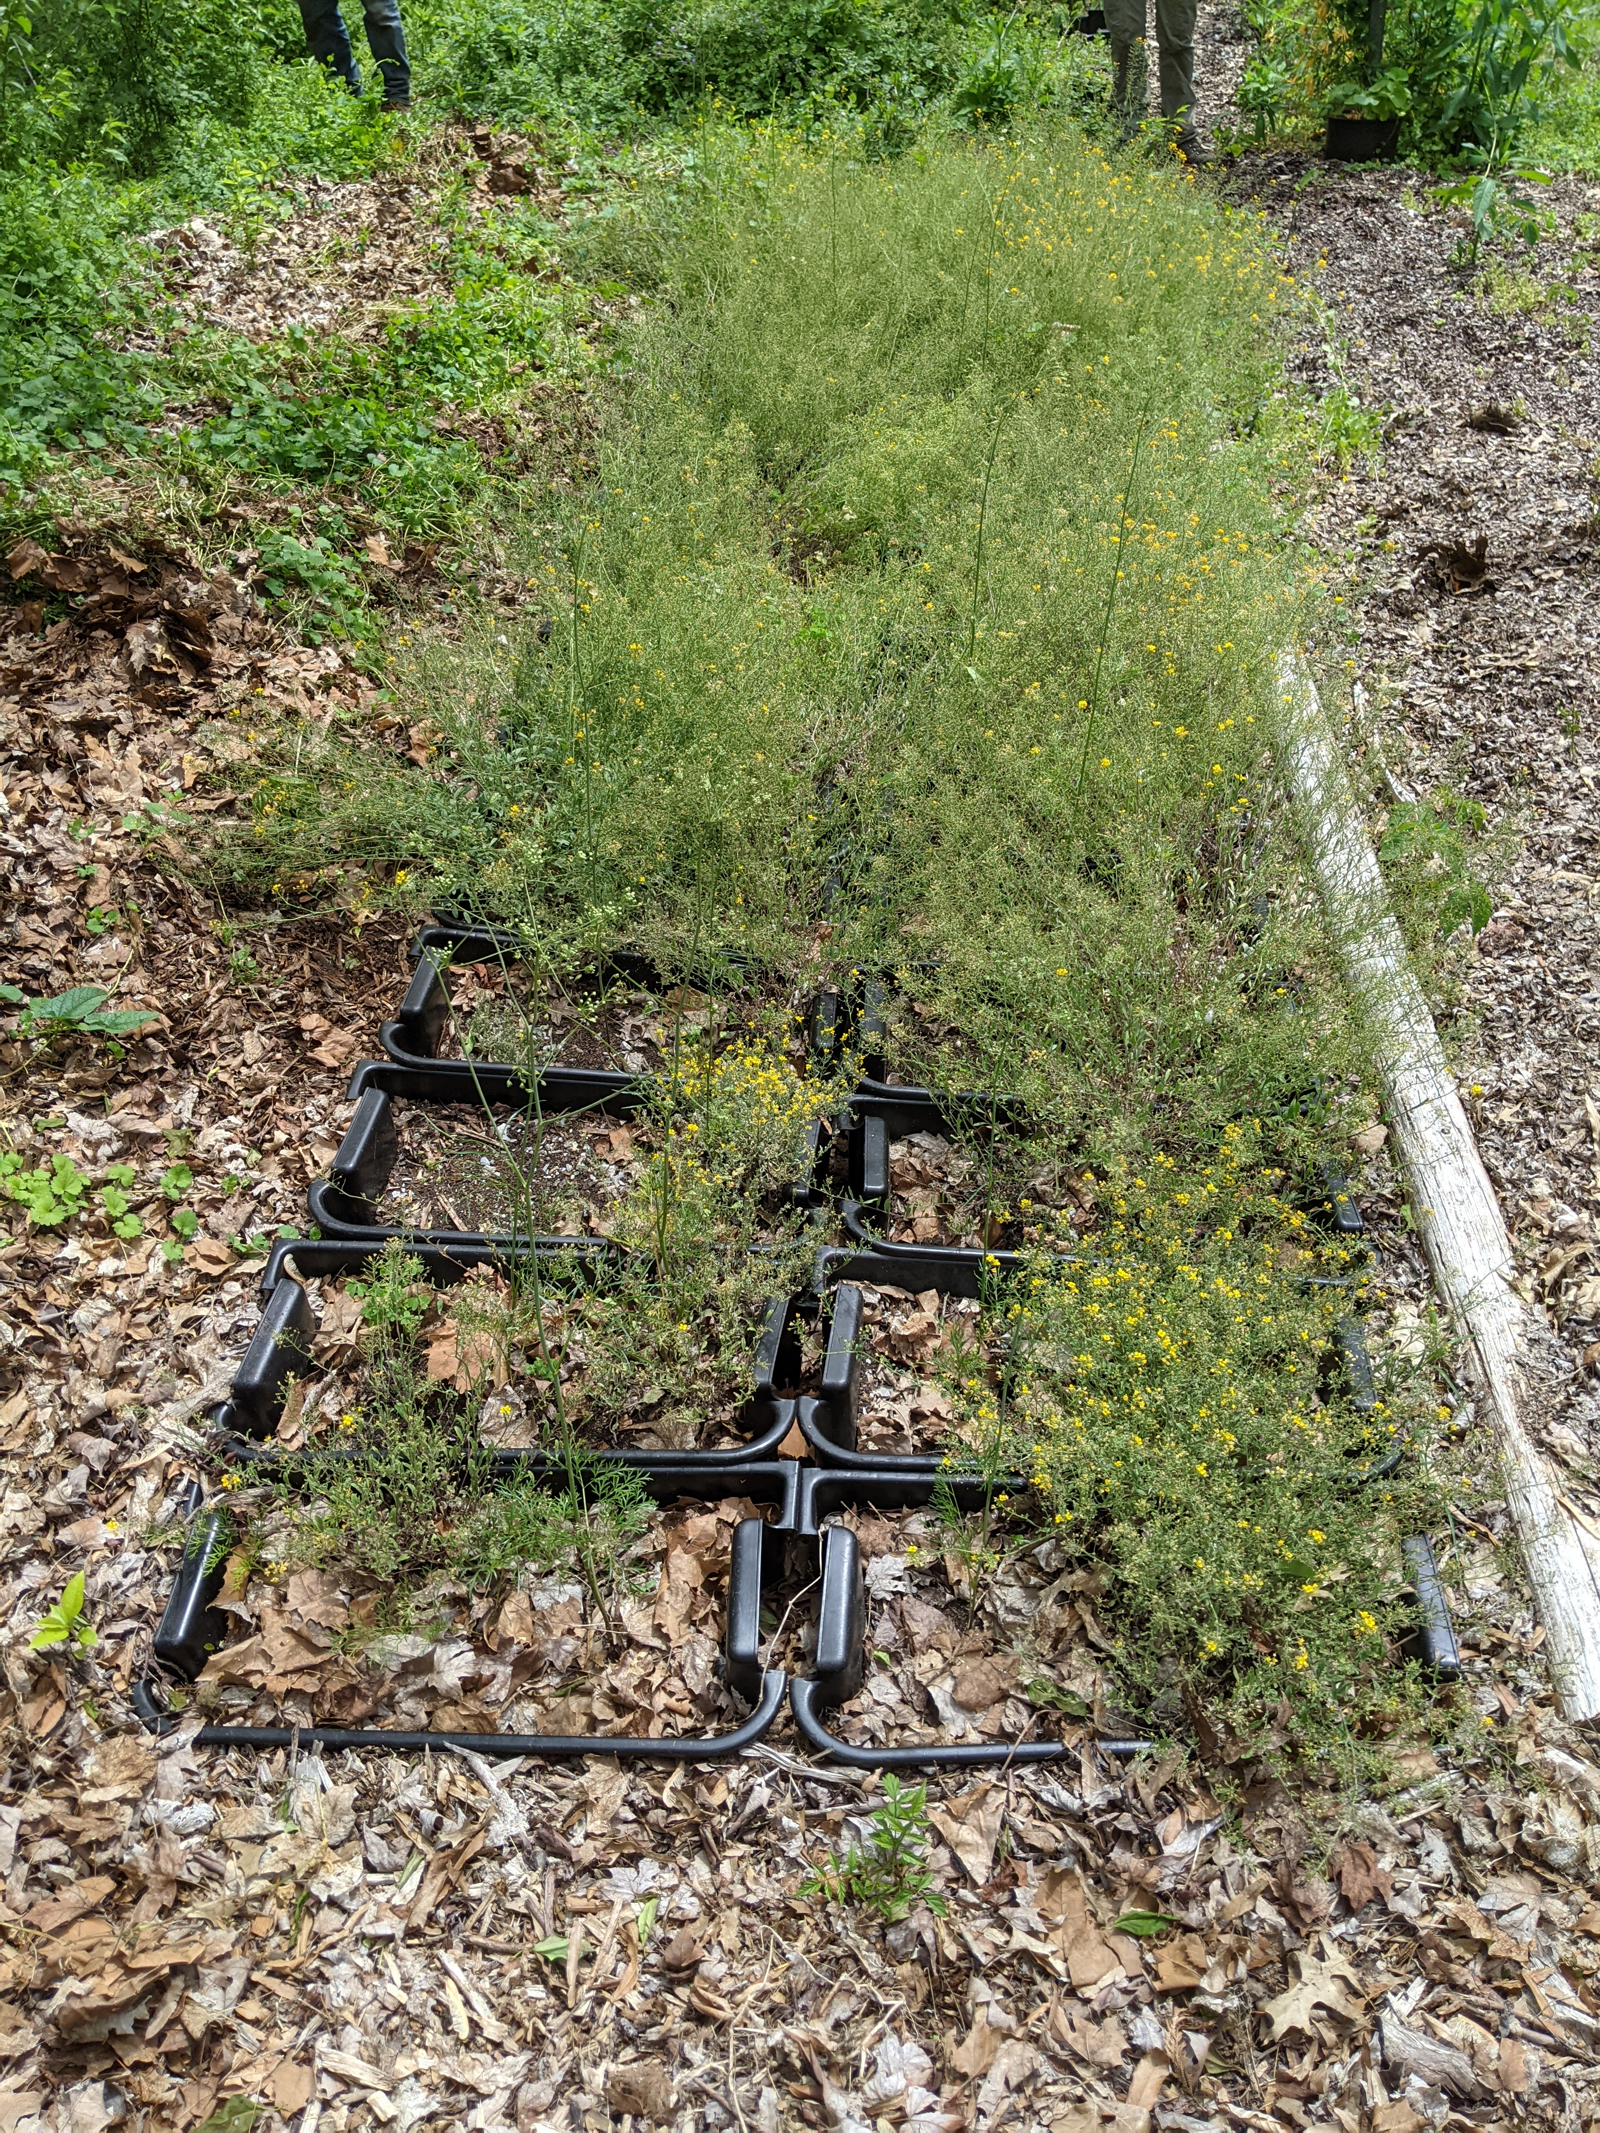 | C  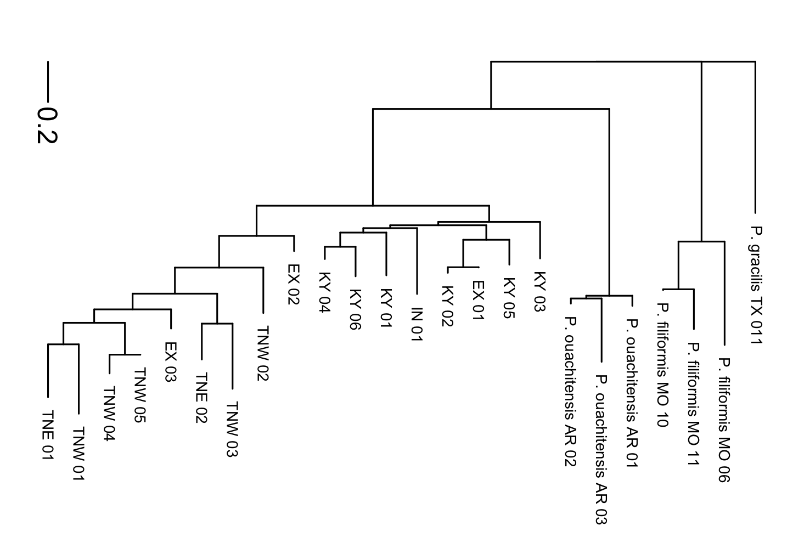

Figure 2. Photos of Physaria globosa and genetic distance tree.
(A), Native habitat. (B), Ex situ site at
based on Nei’s genetic distances.

A
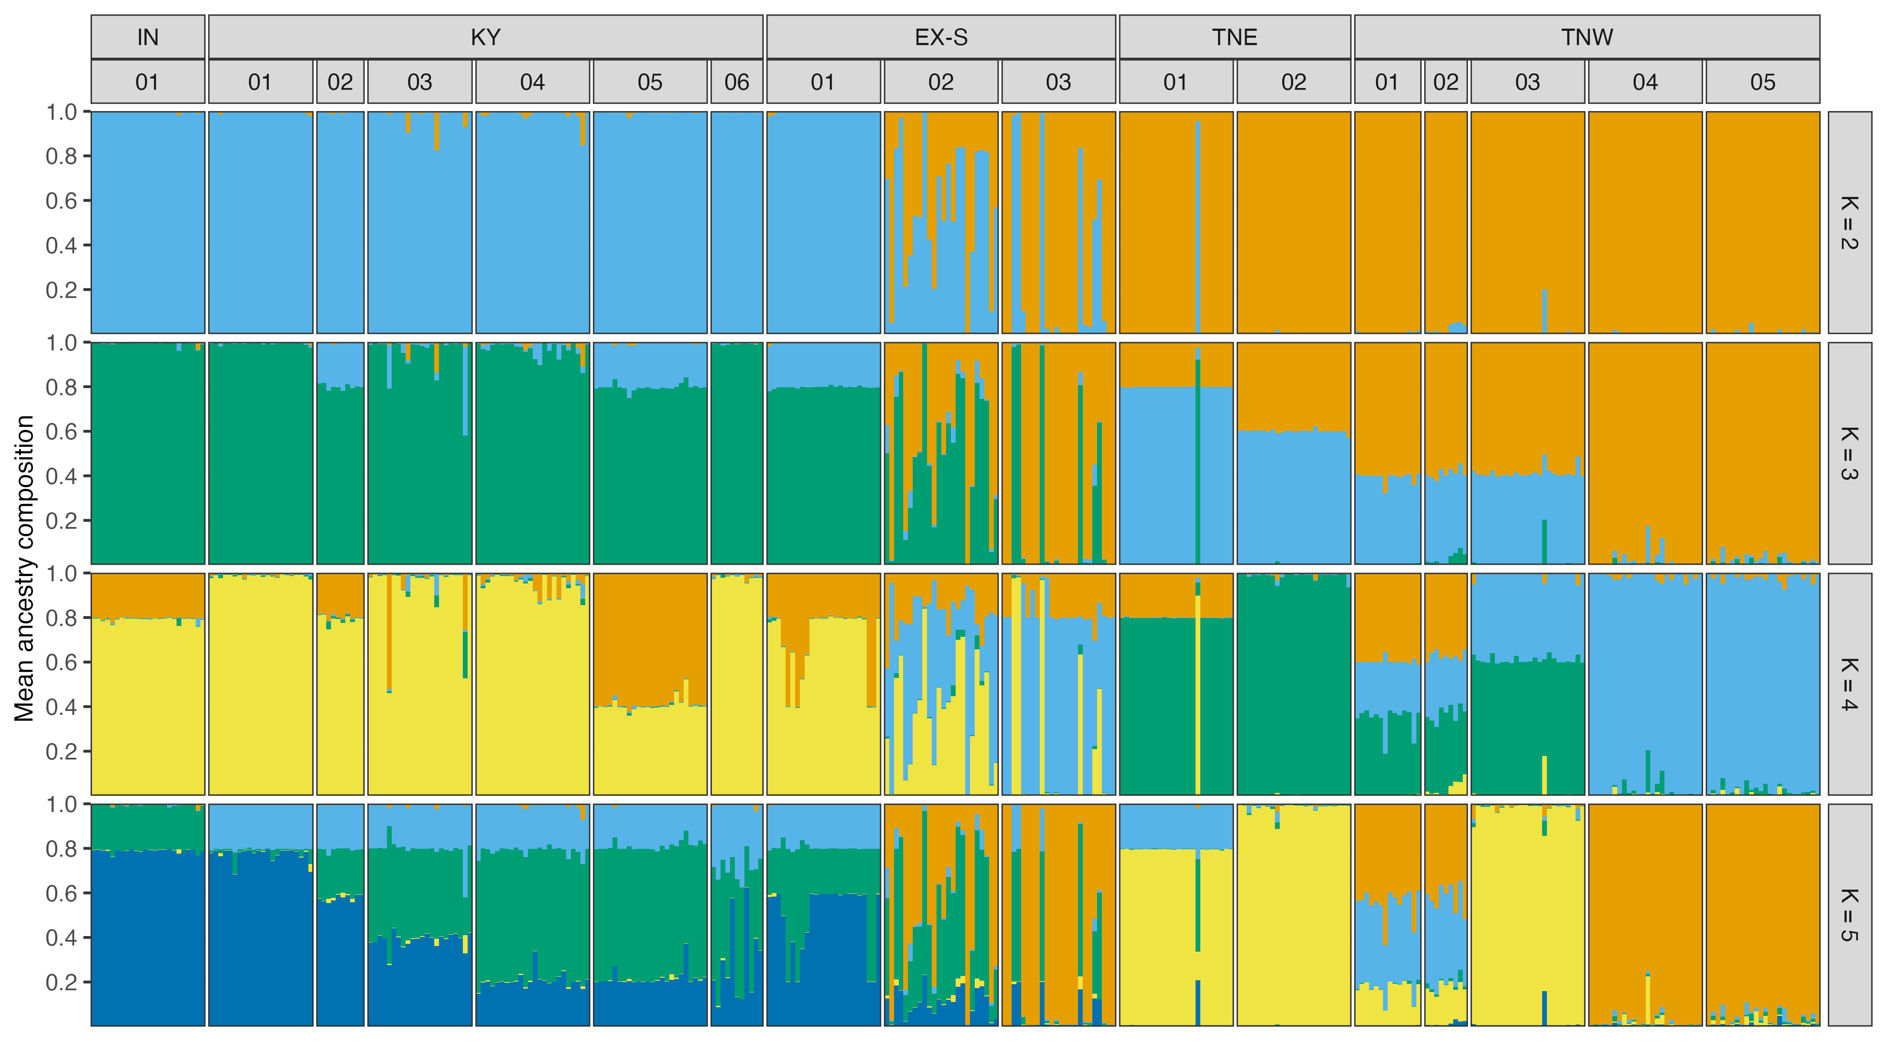
B  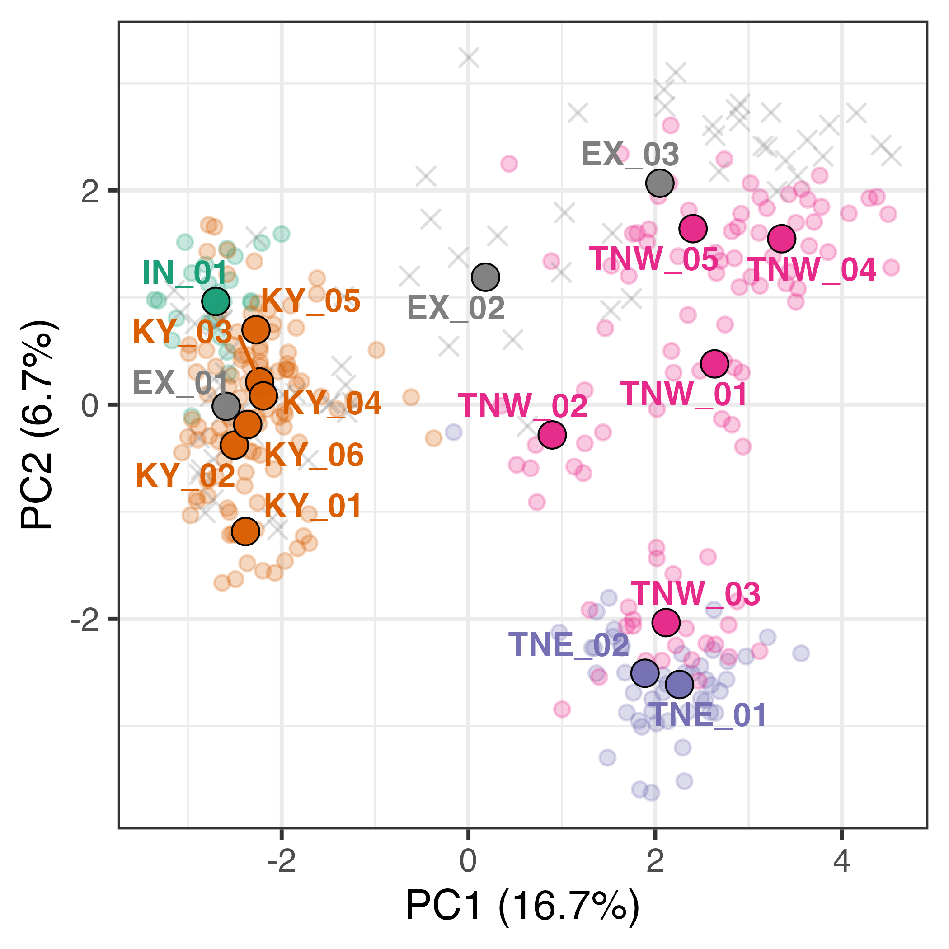 | C  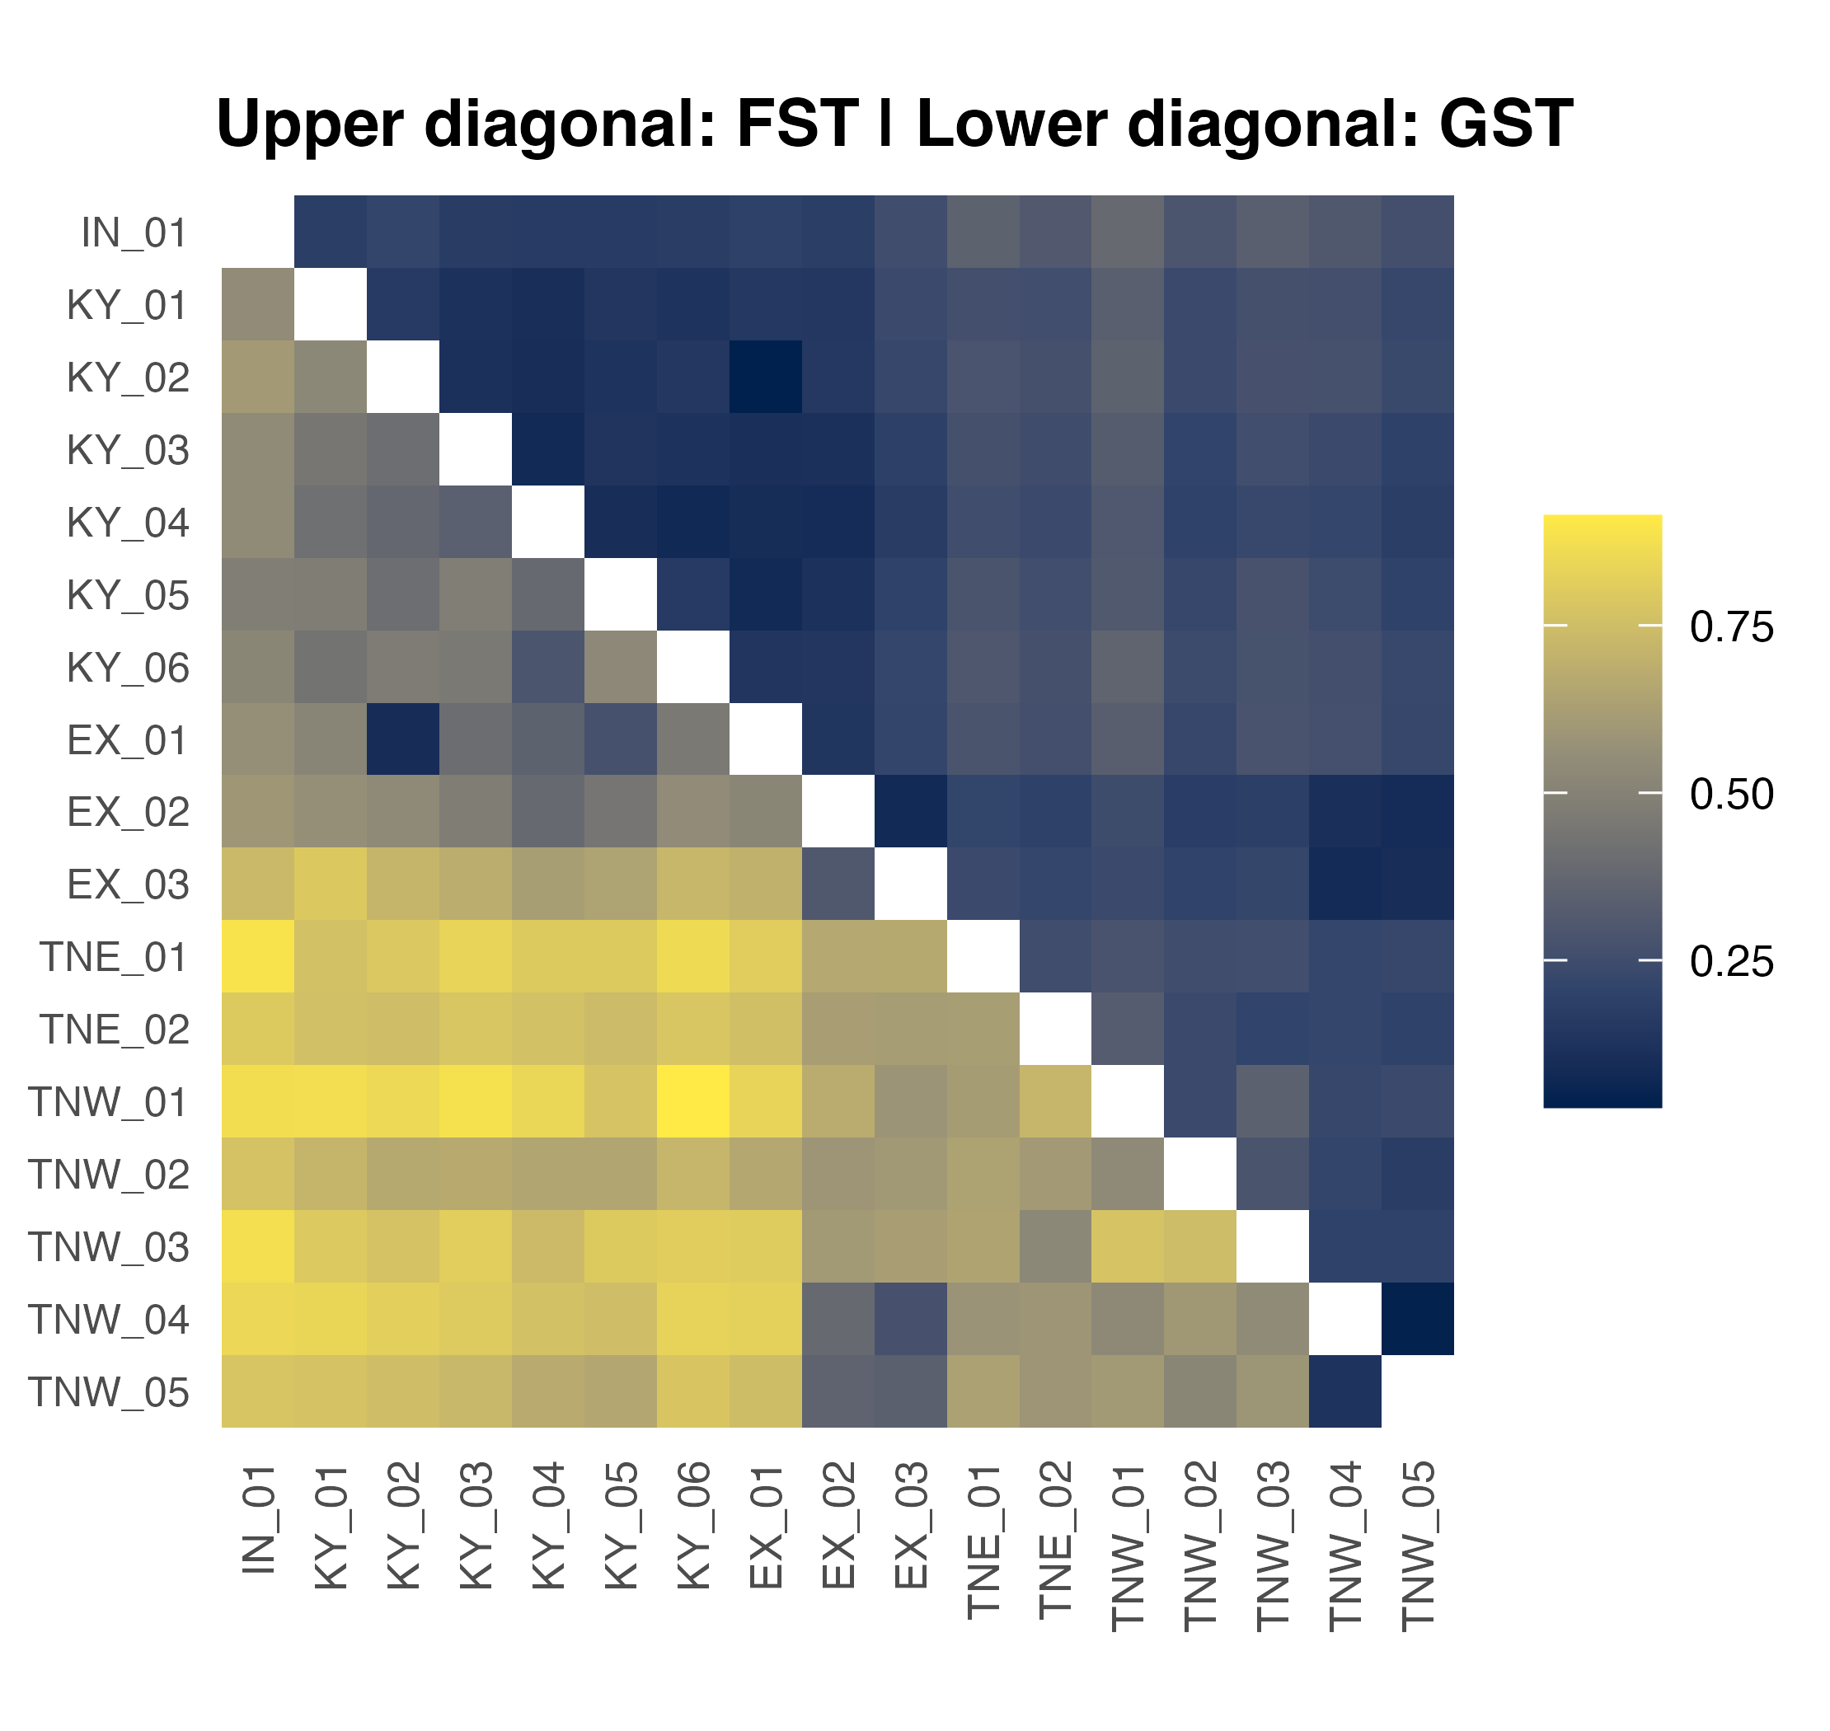

Figure 3. PCA of all wild P. globosa populations, with location and species indicated.
The outgroups (AR1-3=Physaria ouachitensis; MO6, 10 and 11= Physaria filiformis; and TX1=Physaria gracilis) are in pink and purple

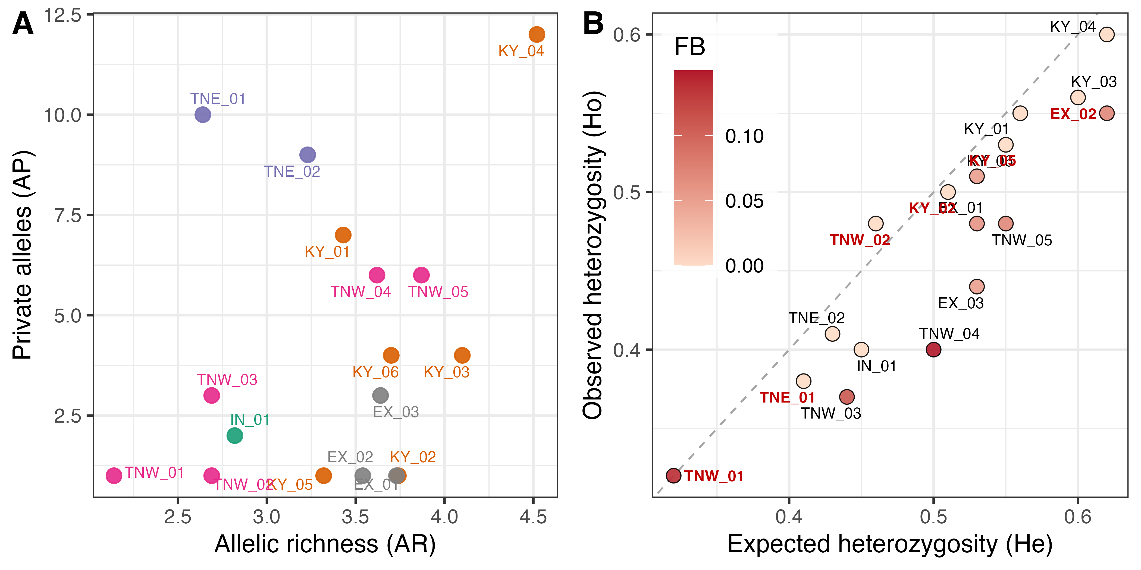

Figure 4

