Range disjunctions and managed hybridization shape conservation strategies for the endangered Physaria globosa (Brassicaceae)

Christine E. Edwards¹*, Clara Landon ^{1,2, 3}, Burgund Bassüner¹, Alex G. Linan¹, and Matthew A. Albrecht¹

¹Center for Conservation and Sustainable Development, Missouri Botanical Garden, 4344 Shaw Blvd., St. Louis MO 63110, USA
²Oberlin College Biology Department, 119 Woodland St., Oberlin, OH 44074
³Current address: Lady Bird Johnson Wildflower Center, 4801 La Crosse Ave. Austin, TX 78739

*Correspondence: Christine.Edwards@mobot.org

Abstract (234 words)
Population genetic analyses of species of conservation concern can directly inform management strategies aimed at maintaining genetic diversity across both natural and ex situ populations. Physaria globosa, a federally endangered mustard, has a geographically restricted and disjunct distribution across river systems in Indiana, Kentucky, and Tennessee in the United States. We sampled populations across the species’ range, including 14 natural and 3 ex situ human-assisted populations, and genotyped 358 individuals at 20 microsatellite loci. Genetic variation in the natural populations was strongly structured into 2 major geographic groups, a northern group in Indiana and Kentucky and a southern group in Tennessee, with significant isolation by distance across the range. Several natural populations showed evidence of reduced genetic diversity, inbreeding, or past bottlenecks, consistent with demographic decline and ongoing pressures such as habitat degradation and competition from invasive plants. In contrast, ex situ populations, including a managed hybrid population founded from multiple source populations, preserved substantial genetic variation, and a reintroduced population derived from this hybrid stock demonstrates the practical conservation value of managed hybridization. Our results indicate that conservation of P. globosa should prioritize the protection of multiple populations within each major geographic region while also using ex situ management to capture and maintain diversity from vulnerable or inaccessible sites. More broadly, this study shows that managed hybridization and reintroduction can be effective tools for conserving genetic variation in endangered plants with disjunct distributions.
Keywords: Genetic diversity; genetic structure; geographic range disjunctions; microsatellites

Introduction (824 words)
Genetic diversity is widely viewed as the raw material underlying phenotypic and functional variation within species, and its maintenance is a central goal of biodiversity conservation (Shaw et al., 2025). Higher genetic diversity is often associated with greater resilience, evolutionary potential, and individual fitness, and can also improve the establishment and persistence of reintroduced populations (Hoelzel et al., 2019). For narrowly distributed species of conservation concern, preserving genetic diversity therefore requires attention not only to natural populations, but also to ex situ collections and any reintroduction efforts derived from them (Aguilar-Gómez et al., 2025).
Conservation strategies for genetically depauperate species generally fall along a continuum from protecting and reconnecting extant populations to more interventionist approaches that deliberately move individuals or genotypes among populations (Bucharova, 2017; Gaitán-Espitia & Hobday, 2021). In plants, these interventions can include assisted gene flow among natural populations, managed crossing among historically isolated populations in ex situ collections, and subsequent reintroduction or population reinforcement (Edwards et al., 2025). Such actions can be valuable when fragmentation, demographic decline, or habitat change have reduced effective population size and limited natural gene flow, because added gene flow may increase genetic diversity, reduce inbreeding, and improve short-term fitness or longer-term adaptive potential. At the same time, these approaches remain controversial because their benefits are context dependent and their outcomes are not always predictable (MacDonald et al., 2025).
For this reason, managed hybridization and other forms of assisted movement raise several general questions in conservation. Do disjunct populations represent distinct historical or adaptive components that should be protected separately (Fraser & Bernatchez, 2001)? When is the risk of inaction greater than the risk of admixture? Can ex situ hybrid populations capture enough diversity to justify their use in reintroduction? And how much divergence among source populations is too great? The major concerns are well known: introduced gene flow may cause outbreeding depression, disrupt local adaptation, or generate maladapted genotypes (MacDonald et al., 2025); hybridization can also produce genetic or demographic swamping if rare lineages are overwhelmed by admixture (Aguilar-Gómez et al., 2025); and assisted movement may create ecological mismatches, including altered biotic interactions, in recipient environments (Bucharova, 2017). In addition, when a small, inbred population remains viable, it may have already purged some deleterious recessive alleles, such that genetic rescue could reintroduce harmful variation and reduce fitness (Dussex et al., 2023). These risks do not argue against intervention, but they do emphasize identifying the biological and demographic rationale for intervention, evaluating risks to both source and recipient populations, and integrating post-release genetic monitoring to assess whether translocated or reintroduced populations retain diversity, establish successfully, and follow the intended management trajectory (Linan et al., 2024; Aguilar-Gómez et al., 2025).
Short’s bladderpod, Physaria globosa (Desv.) O’Kane & Al-Shehbaz, is a federally endangered biennial to short-lived perennial species in the Brassicaceae with a geographically restricted and discontinuous distribution in the central United States (Fuentes-Soriano & Kellogg, 2021). It occurs on steep, rocky bluff and talus habitats, usually on calcareous, south- to west-facing slopes near rivers or streams. The species is distributed across three disjunct regions: the confluence of the Wabash and Ohio Rivers, the Kentucky River watershed, and the Cumberland River watershed. Because these regions are separated by up to hundreds of kilometers and dispersal is likely limited, substantial genetic structure is expected across the range. Physaria globosa is threatened by habitat disturbance, soil erosion, invasive plants, and the genetic consequences of small and isolated populations, including drift, inbreeding, and loss of diversity. Climate change may further intensify these threats in the Midwest, where extended summer droughts and extreme precipitation events can increase both physiological stress and flood- or erosion-related habitat disturbance. Together, these ecological and genetic vulnerabilities make P. globosa a useful system for evaluating whether conservation should prioritize preserving existing population structure or restoring genetic diversity through ex situ conservation, managed admixture, and reintroduction. Although such interventions may help maintain genetic diversity and promote long-term persistence, they also carry risks, including outbreeding depression, disruption of adaptive differentiation, and incomplete representation of natural genetic diversity in ex situ collections. Management decisions should therefore be guided by range-wide data on genetic diversity, population structure, and genetic relationships among natural, ex situ, hybrid-origin, and reintroduced populations.
This study addresses these questions using a comprehensive range-wide analysis of genetic diversity and structure in P. globosa. We sampled 14 natural populations and three ex situ populations spanning the species’ distribution and genotyped 358 individuals at 20 microsatellite loci. Our goals were to determine whether populations show evidence of reduced diversity associated with bottlenecks, drift, or inbreeding; to resolve how genetic structure corresponds to the species’ disjunct river-associated distribution; and to evaluate the conservation implications of these patterns for both in situ protection and ex situ management. More specifically, we assess whether managed hybridization and reintroduction can help retain species-wide genetic variation while remaining consistent with the broader recovery goal of conserving representation, resiliency, and redundancy across the range of this endangered species.

Materials and Methods (955 words)

Study species
Physaria globosa is a member of the mustard family (Brassicaceae). It is morphologically distinct from other eastern U.S. Physaria species, which are annuals with fibrous roots, whereas P. globosa is biennial or perennial and has a woody caudex. Plants may produce multiple stems and grow up to 50 cm tall. Small yellow flowers are produced in April and May and are pollinated primarily by small insects (Thacker et al., 2019). In June and July, the species produces distinctive globular fruits that give bladderpods their common name. Seeds are thought to be dispersed by water and gravity along the rivers (Long et al., 2017).

Sample collection and DNA extraction
We sampled P. globosa across its geographic range in May 2021, with sampling effort proportional to the number of occurrences in each of the four main regions (Table 1). A total of 358 individuals were collected from 17 populations, including the only known wild population in Indiana, USA (IN region), seven wild populations in Tennessee, USA (TN region), six wild populations in Kentucky, USA (KY region; one partially cultivated), and three ex situ populations, including one maintained in a private yard and two reintroduced populations. Between 10 and 24 individuals were sampled per population, depending on population size and site accessibility, and one herbarium voucher specimen per population was deposited in the Missouri Botanical Garden Herbarium (MO). To provide genus-level context for genetic diversity estimates, we also included 17 individuals from three populations of P. filiformis in Missouri, USA, 19 individuals from three populations of P. ouachitensis in the Ouachita Mountains of Arkansas, USA, and 12 individuals from one population of P. gracilis in Texas, USA (Table 2), all previously included in Edwards et al. (2021). The final dataset comprised 406 individuals. Leaf tissue was dried in silica gel in the field, and DNA was extracted from silica-dried tissue using a modified CTAB protocol (Doyle & Doyle, 1987).

Microsatellite markers and genotyping
We used 20 microsatellite markers to genotype P. globosa. We first tested 16 microsatellite markers previously developed for Physaria filiformis (Edwards et al., 2021), of which 10 produced polymorphic PCR bands of the expected size in P. globosa. We then developed 10 additional microsatellite markers for P. globosa following Swift et al. (2016). Briefly, whole-genome libraries were prepared for two P. globosa individuals, one from Tennessee and one from Kentucky, using Nextera DNA Sample Prep Kits and sequenced on an Illumina MiSeq platform with 2 × 150 bp reads. Sequencing yielded 1,049,048 and 1,163,933 paired-end reads, which were assembled de novo into 585,371 contigs using the medium sensitivity/fast setting in Geneious v.7.1.9 (Biomatters, Auckland, New Zealand). MSATCOMMANDER identified 2,054 unique microsatellites from the contig consensus sequences, and PRIMER3 identified 324 unique primer pairs. An M13 tag (5′-CACGACGTTGTAAAACGAC-3′) was added to the 5′ end of each forward primer to enable universal dye labeling (Boutin-Ganache et al., 2001). Of 48 primer pairs tested, 10 additional polymorphic loci showed reliable amplification in P. globosa. These 20 loci (Appendix 1, Table 1) were used to genotype 406 samples.
PCR amplifications were performed in 10 μL reactions containing 0.5 U GoTaq Flexi DNA polymerase (Promega, Madison, WI, USA), 1× Colorless GoTaq Flexi Buffer (Promega, Madison, WI, USA), 1.5 mM MgCl2, 4.5 pmol each of the reverse primer and one of four fluorescently labeled M13 primers (6-FAM, VIC, NED, or PET; Applied Biosystems, Foster City, CA, USA), 0.18 pmol of the M13-tagged forward primer, and 0.5 mM of each dNTP. Thermal cycling consisted of an initial denaturation at 94 °C for 3 min; 35 cycles of 94 °C for 30 s, 52 °C for 30 s, and 72 °C for 45 s; and a final extension at 72 °C for 20 min. Genotyping was conducted by capillary electrophoresis on an Applied Biosystems 3730xl (Applied Biosystems, Foster City, CA, USA) at the Cornell Biotechnology Resource Center, and raw trace files were scored in GeneMarker v.2.6.2 (SoftGenetics, State College, PA, USA).

Analysis of genetic diversity
Samples with >50% missing data were excluded, removing nine P. globosa individuals and leaving a final dataset of 397 individuals. The mean number of alleles per population (A), observed and expected heterozygosity (H_{O}, H_{E}), and the inbreeding coefficient (F_{IS}) were calculated by Genodive (Meirmans & Van Tienderen, 2004). Private alleles (A_{P}) were identified by GenAlEx (Peakall & Smouse, 2012), and allelic richness (A_{R}) was estimated by HP-Rare (Kalinowski, 2005). Null allele frequency (N), genotyping error (b), and the inbreeding coefficient corrected for null alleles (F_{B}) were estimated by INEST v.2.2 (Chybicki & Burczyk, 2009) under a Bayesian MCMC framework with 5,000,000 cycles, sampling every 250 cycles after a burn-in of 500,000. Recent bottlenecks were assessed by the bottleneck function in INEST v.2.2 based on heterozygosity excess and M-ratio deficiency, each evaluated with a Z-test and a Wilcoxon signed-rank test. Populations were considered to show evidence of a recent bottleneck when at least three of the four tests were significant (p < 0.05).

Analysis of population structure
Population genetic structure was characterized by Nei’s standard genetic distance among populations, pairwise F_{ST}, and pairwise G_{ST}, calculated in Genodive. The Nei’s D matrix was used to construct a neighbor-joining tree in R using the ape package (Paradis & Schliep, 2019), rooted with P. gracilis as the outgroup. Genetic structure within P. globosa was also examined by PCA in the R package adegenet (Jombart, 2008) and by Bayesian clustering in STRUCTURE v.2.3.4 (Pritchard et al., 2000). We ran five replicate analyses for each K from 1 to 13, using a burn-in of 600,000 generations and a run length of 1,000,000 generations, and evaluated the most likely number of clusters in STRUCTURE HARVESTER (Earl & vonHoldt, 2012). Hierarchical genetic structure was further quantified by AMOVA in GenAlEx (Peakall & Smouse, 2012).

Results (991 words)

Population structure
We sampled P. globosa from one natural population in the Indiana region (IN), six natural populations in the Kentucky region (KY), five natural populations in western Tennessee (TNW), two natural populations in eastern Tennessee (TNE), and three ex situ populations (EX) (Fig. 1A, B; Fig. 2). The ex situ population EX_01 was sourced from KY_02 and KY_05. The ex situ population EX_03 was a managed hybrid population derived from the parents of IN_01, near KY_05, near KY_06, and TNW_04. The EX_02 population was a reintroduction derived from the EX_03 population.
Broad-scale population structure was consistent across the neighbor-joining tree, STRUCTURE, PCA, and pairwise differentiation analyses. The neighbor-joining tree (Fig. 1C), rooted with P. gracilis, placed the three P. filiformis populations in a group next to P. gracilis, while the three P. ouachitensis populations formed a sister group to P. globosa. Within P. globosa, populations were divided into two major groups: an IN–KY group and a TNE–TNW group. Pairwise F_{ST} and G_{ST} showed a similar pattern (Fig. 3C), further supporting this major split among natural populations. Consistent with this result, PCA separated IN–KY populations from TNE–TNW populations along PC1, which explained 16.7% of the variance (Fig. 2B).
STRUCTURE analyses provided additional resolution of this pattern. Across analyses of K = 1–13, the Evanno method identified K = 2 as the best-supported number of clusters. At K = 2, the IN and KY populations shared consistent ancestral genetic composition, and were separated from the TNE and TNW populations (Fig. 3A). The ex situ population EX_01 grouped with the IN and KY populations, whereas the EX_02 and EX_03 populations showed admixed ancestry. Exploration of higher K values revealed finer-scale structure. At K = 3, a gradient-like pattern was evident among the TNE and TNW populations, except for the TNW_04 and TNW_05, which remained genetically distinct and largely unadmixed through the highest K examined. At K = 5, the IN population became distinguishable from the Kentucky populations, although it still remained more similar to the KY than to the TNE and TNW populations, and a gradient-like pattern was also visible among the KY populations. PCA supported these finer-scale results: PC2, which explained 6.7% of the variance, further separated TNE and TNW populations, except for TNW_03, which clustered with the TNE populations.
The ex situ populations also showed patterns consistent with their documented origins. The EX_01 clustered with the KY populations in both STRUCTURE and PCA, consistent with its origin from the KY_02 and KY_05 populations. The EX_02 and EX_03 populations were positioned between the IN-KY and TNE-TNW populations in PCA and showed admixed ancestry in STRUCTURE, supporting successful planned hybridization at ex situ sites. At K = 5, STRUCTURE further suggested that these two ex situ populations included individuals with varying degrees of admixture, including putative F₁ hybrids and backcrosses. In addition, G_{ST} suggested that the EX_02 and EX_03 populations received stronger genetic contributions from the TNW_04 and TNW_05 populations than from the IN or KY parental populations, a pattern consistent with backcrossing.
Among natural populations, we detected significant isolation by geographic distance (Mantel’s r = 0.505, p = 0.001). AMOVA further showed that genetic variation was partitioned across multiple hierarchical levels (Table 2): 21% of the variation occurred among regions (IN, KY, TNE, and TNW), 21% among populations within regions, and 64% within populations.

Genetic diversity, inbreeding, bottleneck
Populations of P. globosa showed variation in their genetic diversity (Table 3). The average number of alleles per locus (A) in P. globosa ranged from 2.278 – 6.5, the number of private alleles per population (A_{p}) ranged from 1-12, and the allele richness (A_{R}) ranged from 2.14 – 4.52 (Table 3). P. globosa has slightly lower A_{R} than its rare sister species, P. filiformis and P. ouachitensis, and much lower A_{R} than P. gracilis. The P. gracilis has an extraordinarily high A_{P} because we only sample one population of the species. Within P. globosa, both private alleles per population (A_{p}) and the allele richness (A_{R}) were lowest in population TNW_01 from western Tennessee (TNW) region, greatest in population KY_04 from Kentucky region (KY) (Fig. 4). The three ex situ populations (EX) had medium A_{R} but low A_{P}.
Physaria globosa has observed heterozygosity (H_{O}) ranged from 0.323 – 0.596 and expected heterozygosity (H_{E}) ranged from 0.323 – 0.620, which is similar to P. filiformis and P. gracilis, but higher than P. ouachitensis. Within P. globosa, most populations from Kentucky region (KY) showing greater than average H_{O} and H_{E}, and populations from both eastern Tennessee (TNE) and western Tennessee (TNW) showing lower than average H_{O} and H_{E} (Table 3). H_{E} was generally slightly greater than H_{O} in most populations, such that the average inbreeding coefficient (F) was slightly positive (overall mean = 0.08, range -0.036 to 0.227) (Table 3). However, these positive inbreeding coefficients are likely due in part to null alleles rather than inbreeding, as the INEST analysis revealed that the percentage of null alleles (% null) ranged from 0.0771 - 0.4694 (overall mean = 0.2648) (Table 3). After correcting for null alleles, inbreeding coefficients (F_{B}) were generally very close to zero (range 0 – 0.1481; overall mean = 0.04; Table 3), indicating that most populations have not experienced inbreeding. However, three populations (TNW_04, TNW_03, and TNW_01) all from TNW region exhibited inbreeding coefficients greater than >0.10 even when corrected for null alleles, suggesting that they may have experienced some inbreeding.
We used INEST to test for genetic bottlenecks test and considered populations to show significant evidence for a genetic bottleneck when three out of the four tests were statistically significant. This revealed that following six populations representing three out of the four ecoregions had undergone recent bottlenecks: populations KY_02, KY_05, EX_02 from KY; population TNE_01 from the TNE region; and population TNW_01 and TNW_02 from TNW region (Fig. 4). Generally, populations with the lowest A_{R} also exhibited significant evidence of either genetic bottlenecks (TNE_01, TNW_01, TNW_02), inbreeding (i.e., TNW_01 and TNW_03), or both (TNW_01).

Discussion
Our results show that Physaria globosa is neither genetically homogeneous across its range nor uniformly depauperate in genetic diversity across populations. Instead, the species exhibits strong regional genetic structure, substantial variation in within-population diversity, and mixed evidence of genetic vulnerability concentrated in a subset of populations. At the same time, the ex situ hybrid and reintroduced populations show clear signs of admixture, indicating that managed mixing can retain genetic variation from multiple parts of the species’ range. Taken together, these findings support a conservation strategy that prioritizes protection of natural regional structure while also recognizing a potential role for carefully justified and monitored ex situ management.
A central result of this study is the strong genetic structure across the disjunct range of P. globosa. Neighbor-joining, PCA, STRUCTURE, and pairwise differentiation all supported a major split between an IN–KY group and a TNE–TNW group, with additional substructure within each region. This pattern is consistent with the species’ geographically discontinuous distribution and suggests that natural populations from different parts of the range should not be treated as interchangeable units. Significant isolation by geographic distance and the AMOVA results further support this interpretation by showing that differentiation is structured both among regions and among populations within regions. In conservation terms, these results indicate that preserving representation in P. globosa requires maintaining populations from multiple regional groups rather than focusing only on a few accessible or demographically robust sites.
Physaria globosa generally has lower genetic diversity (i.e., Allelic richness, A_{R}) than its congener species, even when the congener species themselves are also rare species. The genetic diversity in P. globosa was unevenly distributed across its range. Allelic richness (A_{R}) and private alleles (A_{P}) varied substantially among populations, with √ showing the highest values and TNW_01 the lowest. This geographic pattern suggests that vulnerability in P. globosa is not simply a species-wide property of rarity, but is instead population specific and spatially structured. For conservation, that distinction matters: some populations, such as KY_04, may currently retain substantial evolutionary potential, whereas others, such as TNW_01, may be more vulnerable to ongoing drift or demographic instability.
Signals of recent bottlenecks and inbreeding reinforce this interpretation. Six populations across three of the four ecoregions showed evidence of recent bottlenecks, including one ex situ population, and the populations with the lowest allelic richness were often the same populations showing bottleneck and/or inbreeding signals. Importantly, the raw inbreeding coefficients appear to have been inflated by null alleles, and the null-corrected estimates indicate that most populations are close to random mating. Even so, three western Tennessee populations retained corrected inbreeding coefficients above 0.10, suggesting that at least some populations may have experienced nontrivial mate limitation or small-population effects. These results suggest that genetic risk in P. globosa is localized rather than pervasive: most populations do not show strong evidence of inbreeding, but several populations, especially in western Tennessee, may warrant closer demographic and genetic monitoring.
The ex situ results are especially important because they speak directly to the management question posed in the Introduction. EX_01 grouped with the Kentucky populations, consistent with its documented source populations, whereas EX_02 and EX_03 were clearly admixed and occupied intermediate positions between the northern and southern regional groups in PCA and STRUCTURE. These results indicate that managed hybridization was successful in the narrow genetic sense that it generated mixed-ancestry populations and retained contributions from multiple source regions. At the same time, the admixture pattern was not fully even: GST suggested stronger genetic contributions from TNW_04 and TNW_05 than from the Indiana or Kentucky parental sources, and higher-K STRUCTURE results suggested the presence of individuals with varying levels of admixture, including possible F1 hybrids and backcrosses. Thus, ex situ hybridization in P. globosa appears feasible and potentially useful, but its products should not be assumed to represent balanced or stable mixtures without continued monitoring.
These findings support a risk-benefit view of conservation management in P. globosa. On one hand, the strong regional structure argues against treating all populations as interchangeable seed sources, because doing so could erode historically differentiated components of the species’ diversity. On the other hand, the low diversity, bottleneck signals, and localized inbreeding detected in several populations indicate that complete reliance on passive protection may not always be sufficient. The most defensible interpretation is therefore not that management must choose between preserving structure and restoring gene flow, but that both goals must be balanced. In situ conservation should remain the foundation of recovery because it preserves the full geographic distribution of diversity and supports representation and redundancy across the range. Ex situ conservation, managed hybridization, and reintroduction may nevertheless be valuable tools when used to complement, rather than replace, the protection of natural populations, especially when interventions are guided by genetic data and followed by post-release monitoring.
More specifically, our results suggest three broad management implications. First, conservation should aim to protect multiple populations across both major regional groups to retain species-wide representation. Second, populations showing low allelic richness, bottleneck signatures, or elevated corrected inbreeding should be prioritized for closer monitoring and, where appropriate, habitat management or demographic reinforcement. Third, ex situ populations can play a useful role in conservation planning, but their value will be greatest when their ancestry is well documented and when they are used within an explicit framework that considers source representation, local conditions, and long-term genetic outcomes. Because the ex situ populations in this study retained only medium allelic richness and low numbers of private alleles, they should be viewed as useful management assets rather than full substitutes for the diversity present across natural populations.
Finally, this study also highlights the limits of inference from neutral microsatellite data alone. The present dataset is well suited to assessing genetic structure, relative diversity, bottleneck signals, and the ancestry of ex situ populations, but it cannot by itself determine whether the regional groups differ in adaptive traits or whether admixture will improve or reduce fitness after reintroduction. That uncertainty is important in a species for which conservation decisions may involve deliberate movement of genotypes among historically differentiated populations. Future work that integrates demographic monitoring, common-garden or fitness data, and genome-scale markers will therefore be especially valuable for determining whether managed admixture in P. globosa enhances persistence while remaining consistent with the broader recovery goals of representation, resiliency, and redundancy.

#######

Factors Affecting Genetic Diversity in P. globosa
The first goal of the study was to measure levels of genetic diversity in P. globosa and to infer whether populations show evidence of having experienced reductions in genetic diversity as the result of inbreeding, genetic bottlenecks, or genetic drift. On average, levels of genetic diversity in P. globosa were comparable to or even greater than those found in populations of P. filiformis, P. ouachitensis, and P. gracilis. For example, average values of H_{O} and H_{E} across the three populations of P. filiformis were 0.40 and 0.53, respectively, and in P. globosa, they were 0.47 and 0.51 (Table 3). These estimates are directly comparable to each other with little ascertainment bias because the microsatellite markers were developed in both species. Thus, we did not find evidence that P. globosa’s specific life-history characteristics have led to wholesale declines in its genetic diversity relative to its congeners.
Although P. globosa overall has comparable levels of genetic diversity to it congeners, levels of genetic diversity in populations of P. globosa differed across its geographic range, with populations in the southern part of its range in TN exhibiting lower genetic diversity than those found in the northern part of the species’ range in KY and IN (average H_{O} and H_{E} of 0.40 and 0.44, respectively, in TN, versus 0.512 and 0.55, respectively, in KY and IN). This is the opposite of the pattern found in another endangered mustard, Boechera perstellata, which occupies a similar geographic range (Baskauf et al., 2013). The lower genetic diversity in the southern part of P. globosa’s range is likely partially due to population-specific factors such as genetic bottlenecks or inbreeding in specific questions (see below). However, even the sites with the greatest genetic diversity in TN had lower genetic diversity than almost all of those in KY/IN (Table 3), suggesting that population-specific declines in genetic diversity cannot fully explain why genetic diversity is lower in the southern part of the range. Another explanation for why the genetic diversity in the northern and southern portions of the species’ range differs is because of differences in the extent to which they have been exposed to long-term stressors, either as the result of anthropogenic activities or climate stress. In the KY and IN populations, most sites occupied by P. globosa have largely intact habitat, whereas in the southern part of the range, populations overall have experienced greater long-term anthropogenic pressures. For example, historically, a series of locks and dams was constructed to deepen the channel of Cumberland River (Olson, 2021), a railroad was constructed that once ran through P. globosa habitat in TN (Hicks, 2023). Currently, several populations in TN occur on roadsides that are managed with herbicides, and some are impacted by development or recreation (Long et al., 2017). It is possible that these long-term anthropogenic disturbances have slowly eroded genetic diversity in the southern part of P. globosa’s range.
The lower genetic diversity in the southern part of P. globosa’s range is also consistent with the pattern expected in species experiencing leading edge/trailing edge dynamics in response to warming climates (Hampe & Petit, 2005). Under this hypothesis, leading edges of a species’ range (at the highest latitudes or elevations) represent areas where climate warming is causing population expansions due to increases in range-limiting low temperatures, whereas trailing edges (at the lowest elevations or latitudes) represent older areas of the species range where climate warming may impose new, range-contracting stresses (Hampe & Petit, 2005). In the southern part of P. globosa’s range, previous research found that populations have experienced a greater total number of weeks of drought and droughts of considerably longer duration than those in Indiana and Kentucky (Long et al., 2017). Furthermore, many species of Physaria reproduce in spring, avoiding hot summer temperatures (Rollins & Shaw, 1973); It is also possible that greater climate warming or shorter duration of spring in the southern populations of P. globosa have led to decreases in fecundity and genetic diversity. Additional research is needed to determine which factors are the underlying causes of these declines in P. globosa so that they can be properly addressed.
In addition to lower genetic diversity observed in the more southern populations of P. globosa, several populations exhibited evidence for declines in genetic diversity associated with small population size. Six populations showed evidence of recent genetic bottlenecks, three each in KY and TN. One was found in an ex-situ population, population EX_02 (Jessamine Creek Gorge in KY), which is logical as it was recently seeded from population EX_03 (Private yard). The remaining bottlenecks were found in five wild populations, including populations KY_02 (Cove Spring--KY), KY_05 (Delaney Ferry Rd.--KY), TNE_01 (Hartsville--TN), TNW_02 (Jarrell Ridge Rd--TN), and TNW_01 (King and Queen’s Bluff--TN). One possible explanation for these bottlenecks is that these populations are some of the most severely impacted by the invasive species, bush honeysuckle (Lonicera maackii). In heavily invaded sites, L. maackii forms a dense shrub layer that reduces light availability, alters soil chemistry, and dramatically decreases the growth and abundance of native plants (McNeish & McEwan, 2016). Given P. globosa’s preference for sites with high light and shallow soils with frequent disturbance regimes that help maintain an open canopy (Long et al., 2017; Krosnick et al., 2022), declines in habitat quality caused by the invasion of Bush honeysuckle may have led to losses in genetic diversity, possibly through declines both in fecundity and seedling recruitment. However, it appears that management may help counteract these effects; for example, population KY_04 (Ninevah Rd.) is regularly managed with fire and removal of Lonicera maackii, and it had among the greatest genetic diversity of all populations of P. globosa, possibly via recruitment from a persistent seed bank, which is common in the genus Physaria (Elberling, 2000). However, an experiment to investigate how genetic diversity in populations of P. globosa changes before and after management is needed to test this hypothesis. Because L. maackii invasion represents a serious threat to the persistence of P. globosa, management activities to remove Bush honeysuckle from P. globosa populations are critical to maintain population sizes and prevent losses in the genetic diversity of the species.
Finally, several populations of P. globosa exhibited greater-than-expected inbreeding coefficients, which could be of concern in this endangered species. Because P. globosa is thought to exhibit sporophytic self-incompatibility (Long et al., 2017), we expected populations to show little evidence of inbreeding. Although most populations showed inbreeding coefficients approaching zero, which is generally indicative of random mating, inbreeding coefficients were greater than expected for three populations from W-TN (TNW_04, McMinn’s Bluff; TNW_03, Lock B Rd.; and TNW_01, King and Queen’s Bluff), even after correction for null alleles. Generally, self-incompatibility limits inbreeding, raising the question of whether these populations could be self-compatible. However, the more important question is whether inbreeding is detrimental to these populations, which depends on the history of inbreeding in a species. Biparental inbreeding and self-fertilization increase homozygosity within a genome, increasing the likelihood of inbreeding depression, which occurs when individuals are homozygous for recessive deleterious alleles (Charlesworth & Charlesworth, 1987; Charlesworth & Willis, 2009). In species that are strongly selfing, purifying selection purges these highly deleterious alleles from a population, reducing inbreeding depression (Charlesworth & Charlesworth, 1987; Charlesworth & Willis, 2009). In contrast, outcrossing species tend to maintain recessive deleterious alleles in a heterozygous state, such that inbreeding in these species is more likely produce offspring that are homozygous for these deleterious alleles and thus suffer reduced viability and fecundity (Charlesworth & Charlesworth, 1987; Charlesworth & Willis, 2009). Because P. globosa is self-incompatible and normally reproduces through outcrossing, inbreeding may lead to inbreeding depression in the species; however, additional research is needed to test the effects of inbreeding in P. globosa. If inbreeding does cause inbreeding depression, then actions such as conservation augmentations or translocations may be needed to increase mate availability and reduce inbreeding depression in populations with positive inbreeding coefficients.
One limitation of using microsatellite markers in conservation management is that neutral markers cannot tell functional traits and local adaptation. You can refer:
The inflated significance of neutral genetic diversity in conservation genetics (Teixeira & Huber, 2021)
We have an ongoing project using common garden phenotyping and whole genome resequencing data to provider higher resolution in conservation solutions.

Genetic structure across the range of P. globosa
The second goal of the study was to analyze rangewide patterns of genetic structure in P. globosa to understand how it is affected by disjunctions in the species range. Both the genetic distance tree and PCA grouped populations into two major groups, one containing populations in the northern part of the species range in KY and IN, and the other containing populations from TN, including those from both the Nashville Basin and Highland Plateau ecoregions. Within the northern and southern groups, populations were further divided into several distinct subgroups, indicating extensive genetic structure. At K=11, STRUCTURE grouped the eight wild northern populations into four genetic groups and the seven TN populations into four genetic clusters. These overall strong patterns of genetic structure are likely due to barriers to gene flow, created both by the complex topological structure of the landscape occupied by P. globosa as well as the short flight patterns of the ground-nesting bees and flies that serve as pollinators of the species (Thacker, 2018).
Generally, most populations placed into the same genetic cluster were found within the same ecoregion and were geographically proximal to one another, suggesting limited migration has occurred between these proximal populations. For example, the genetic distance tree and STRUCTURE placed the geographically proximal populations TNW_04 and TNW_05 from western TN in the same genetic cluster. However, we observed three notable exceptions to this. The first involves the IN population, which was nested within the KY populations in the genetic distance tree, suggesting that they arose via dispersal from KY, with estimates of genetic distance placing it closest to population KY_05 (Delaney Ferry Rd—KY) and STRUCTURE placing it in a genetic cluster with population KY_01 (Camp Pleasant). In terms of timing, the fact that the IN populations have two private alleles and a slightly higher F_{ST} value with the KY populations (range 0.537-0.637) relative to that found between KY populations (range 0.378-0.555) suggests that it may have dispersed many generations ago with no ongoing gene flow. Whether it was human-mediated or natural dispersal is unknown, but demographic modeling would likely provide additional resolution to clarify the source and timing of dispersal from KY to IN.
The second two instances where genetically similar populations were geographically separated are two pairs of TN populations, TNE_02/TNW_03 and TNE_01/TNW_01, which occur on opposite sides of the greater Nashville metropolitan area. These geographically separated populations all occur along the Cumberland River and it is possible that seed dispersal has occurred naturally between these geographically distant sites through water dispersal or flooding events. It is also possible that these dispersed through small amounts being transferred on the hooves of animals, in the treads of boots, or on boats. Moreover, populations TNE_02 and TNW_03 were historically connected by the Tennessee Central Railway (Hicks, 2023), which could have carried plant matter and created gene flow. Additional demographic modeling is needed to understand the timing and directionality of these dispersal events.

Conservation recommendations
Because P. globosa exhibits relative strong among-population genetic structure, it will be necessary to conserve multiple populations throughout its geographic range to conserve its genetic variation. Ideally, this would involve public protection and habitat management of multiple populations within each ecoregion, whenever possible. Currently, likely the only region to meet these criteria is in IN, where the single population is protected and well managed. In eastern TN, quite a few populations that occur along the Cumberland River are protected, and because they occur on rock faces and ledges, they are resistant to invasion by bush honeysuckle; however, the genetic diversity of many of these sites is unknown because we were unable to access many of them during the study. Many of the populations in KY and eastern TN occur on private land, need management, and are therefore important targets for future conservation and management efforts. However, it is worth nothing that management of P. globosa is often complicated by the fact that plants occur on the tops of cliffs, which are difficult and dangerous to access and manage.
Given the lack of accessibility and difficulty managing many wild populations, another strategy that can be used to conserve the genetic diversity of P. globosa is ex situ conservation. For example, seeds could be harvested from hard-to access sites, and then used to establish new populations in more easily accessible protected areas. One example of this is in KY population EX_01, where seeds were harvested from the difficult-to-access Cove Spring population (Population KY_02) and used to establish a population in a neighboring protected area (Population EX_01), which is more accessible and easier to manage. P. globosa has successfully been introduced in several new locations, indicating that ex situ conservation efforts and introductions are a feasible option for conservation of P. globosa. However, currently, much of the source material used for the ex situ conservation efforts originated from a small number of locations (i.e., both KY EX_02 and EX_03 were sourced from a mixture of material from KY KY_04/KY_06 and TN TNW_04/TNW_05). To increase the conservation value of these introduced populations, seeds should be collected from wild populations from throughout the range of the species so that new introductions can use locally collected material to help ensure that the plants are well adapted to the local environment. This same strategy could also be used for augmentations if they are needed to help alleviate inbreeding depression. In summary, much needs to be done to help conserve and maintain genetic diversity in P. globosa, including additional research to understand climate stress and inbreeding depression, additional management to improve habitat quality throughout the range (but particularly in TN), and both in situ and ex situ conservation of extant populations.

Acknowledgements
Funding for this project was provided through a cooperative agreement (F19AC00621) with the US Fish and Wildlife Service. We thank Geoff Call, Tara Littlefield, Caitlin Elam, Noah Dell, Julian Campbell, Shawn Krosnick, Scott Namestnik, and John Malone for assistance with funding, collection permits, and sampling.

Data availability
All raw data and analyzing scripts were archived at DRYAD (DOI: 10.5061/dryad.k98sf7mnw).

Literature cited

Tables

Aguilar-Gómez D, Yuan L, Zhang Y, Ochoa A, Culver M, Fitak RR, Onorato D, Lohmueller KE, Nielsen R. 2025. Genetic rescue of Florida panthers reduced homozygosity but did not swamp ancestral genotypes. Proceedings of the National Academy of Sciences 122(31): e2410945122.
Baskauf CJ, Jinks NC, Mandel JR, McCauley DE. 2013. Population Genetics of Braun’s Rockcress (Boechera perstellata, Brassicaceae), an Endangered Plant with a Disjunct Distribution. Journal of Heredity 105(2): 265-275.
Bucharova A. 2017. Assisted migration within species range ignores biotic interactions and lacks evidence. Restoration Ecology 25(1): 14-18.
Charlesworth D, Charlesworth B. 1987. Inbreeding Depression and Its Evolutionary Consequences. Annual Review of Ecology and Systematics 18: 237-268.
Charlesworth D, Willis JH. 2009. FUNDAMENTAL CONCEPTS IN GENETICS The genetics of inbreeding depression. Nature Reviews Genetics 10(11): 783-796.
Edwards CE, Bassüner B, David AS, Dell N, Foye CJ, Herron S, Koontz S, Peterson C, Smith SA, Weekley CW, et al. 2025. Parentage analysis of conservation translocations in the endangered, self-incompatible shrub Pseudoziziphus celata reveals reproductive constraints, variable survival and a case for genetics-driven conservation. Annals of Botany.
Elberling H. 2000. Spatial pattern of Lesquerella arctica: effects of seed bank and desiccation cracks. Ecoscience 7(1): 86-91.
Fraser DJ, Bernatchez L. 2001. Adaptive evolutionary conservation: towards a unified concept for defining conservation units. Molecular Ecology 10(12): 2741-2752.
Gaitán-Espitia JD, Hobday AJ. 2021. Evolutionary principles and genetic considerations for guiding conservation interventions under climate change. Global Change Biology 27(3): 475-488.
Hampe A, Petit RJ. 2005. Conserving biodiversity under climate change: the rear edge matters. Ecology Letters 8(5): 461-467.
Hicks JA 2023. A Brief History of the Tennessee Central Railway Company.
Hoelzel AR, Bruford MW, Fleischer RC. 2019. Conservation of adaptive potential and functional diversity. Conservation Genetics 20(1): 1-5.
Krosnick SE, Thacker JH, Mattingly HT, Call GP, Maynord SC, Adams DS, Wheeler K. 2022. Ecological Correlates of Reproductive Output in a Tennessee Population of Short's Bladderpod, Physaria globosa (Brassicaceae). Castanea 87(1): 20-38.
Linan AG, Gereau RE, Sucher R, Mashimba FH, Bassuner B, Wyatt A, Edwards CE. 2024. Capturing and managing genetic diversity in ex situ collections of threatened tropical trees: A case study in Karomia gigas. Applications in Plant Sciences 12(3): e11589.
Long Q, Albrecht M, Call G. 2017. Species Status Assessment Short’s Bladderpod (Physaria globosa): United States Fish and Wildlife Service.
MacDonald ZG, Dupuis JR, Glasier JRN, Sissons R, Moehrenschlager A, Shaffer HB, Sperling FAH. 2025. Whole-Genome Evaluation of Genetic Rescue: The Case of a Curiously Isolated and Endangered Butterfly. Molecular Ecology 34(4): e17657.
McNeish RE, McEwan RW. 2016. A review on the invasion ecology of Amur honeysuckle (Lonicera maackii, Caprifoliaceae) a case study of ecological impacts at multiple scales1. The Journal of the Torrey Botanical Society 143(4): 367-385.
Olson K. 2021. Cumberland River Resource Stewardship and Protection: Managing the Cumberland River and the Land Between the Lakes Landscapes. . Journal of Water Resource and Protection 13,: 92-111.
Peakall R, Smouse PE. 2012. GenAlEx 6.5: genetic analysis in Excel. Population genetic software for teaching and research--an update. Bioinformatics 28(19): 2537-2539.
Rollins RC, Shaw EA. 1973. The genus Lesquerella (Cruciferae) in North America: Harvard University Press.
Shaw RE, Farquharson KA, Bruford MW, Coates DJ, Elliott CP, Mergeay J, Ottewell KM, Segelbacher G, Hoban S, Hvilsom C, et al. 2025. Global meta-analysis shows action is needed to halt genetic diversity loss. Nature 638(8051): 704-710.
Teixeira JC, Huber CD. 2021. The inflated significance of neutral genetic diversity in conservation genetics. Proc Natl Acad Sci U S A 118(10).

Table 1. Information about the populations and samples of Physaria globosa included in the study, including voucher number, collection locality, ecoregion, GPS coordinates, and number of samples collected per site.
Population | Collector | Species | State, County, Locality  (Element Occurrence number) | Ecoregion | Latitude | Longitude | Number of samples
IN_01 | Edwards and Linan 346 (MO) | P. globosa | IN, Posey, Big Cypress Slough | Shawnee Hills | 37.82 | -88.00 | 24
KY_01 | Edwards, Linan and Littlefield 349 (MO) | P. globosa | KY, Franklin, Near intersection of Camp Pleasant Rd. and Gregory Woods Rd. (EO23a) | Bluegrass | 38.31 | -84.80 | 24
KY_02 | Edwards, Linan and Littlefield 347 (MO) | P. globosa | KY, Franklin, EO 18, Cove Spring, Area North of parking lot on 127, just north of its intersection with 421 (EO18) | Bluegrass | 38.22 | -84.85 | 11
KY_03 | Edwards, Linan and Littlefield 350 (MO) | P. globosa | KY, Franklin, Bald Knob (EO07) | Bluegrass | 38.20 | -84.88 | 23
KY_04 | Edwards, Linan and Littlefield 351 (MO) | P. globosa | KY, Franklin, Ninevah Rd. (EO 04) | Bluegrass | 38.11 | -84.87 | 24
KY_05 | Edwards, Linan and Littlefield (MO) | P. globosa | KY, Woodford, off Delaney Ferry Rd (Murphy property, EO28) | Bluegrass/ partially cultivated | 37.97 | -84.69 | 24
KY_06 | Edwards, Linan and Littlefield (MO) | P. globosa | KY, Madison, Valley View (EO10a) | Bluegrass | 37.84 | -84.42 | 11
EX_01 | Edwards, Linan and Littlefield 348 (MO) | P. globosa | KY, Franklin, Cove Spring reintroduction (EO30), source: KY_02 and KY_05 (EOs18 and 28) | Ex situ | 38.22 | -84.84 | 24
EX_02 | Edwards, Linan and Littlefield (MO) | P. globosa | KY, Jessamine Creek Gorge Preserve source: Julian Campbell’s yard (see EX_03) | Ex situ | 37.83 | -84.64 | 24
EX_03 | Edwards, Linan and Littlefield (MO) | P. globosa | KY—Julian Campbell's yard in Lexington  Human-assisted hybrid population. Parent source: IN_01, near KY_05? KY_06? (Jessamine County), TNW_04? (Davidson Co) | Ex situ | 37.98 | -84.49189 | 26
TNE_01 | Edwards, Albrecht, and Elam (MO) | P. globosa | TN, Troutsdale, East of Hartsville Boat Ramp (EO03) | Nashville Basin | 36.3736 | -86.172 | 24
TNE_02 | Edwards, Albrecht, and Elam | P. globosa | TN, Smith, North of Cordell Hull Dam, Bluffs over Cumberland River (EO24) | Nashville Basin | 36.3058 | -85.9404 | 24
TNW_01 | Edwards, Linan and Dell | P. globosa | TN, Montgomery, King and Queen's Bluff (EO 12) | Highland Rim | 36.501393, - | -87.318045 | 14
TNW_02 | Edwards, Linan and Dell | P. globosa | TN, Montgomery, Jarrell Ridge Road (EO28) | Highland Rim | 36.39425 | -87.262326 | 9
TNW_03 | Edwards, Linan and Dell (MO) | P. globosa | TN, Cheatham, Lock B Rd. near Recycle Center/train tracks (EO01) | Highland Rim | 36.242107 | -87.042081 | 24
TNW_04 | Edwards, Linan and Dell (MO) | P. globosa | TN, Davidson, McMinn’s bluff #1 (EO04) | Highland Rim | 36.208363 | -86.980126 | 24
TNW_05 | Edwards, Linan and Dell (MO) | P. globosa | TN, Davidson/Cheatham, McMinn’s bluff #3 (EO10) | Highland Rim | 36.213167 | -86.961927 | 24
AR_01* | Yatskievych 15-003 (MO) | P. ouachitensis | Garland county AR; Cedar Fourche Recreation Area | Ouachita mountains | 34.666 | -93.283472 | 5
AR_02* | Yatskievych 15-009 (MO) | P. ouachitensis | Garland county AR; North side of Lake Ouachita | Ouachita mountains | 34.663528 | -93.268444 | 9
AR_03* | Yatskievych 15-012 (MO) | P. ouachitensis | Hos Spring County, AR; Ross Foundation Property | Ouachita mountains | 34.350361 | -93.067444 | 4
MO_06* | Rimer s.n. (MO) | P. filiformis | Greene County, MO; Seepside Glade | Ozark Plateau | 37.296224 | -93.406067 | 4
MO_10* | Edwards 281 | P. filiformis | Greene County, MO; Wilsons Creek - Wire Road | Ozark Plateau | 37.092 | -93.415 | 6
MO_11* | Edwards 282 | P. filiformis | Greene County, MO; Wilsons Creek - Bloody Hill | Ozark Plateau | 37.1044 | -93.41138 | 7
TX_01* | Yatskievych 16-110 (TEX) | P. gracilis | Williamson county, TX; near San Gabriel River | Coastal Plains | 30.656944 | -97.415278 | 11
*Samples collected as part of a previous study on Physaria filiformis (Edwards et al. 2021)

Table 2. AMOVA summary table with populations divided into groups by the four regions they occupy: Indiana (IN), Kentucky (KY), Tennessee east (TNE), and Tennessee west (TNW)
Source of variation | df | SS | MS | Est. Var. (%) | F-statistic
Among Regions | 3 | 640.363 | 213.454 | 1.084 (15%) | F_{RT}=0.145
Among pops within regions | 10 | 646.048 | 64.605 | 1.591 (21%) | F_{SR}=0.245
Within populations | 540 | 2584.181 | 4.786 | 0.825 (64%) | F_{ST}=0.358
Total | 553 | 3870.592 |  | 7.459 (100%)

Table 3. Genetic diversity metrics for Physaria globosa and related species.
Population | Region | n | A | A_{R} | A_{P} | Ho | He | F_{IS} | % null | F^{B}
P. globosa
EX_01 | EX | 24 | 4.72 | 3.73 | 1 | 0.48 | 0.53 | 0.08 | 0.46 | 0.06
EX_02 | EX | 24 | 4.39 | 3.54 | 1 | 0.55 | 0.62 | 0.09 | 0.18 | 0.07
EX_03 | EX | 24 | 5.11 | 3.64 | 3 | 0.44 | 0.53 | 0.21 | 0.41 | 0.05
IN_01 | IN | 24 | 3.28 | 2.82 | 2 | 0.4 | 0.45 | 0.08 | 0.16 | 0
KY_01 | KY | 22 | 4.11 | 3.43 | 7 | 0.55 | 0.56 | 0 | 0.22 | 0
KY_02 | KY | 10 | 4 | 3.74 | 1 | 0.5 | 0.51 | 0.05 | 0.18 | 0
KY_03 | KY | 20 | 5.33 | 4.1 | 4 | 0.56 | 0.6 | 0.07 | 0.3 | 0
KY_04 | KY | 24 | 6.5 | 4.52 | 12 | 0.6 | 0.62 | 0.03 | 0.26 | 0
KY_05 | KY | 24 | 3.94 | 3.32 | 1 | 0.51 | 0.53 | 0.03 | 0.18 | 0.05
KY_06 | KY | 11 | 4.06 | 3.7 | 4 | 0.53 | 0.55 | 0.06 | 0.28 | 0
TNE_01 | TNE | 23 | 3.22 | 2.64 | 10 | 0.38 | 0.41 | 0.11 | 0.15 | 0
TNE_02 | TNE | 24 | 4.17 | 3.23 | 9 | 0.41 | 0.43 | 0.02 | 0.33 | 0
TNW_01 | TNW | 14 | 2.28 | 2.14 | 1 | 0.32 | 0.32 | 0.03 | 0.08 | 0.14
TNW_02 | TNW | 9 | 2.78 | 2.69 | 1 | 0.48 | 0.46 | -0.04 | 0.17 | 0
TNW_03 | TNW | 24 | 3.28 | 2.69 | 3 | 0.37 | 0.44 | 0.23 | 0.47 | 0.11
TNW_04 | TNW | 24 | 4.72 | 3.62 | 6 | 0.4 | 0.5 | 0.16 | 0.33 | 0.15
TNW_05 | TNW | 24 | 5.44 | 3.87 | 6 | 0.48 | 0.55 | 0.11 | 0.36 | 0.07
Average across P. globosa |  |  | 4.2 | 3.38 | 4.24 | 0.47 | 0.51 | 0.08 | 0.26 | 0.04
P. ouachitensis
AR_01 | AR | 5 | 1.79 | 7.14 | 3 | 0.17 | 0.27 | 0.37 | 0.45 | 0
AR_02 | AR | 9 | 2.4 | 5.52 | 2 | 0.16 | 0.3 | 0.46 | 0.53 | 0.38
AR_03 | AR | 4 | 1.85 | 6.37 | 2 | 0.15 | 0.4 | 0.61 | 0.57 | 0
Average across P. ouachitensis |  |  | 2.01 | 6.34 | 2.33 | 0.16 | 0.32 | 0.48 | 0.52 | 0.13
P. filiformis
MO_06 | MO | 4 | 2.53 | 5.95 | 4 | 0.45 | 0.49 | 0.08 | 0.24 | 0
MO_10 | MO | 6 | 3.18 | 4.38 | 8 | 0.42 | 0.61 | 0.32 | 0.54 | 0
MO_11 | MO | 7 | 2.81 | 4.25 | 5 | 0.35 | 0.48 | 0.29 | 0.42 | 0
Average across P. filiformis |  |  | 2.84 | 4.86 | 5.67 | 0.4 | 0.53 | 0.23 | 0.4 | 0
P. gracilis
TX_01 | TX | 11 | 5 | 8.42 | 42 | 0.534 | 0.711 | 0.249 | 0.77 | 0
Column definitions: n=number of individuals; A=average alleles per locus; A_{R}=allelic richness; A_{P}=private alleles per population; H_{O}=observed heterozygosity; H_{E}=expected heterozygosity; F=fixation index; % null=percentage of null alleles; F_{B}=fixation index adjusted for null alleles.

Figures
A   | B  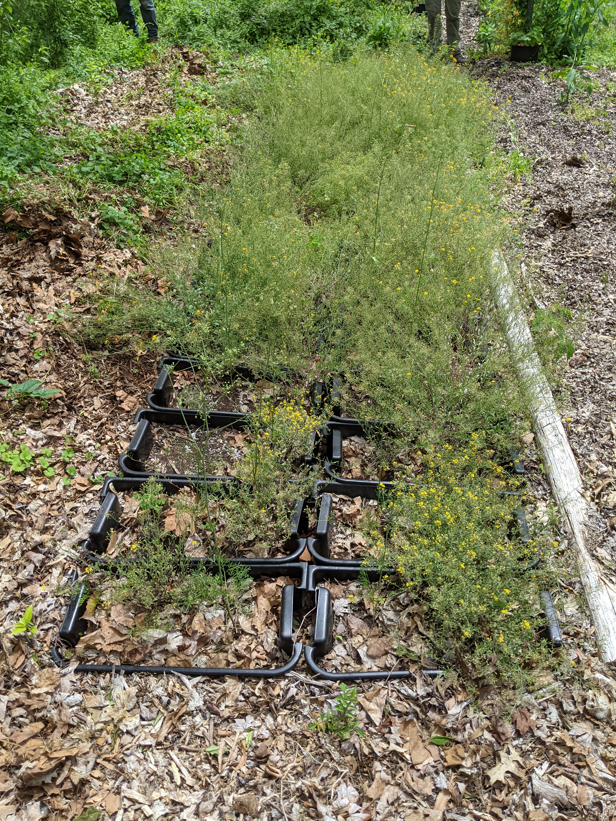 | C  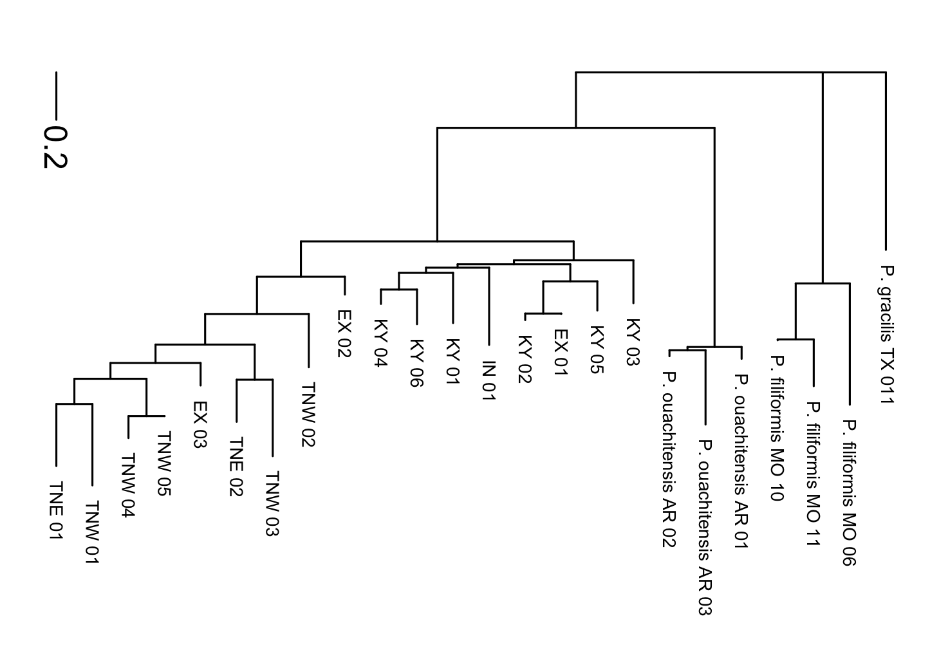

Figure 1. Photos of Physaria globosa and genetic distance tree.
(A), Native habitat. (B), Ex situ site (EX_03). (C), Neighbor-Joining tree based on Nei’s genetic distances. The tree was rooted at P. gracilis.

Figure 2. Map of P. globosa collection localities, with population structure K = 3 shown in pie charts.
The size of the pie chart reflects the sampling size per population. See Table 1 for detailed information.

A
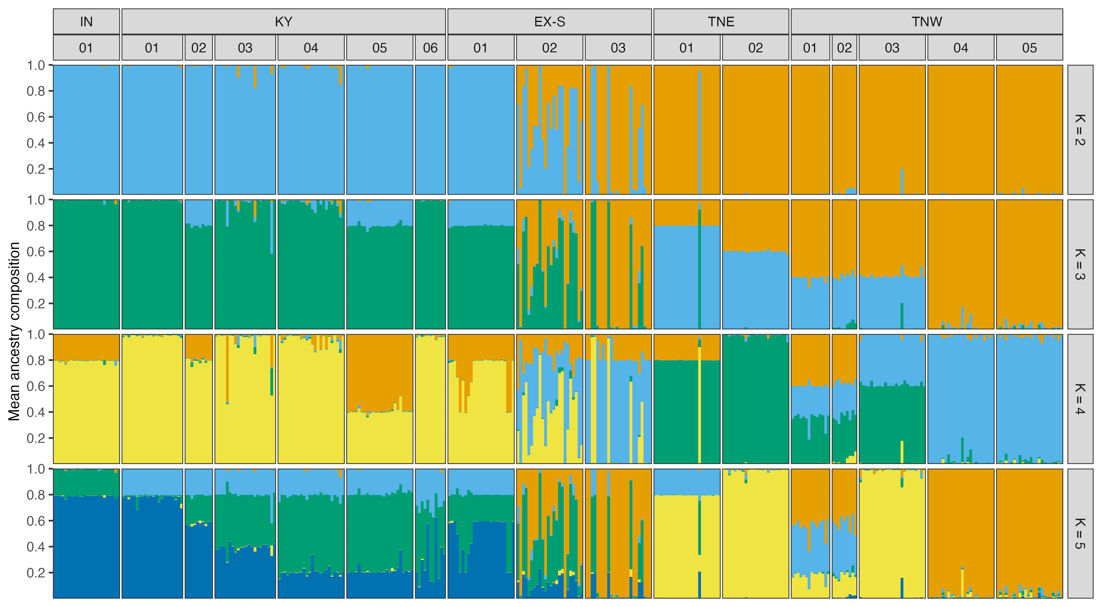
B  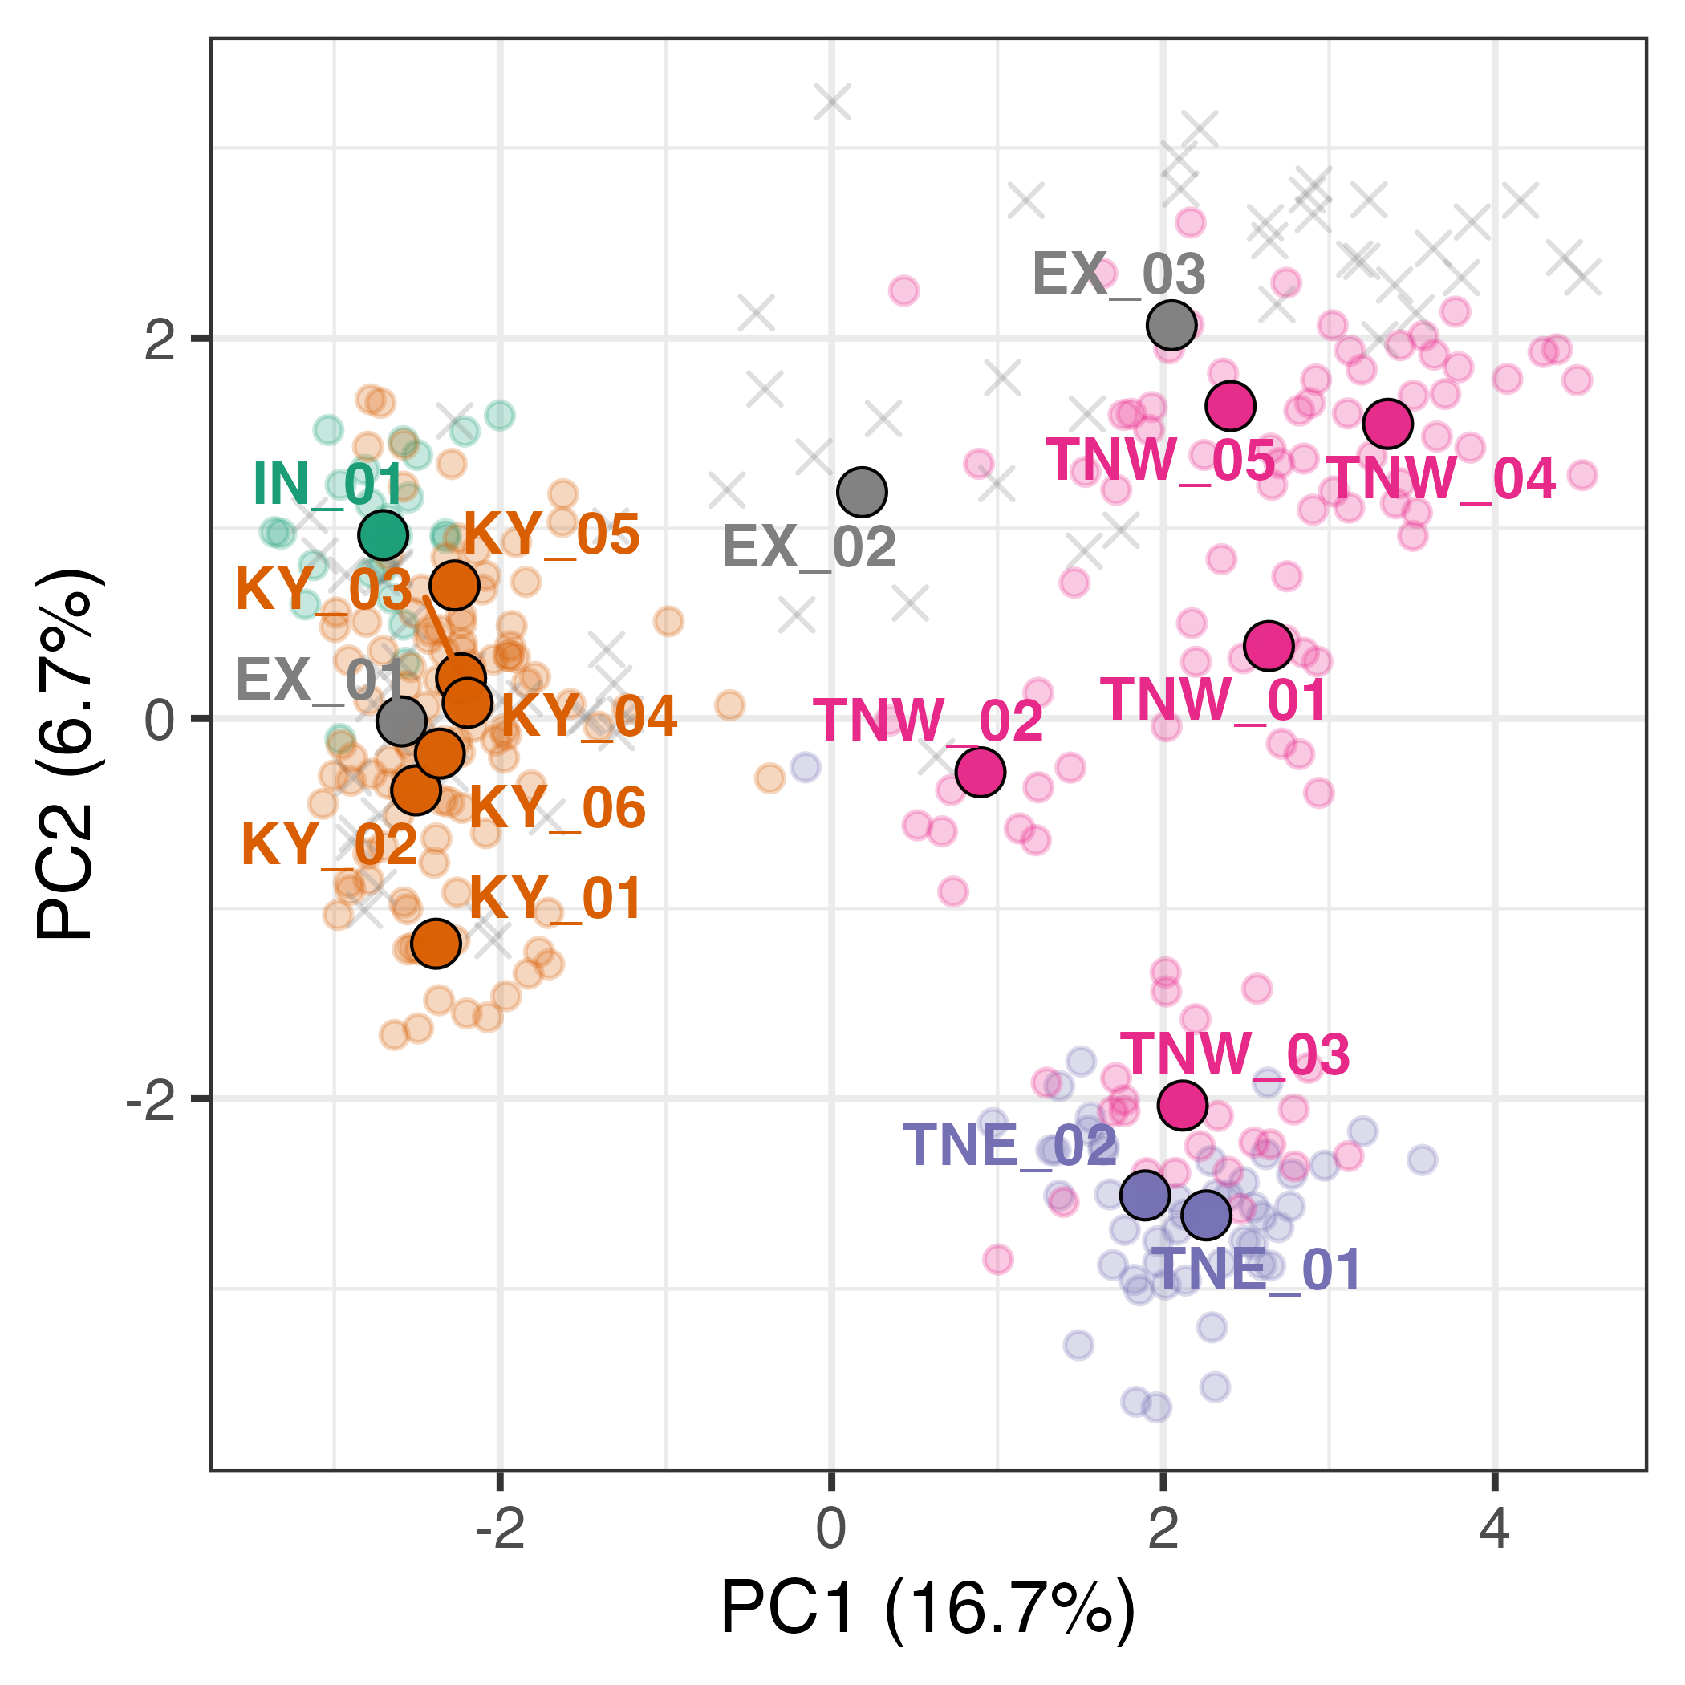 | C  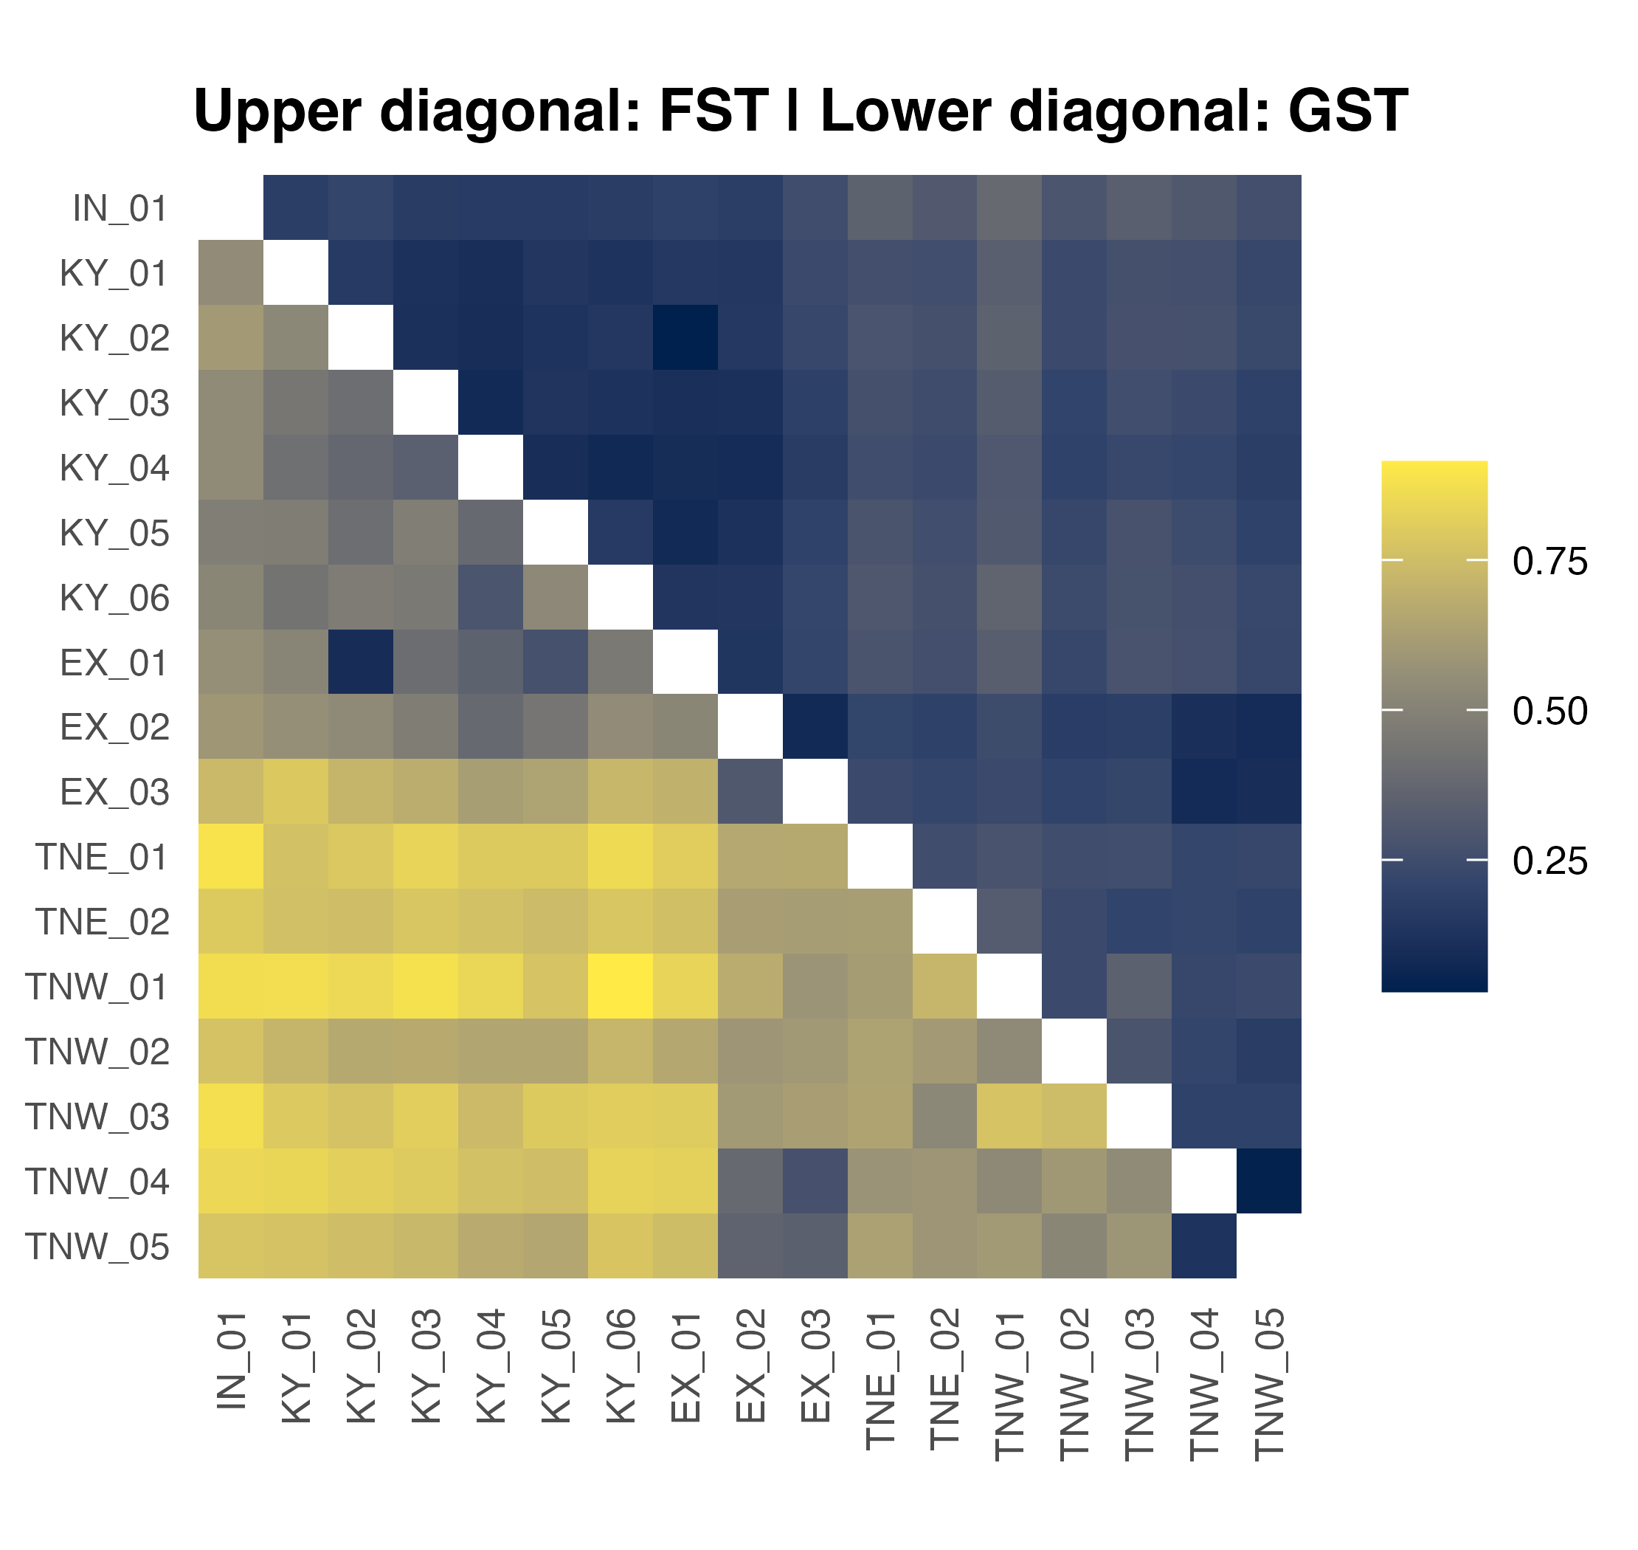

Figure 3. PCA of all wild P. globosa populations, with location and species indicated.
(A) STURCTURE analysis result (K = 2-5). (B) PCA plot. The big points with black stroke outline are population means. The small points without black stroke outline are individuals from natural populations. The crosses are individuals from ex situ populations. Points are colored by regions and population codes are labeled. (C), heatmap of F_{ST} and G_{ST}. See Table 1 for the population codes.
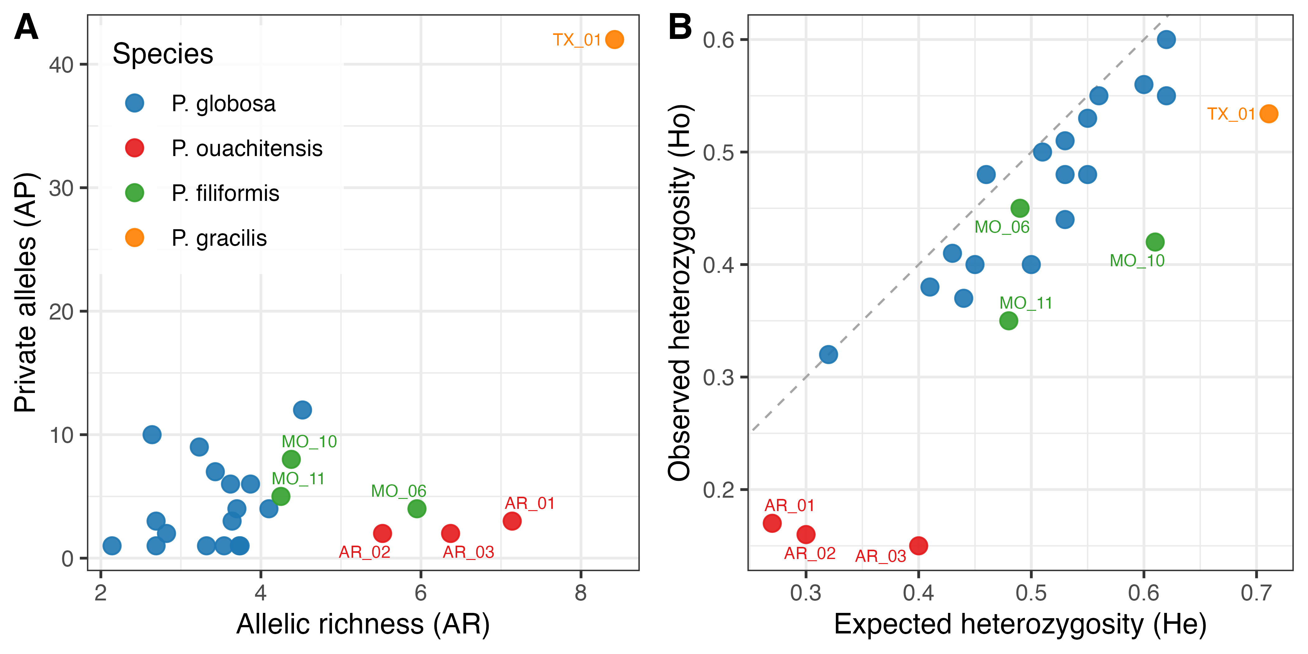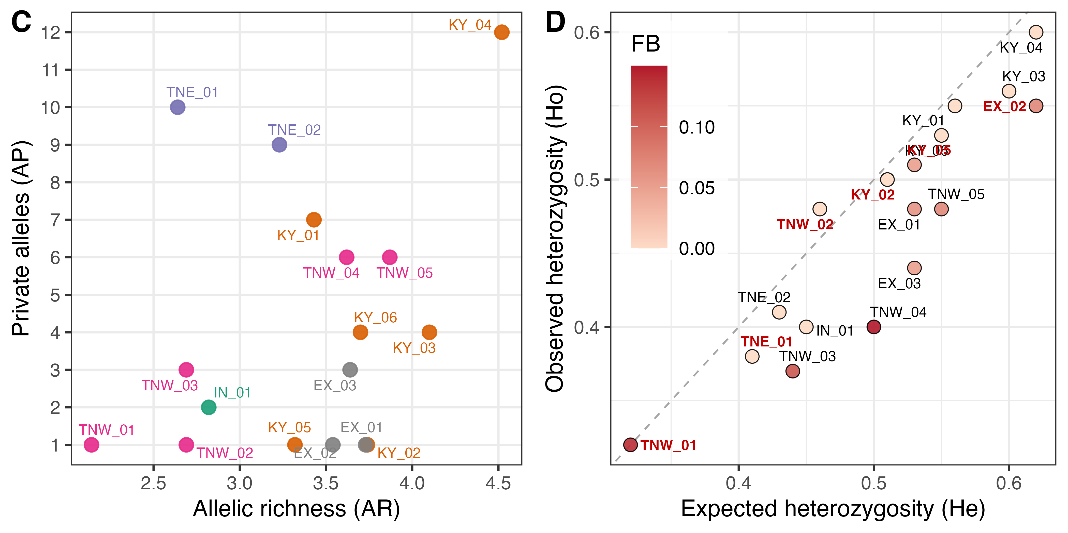

Figure 4. Genetic diversity analyses plots.
(A-B), Physaria globosa and outgroup species. (C-D), Physaria globosa with population labels. F_{B}., inbreeding coefficient after correction for null alleles. The six populations with excessive heterozygosity are labeled in red in (D). See Table 1 for the population codes.

