**Lab1-2**

*Basic syntax, variables, and operators*

1. **Mini assignment**
   1. Use triple quotes (""") to denote string literal more than one line with the following details: firstname, lastname, and address
   2. 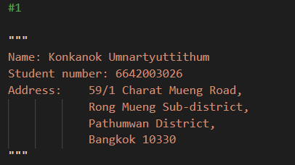
2. **~~Mini assignment~~**
   1. ~~Use multi-line statement to print your firstname and lastname~~

~~<<fill your result>>~~

1. **Mini assignment**
   1. displays the prompt, the statement saying “hello <<your ID>> <<your full name>>

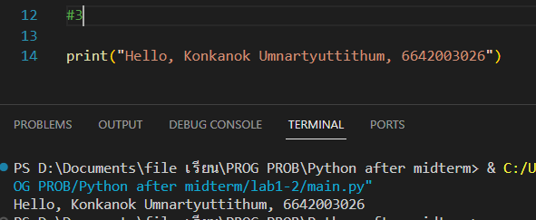

1. See how multiple commands can be written in one line

import sys; x = 'foo'; sys.stdout.write(x + '\n')

3

1. **Mini assignment**
   1. Use help function for "print" command

help(print)

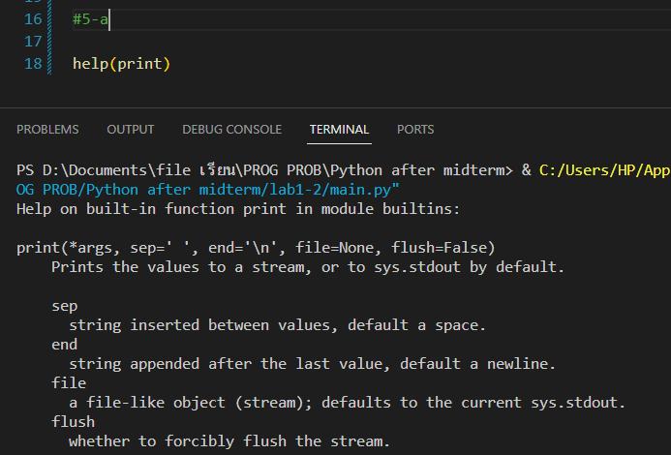

* 1. Use option "sep" and "end" to see the result
     1. Use "," for "sep" and use "-" for "end"

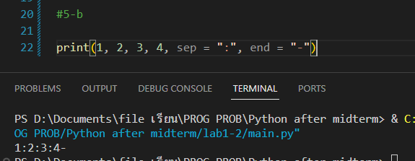

1. **~~Mini assignment~~**
   1. ~~Use help function for "sys.stdout.write" command~~

~~(This is not straightforward, try yourself Hint: use quote)~~

~~<<fill your result>>~~

1. **Mini assignment**
   1. Print the following values one by one

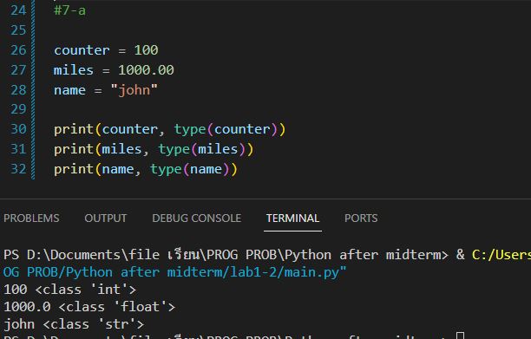

* 1. Print the following values one by one

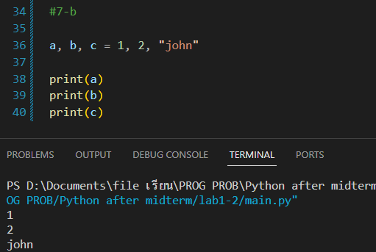

* 1. Print the following values one by one

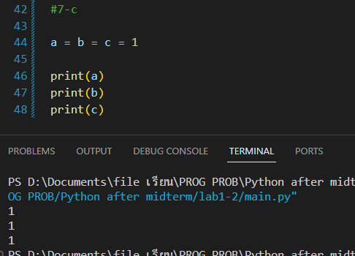

1. **Mini assignment (String)**
   1. Fill the following output (Note: use parenthesis after print command)

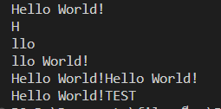

1. **Mini assignment (List)**
   1. Fill the following output

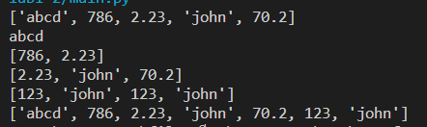

Try

l1 = [1,2,3]

l2 = ['a','b','c']

l1 + l2

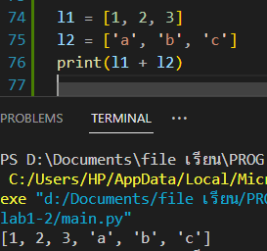

*Note + used in list means concatenation

1. **Mini assignment (Tuple)**
   1. Fill the following output

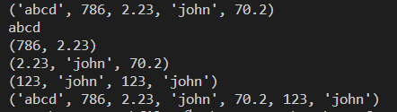

1. **Mini assignment (Tuple vs List)**
   1. Fill the following output and error

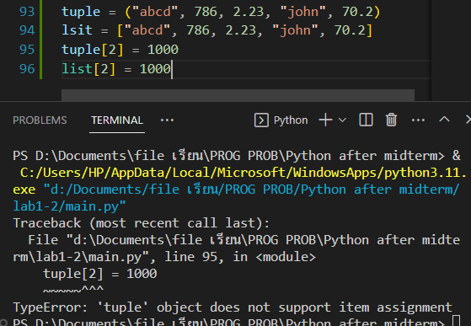

1. **Mini assignment (Dictionary)**
   1. Fill the following output

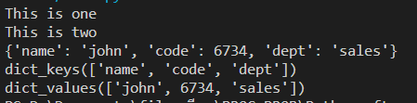

***Tip: Use "type(x)" to see data type

12.1

