Melike Kupen 16030411054/MIS

I was out of my language course the other day and I was walking towards my bus stop. Later I noticed a crowd on my way, everyone looking up. When I looked up to see what they were looking at, I saw a middle-aged man rise on the roof of one of the tall buildings. He said he would commit suicide. Police teams and ambulance arrived immediately, they tried to persuade the man, but the man insisted on not getting off. At that time, it came to my mind that I witnessed such an event for the first time. While thinking about what has happened so far, I realized that Covid-19 cases may be linked to this difficult process that has peaked. Nowadays, when we are going through a difficult period in terms of economy, people have been dismissed due to the pandemic, their relatives got sick and some even died. Thinking that this was a factor that could affect suicide cases, I decided to investigate.

First of all, I started to investigate the number of Covid-19 cases in the England regionally. I visualized this data by showing it on the map. According to the density of the number of cases on the map, I increased the density of the color and made it readable. The most intense place was London with 724218 cases, followed by the North West, South East, West Midlands, Yorkshire and The Humber, Eastern, East Midlands, South West and finally North East.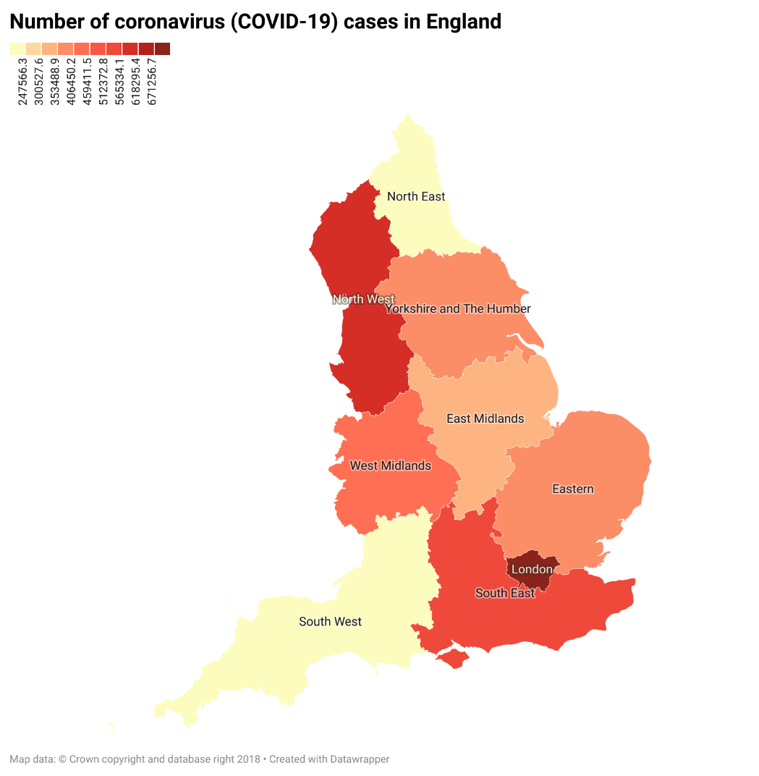

A healthy comparison required not only the number of cases but also the number of people living there. I used the "Statista" website to obtain this data. As you can see in the graph, if I need to rank the regions by population, South East is at the beginning, London, North West, East, West Midlands, South West, Yorkshire and The Humber, East Midlands, North East. As expected, the number of Covid-19 cases was higher in areas with high populations.

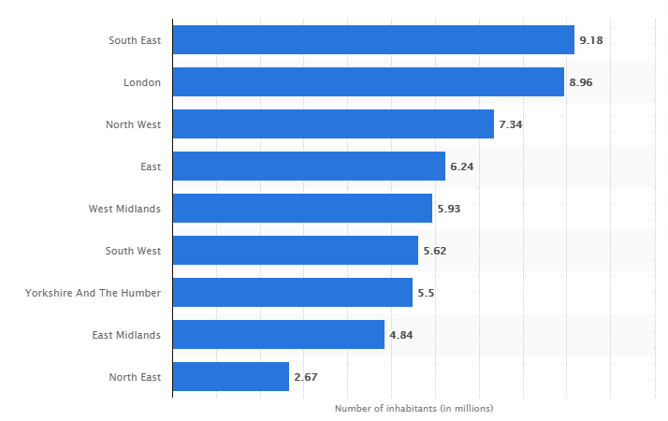

After these graphs, I also wanted to visualize the number of suicide cases regionally. Although I did not think there would be a regional relationship at the beginning, I realized that there was such a possibility while doing research. You can see the number of suicide cases by region below. Likewise, the area with the most cases is shown in the darkest color. When I examined the distribution of the number of suicide cases and the number of Covid-19 cases by region, I realized that although there was no exact similarity, I realized that they were generally related. However, in order to understand this relationship correctly, I had to compare it with previous years. Since the first case was detected in the England in January 2020, I thought the 2020 data would be healthier in this sense.

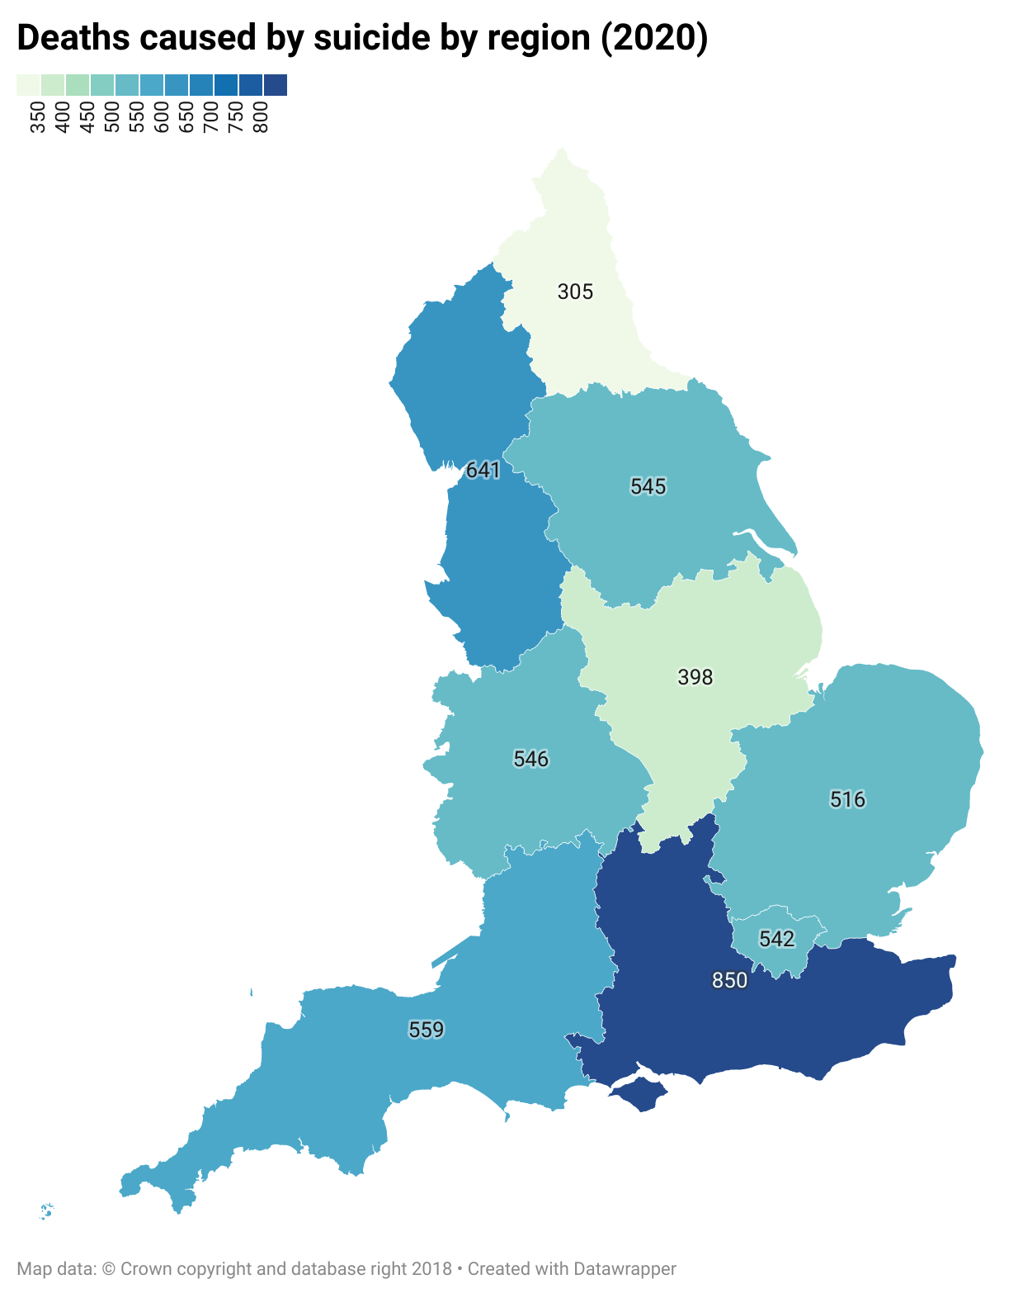

Now I had to compare the number of suicide cases in previous years with January 2020, when the first Covid-19 case was detected. For this, I considered the number of suicide cases between 2011-2020 and visualized this data with the Lines Chart. In the graph, you can see the number of people who died from suicide by 4 quarters of the year. The second quarter of 2020 had the lowest number of suicide cases since 2011. In the first quarter of 2020, the number of suicide cases is above average, and when we look at the 4th quarter, we can see the highest number of cases since 2011 with 1461 suicide cases. Considering that the dismissals and quarantine process caused by Covid-19 started in the 3rd quarter and after, we can notice that the suicide rate of people increased during the pandemic process.

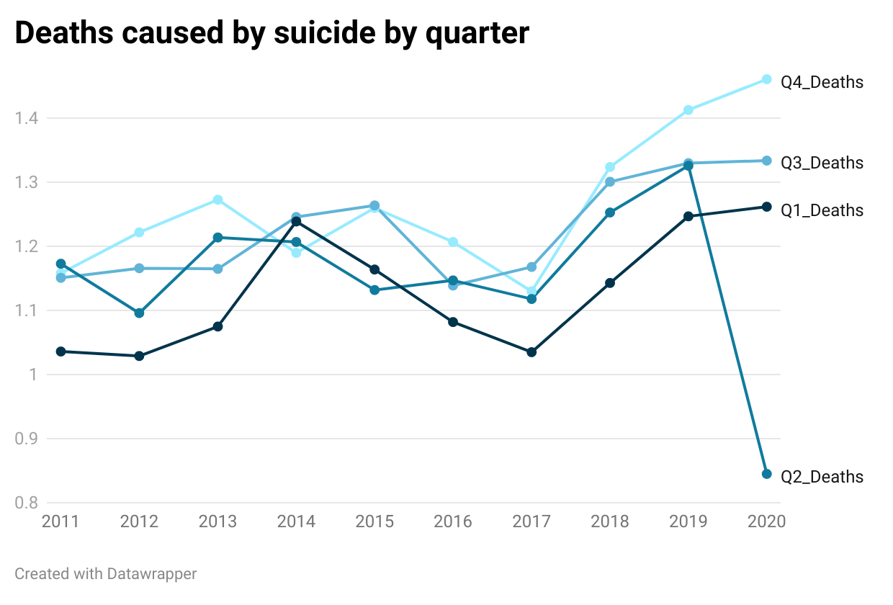

Later, I wanted to examine the number of suicide cases by gender in order to refine my research. Because both women and men were affected differently by the process and took an approach accordingly. While women complained about the increased housework due to the closure of all family members at home, they also had to continue their work, even from home. Men made up the majority of people fired. The companies of individuals who had their own business were on the brink of bankruptcy due to the economic damage added to the current economic problems and the pandemic. Therefore, I decided to examine men and women in two separate charts. If we start with women first, I visualized the number of women who committed suicide between 2011-2020 with Stacked Bars so that a comparison could be made on the basis of quarters of all years. According to the graph, the number of women who committed suicide in the first quarter of 2020, that is, in the period when the first case was detected, is the first quarter with the highest number of suicide cases since 2011 with 316. Although a decrease is observed in the 2nd quarter, we see the highest number of cases in the 3rd quarter just like the 1st quarter. When we examine the number of suicides that have taken place in the 4th quarter since 2011, we are faced with the highest number of suicides not only in the 4th Quarters, but also in all years until 2020.

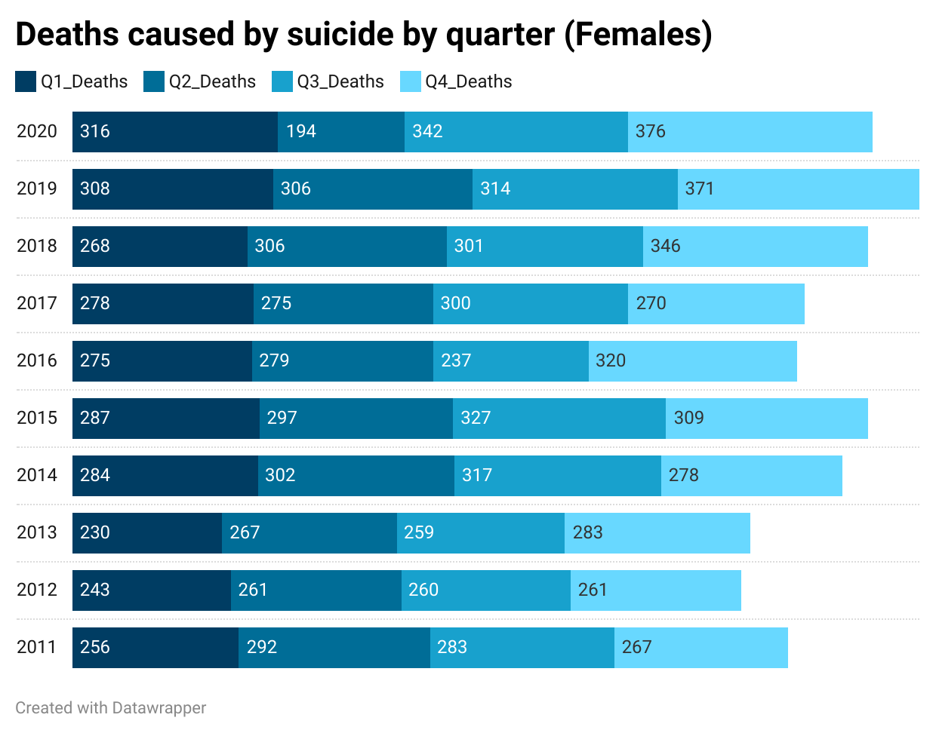

Later, in the same way, I examined the number of suicide cases of men between 2011-2020 on the basis of quarters of the year and visualized the data with the Area Chart. Here I noticed that the number of suicides of men in general is higher than that of women. Similar to women, we see that men have the highest number of suicide cases since 2011 in the 3rd and 4th quarter of 2020, but you may notice that there are more suicides than women in the first quarter of 2020. Therefore, I would like to draw attention to the fact that the number of suicides of both sexes has increased during the Covid-19 Pandemic process, but the number of men exceeds women. I think it would not be wrong if we deduce that men are more affected than women by the process.

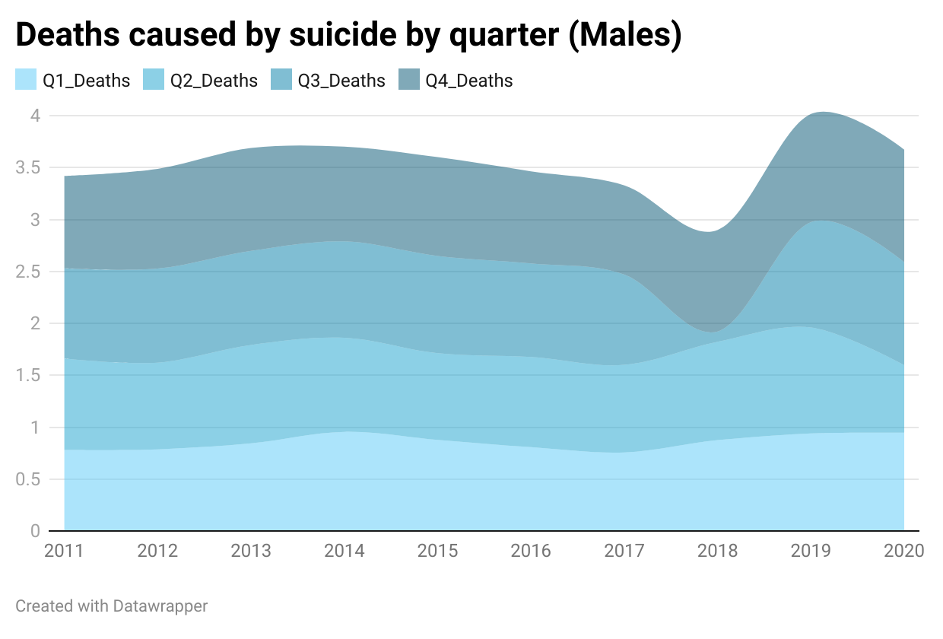

However, as I searched more, I realized that not only that, but also that we had to go deeper. Therefore, I decided to examine suicide cases according to age groups. I expected the highest number of suicide cases to be from the middle age group, who do not need much workforce but are expected to support their homes, and to test the accuracy of this, I obtained a dataset of suicide numbers by age group since 2015. I got the average number of suicides from 2015 to 2019 by summer groups so that I could compare these data with the number of suicides in 2020. I visualized the dataset with a Grouped Column Chart. As a result, I realized that the highest number of suicides was between the ages of 45 and 49, just as I expected. But this was not only specific to the Covid-19 process, in all years the group who committed the most suicide in the same way was the 45-49 age group, even the number of suicide cases of this group did not increase during the Covid-19 process, this surprised me. When I examined it in more detail, I realized that suicide cases did not change according to the age group during the pandemic process. Although the number of suicides in general increased during this period, it did not seem to have anything to do with the age group. The number of cases was similar to the previous years, you can examine this graph below.

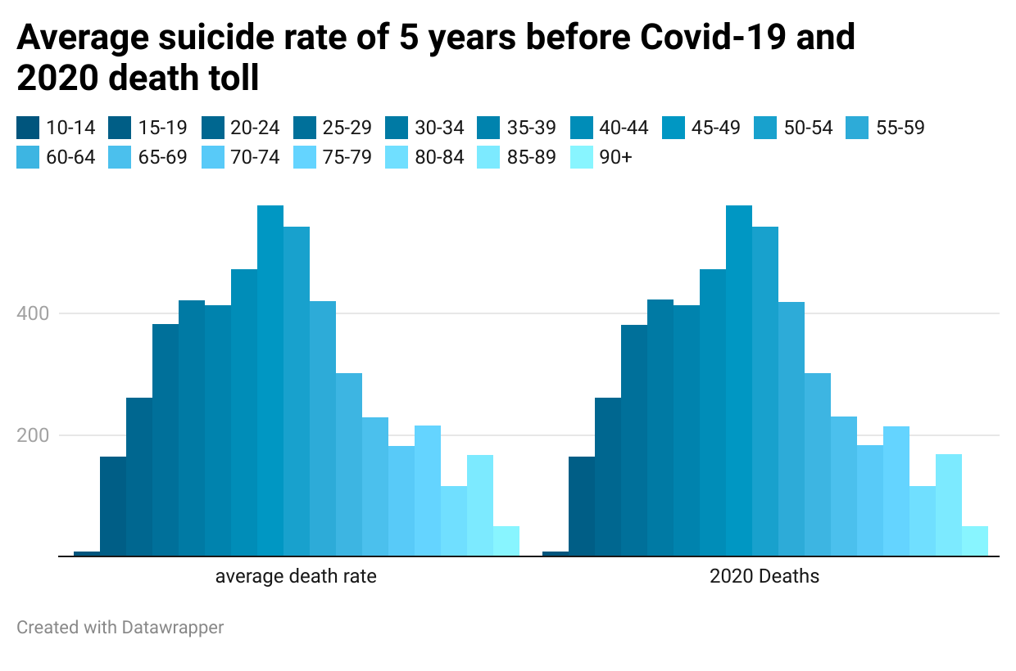

As a result of this research, I examined the effect of the Covid-19 pandemic process on suicide cases and observed that there was a relationship between these two situations. During my homework, I used the "DataWrapper" tool as a data visualization tool. When I searched the literature, I realized that there was not enough work on the relationship between these two issues. For this reason, I believe that this issue should be examined in detail by the experts of the field and the state should take measures in this direction as a result of the investigations.

# References

Clark, D. (2020, June). *Population of England in 2019, by region*. Statista: https://www.statista.com/statistics/294681/population-england-united-kingdom-uk-regional/

*COVID-19 Daily Deaths*. NHS: https://www.england.nhs.uk/statistics/statistical-work-areas/covid-19-daily-deaths/

Menders, B., & Windsor-Shellard, B. (2020, September). *Suicides in England and Wales Statistical bulletins*. Office for National Statistics: https://www.ons.gov.uk/peoplepopulationandcommunity/birthsdeathsandmarriages/deaths/bulletins/suicidesintheunitedkingdom/previousReleases

Stewart, C. (2021, May). *Coronavirus Cases by Region*. Statista: https://www.statista.com/statistics/1102151/coronavirus-cases-by-region-in-the-uk/