Practical-4
2520030233
K.Akshitha
S-7

C File for the Wait program-
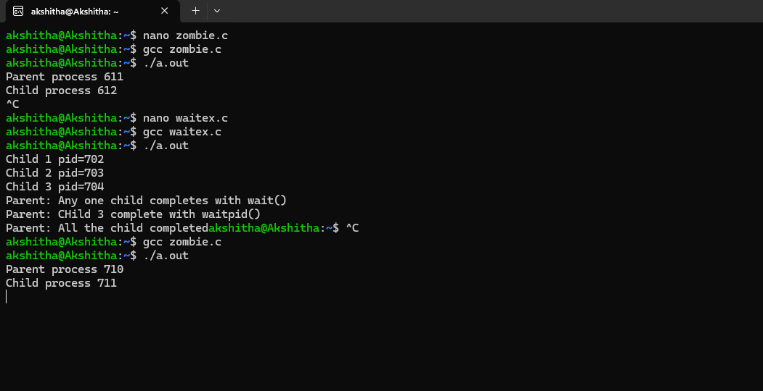

Output for the Zombie process experiment:

