Practical-4
2520030245
T.Meghana sai
S-7

C File for the Wait program-

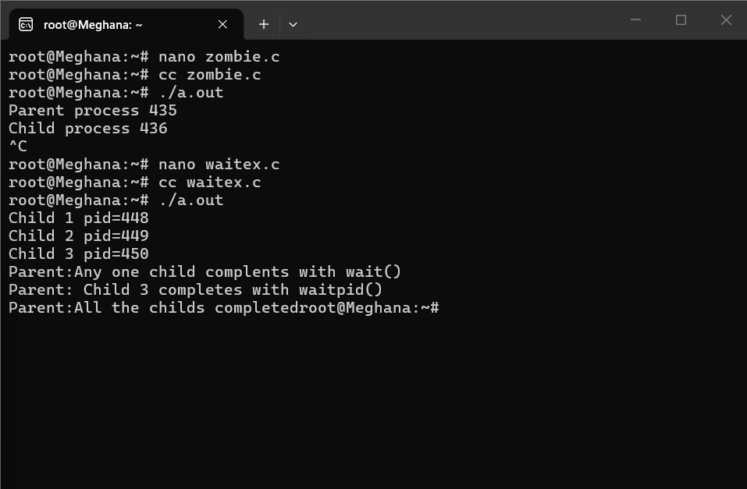

Output for the Zombie process experiment:

