Practical-3
2520030233
K.Akshitha
S-7

C file(the program):

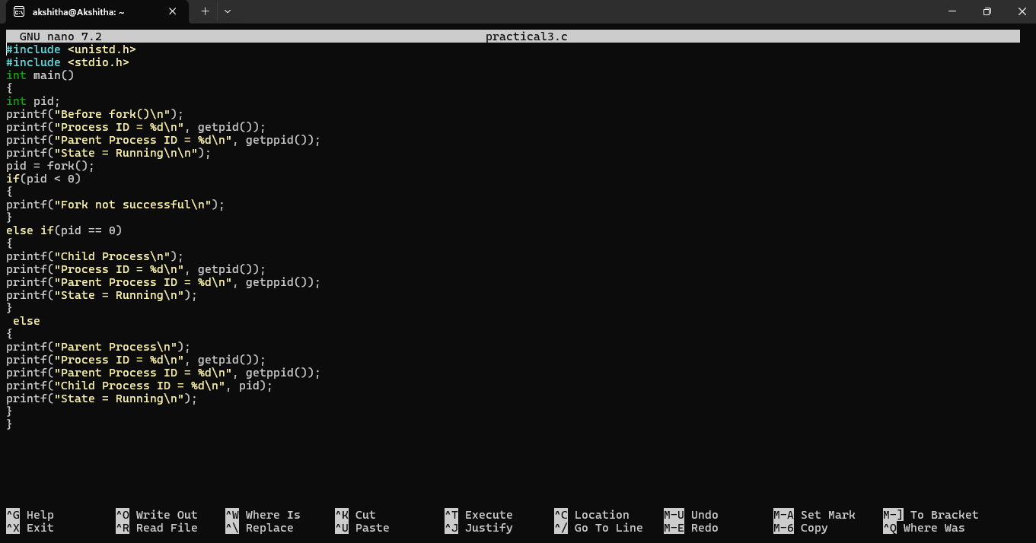
Output:

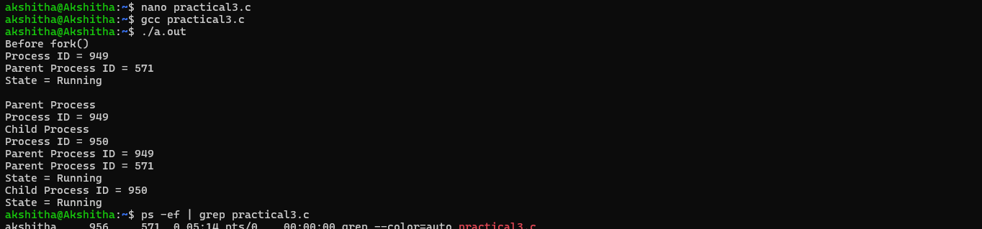

Ps (we got 326 as gthe pid and it is show here)
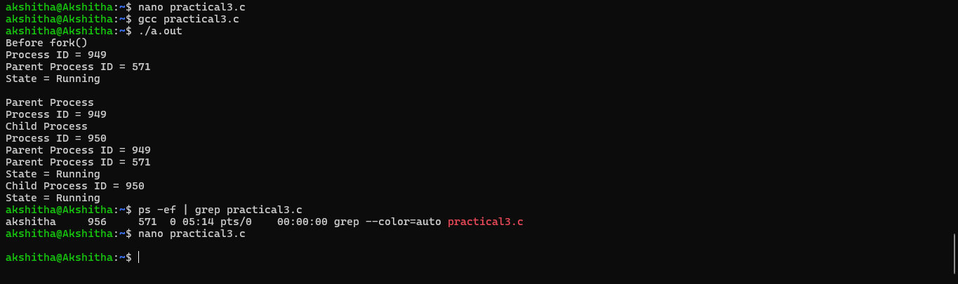
Top command using the 326 pid

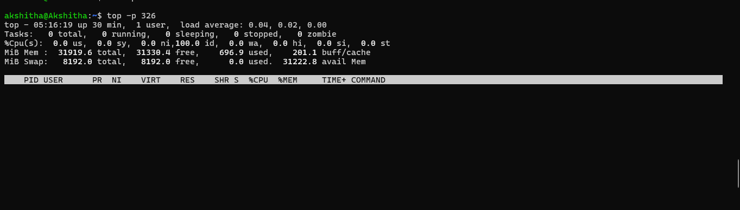

/proc command

