TEAM MEMBERS: C.K.AKSHAYA PRATHIKSHA

S.SONIA

A.DIVYA

KUPPAIAH PAVITHRA

# FAKE NEWS DETECTION USING NPL

Detecting fake news using Natural Language Processing (NLP) involves a multi-step process that includes data collection, preprocessing, feature extraction, model training, and evaluation. Here's a detailed approach to building a fake news detection system using NLP:

1. Data Collection:

- Collect a diverse dataset of labeled news articles, categorizing them into "fake" and "genuine" categories. Reliable sources for labeled data include Kaggle, Snopes, PolitiFact, and other fact-checking websites.

2. Data Preprocessing:

- Perform text cleaning, including removing special characters, HTML tags, and irrelevant information.

- Tokenize the text into words or subwords.

- Remove stop words and apply stemming or lemmatization to reduce words to their root forms.

3. Feature Engineering:

- Use techniques like TF-IDF (Term Frequency-Inverse Document Frequency) or word embeddings (e.g., Word2Vec, GloVe) to convert text into numerical features.

- Consider additional features like sentiment analysis, named entity recognition, and part-of-speech tagging.

4. Model Selection:

- Choose a suitable machine learning or deep learning model for classification, such as:

- Logistic Regression

- Support Vector Machines (SVM)

- Multinomial Naive Bayes

- Random Forest

- Long Short-Term Memory (LSTM)

- Bidirectional Encoder Representations from Transformers (BERT)

5.Model Training:

- Split the dataset into training and testing sets (e.g., 80% for training, 20% for testing).

- Train the chosen model(s) using the preprocessed data and appropriate features.

- Fine-tune hyperparameters for optimal performance (e.g., using cross-validation).

6. Model Evaluation:

- Evaluate the model's performance using metrics such as accuracy, precision, recall, F1-score, and area under the ROC curve.

- Analyze confusion matrices to understand false positives and false negatives.

7. Post-Processing and Refinement:

- Apply post-processing techniques to further refine predictions, such as threshold adjustment or incorporating ensemble methods.

8. Deployment:

- Deploy the model using a web application, API, or any suitable platform for user interaction.

- Provide a user-friendly interface for users to input news articles and receive predictions regarding their authenticity.

9. Monitoring and Maintenance:

- Monitor the model's performance in real-time and gather user feedback for continuous improvement.

- Periodically retrain the model with updated data to ensure its effectiveness and relevance.

10. Education and Awareness:

- Educate users about the limitations of the model and the importance of critical thinking when evaluating news sources.

By following this approach, you can develop an effective fake news detection system using NLP, contributing to the fight against misinformation and promoting a more informed society.

Start

|

|--- Data Collection

| |--- Collect a diverse dataset of labeled news articles

| (Fake vs. Genuine)

|

|--- Data Preprocessing

| |--- Text Cleaning (remove special characters, HTML tags, etc.)

| |--- Tokenization (split text into words or subwords)

| |--- Stopword Removal and Lemmatization

|

|--- Feature Engineering

| |--- TF-IDF or Word Embeddings (e.g., Word2Vec, GloVe)

| |--- Additional Features (sentiment analysis, named entity recognition, etc.)

|

|--- Model Selection

| |--- Choose a suitable ML/DL model for classification (e.g., LSTM, BERT)

|

|--- Model Training

| |--- Split data into training and testing sets

| |--- Train the selected model(s) using the preprocessed data

|

|--- Model Evaluation

| |--- Evaluate model performance using metrics (accuracy, precision, recall, F1-score)

|

|--- Post-Processing and Refinement

| |--- Apply post-processing techniques for refining predictions

|

|--- Deployment

| |--- Deploy the model using a web app, API, or platform

| |--Provide a user interface for inputting news articles and receiving predictions

|

|--- Monitoring and Maintenance

| |--- Monitor model performance and gather user feedback

| |--- Periodically retrain the model with updated data

|

|--- End 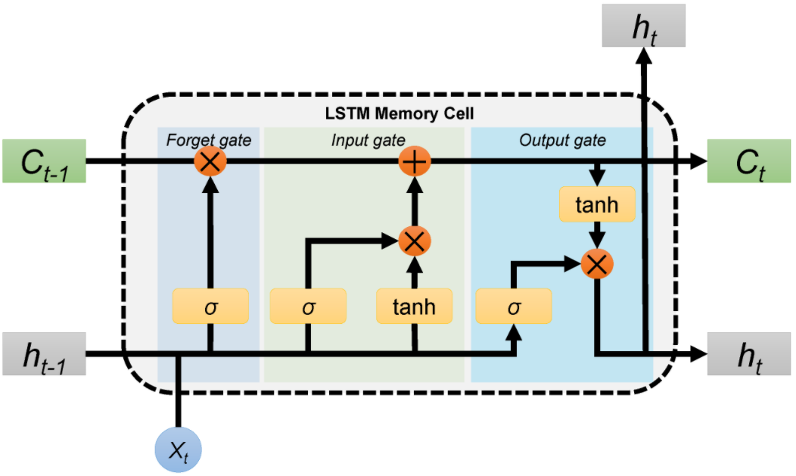

This flowchart provides an overview of the process, starting from data collection and preprocessing, moving through feature engineering, model selection and training, evaluation, post-processing, deployment, and finally, monitoring and maintenance. Each step is essential in building an effective fake news detection system using NLP.

BUDGET AND RESOURCE

Creating a budget for fake news detection using Natural Language Processing (NLP) involves several factors, including technology, data acquisition, human resources, and ongoing operational costs. Here's a breakdown of potential costs:

Technology and Infrastructure:

NLP Tools and Software Licenses: Cost for obtaining or subscribing to NLP frameworks, libraries, and tools (e.g., spaCy, NLTK, TensorFlow, PyTorch).

Cloud Computing Services: Expenses for using cloud platforms like AWS, Azure, or Google Cloud for processing and storing data.

Hardware: Cost for computing hardware if opting for on-premises infrastructure.

Data Acquisition and Preparation:

Data Collection: Expenses for acquiring a diverse dataset of fake and genuine news articles for training and testing the NLP models.

Data Cleaning and Annotation: Costs associated with cleaning, annotating, and preparing the data for training models.

Model Development and Training:

Development and Programming: Cost of hiring developers and data scientists to create and train NLP models for fake news detection.

Model Training Infrastructure: Additional cloud computing costs for training the NLP models.

Human Resources:

Data Scientists and Machine Learning Engineers: Salaries and benefits for professionals responsible for developing and refining the NLP models.

Data Labeling and Annotation: Costs associated with hiring annotators to label data for training the models.

Ongoing Operational Costs:

Model Maintenance and Updates: Ongoing costs for maintaining, updating, and improving the NLP models to keep them effective against evolving fake news tactics.

Monitoring and Evaluation: Resources for continuously monitoring the model's performance and making necessary adjustments.

Validation and Testing:

Cross-validation and Testing Infrastructure: Costs associated with testing and validating the models for accuracy, precision, recall, and other performance metrics.

Legal and Compliance:

Compliance Costs: Expenses for ensuring compliance with legal and ethical guidelines regarding data usage and privacy.

Contingency and Miscellaneous:

Contingency Budget: Allocated budget for unforeseen expenses or adjustments needed during the project.

Miscellaneous Expenses: Other potential costs not covered above.

It's challenging to provide precise budget estimates without specific project requirements and scale. The budget could range from a few thousand to several hundred thousand dollars, depending on the complexity of the project, the scale of deployment, and the accuracy required for the fake news detection system. It's advisable to consult with experts in the field and conduct a thorough analysis to arrive at an accurate budget for your project.