Karan Uppal
Dec 15, 2010

1) Pattern Selection based on classification (implemented in R):

A new feature selection algorithm based on a consensus scoring methodology was implemented. The algorithm is divided into three steps. The first two steps use the CMA package implemented in R, and the last step uses a particle swarm optimization based search strategy to find the optimal set of features that would allow maximum classification accuracy.

The user uploaded dataset is first randomly divided into distinct training and test sets based on the splitting percentage provided by the user (default: 60% train, 40%test).

In the first step of the feature selection process, a ranked list of features is generated by performing a t.test on the training dataset. Only the top X number of features (default 150; user defined) are retained for further analysis.

The second step uses one or more feature selection algorithms selected by the user to determine a consensus set of best features. The user can select t.test, f.test, kruskal.test, recursive feature elimination, random forest, Welch.test, Wilcox.test, lasso, elasticnet, and boosting. For every selected algorithm, the number of features is iteratively increased from 1 to X (default 150) in increments of delta (default 5) till there is no improvement in the 10fold cross validation accuracy for I number of iterations (default 10). This gives m subsets of top ranked features where m is the number of selected feature selection algorithms. A consensus score of a feature is defined as the number of subsets that include that feature, and its value ranges from 0 to m.
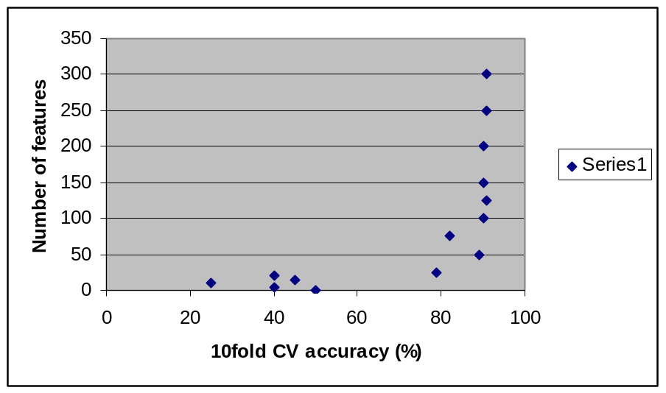
In the final step, the consensus subset of features selected by at least M_min (default=100%) algorithms is then used as an input for the PSO algorithm. The PSO algorithm is designed to avoid particles from getting stuck in local optima. The search criteria (local or global search) depends on the rank of a particle. In other words, the best particle will have a narrow or local search space while the worst particle will have a much broader or a global search space controlled by the inertia variable in the velocity update equation of the PSO algorithm.

2) Pattern Selection based on regression (implemented in R):

A new feature selection algorithm that uses PSO based stochastic search to select optimal set of features and a SVM-regresssion method for evaluating the fitness or the mean squared error of the selected features. The user uploaded dataset is first randomly divided into distinct training and test sets based on the splitting percentage provided by the user (default: 60% train, 40%test).

The PSO algorithm is designed to avoid particles from getting stuck in local optima. The search criteria (local or global search) depends on the rank of a particle. In other words, the best particle will have a narrow or local search space while the worst particle will have a much broader or a global search space controlled by the inertia variable in the velocity update equation of the PSO algorithm.

3) Heterogeneous population:

- Split the training set into 10 sets of 1000 bootstrapped samples.
- Perform cross-validation on the nth set and use the remaining 9 sets for validation
- Get the best set of features for each set
- Get the consensus features that are selected in each set

