Create a VPC with a public subnet and private subnet

* <https://docs.aws.amazon.com/codebuild/latest/userguide/cloudformation-vpc-template.html>

Upload cloudformation template

Create a new Bastion EC2 in public subnet

Allow 22 anywhere

Create phpmyadmin ec2 in private subnet

Attach jumpnginx sg to allow port 22

Ssh into the instance through your public ec2

Sudo apt update && upgrade

Create Nginx ec2 in private subnet

Allow 22 from bastion

80 anywhere ipv4

443 anywhere ipv4

Part 2:

Create a target Group

Port 80

VPC should be the vpc you created

Targets your nginx ec2

Create a Load Balancer

Network map to public subnet

Default Security Group

Register your reverse proxy instance as target

Ssh into BasitonHost

sudo apt update

sudo apt upgrade -y

Create a copy of your pem key in the bastion host

sudo nano mykey.pem

Ssh into your reverse proxy ec2

sudo apt update

sudo apt upgrade -y

Do the same for the other ec2

Part3

Create your subnet groups and choose your private subnets

Create the database

MySql

Free Tier

Choose a password and username

Choose your vpc

Part4

Create subnet groups

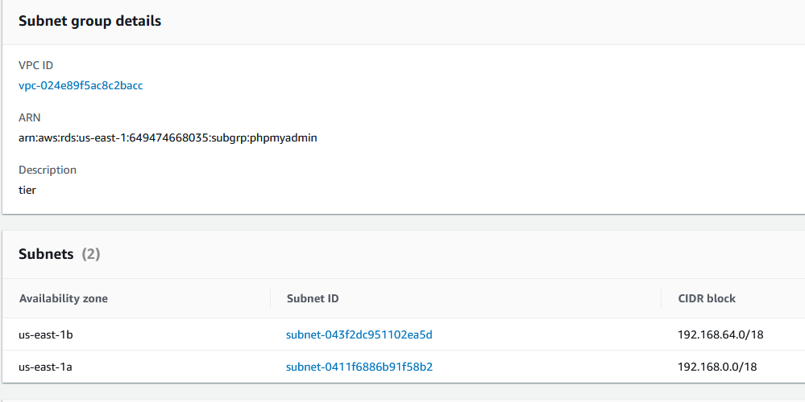

Ssh into myphpadmin ec2

sudo apt install apache2

- install apache2

- check apache

- install: sudo apt install php libapache2-mod-php php-mysql

- check php: touch /var/www/html/test.php: and make: <?php phpinfo();

- install mysql: sudo apt install mysql-server

- sudo mysql_secure_installation

- log into mysql with: mysql -u root -p

- install: sudo apt install phpmyadmin php-mbstring php-zip php-gd php-json php-curl

- abort

- UNINSTALL COMPONENT "file://component_validate_password";

- sudo apt install phpmyadmin

- INSTALL COMPONENT "file://component_validate_password";

- sudo phpenmod mbstring

- log into mysql

- SELECT user,authentication_string,plugin,host FROM mysql.user;

- ALTER USER 'root'@'localhost' IDENTIFIED WITH caching_sha2_password BY 'password';

- edit the /etc/php/7.4/apache2/php.ini and line 895 uncomment

- edit the /etc/apache2/apache2.conf and add: include /etc/phpmyadmin/apache.conf

Exit phpmyadmin ec2

Ssh into nginx ec2

Sudo apt install nginx -y

cd /etc/nginx/sites-available/

sudo unlink /etc/nginx/sites-enabled/default

Sudo nano reverse-proxy.conf

server {

listen 80;

location / {

proxy_pass http://172.31.81.201;

}

}

Replace proxy pass with phpmyadmin private ip

sudo ln -s /etc/nginx/sites-available/reverse-proxy.conf /etc/nginx/sites-enabled/reverse-proxy.conf

Sudo nano /etc/phpmyadmin/config.inc.php

Goto line 102 and below it paste the following

$i++;

$cfg['Servers'][$i]['host'] = '__FILL_IN_DETAILS__';

$cfg['Servers'][$i]['port'] = '3306';

$cfg['Servers'][$i]['socket'] = '';

$cfg['Servers'][$i]['connect_type'] = 'tcp';

$cfg['Servers'][$i]['extension'] = 'mysql';

$cfg['Servers'][$i]['compress'] = FALSE;

$cfg['Servers'][$i]['auth_type'] = 'config';

$cfg['Servers'][$i]['user'] = '__FILL_IN_DETAILS__';

$cfg['Servers'][$i]['password'] = '__FILL_IN_DETAILS__';

Access the load balancer using the url and add /phpmyadmin to the url

If you can’t access the web server:

Check your load balancers security group and make sure it allows port 80 and port 443 anywhere ipv4