Mohamed Hassan

Kura Labs

Deployment 3

Ran test

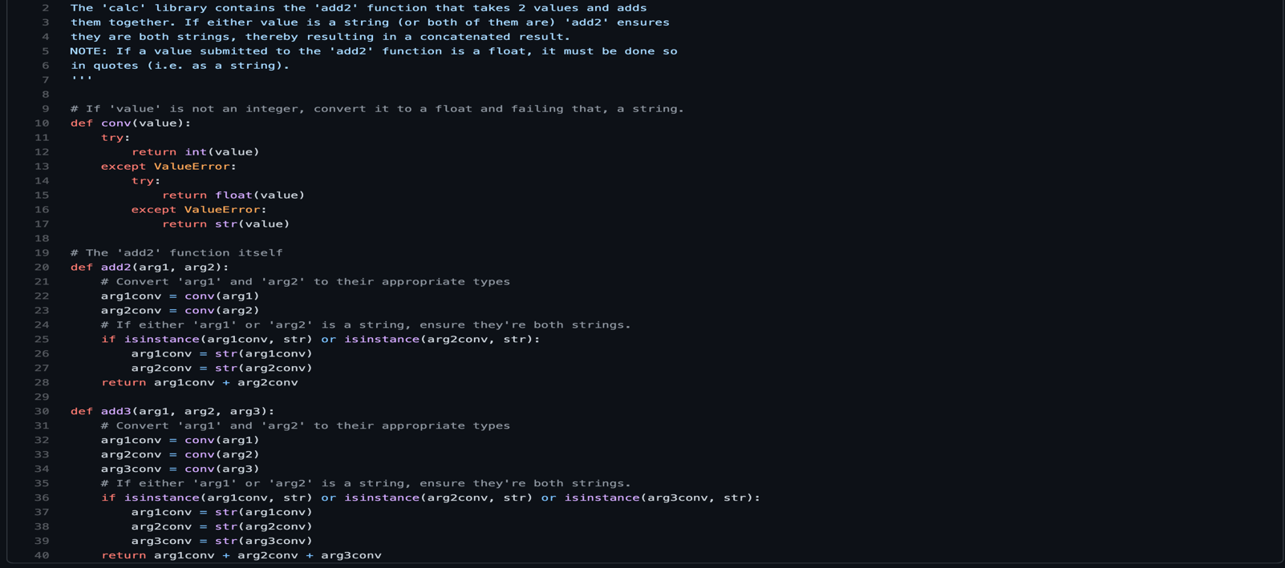

(add2vals.py)-Added feature which adds a value(arg3) along with arg1 and arg2

(test_calc.py) Added a value/string and edited the result

Broke the code (add3 was not given the ability to accept three parameters)



Fixed the code



