* [x]Screenshot the first successful test build.



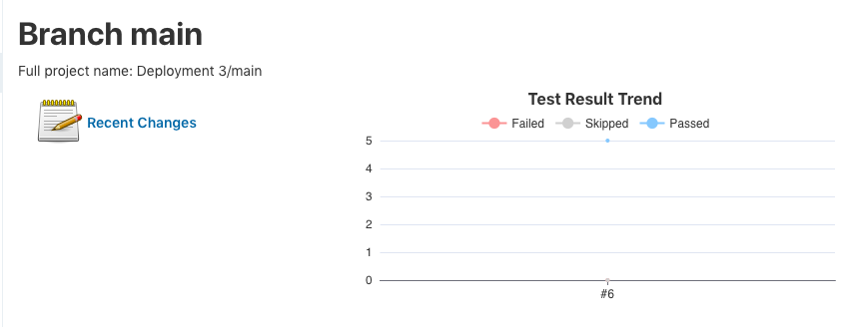

* [x]Document your added component or feature.

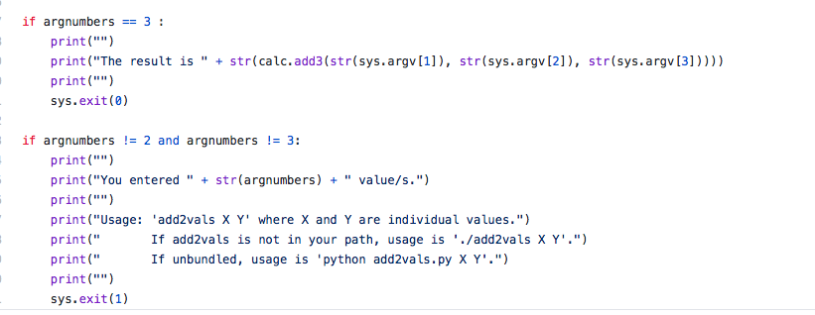

Within addv2val.py, what was added was the if statement where I added if the variable argnumbers was equal to 3 a result was printed as well as if argnumber is not equal 3 print the following.

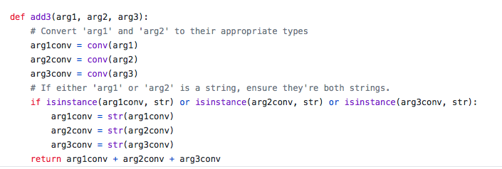

Within calc.py, the parameter of arg3 was added and subsequently as well as variables arg3conv in order to convert the value attributed to it.

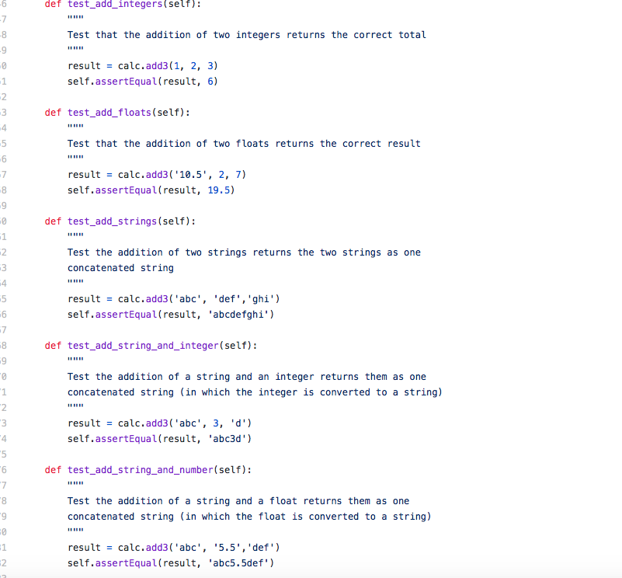

In terms of testcalc.py, for every result we added an attribute to facilate the change created from changing add2 to add3.

* [x]Screenshot your failed test and document why your test failed.

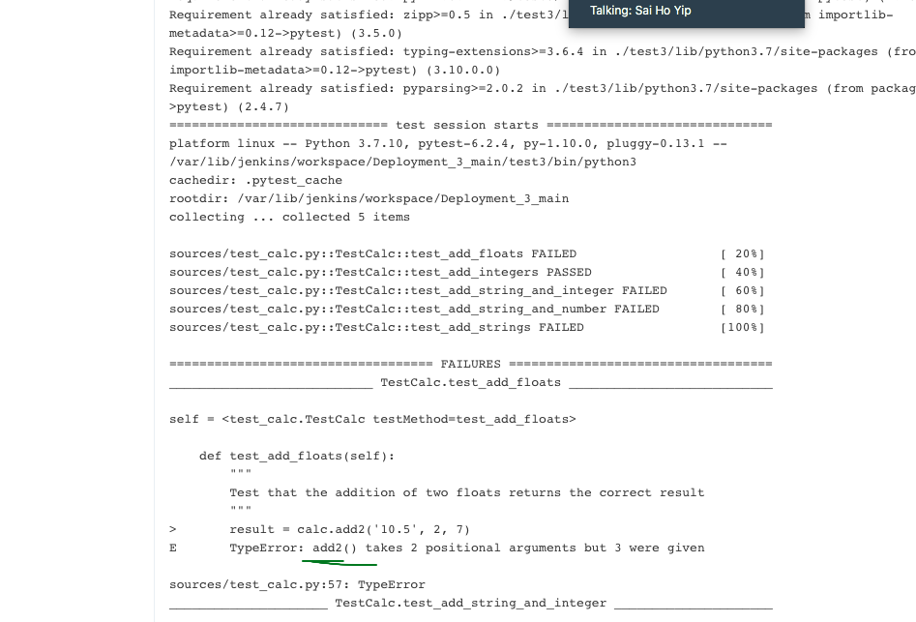

As we see in the error message above, several test failed. The reason is to see if the additional attributes would be successful while the calc.add method wasn’t adjusted to fit the parameters set. Only one test passed as shown above because it was the only test that was given 3 positional arguments and provide 3 as well.

* [x]Screenshot your successful test build and document what you did to fix your failed test build

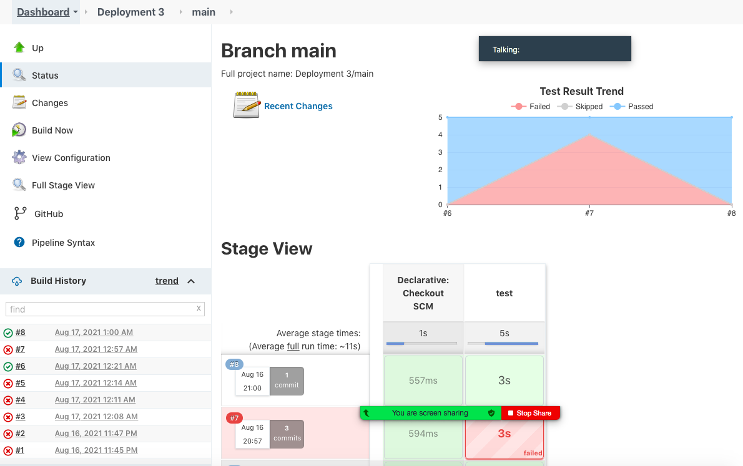

What was needed to fix the error was to replace add2 with add3 in order to go along with the 3 arguments that were already provided.

* [x]Initiate a pull request to the kura_labs_org/DEPLOY_3_TEST repo with your documentation, screenshots(add screenshots to documentation), test_calc.py with your added test, and add2vals.py with your added feature or component.