Issue:

One of the biggest issues we encountered was that when jenkins served cypress it got stuck and wasn’t continuing onto the second stage of the build on the pipeline.

Solution:

We solved this issue by adding & wildcard to run the server in the background so that it doesn’t hog up the cmd and lets jenkins continue it’s job while the server runs in the background.

What I did to make the build fail:

We went into the integration folder and in the test.spec.js we changed it so that it would test for a string that did not match the string displayed on the webpage.

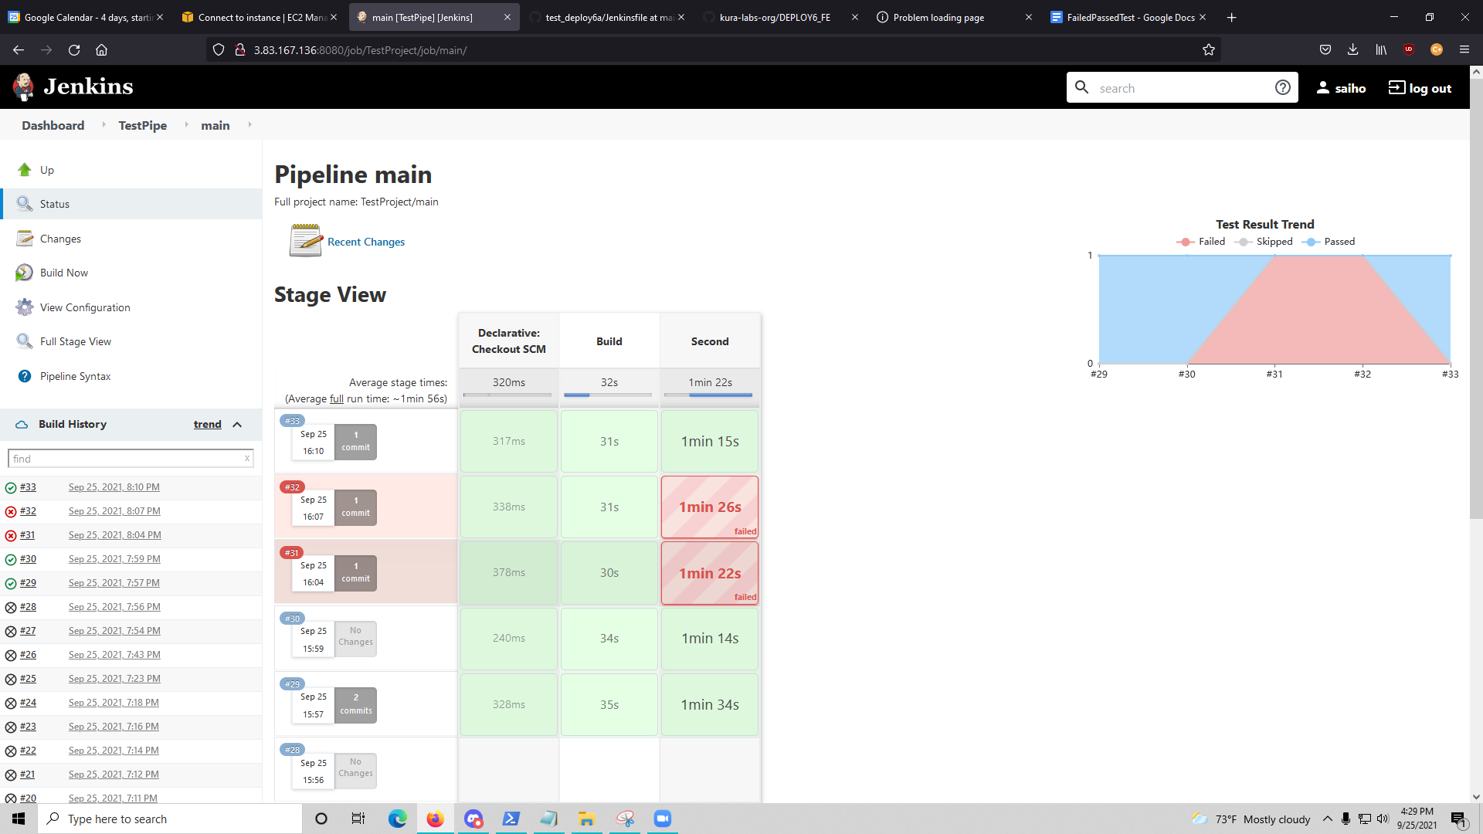

find /home -name \*.mp4